Unit 3
FASCINATING PARKS
Discover useful structures
The -ing form as the subject
教学设计
教学目标：To learn and practise the -ing form used as subject.
教学过程：
一、Leading-in
Showing some pictures and make some sentences according to the Chinese reference .
1.Visiting theme parks can bring you into different world.
2. Going to the Cambridge University is my dream.
V-ing form used as the subject
3. Travelling is a good way to relax.
4. Playing basketball makes me happy.
5. Laughing at others is impolite.
6. Being a basketball player like Kobe has been my life goal.
二、While-class
Activity 1:Find more sentences with the –ing form as the subject from the reading passage.
1.Being in such a beautiful and wild place makes me feel blessed to be alive.
2.Even though the sun is brightly shining, telling whether it is morning or night is impossible.
3.Getting here is quite difficult, so apart from the Semi very few people have ever seen Sarek.
4.For hundreds of years, looking after reindeer was a way of life for the Sami.
A.Observe and discover 1 .
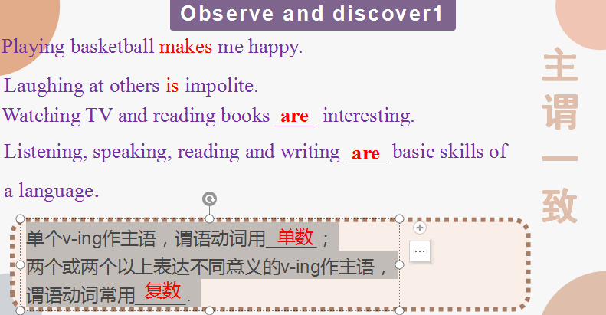
- Observe and discover 2 .
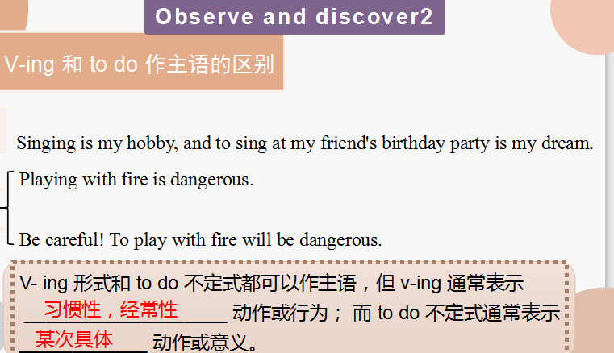
C. Observe and discover 3 .
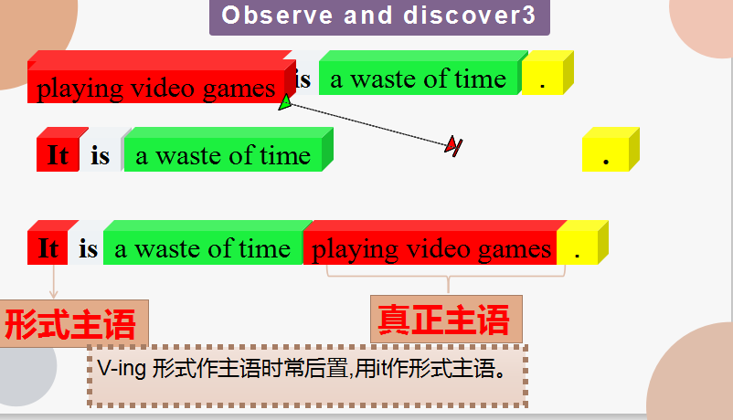
It is a waste of time doing... 做...是浪费时间的
It is / was no good / use doing.. 做... 是没用的
It is /was hardly / scarcely worth doing... 做... 是不值得的
It is worth / worthwihile doing ... 做... 是值得的
D. Observe and discover 4 .
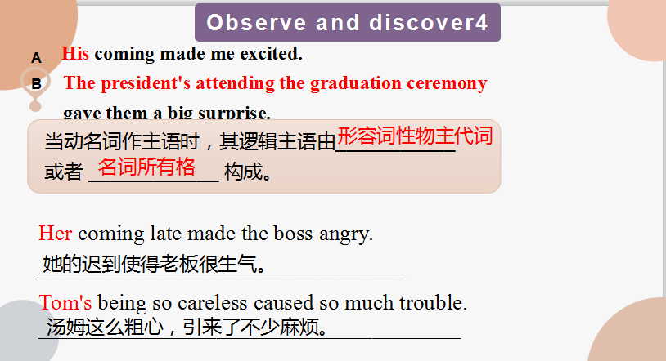
E. Pactice and Apply

