选择性必修二Unit4 Write about a rail journey across Canada学案
Task1 Complete the blanks about the detailed information of their experiences in different places.
Jasper

Lake Louise
Vancouver

took the train;
___________________ looked massive;
__________ took their breath away
took a __________ out into the bay;
visited __________;
took a hike in a______
took a ______ through the Canadian Rockies;
spectacular __________________;
creatures

The Prairie
Winnipeg
Edmonton

center of Canada’s ______________ drilling industry;
____________ in winter;
large ________________
amazed by the open country;
went through two _____________ provinces;
a bunch of __________
an _________ area

Montreal
Toronto
Ontario

signs and ads in ____________;
people speak English with ________;
visited lovely shops;
visited _______________________ along St Paul Street;
met Jean Philippe in a restaurant alongside _____________________; unique _____________ culture and traditions
The__________________ city in Canada;
went up the_____________;
saw misty clouds rising from ___________________;
__________ of glass and steel; ___________________ cars;
met Lin Fei in ___________.
a land of forests and _____; rolling _________;
bushes and ____________;
the wide stretch of Lake Huron

Task 2 Complete the mindmap about Canada.
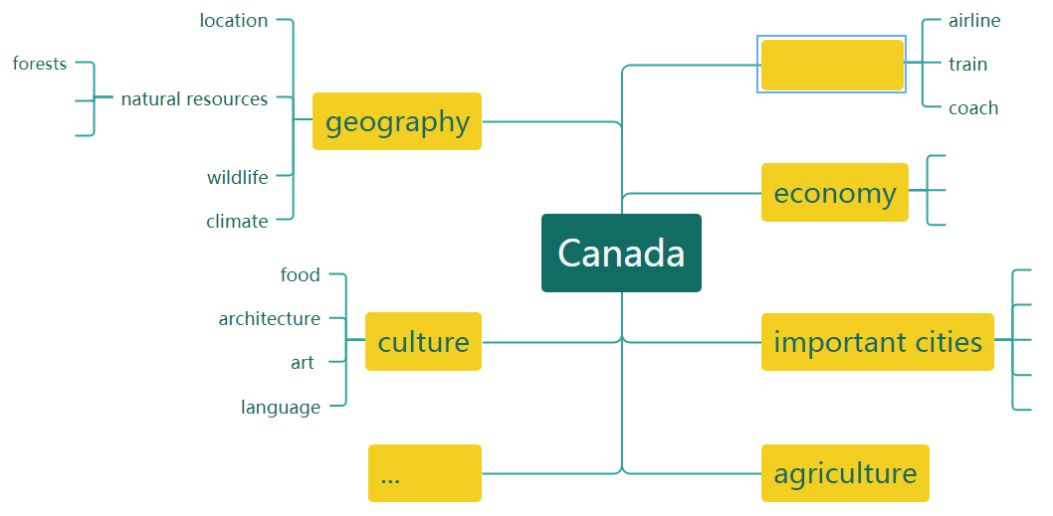

Task 3 Writing

Dear Mum and Dad,
______________________________________________________________________________.
We started in Vancouver, _______________________________________________. Then,_________________________________________________________________________.
From there, we_________________________________________________________________.
_____________________________. Then after we__________________________, we went on to ____________________________________________________________________________.
Finally,________________________________________________________________________.
Love,
Daiyu

