B5U3 Food and Culture
Discover useful Structure: The Past Perfect Tense
Learning Sheet
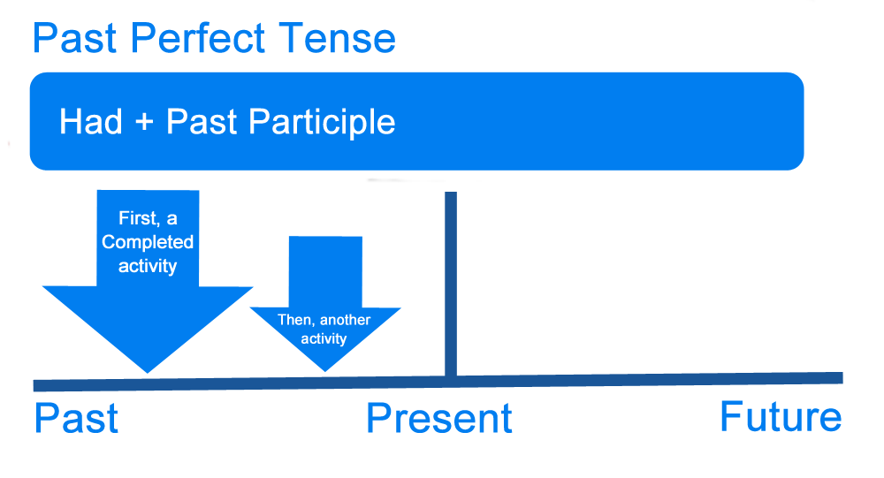

1. Give the correct forms of the verbs. If necessary, draw a time axis to help you.
(1) When I __________(arrive) home last night, I discovered that Jane ___________(prepare) a
beautiful candlelight dinner.
(2) Since I began acting, I (perform) in two plays. However, I __________ (speak, never) publicly before I came to Hollywood in 2010.
(3) By the time I got to the office, the meeting_______________ (begin, already) without me.
2. Create your sentences with the past perfect tense.
(1) Sam froze.
(2) The kitchen was in an unbelievable mess.
- They became homeless.
- (4) The girl felt proud.
- Create your version about the love story between Jake and Ann, which is an embarrassing yet happy-ending story. Use the past perfect tense when necessary.

Homework：Create a mini story about one of the pictures. Use the past perfect tense when necessary.







