Continuation Writing-How to show sentences（Review a classic film-Titanic）
Teaching aims:
By the end of the class, students will
1. tell the difference between “telling” and “showing”.
2.appreciate “to show ”sentences
3. polish ordinary writings with “to show” sentences.
Teaching procedure
Step 1: Lead-in
Enjoy a classic clip from Titanic
Ask the students to notice the change of Jack’s emotion while they are enjoying it.
When Jack saw Rose walking towards him, a great sense of excitement took hold of him.
Leading to this class’ learning aims and the standard of a good continuation writing,then tell the students the focus of this class(linguistic（语言） description )
Step 2: Tell the difference between “telling” and “showing” and appreciate “to show ”sentences through “Titanic”(from four moments)
Compare two versions and find out the useful structures
Scene Ⅰ—Beginning: when they met
Scene Ⅱ—Development: when they loved
Scene Ⅲ—Climax: when they were trapped
Scene Ⅳ—Ending: when they said goodbye
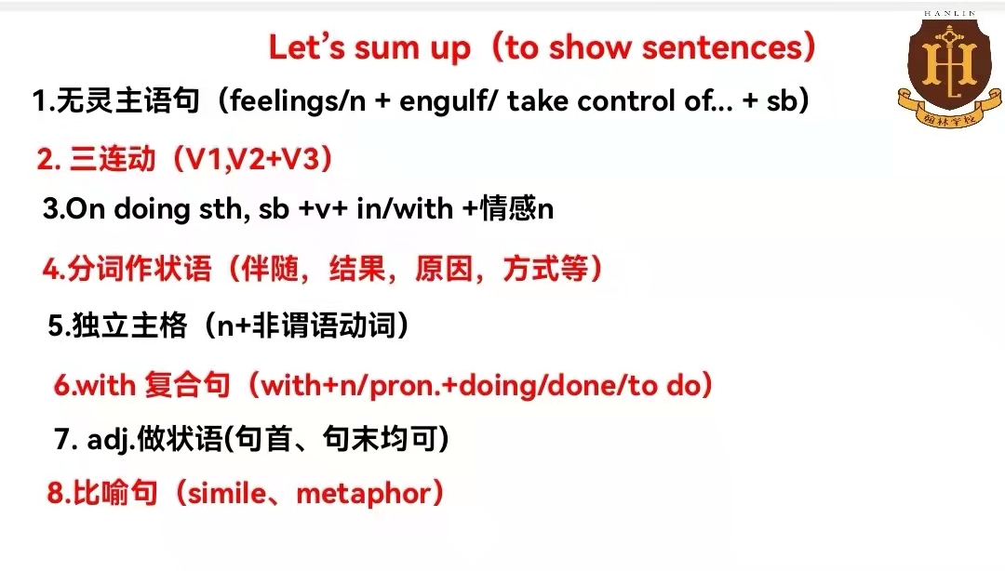
Step 3:Application: polish ordinary writings with “to show” sentences.
Give students some simple writings from previous tests and ask then to polish them with the structures they learned just now.
When I entered the classroom with only shabby tables and chairs, I was shocked.(第三期报纸)
My father picked up the money and gave it to the man.（十月月考）
As soon as the children received their gifts ,they were very moved.(十月月考)
When I reached the vet’s office, I scooped(抱起) the dog and urged（催促） the vet to examine Shep.（期中考试）
I was very relieved and happy, so I hugged the dog gently. (期中考试)
Step4.summary again
Step 5 Homework

