OCB2U4-Reading and Thinking Seeing the True North via Rail: Vancouver and the Heart of Canada

Task 1 Read for Travel Experience
Read paragraph 3-6, draw a mind map about their travel experience. Your map should include the following information. (G1-3: para. 3-4; G4-6: para. 5-6)
- 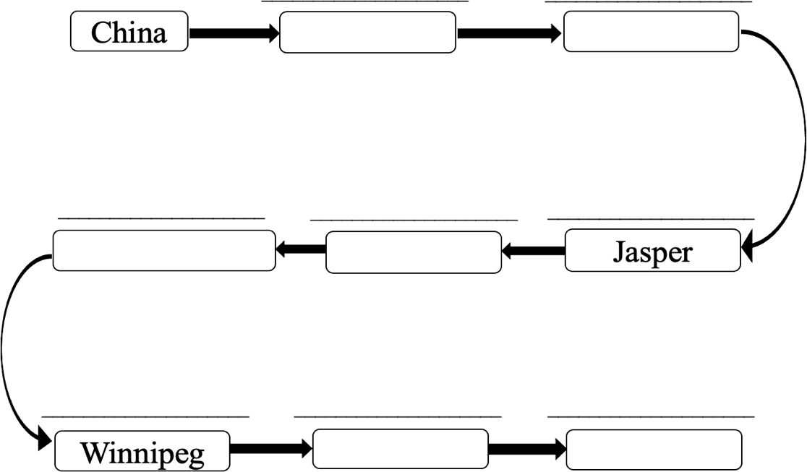What they saw/did/learnt • How they felt

Task 2 Discuss in groups
Based on what Li and Liu saw and learnt, what do you think they have gained from the journey?
What they saw/did/learnt | What they gained

Assignment
Write down your travel experience of a long journey, including the following information:
  - the places you visited
  - what you saw/did/learnt
  - how you felt
  - what you have gained
The rail journey across the vast land really makes a difference to me.

