Micro skill in writing -inanimate subjects
教师介绍：谢艳萍 中学一级英语教师 曾获东莞市优课二等奖，校级公开课一等奖，所教学生中，多名学生被北大等名校录取，2021届首届新高考中有7名学生英语140+
Teaching aims:
By the end of the class, students will
1.know what inanimate subject is
2.have a knowledge of four different types of inanimate subjects
3.apply inanimate subject to writing properly.
Teaching procedure
Step 1: Lead-in
A sentence from a clip of Cinderella to lead today’s topic-inanimate subject: The shoes fit Cinderella’s feet perfectly.
Ask the students to notice the subject of this sentence.
Step 2:Inform the students of the standard of good writings, one of which is linguistic description, and then lead to today’s topic: one of the skills-inanimate subject.
Give the students the definition of inanimate subject and find out inanimate subjects from two writing versions of Gaokao.
Step 3:Comprehension: four types of inanimate subjects
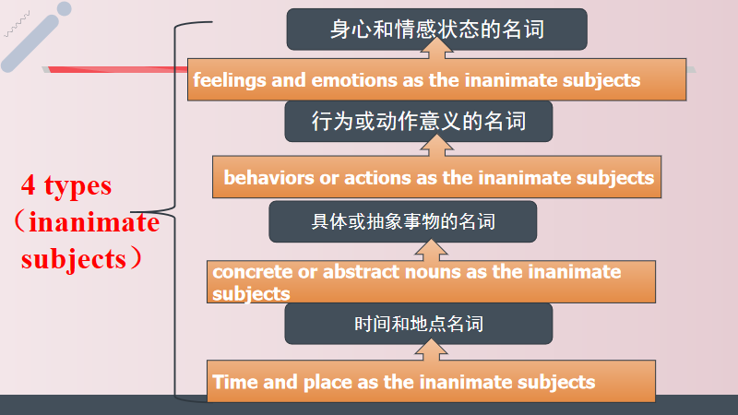
Use different examples to know the four patterns better
Step 4:Application: matching: fill in the blanks with proper verbs
Polishing: polish ordinary writings with inanimate subject sentences.
Give students some simple writings from previous tests and ask then to polish them with the structures they learned just now.
Translation: translate some sentences from previous tests with such patterns
1.当医生给Mike检查的时候，他变得越来越紧张。（金考卷）
2.很快，房间里充满着他们的欢声笑语，他们开心地一起玩耍就像多年的好朋友一样。（惠州联考）
3.首先，通过这个活动你不仅可以拓宽眼界，而且还可以更深入了解中国文化。（九月月考）
Step5.summary
Step 6 Exercise
Enjoy a clip of a video of Peter the rabbit and then predict what would happen next using such patterns to consolidate what we learned.

