Book2 Unit1 Using language2
Write about what makes a great scientist
Period 1
- Read for the main idea and structure
The Father of China's Aerospace
Para. 1 His personality
Para. 2-5 General description of Qian Xuesen
Para. 6 His death and people’s appreciation of him
Para. 7 His personal history and accomplishments

A World of Pure Thought
Para. 1 His claim to fame
Para. 2 Characteristics that made him great
Para. 3 Physical description of Stephen Hawking

Q: What does biography usually consist of?

- Read for details
Complete the table and underline the linking words and phrases.
scientist | personalities and qualities | examples
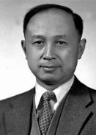

Q:What are similarities of these two scientists?

- Work in groups
Q: What do you think a great scientist need most? Why?
professional knowledge logical reasoning (逻辑推理)
research methods the questioning mind
leadership patriotism (爱国主义)
devotion determination
imagination creativity
inspiration(灵感) talent ...

______________________________________________________________________________________________________________________________________________________________
_______________________________________________________________________________

- Homework
- Design character cards for Yuan Longping, Tu Youyou, Albert Einstein or John Snow.

Name:
Field:
Life story/ Important events:
Personality:

- Micro-writing: Choose one personal quality a scientist must have to be successful and write a short paragraph. Refer to your character cards and add some stories to illustrate the scientific spirit.

Useful sentence structures:
What impresses me most is...
What matters to a scientist is (not...but...)
My reasons are as follows...
The definition of scientific spirit is...
Take ... for example.
...play(s) a crucial/ significant role in...

Write about what makes a great scientist
Period 2
- Group presentation
Share your character cards and micro-writing in class.
Examples:
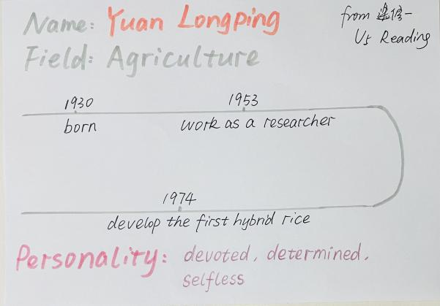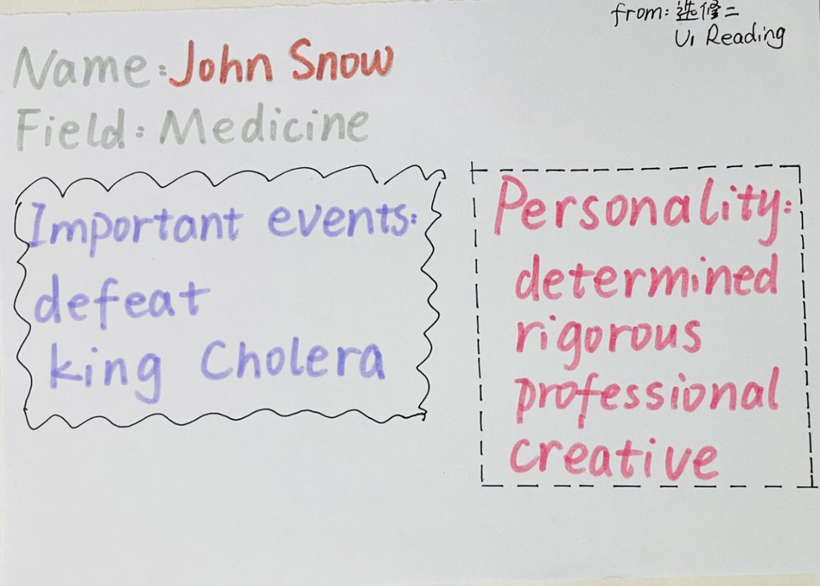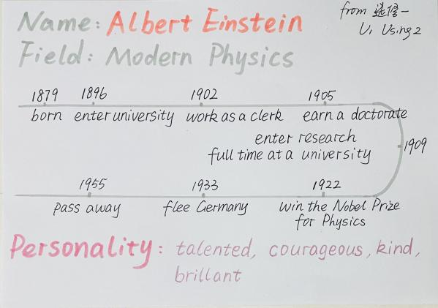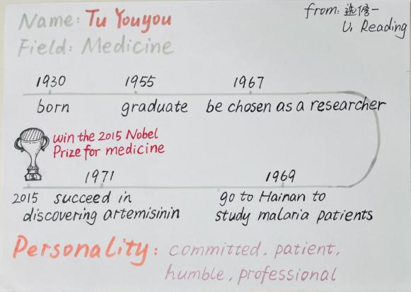
Possible versions:
Great scientists have some common characteristics: they are knowledgeable, gifted and self-sacrificing for the greater good of the country or humanity, brave and determined. What impresses me most is Tu Youyou’s devotion and perseverance in discovering artemisinin. She has spent 40 year’ time on scientific research. Thus science is never about instant success.

What matters to a scientist is also leadership and patriotism. We can see this in Qian Xuesen’s life, pioneering to another country to work with and inspire like-minded people in his field and to collaborate on their work. We can see it in his vigour to return to China and lead their aerospace programme through its birthing stages.

- Writing
Write an essay about the scientific spirit.
Step 1: discuss about the framework of the essay
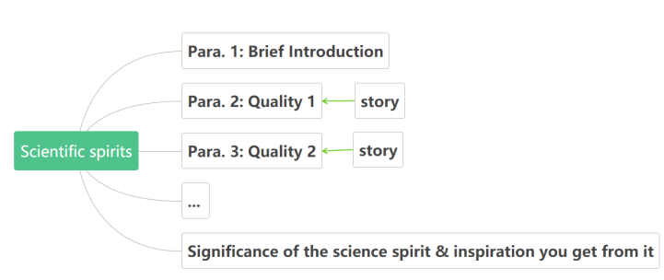
Step 2: organize the body in time order and use linking words and phrases
Step 3: work by yourself to write an essay about the scientific spirit

Great Scientific Minds
_____________________________________________________________________________________________________________________________________________________________________________________________________________________________________________
______________________________________________________________________________________________________________________________________________________________
_____________________________________________________________________________________________________________________________________________________________________________________________________________________________________________
______________________________________________________________________________________________________________________________________________________________
______________________________________________________________________________________________________________________________________________________________
______________________________________________________________________________________________________________________________________________________________

Step 4: Exchange your draft with a partner. Use this checklist to help you revise the draft. Then take your draft back and revise it using your partner’s comments.

Does the writer explain clearly the personal qualities that make up the scientific spirit?
Does the writer give examples from the lives of the scientist(s) to illustrate the points?
Does the writer describe the personality of a great scientist?
Does the writer use appropriate linking words and phrases to tie the ideas together?
Does the writer use separate paragraphs, each with its own function?

- Homework
Learn more about scientific spirit with the help of the following websites.
https://www.scientificamerican.com/
www.scientific.news/

