Handout for Unit 2 Morals and Virtues
Period 2 Reading and Thinking

Activity 1 Guessing Game - match the pictures with the introductions
Q:What do they have in common?
1.They made wise choices when they were .
2.They kept on chasing（追逐） their .
3.They made great achievements that made the world a place.

Activity 2 Analyzing the structure of the passage
1.From the title and the pictures, we can know the passage might be about a female _______ who______________________.
2. What is the purpose of the text ?
A.To prove a point B. To describe a job C. To introduce a person (The type of the text: )
3. How is the passage developed?
A.By following time order B.By comparing facts C.By listing numbers
4.How can the passage be divided into?
A. 123/456 B. 1/2/3456
5.Choose the key words to complete the main idea of each part
Part 1:The that led to her life choices.
Part 2:The that made her life choices possible.
Part 3:The she chose.
- career B. education C. belief

Activity 3 Learning more information about Lin's life
Name | Lin Qiaozhi
Nationality | China
Job
Events | At age 5, Lin Qiaozhi’s mother , which affected her a lot.
Events | At age 18, she made up her mind to .
Events | At age 26, she from PUMC and was named a chief resident physician.
Events | After a few years, she went to study in .
Events | At age 38, she the offer from the US and returned to China.
Events | At age 40, she was director of the OB-GYN department of the Hospital, but a few months later, she opened a .
Events | At age 53, she was to the first National People's Congress. However, she was more interested in patients....
Events | At age 82, she passed away.

Activity 4 Learning about Lin’s hard choices
Choose the right answers from A to L to fill in the form.
Choices | Difficulties | Results
A.Holding important positions  B.To study medicine  C.To focus more on work  D.Marrying  E.To open a clinic  F.Working in the US | G. Facing the danger of losing life or getting hurt  H. Living a hard life in China  I. Being objected by her brother | - Continued to provide medical care for the people in need of help  - Served the women and children at home  - Known as “the mother of ten thousand babies”
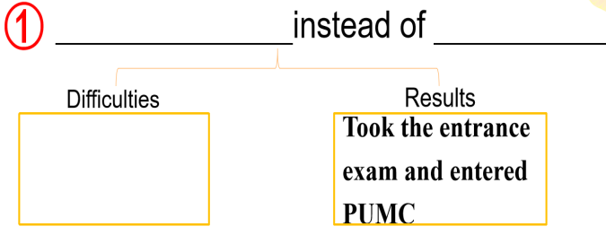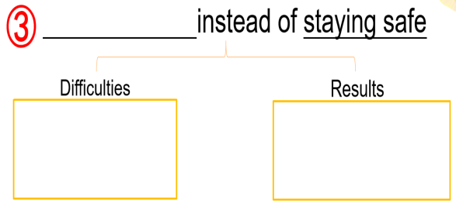
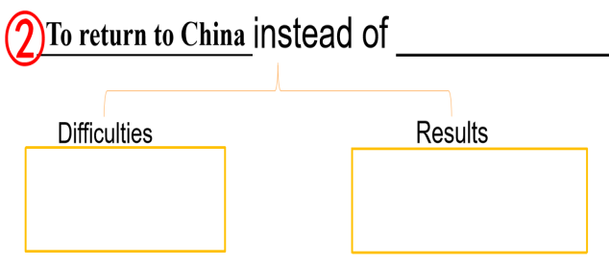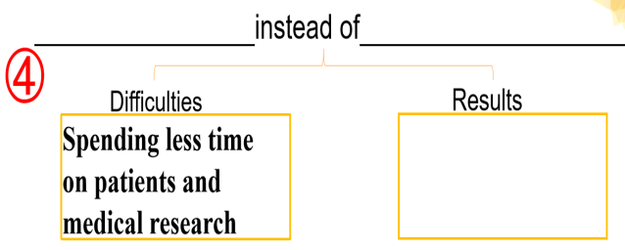
The first choice:
At age 18, Lin Qiaozhi chose to instead of , which meant the difficulties she faced was . Finally, she .
The second choice:
At age 38, Lin Qiaozhi chose to instead of , which meant the difficulties she faced was . And she .
The third choice:
At age 40, Lin Qiaozhi chose to instead of , which meant she might . And she .
The fourth choice:
At age 53, Lin Qiaozhi chose to instead of , which meant she would . And she .

Activity 5 Drawing conclusions
We all choices, but in the end our choices us.

Assignments
1.What are your expectations for life? What life choices will you make? What would you do? Please write a short passage to share it with us.
2.（Optional）What would Lin Qiaozhi's life have been if she had made another choice? Please rewrite her life in a short paragraph.

