选择性必修四Unit 1 Reading and thinking教学设计
文本分析
本单元的主题是“科幻小说”，在reading and thinking环节是一篇记叙文，改编自阿西莫夫的科幻短篇小说《包你满意》，讲述的是机器人制造公司员工Larry的妻子Claire和测试版家庭机器人Tony之间发生的故事。语篇主要分为明暗两条线。明线是妻子Claire对Tony从排斥、警觉，到接受、信任，再到被深深吸引的情感变化过程；暗线是机器人试验的成功与否。该语篇也曾是人教版选修七第二单元的阅读文本，但是新教材又进行的二次改编，除了语言上的细微改动外，故事以Tony突然对Claire做出亲昵举动，并倾述了一段不合常规的表白作为结束，特意在高潮处戛然而止，留下悬念，而结局在读后听力活动中呈现。
教学思路
该阅读文本主要围绕机器人制造公司员工Larry的妻子Claire对测试版家庭机器人Tony之间的情感变化过程和机器人试验这明暗两条线展开。学生首先通过整体阅读在宏观上把握好语篇结构，再通过精读细节在微观上梳理Claire对Tony的情感变化这一明线，并充分利用好语篇结尾处留下的悬念，通过设问，一步步引导学生积极思考故事情节的发展和结局，并在课后续编结尾。同时，本单元的reading and thinking环节不同于其它各单元，阅读文本结尾处留下的悬念，在读后听力环节呈现。因此，该阅读课可分为两课时，第一课时完成阅读文本内容的处理和读后续编，第二课时欣赏学生的续编的不同故事结局，完成读后听力活动，了解小说原有的结局，并针对机器人试验这条暗线辩证思考人与机器之间的关系。
教学过程
Step 1 Pre-reading
Activity 1 Explore the relationship between humans and robots.
Q1. How do humans and robots get on with each other?
Activity 2 Talk about the genre of this text.
What’s the genre（体裁）of this text?
- Narration C. Exposition D. Argumentation
Activity 3 Talk about the title.
Q1. How do you understand the word “adapted”?
Q2. How do you understand the title “Satisfaction Guaranteed”?

Step 2 Reading for the main idea and the structure
Activity 1 Read for the main idea.
Main idea: It is mainly about how a household Robot was tested out in a family.
Activity 2 Read for the structure.
Part1 Tony’s arrival at Claire’s home.
Part2 (Para.2-8) The process of Tony helping Claire.
Part3 The result of Tony living with Claire.
Step 3 Reading for the characters
Activity Clarify the main characters and their relationships to each other.
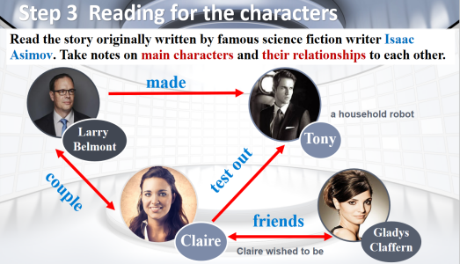
Step 4 Reading for the details
Activity1 Read the story carefully and pay attention to the changes of Claire’s feelings towards Tony as the story developed.
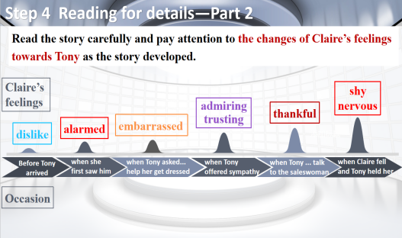
Activity 2 Read for the result of Clair living with the robot.
Q: What happened before the party began?
Step 5 Discussing and writing
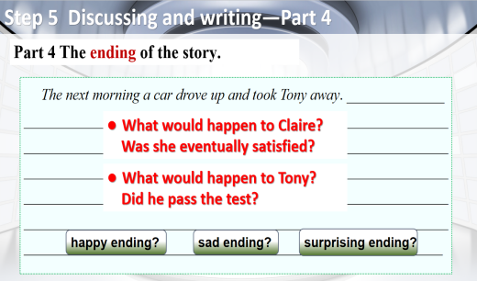
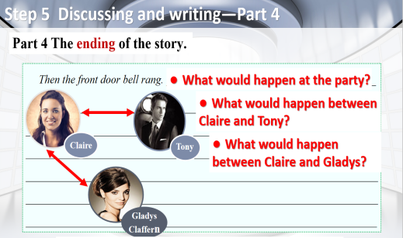
Activity Work in groups and come up with a reasonable ending.
Step 6 Listening and discussing
Activity1 Listen to the rest of the story and discuss with your deskmate about how different is it from your ending.
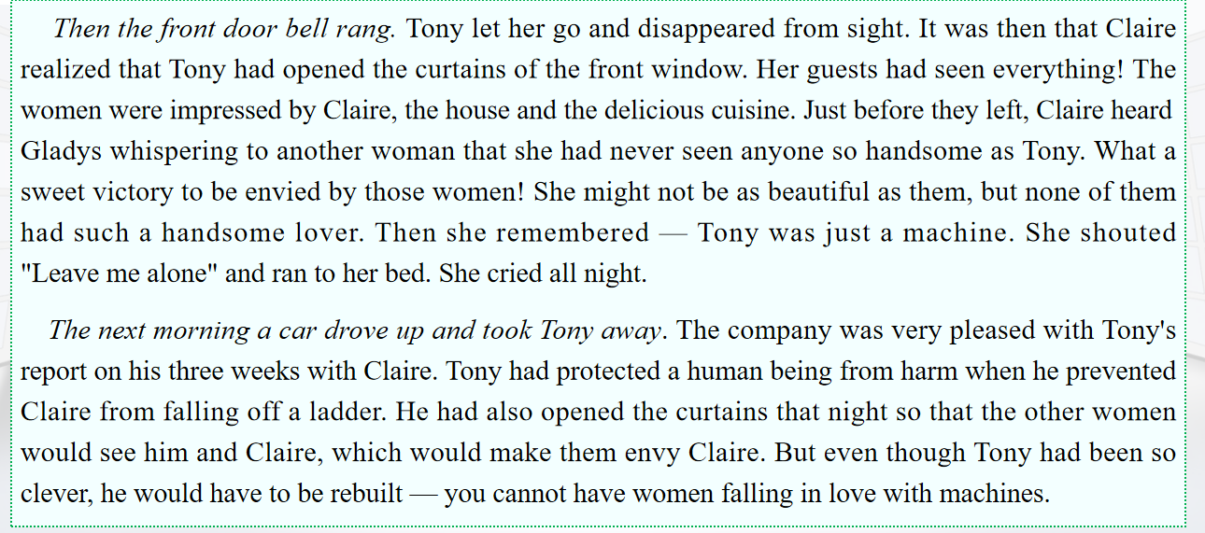
Activity 2 Continue to complete the changes of Claire’s feelings towards Tony.
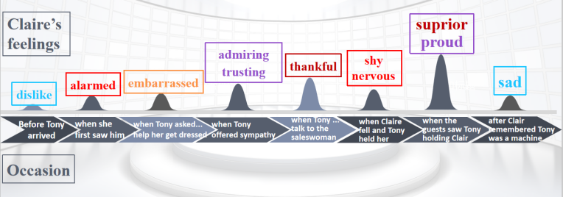
Step 7 Thinking
Activity 1 Think about the similarities and differences between Tony and human being.
Activity 2 Discuss the two questions in groups.
Q1.What relationship do you think will develop between humans and robots in the future?
Q2. Nowadays the application of the robots has already become an irresistible trend.
Is it a challenge or an opportunity for the future development of mankind?Why?

