A lesson Plan of M2U5 Reading for writing
龙泉一中 兰建珍
教师姓名 | 学校 | 上课学校与年级 | 课题名称
兰建珍 | 龙泉一中 | 龙泉一中，高一（11）班 | M2U5 Music
课型 | Reading for writing
Aims | By the end of this lesson, students will be able to:  1. master following new words and phrases: stringed, classical, perform, performer, touch my soul, give me energy, remind me of home, run food stand, set up equipment；  2. learn some important rhetorical devices（like repetition, simile, metaphor, personification,quote,etc）；  3. express their preference for music using the rhetorical devices they learn and their willing to take part in the school music festival fluently
Focus | 1. learn some important rhetorical devices（like repetition, simile, metaphor, personification,quote,etc）；  2. express their preference for music using the rhetorical devices they learn and their willing to take part in the school music festival fluently
Difficulty | Help students express their preference for music using the rhetorical devices they’ve learnt.
Procedures | Step 1 Lead-in by free talk after watching a short video  1.T: How can music help you?  Ss: touches my soul/heart;  gives encouragement/energy/hope/confidence...;  provides joy/peace/happiness…;  makes me feel relaxed/happy...;  helps me remember/forget...;  reminds me of home/people/...I love;  keeps me company when..., keeps worries away when...;  Intentions: Use the video to arouse what the students have already known about the topic to pave the way for later learning.  2.T: What would you like to know about a passage?  Ss: What’s the type of the text?  What’s the topic of the text?  What’s the structure of the text（main idea of each paragraph）  What’s the background of the text?  Why did the author write the text?  What can we learn from the text?  Intentions: With the above tasks, students are clearer about what they are going to read for.  Step 2 While you read  - Focus on Para.1 and answer the following questions:  Q1: What’s the type of the text? How do you know?  Q2: What’s the main idea of this paragraph?  - Focus on Para.2 and answer the following questions:  Q1: What was Sarah's problem?  Q2: How did music help her during her difficult time?  - Focus on Para.3 and answer the following questions:  Q1: How do you like the language above?  Q2: What rhetorical devices (修辞手法) are used here?  1. Metaphor(暗喻)  ＊It was a rock I leant on to become strong and to get through those hard times.  ＊Music is the medicine for the breaking heart.  2. Simile（明喻）  ＊Living without an aim is like sailing  without a compass(指南针).  ＊Life is like riding a bicycle. To keep  your balance, you must keep moving.  --- Albert Einstein  ＊As busy as a bee  ＊As white as snow  3. Personification(拟人)  ＊I walked home happily, birds singing beautiful songs and leaves dancing in the breeze.  ＊The sun stretched(伸展) its golden arms, climbed above the mountains, and smiled down on us.  4. Quotes （引言）for music  As Hans Christian Anderson said, “Where words fail, music speaks.”  As Henry Wadsworth Longfellow put it, “Music is the universal language of mankind.”  5.Rhetorical question（疑问,反问）  ＊Have you ever faced a time when things looked dark and you had no hope at all（Para.2）?  ＊If winter comes, can spring be far behind?  6. Repetition（重复）  Music gave me happiness...  Music gave me strength and brought me relief...  Music gave me hope and a sense of satisfaction...(Para.3)  Music keeps us company when we're lonely ;  Music removes all the worries when we're upset;  Music inspires us when we're under great pressure.  Step 3 After you read  - Structure of the passage  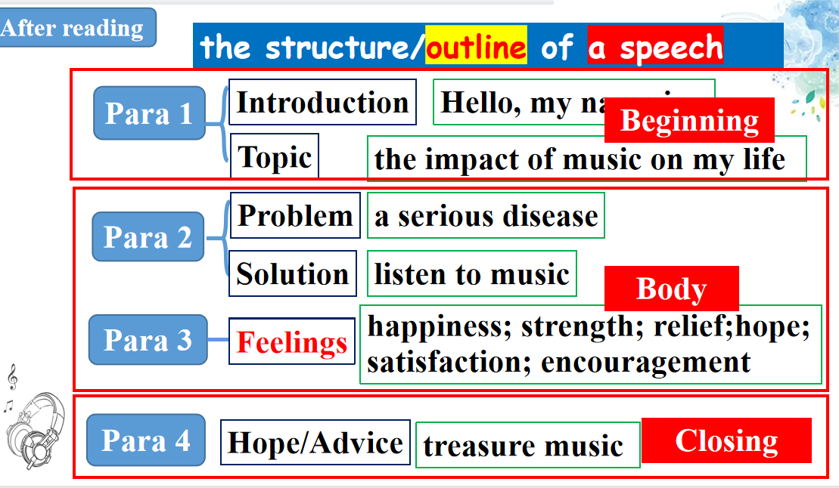  - writing  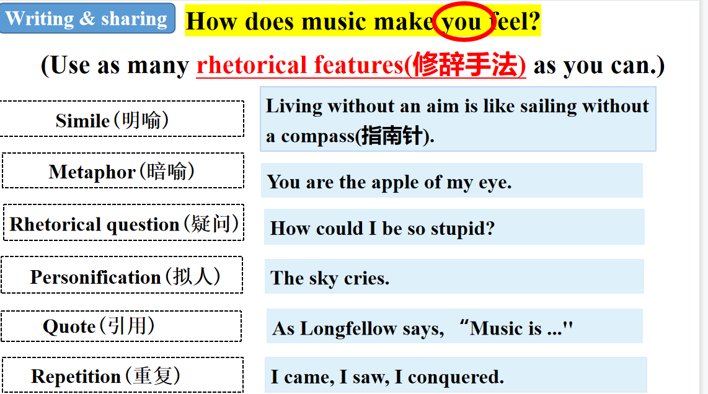  - Assignments  Write a speech about your feelings about music based on the language and structure we’ve learnt today.
Reflections | Will the students be motivated?  Will the students obtain the knowledge showed in the passage?  Will the students fully understand the deep meaning of this passage?  Will the students apply what they learnt during this class in their writing or even their later English learning?  …
Blackboard Design | M2U5 Music—Reading for writing  beginning  body  ending  ※ self-introduction & topic  ※ personal experience  ※ your feelings bout music  ※ hope, advice & gratitude  speech

