Unit 2 workbook -Reading and writing
Teaching Design of 40 minutes [教学设计]
Title: Unit 2 workbook -Reading and writing, Book 5
Type of lesson |  | Reading + writing
Teaching aids |  | Chalk, blackboard, powerpoint
Students: Class X, grade X
Time & Date: |  |  |  | 40minutes
Teacher: | Liu Yanlin |  | School: | Dongfeng High School

- Analysis of Teaching Contents and Design Concept [教学内容与设计思想分析]
This passage is an email from Jim to his Aunt Joan about his recent life in China. The key points lie in that students are able to write an email back to Jim to express their desire to be the host family. While learning, the teacher should instruct students to dig out the reasons why the foreign students would like to come to China to study and improve their culture confidence and also understand that civilizations don't have to clash with each other; what is needed are eyes to see the beauty in all civilizations.

- Analysis of Students [学情分析]
Students have learned the relevant passages in the early parts of the unit , so they can understand the passage easily, but it’s still hard for them to summarize the words and expressions that can be used in the writing..
- In terms of language ability, the students are in the first grade senior high school. Students have got some knowledge on the usage of words in the culture and life , so they can get the main idea of the passage, but it’s still hard for them to summarize the words and expressions that can be used in the writing.
- In terms of learning ability, students develop a good habit of preparation and review, and most students are willing to participate in classroom interaction and expression. Students can accept group cooperative learning.
- Through this lesson, students have a general understanding of some writing skills, and their ability to put them into use are improved.

Ⅲ Teaching Objectives [教学目标]
After the class, students are able to:
Subject Qualities [学科素养]
- Learn to summarize the important details from the passage.
- Grasp some writing skills to put them into practical use.
Key Abilities [关键能力]
- Let the Ss learn some reading strategies by scanning and skimming.
- Enable the Ss to understand the structure and the writing style of the passage well.
Core Values [核心价值]
- Improve students’ culture confidence.
- Learn to use their eyes to see the beauty in all civilizations.

Ⅳ Learning Strategies [方法与策略]
- Use situational teaching method, TBLT and communicative method
- Do self-check and example -learning.

Ⅴ Presupposed Process [预设过程]
Process | Activity | Skills
Lead in | A short video | listening
Situation | An ad on a website | Reading-predicting
reading | - Read for structure | Scanning
reading | - Read for details | Reading and analyzing
writing | - Structure for the letter | Writing an outline
writing | - Writing preparations | summarizing
writing | - Student’s job | Example-learning

Ⅵ Difficult Points [教学重难点]
- How to put the language materials into practical use.

Ⅶ Teaching Procedure [教学过程]

Step one: warming-up (2min)
- Enjoy a video to show foreigners on 40 years of development in China.

Step two: Lead-in and Situation (3min)
- To show a picture of Jim and let the students get into the situation.
- To show the ad Jim posted on the website to introduce the email.
- To show a picture of a host family and let the students be the writer themselves.

Step-three:Reading (10min)
3.1 To ask students to read the email for structure.
Students can divide the email into 3 parts.
Para 1-2 reasons
Para 3-4 Experiences
Para 5-6 Plan and needs

3.2 Reading for details of paragraph 3-4
To ask a question: Which three aspects impressed Jim most?
Students can summarize the information into into 3 parts.
Food Food is all delicious!
Food is very________________ , so it’s great for my_________ !
Enjoy a____________ breakfast on the street

People The people are all welcoming, but sometimes a bit _________ as not everyone can speak English.
To choose one word to replace overwhelming
A. thrilled B. satisfied C. disappointed D. doubted

Park really interested in tai chi; full of people playing traditional instruments, Chinese chess, and even writing calligraphy on the ground.

3.3 Reading for details of paragraph5-6
Students can summarize the information into into 2 parts.
Learn Chinese Improve my Chinese, especially my written Chinese, which I find the most difficult to grasp.
I will get more exposure to Chinese culture.

Learn Chinese food recipes
I hope I can learn some Chinese food recipes and I promise to make everyone a meal when I return!

Step four: writing (22min)
4.1 To instruct the students to analyze the structure for the reply
para 1: background + purpose
Outdoor activities
para 2&3: Body
Indoor activities

para 4: Ending ---hope/wishes

4.2 To help students to sort out outdoor activities
Location: it’s just 5 minutes’ walk to a big park . (playing traditional instruments、Chinese chess、tai chi)
Combination: It’s just 5 minutes’ walk to a big park, which is always full of people_ playing
traditional instruments, Chinese chess and tai chi.
Food: delicious、on the street、freshly made breakfast、reasonable price; budget
Combination： There are kinds of delicious freshly made breakfast ___at____ reasonable price, __which_ is great for your budget!

4.3 To help students to sort out indoor activities
people--family member: friendly、easy-going、good at English
needs: improve Chinese level、learn some Chinese recipies
Group work: Try to make sentences with the information.

4.4 To give students 10 mins to finish the reply to the ad.

4.5 To show a student’s job and let the students read and learn. Handwriting is also mentioned.

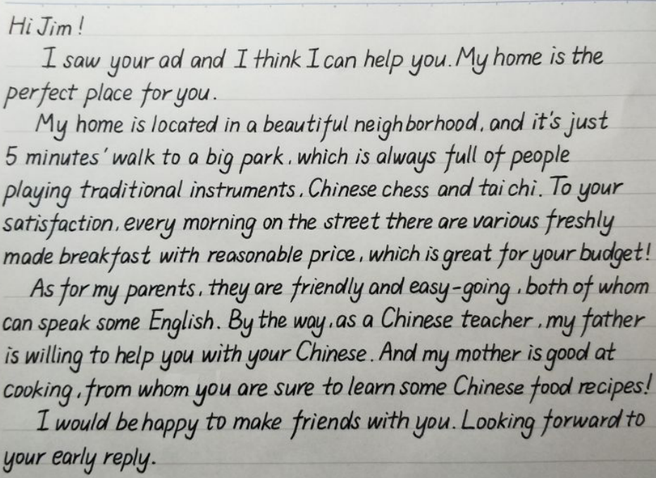

Step five: Homework (1min)
Try to find another ad for a house wanted and write a reply accordingly.

Step six: Conclusion (2min)

Let students read the words from the speech of Xi Jinping to improve students’ culture confidence and learn to use their eyes to see the beauty in all civilizations.

The President Xi Jinping was quoted in the Conference on Dialogue of Asian Civilizations as saying that China today is more than the country itself; it is very much a part of Asia and the world. In the time to come, China will open its arms wider to embrace the world and contribute the dynamic achievements of Chinese civilization to a better world in the future.
(今日之中国，不仅是中国之中国，而且是亚洲之中国、世界之中国。未来之中国，必将以更加开放的姿态拥抱世界、以更有活力的文明成就贡献世界。)

- Teaching reflection

