B1U1 Reading & Thinking 教学设计 by华师一附中光谷分校 尚洁
本次课堂教学由“Break the impression”这一活动开启，询问学生对于美国高中生活的印象，预期学生在完成文章阅读后打破对美国校园生活“轻松无压力”的印象，并鼓励学生对中美高中校园生活进行对比。读后回归“Break the impression”这一活动，引导学生分享各自初入高中生活遇到的挑战，打破对同龄人（尤其是“优秀同龄人”）的刻板印象，使学生们明白人人都会遇到挑战；引导学生互相学习应对挑战的方式，鼓励学生不畏挑战，为未来充满更多挑战的生活做好心理准备。
Step1: Warming up（Pre Reading）
Q1：What do you think of senior high school life in the U.S.?
（教师可在ppt里借用图片呈现比较丰富的美国高中校园生活，提问学生对于美国校园生活的印象，引导学生们回答出类似于easy relaxing这种轻松印象。）

Q2：According to the photo, what is your first impression of Adam? Guessing: How does he feel about his senior high school life?
（教师可引导学生关注Adam的表情，引导学生回答类似于“happy”、“confident”等积极向情绪；引出今天阅读文章和Adam有关）
Q3：Today we are going to learn an article from Adam, which may break your impression of American senior high school life. Now, look at the title. What does “challenge” mean? Who is the freshman?
（学习本单元生词，并引导学生根据标题预测文章内容，过渡到读中活动）

Step2: While Reading
Activity1: Read for main ideas
Q1: Ask Ss to read the text quickly to find the topic sentence of each para.
Q2: Set up P14 Ex2: Summarize main ideas of each para.
（教师引导学生总结出两个阅读技巧和一个语言点：
Tip1: Find main ideas by taking a quick look at topic sentences.
Tip2: Topic sentences sometimes are the first sentence of each paragraph.
Tip3: Use “have to” to show your challenges.）
Activity2: Read for structure
Q: Which para. is the main part? Which paras. are the supporting parts?
（教师利用框架图呈现文章的总分结构）
Activity3: Read for details
Q1: Set up P15 Ex4: Read again & Complete the outline

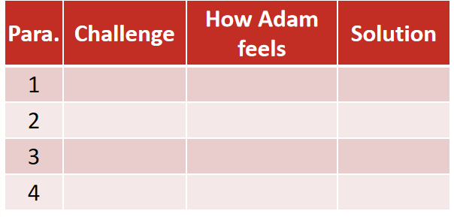
（教师以第一段为例，展示阅读细节的过程）
Q2: Para.2: Additional question: Why did the adviser recommended that Adam should choose Chinese/ English?
Q3: Para.3: Additional question: What can you learn from Adam’s experience?
Q4: Review the outline.
（读细节时，通过额外的设问引导学生关注Adam在遇到挑战时具体是如何做的，为之后的输出活动搭建内容和语言支架；
复习文章结构时，教师再次强调文章的总分关系，为之后的输出活动搭建结构支架）

Step3: Post Reading
Activity1: Set up P15 Ex4
Q1: According to the text, what kind of person do you think Adam is? Why?
Q2: Do you face the same challenges as Adam?
Q3: What other challenges are you facing? Compare Adam’s school life with yours.
（问题1：基于文章细节对Adam进行性格分析，既引导学生关注Adam积极面对困难的优秀品质，同时也是对Welcome Unit当中人物性格词汇的复习；
问题2&3：引导学生对比中外高中生活，将焦点由Adam拉回至自身的高中生活，为下一个讨论活动做铺垫。）
Activity2: Break the impression
Now, it’s your turn. Discuss in groups & Share one of your challenges (+ feelings & solutions)
（教师可呈现从文中摘取的合适语言，引导学生借助课文中的句子表达自己的challenge/feelings/solutions；对于学习基础较好的学生，可在之前read for details环节时，即时记录积累文中关于challenge、feelings、solutions的语言表达）
展示环节：教师可先提问：In your opinion, who is the best in our class? Okay, let’s see what challenges does he/she face? 之后请该同学选择下一位分享，完成分享接龙。
（该活动主要目的有三：1.打破学生对其他学生们的固有印象，让学生们了解看起来优秀的同龄人也有自己的烦恼；2.帮助学生们互相了解学习应对挑战的心态和措施；3.收集尚未解决的挑战，为reading for writing做准备。）

Step4: Summary
No matter what kind of challenges we meet, we are expected to ...
To maintain a spirit of youth and vigor.
Young people should be self-confident, self-reliant, and high in spirits.
They should seek to improve and extend themselves, fulfill their dreams, show their worth, and strive to present themselves in the best possible light.
--the State Council Information Office of China <Youth of China in the New Era>
（摘取白皮书《新时代的中国青年》作为课堂结语，鼓励学生们积极面对挑战，成长为优秀的中国青年。）

