Worksheet
My Experiences With Computer Games

- Read the passage carefully and complete the table.
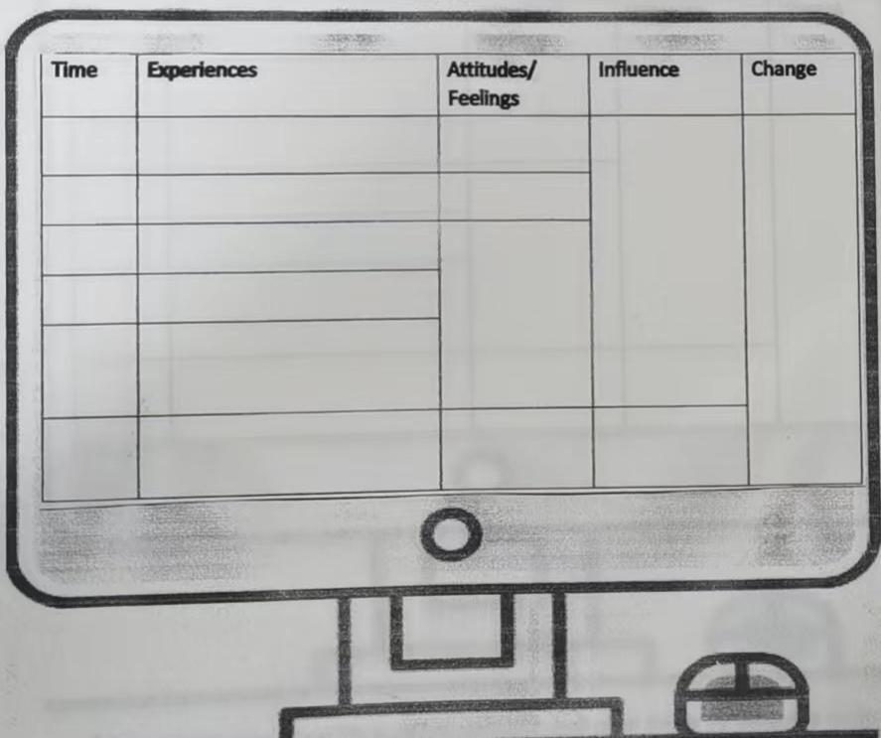
- Share a similar case in our life in which someone spoil good things by doing too much and put forward your suggestions accordingly.
the experience should include:
the good thing
the behaviour
the attitude/feeling
the influence
your suggestion

____________________________________________________________________________________________
____________________________________________________________________________________________
____________________________________________________________________________________________
____________________________________________________________________________________________
____________________________________________________________________________________________

