The Face-down Generation
Worksheet
- Which one is the correct structure?

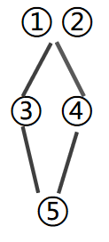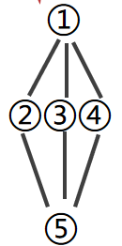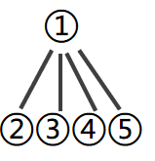

- Complete the form
Topic |  | Reasons
Attitudes | Some adults
Attitudes | Other adults
Attitudes | The writer
Conclusion

- Write down the expressions and writing tips you’ve learnt from this text.

