Teaching Plan for The hummingbird
- Teaching objectives
After this lesson, students are expected to
- Learn the methods of analyzing original articles, given opening sentences and then apply them to future writing practice.
- Develop critical thinking ability, divergent thinking ability and creative thinking ability by digging out the theme of the story and discussing how the plot will develop.
- Improve continuation writing skills by applying all-rounded synergy to writing practices.
- Develop correct life outlook and value by analyzing the theme of the story—the harmony between animals and human beings.
- Teaching procedure (T=teacher; Ss=students)
Step 1: Warming-up
T presents 3 pictures.
- What can you see in the pictures?
- What’s the relationship between animals and human beings?
- How can we maintain the harmony?
Step 2: Leading-in
Consolidate and classify the process and skills of continuation writing
- what to read: Characters, Setting, Plot-theme, POV, Language
- what to write: based on plotting—highlight the theme and personality of characters; two opening paragraphs
- how to write: achieve all-rounded synergy (协同)
Step 3: Reading
find out information related to character, setting, plot-theme, POV, and language
- characters: I, the hummingbird, an old friend (all need to be mentioned in the writing to be continued)
- setting: on the farm, a milking house
- plot: (detailed information—summary of two parts)—the first encounter
- pay attention to the interaction of characters and see how it develops over time (by locating the cohesive words—still; again)
- the theme is conveyed through the interaction of the characters
- POV
Description from the 1st person limited point of view
hearing | - A noise at a window caught my attention.  - …then let out a squeaking call …  - Then someone said, “She must have come to say good-bye.”
vision | - She was covered in spider-webs (蛛网) and was barely able to move her wings. She ceased her struggle…  - With the bird in my cupped hand, I looked around to see how she had gotten in.  - When I opened my hand, the bird did not fly away; she sat looking at me with her bright eyes.  - I stopped, and she soon took wing but did not immediately fly away. Hovering (悬停), she approached within six inches of my face. For a very long moment, this tiny creature looked into my eyes, turning her head from side to side. Then she flew quickly out of sight.  - I was standing by the car when a hummingbird flew to the center of our group and began hovering.  - She turned from person to person until she came to me. She again looked directly into my eyes, …
touch | - I removed the sticky spider-webs that covered her head and wings.
thinking | - Perhaps she had been struggling against the window too long and was too tired? Or too thirsty?
- Language
- “she” — pronoun— to directly narrate what “I” saw, heard, touched and thought;
  - personification (rhetorical device 修辞手法)
- “the bird, this tiny creature, a hummingbird” — use different/ varied names to avoid repetition.
- use some cohesive words—still; again… to show how interaction of characters develops over time
- use simple but descriptive words and expressions
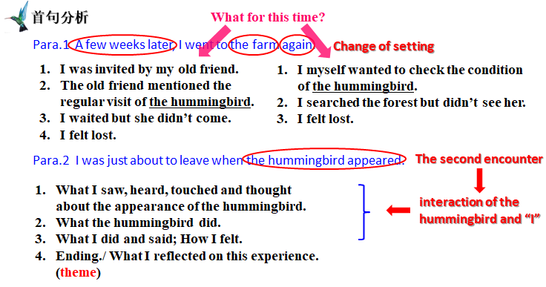
Step 4: Designing the plot
- by relating to the analysis of original article
- by relating to the two opening sentences (key words)
- by relating to the theme
- by focusing on the logic and coherence of the plot
Step 5: Writing practices
- writing by echoing
- writing the whole passage by applying all the strategies mentioned above.

