A Teaching Plan for Reading and Thinking
Read about Xie Lei’s experience on an exchange programme
by Ren Xvfang from Yuhang High School

Lesson Type: Reading & Thinking
- Teaching objectives:
After this class, the students will be able to
- analyse the information organization of the text by applying the two clues of the text: bridging cultures and changes of the feelings.
- use learned expressions to convey ideas on students’ own experiences and lives ;
- understand the role of students studying abroad in showcasing China to the world
- Teaching Focus and Difficulties
- Summarize the two clues of the text and use it to understand the information organization
- Teaching Procedures
Procedures | Students’ Activities | Aims
Leading-in | - Before reading  - Watch and answer  — What is the video about?  - Share your ideas  - After watching the video, do you want to study abroad? Why?  - What challenges do you expect to meet? How would you feel then?  - Do you think you can overcome them? How?  - Look and predict  — What information can you get about the girl? | To introduce the topic and activate students’ knowledge about studying abroad.  To practice students’ ability to view the title and pictures and make a prediction
Listening | - While reading  - Task 1: read for information  — Where might you read this article?  — Xie Lei, an exchange student majoring in business, is building bridges between ____________ and ___________.  - Task 2: read for main points  — Which paragraphs talk about Xie Lei’s adaption to the British culture?  — How did the writer describe it?  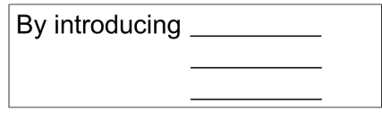  - Task 3: read for challenges, solutions and feelings  — 1. Read para.3— para.7, find out the challenges Xie Lei faced and what she did to overcome them.  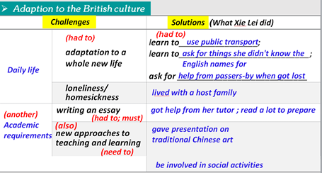  2. What other challenges do you think students studying abroad might face? Can you give some advice to help them handle these challenges?  3. Circle the words to trace Xie Lei’s feelings.  4. Read and find out what Xie Lei did to spread the Chinese culture.  5. Besides Chinese cuisine and art, what else can we introduce to foreign friends to spread our profound culture? | To practice scanning for required information.  To practice summarizing the main points of the paragraphs.  To practice scanning for required information and make inferences if necessary  To identify the words indicating challenges and wording showing logic between the information.  To use the learned expression to present ideas.  To practice scanning for required information and the ability to summarize if necessary  To further explore how to better spread Chinese culture
Talking | - After reading  Group work: Critical thinking  1. If you have an opportunity to get involved in an experience programme like Xie Lei, will you grasp it?  2. As a high student, how can we better prepare ourselves to act as a cultural messenger building bridges between cultures?  ( Expressions for reference: adapt to; engage in; be involved in; expose sb/ oneself to…; participate in; give sb an insight into sth; gain a global perspective/ angle; improve competence; cooperate with sb…) | To use the learned expressions to talk about students’ own experiences and lives
Homework | - Make a presentation  - Choose one of the questions and make a presentation.  (Requirements:1. Use logic words to make it a well-organized passage 2. Use the learned expressions as much as possible. ) | To better consolidate what have been learned.

