202302杭州八县市高二期末应用文讲评

原题：
假定你是李华，从互联网（the Internet）上得知一个国际中学生组织将在新加坡（Singapore）举办冬令营，欢迎各国学生参加。请写一封电子邮件申请参加。
内容包括：
1．自我介绍（包括英语能力）;
2．参加意图。
Worksheet：
一、Read and understand the requirements
- What kind of practical writing is it? _____________________________________
- What kind of person should be adopted while writing? __________________________
- What kinds of tenses should be adopted? _________________________________________________________________________
二、The structure of an application letter
- Usually, when will people write an application letter ?
- Who are the intended readers? How do we usually address them?
- If you want to gain the recognition of the receiver, what should be included in your letter?
______________________________________________________________________________
What is the structure of an application letter?

Part 1: __________________________________________
Part 2: 申请理由，阐述优势（_____________________________________________）
Part 3: ___________________________________________
三、How to organize each part
Part 1: 夺人眼球开头句——开篇表意，提出申请
（1）Student1’s beginning:
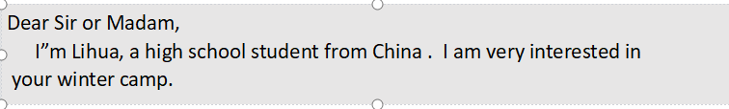
How to polish it? Have a try.
- 举一反三 More sentences to express eagerness for an application.
Part 2 亮点出彩篇中句
—— 阐述优势(资格、性格特征、语言能力、交际能力和相关经验）
Q: How to show your qualifications and advantages?
Work in groups and come up with as many sentences as you can .
Practice 亮点出彩篇中句
- have a good command of oral /spoken English (必备硬件：语言能力）
我认为我能成为一名好的冬令营成员。（总起）
I believe I am qualified to be a good member of the winter camp.
★ 首先，我英语非常流利，这使得我能够很好地/ 很轻松地与来自其他国家的成员进行交流。
Firstly, I have a good command of spoken English,_____________________________________.
( which enables me to communicate with other people with ease; enabling me to communicate with other people with ease)
★ 能够流畅地用英语进行交流，这是我优势之一。（v-ing 或者 with的复合结构）
__________________________ is one of my biggest advantages/strengths.
________________________ , I can communicate well with others.
( Being fluent in spoken English; With fluent spoken English)
- be optimistic and enthusiastic 或 previous experiences （软件优势：性格特点或以前的经历）
★ 乐观又热情，我会积极地参与各种活动。
____________________, I will actively take part in various activities
（Optimistic and enthusiastic）
★ 我不仅善于交际，而且乐于承担责任，我会积极地参与各种活动。
____________________________________, which will contribute to my participation in all kinds of activities. ( Not only am I sociable, but also I am responsible)
★ 我曾经参与过类似的活动，我相信我可以向大家更好地介绍中国，同时也增进对他国文化的理解。
____________________________________, I’m confident that I can introduce my country China to students from other countries, and meanwhile learn about their countries as well. ( Having acquired some relevant experiences ）
- broaden my horizons as well as improve myself
★ 我相信这次活动不仅能拓展我的视野，更能给我提供一个好的交友的机会。
________________________________________, but also provide me with a good platform / opportunity to make more friends.
(I believe this activity will not only broaden my horizons )
★ 参加冬令营不仅能丰富我的阅历，而且能让我对其他国家的文化有更深刻的认识。
________________________________________, but also _____________________________.
(Not only will this activity enrich my life experience; help me gain a deeper glimpse of other cultures)
Part 3 韵味无穷结尾句 （结尾点题，盼回复）
The ending of an application letter should be ____________________________________.
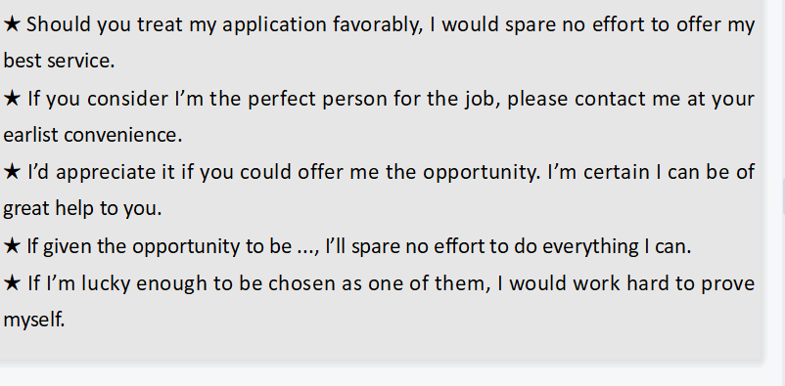
Practice 韵味无穷结尾句
★ 如果你认为我能成为一名合格的冬令营成员，请尽快联系我。
_____________________________________________________________________________
★ 如果能给我这个机会，我将不胜感激。我不会让您失望的。
_____________________________________________________________________________
★ 如果有机会成为冬令营的一员，我将竭尽全力做到最好。
_____________________________________________________________________________

- Polish a student’s version
A student’s version How to polish it? (Please write on the right)
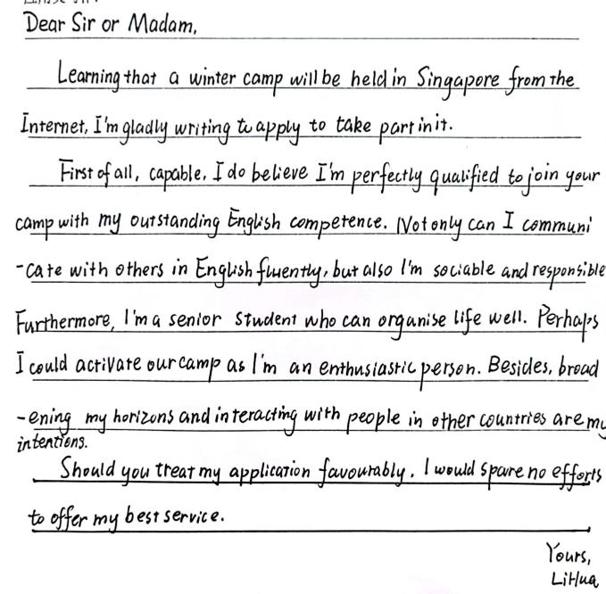

Appreciate an official version and the teacher’s version
- Homework
假定你是李华，寒假在纽约学习，得知当地艺术家协会要举办中国书法展览。请写一封信请做志愿者。
内容包括：
1．写信目的；
2．个人优势；
3．能做的事情。
注意：（1）写作字数应为80左右。
（2）可以适当增加细节，以使行文连贯。

