2023年6月全国高考新课标I卷语法填空真题
Xiao long bao(soup dumplings), those amazing constructions of delicate dumpling wrappers, encasing hot, 56 (taste) soup and sweet, fresh meat, are far and away my favorite Chinese street food. The dumplings arrive steaming and dangerously hot. To eat one, you have to decide whether 57 (bite) a small hole in it first, releasing the stream and risking a spill (溢出), 58 to put the whole dumpling in your mouth, letting the hot soup explode on your tongue.
Shanghai may be the 59 (recognize)home of the soup dumplings but food historians will actually point you to the neighboring canal town of Nanxiang as Xiao long bao's birthplace. There you will find them prepared differently-more dumpling and less soup, and the wrappers are pressed 60 hand rather than rolled.
Nanxiang aside, the best Xiao long bao have a fine skin, allowing them 61 (lift) out of the steamer basket without tearing or spilling any of 62 (they) contents. The meat should be fresh with 63 touch of sweetness and the soup hot, clear and delicious.
No matter where I buy them, though, one steamer is 64 (rare) enough, yet two seems greedy, so I am always left 65 (want) more next time.
56.____________ 57. __________ 58. _____________ 59 .____________ 60. _____________
61. ___________ 62. __________ 63. _____________ 64. ____________ 65._____________

延伸外刊阅读挖呀挖呀挖，玩转语法填空开出小红花——你改编的语法填空题
What to Eat in China: A Traveler's Guide
by Fiona Reilly
Fiona Reilly is a contributing writer at Serious Eats.
Fiona Reilly is a freelance writer and photographer passionate about food and travel in China.

I've spent the lion's share of the last eight years living in China, crisscrossing the country in search of amazing food. And if my travels have taught me anything, it's that Chinese cuisine bears only a passing resemblance to the dishes most Westerners think of—China is home to a magnificently diverse culinary landscape, with a range of complex and varied flavors hailing from each of its 23 provinces, five autonomous regions, and 56 ethnic groups.
Picking and choosing the best dishes from such a vast spectrum is, of course, impossible. Instead, I've decided to look back and consider the flavors I pursued most passionately and the ones I remember most vividly. From the tart-sour fruit yang mei, which I devoured in Yunnan, to the savory blood tofu that's a specialty of Guizhou province, these are the 15 most memorable bites, tastes, and sips I encountered on my travels, along with tips for locating the best versions if you're lucky enough to find yourself in China.
1.Meigancai (Dry Pickled Mustard Greens)
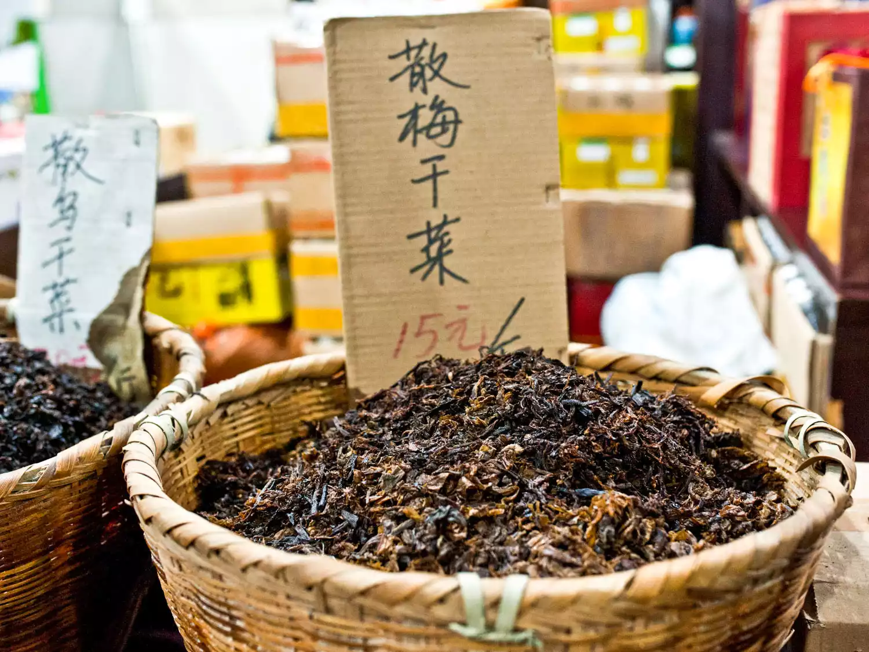
Meigancai in a basket in an open-air market.
Wrinkled and deep brown, meigancai looks more like soft, dark tobacco than a cooking ingredient at first glance. But one sniff of its strong, beefy aroma is enough to hint at its culinary potential. The salted, fermented, dried, and aged mustard green is a specialty of China's eastern city of Shaoxing, where it's sold in the tiny wine shops and dry-goods stores that line Canqiao Straight Street. Thanks to its intense umami character, the pickled green is right at home in Shaoxing's local cuisine, which is abundant with foods like fermented amaranth, stinky tofu, dried fish, and rice wine, each with its own uniquely savory flavor. I first tasted meigancai in a dish of slow-cooked pork belly—the luscious sweetness and soft texture of the belly fat contrasting with the rich saltiness and yeasty aroma of the fermented green. But it's also a not-so-secret key ingredient in countless preparations, with wisps of its dark leaves deepening the flavor of steamed baozi and crisp flatbreads, and small handfuls adding nuance to soups and braises.
- 玩转语法填空——你改编的语法填空题：

2.Shaoxing Wine
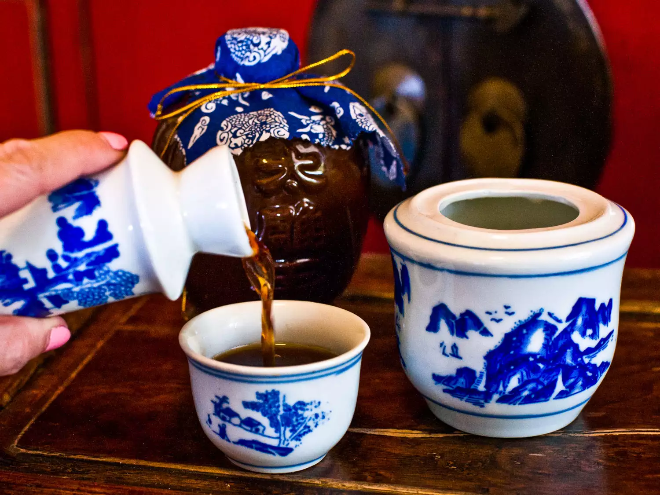
Shaoxing is known for its mist and rain, its ancient canals crossed with stone bridges, and the best traditional rice wine in China. I first tried the latter in one of the city's old wine shops, surrounded by tall jars filled with aged wines. There, it was served from a small ceramic flask that was warmed in a bath of hot water to enhance the drink's aroma and flavor—perfect for sipping on a cold, damp winter day.
Given its long history (we're talking over two and a half thousand years), it's no surprise that variations abound. The wine, made by fermenting glutinous rice with wheat and aging it in deep earthenware vessels for up to several decades, can be anywhere from light amber to deep brown in color. And, though a slight raisin-y sweetness and mellow sherry-like flavor are typical, the wine ranges from quite dry to extremely sweet. Do note that none of the legit stuff tastes a bit like the abominable liquors that pass for Shaoxing wine in supermarkets—beware the cheap, salted versions sold as "cooking wine," and instead pay a visit to a specialty wine purveyor or a reputable Chinese market. A good bottle will have been aged for at least five years and cost a minimum of $10. Once you've got your hands on true Shaoxing wine, make the most of it, incorporating it into your cooking and sipping it on its own.
- 玩转语法填空——你改编的语法填空题：

3.Hairy Crab
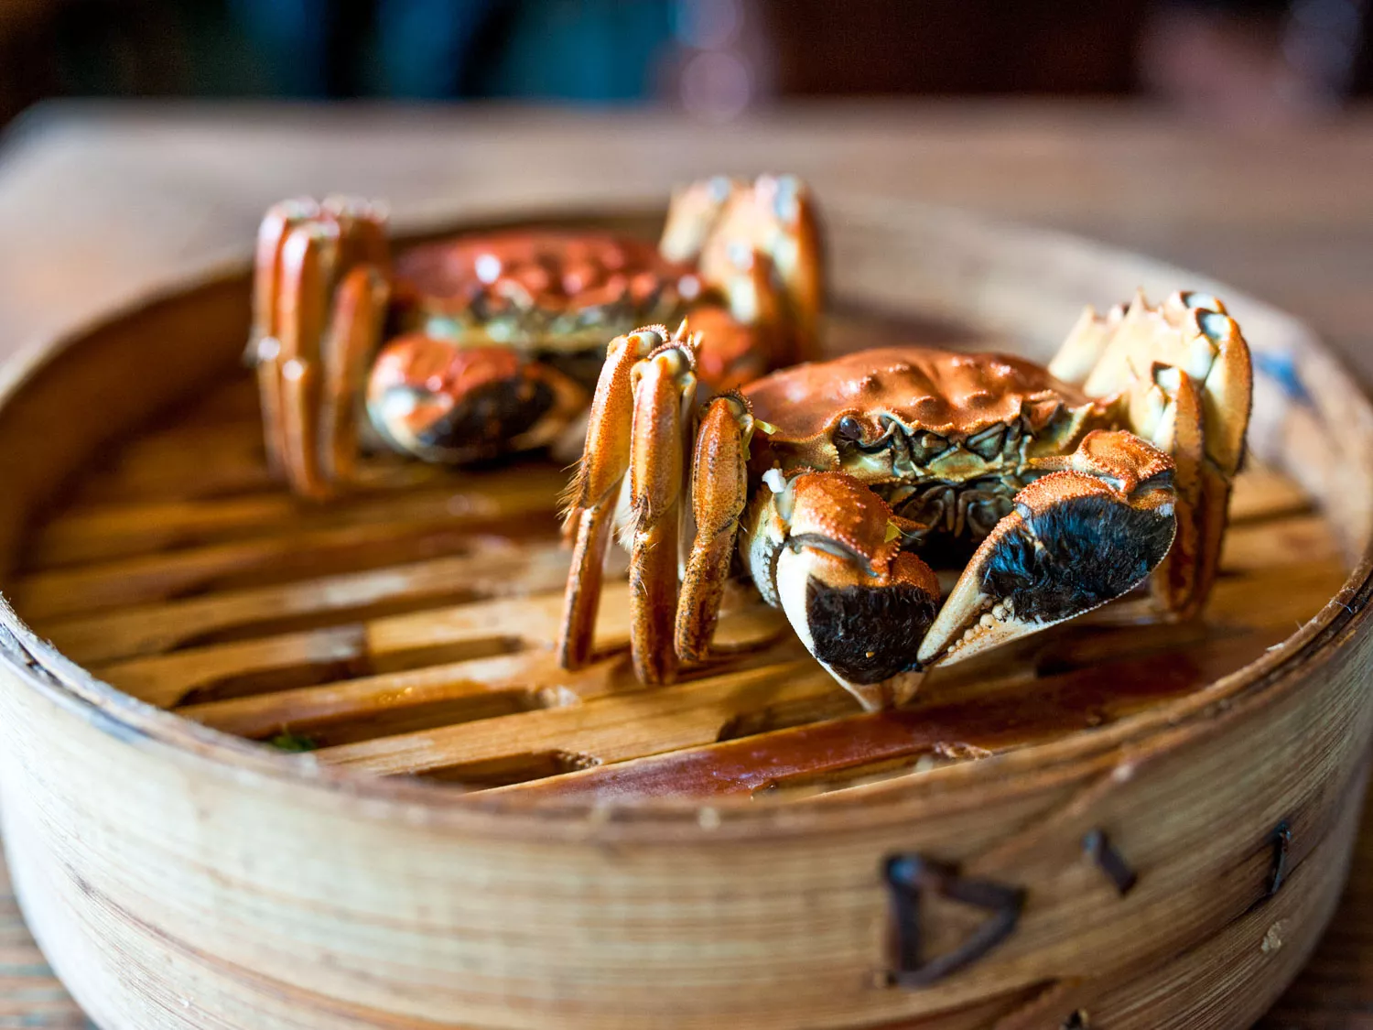
Two hairy crab on top of a steam basket
There is one single seasonal delicacy prized by Shanghai's food lovers above all others: the sweet flesh and creamy roe of the hairy crab. In the first crisp days of early autumn, Shanghai locals start to pester their vendors at the wet market (the common term for a fresh meat and produce market), and, once hairy crab season starts in earnest, it's a nonstop three-month-long feast. The best crabs, with fluffy black mittens on the ends of their claws (hence their other name, "mitten crab"), appear early—in the ninth lunar month for females, when the roe is at its peak, and in the 10th lunar month for males, when the flesh is at its sweetest.
I've always found them something of a fiddly nightmare to eat, but the roe, which stains your lips and fingers yellow, is a worthy prize: astoundingly rich, with the flavor of a just-coddled egg yolk.
The usual accompaniment to the crab is Shaoxing wine, said to perfectly balance the cooling properties of the crab in traditional Chinese medicine. It's hard to beat dining on hairy crab in one of the many restaurants perched on stilts around the edge of Yangcheng Lake, an hour northwest of Shanghai, where it's claimed the best crabs are found—heavy for their size, with the flesh clean and the females full of roe. On a clear autumn day, the lake is gloriously dark blue, and you can drink cold beer (or warm Shaoxing wine) sitting outside at a plastic-covered table. Some of these spots will even undertake the mess and bother for you, removing the meat and discarding the shells. Then again, where's the fun in that?
- 玩转语法填空——你改编的语法填空题：

4.Xiao Long Bao (Soup Dumplings)
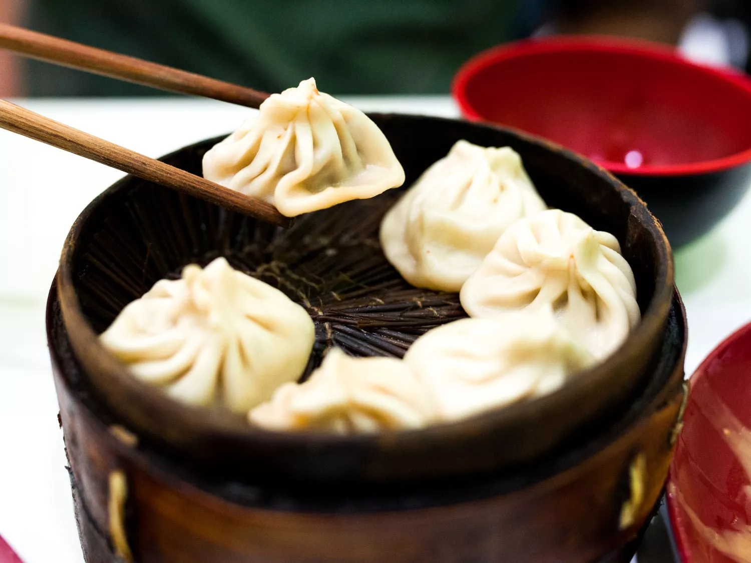
Xiao Long Bao in a steamer
Xiao long bao, those miraculous constructions of delicate dumpling wrappers encasing a big slurp of hot, savory soup and sweet, fragrant ground pork, are far and away my favorite Chinese street food. The pocket of soupy stock is the dumpling's essential element: a flavored pork aspic, typically made with pork skin, chicken bones, ginger, scallions, and Shaoxing wine, simmered for hours until the collagen-heavy ingredients have turned to gelatin, and then cooled until it sets. The dumplings arrive steaming and dangerously hot—to eat one, you have to decide whether to nibble a hole in it first, releasing the steam and risking a spill, or throw caution to the wind and pop the whole dumpling in your mouth, a burst of near-scalding broth exploding on your tongue.
Shanghai may be the recognized home of the soup dumpling, but food historians will actually point you to the neighboring ancient canal town of Nanxiang as xiao long bao's birthplace. There, you'll find them rustically prepared—more dumpling and less soup—and the wrappers are pressed by hand rather than rolled, for a thicker and heartier dough.
Nanxiang aside, the best xiao long bao have a fine, almost translucent skin, allowing them to be lifted out of the steamer basket without tearing or spilling any of their contents. The meat should be savory with a touch of sweetness, and the surrounding broth hot, clear, and aromatic with pork, ginger, and Shaoxing wine. Most vendors serve them with tangy, dark Zhenjiang vinegar and slivers of fresh ginger to complement the sticky-rich soup, though you'll also find them served alongside a bowl of clear soup. If you're lucky enough to be in China during hairy crab season, you can also find the pork mixed with the meat and roe of the crab, for an even sweeter, richer filling. No matter where I buy them, though, one steamer basket is rarely enough, yet two seems greedy, and so I am always left wanting more next time.
- 玩转语法填空——你改编的语法填空题：

5.Siu Mei (Cantonese Barbecued Meat)
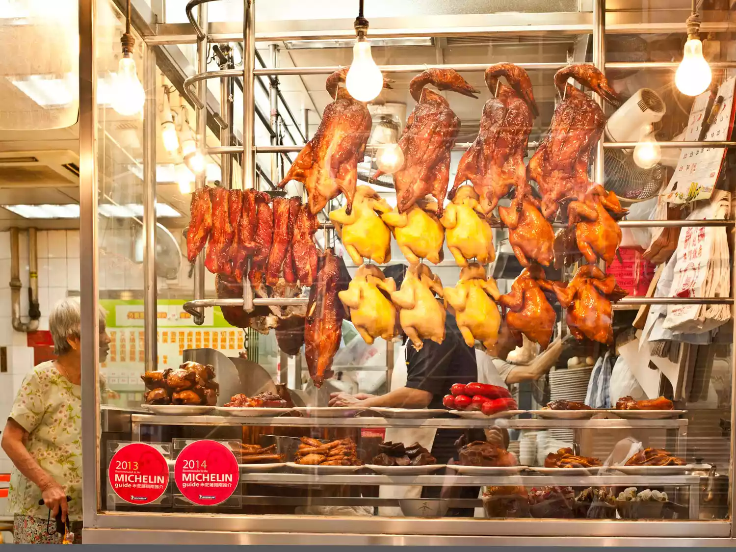
Siumei handing in the window of a market
Whenever I walk the streets of Hong Kong, I can't help myself—if I pass a barbecue shop, I have to go in and eat. The gloss on the roast ducks and pigeons gleams under the incandescent heat lamps, amid crisp-crusted pork, goose, soy-marinated chicken, and cuttlefish. The hanging delicacies—mahogany, gold, burnished, and fragrant with five-spice powder—await the sharp thwack of the cleaver as the vendor chops your chosen meat into pieces and serves it over rice with a sticky-sweet sauce. Ignore the grubby laminated tabletops and rough chopsticks sitting in a plastic cup.
If the shop is filled with locals on their lunch breaks, and if a steady stream of customers arrives for takeaway siu mei to eat at home, then you're in the right spot. Sheung Wan district has some of the best, and its streets are great for wandering, with the enormous indoor wet market on Morrison Street and the nearby shops selling premium teas and abalone that's often spread out in the sun to dry.
- 玩转语法填空——你改编的语法填空题：

6.Fresh Tofu
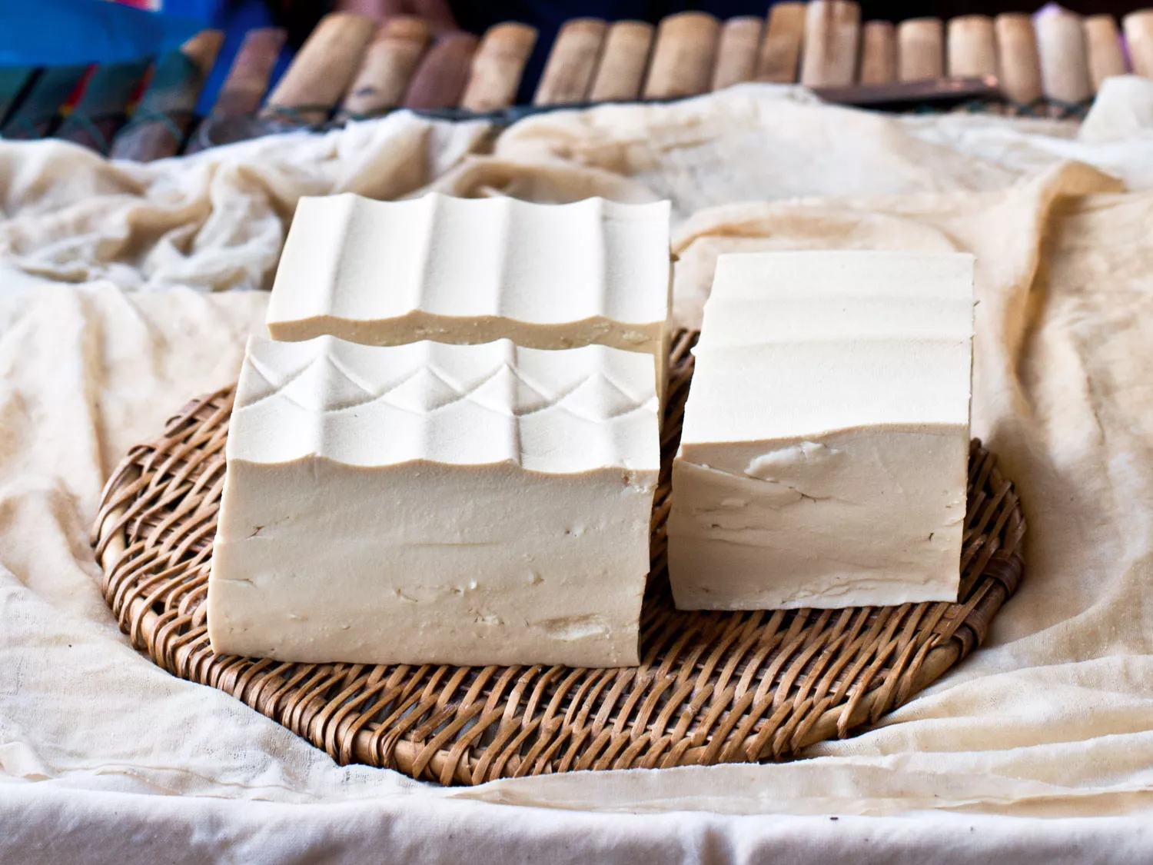
blocks of fresh tofu on a woven mat
Until I lived in China, I had only ever tasted vacuum-packed, rubbery, tasteless supermarket tofu—the kind that lasts for months in the refrigerator. I consumed it, resentfully, during a brief vegetarian phase in my early 20s, and never again. But eating homemade tofu, warm and lightly steaming, sliced on its muslin wrapping cloth with a worn and hefty cleaver, is a revelation. The texture is smoother than the finest ricotta; the aroma comforting and bean-y; the flavor light, with fresh soybean overtones.
It's so fragile, so delicate and quivering, that if you don't eat it immediately (I would always take it home and add a few drops of sesame oil and a touch of the best soy sauce), you have to keep it floating in a water bath to cushion it from injury. Locals buy their tofu in the morning, when it's freshest, and cook it the same day. Finding fresh tofu in China isn't challenging, as it's made everywhere. But for the best homemade tofu, you'll need to go into the countryside, to an open-air market. The best I've ever tasted was in Yunnan province at the Yousuo Friday Market, outside Dali.
- 玩转语法填空——你改编的语法填空题：

7.Crystal Sugar Hawthorns
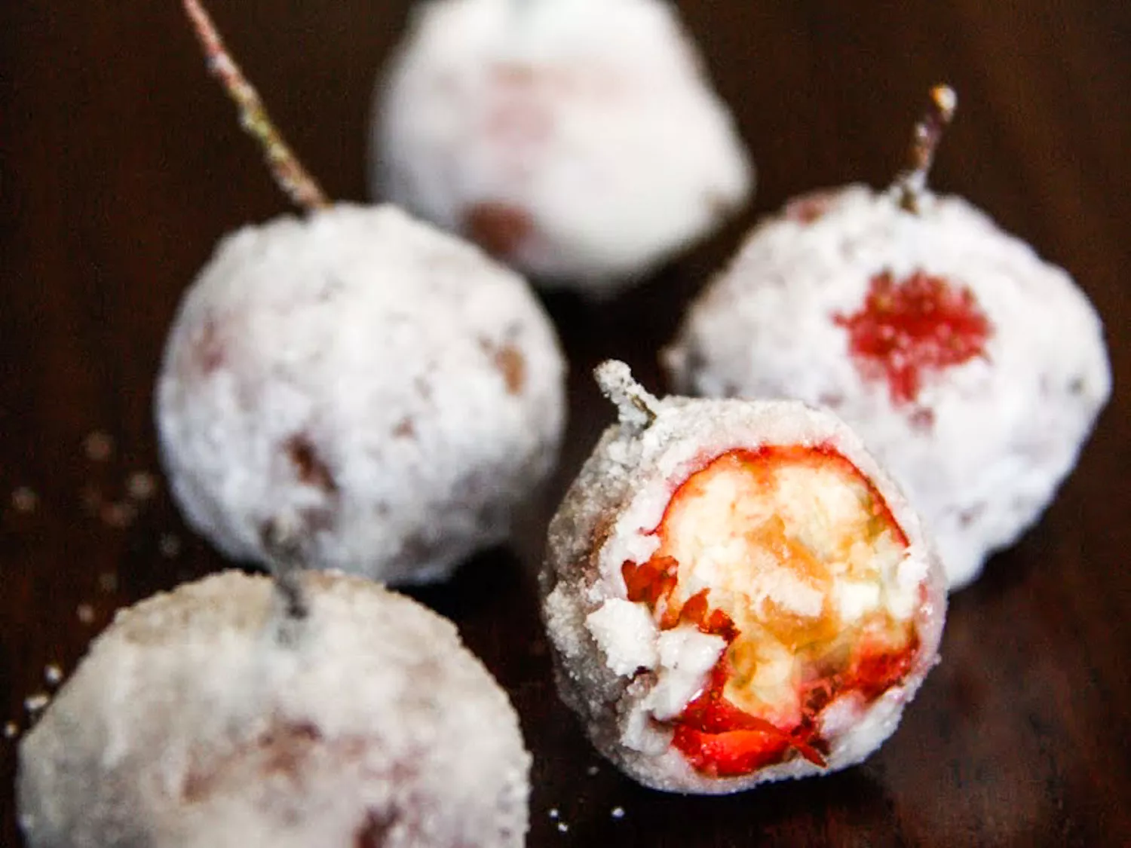
Crystal sugar hawthorns rolled in sugar
The arrival of winter means that hawthorns—which are related to rose hips—are in season. The round red berries have a cream-colored flesh with a flavor close to that of a tart green apple, peppered with dark brown seeds. They're found in China's colder provinces, north of the Yangtze. Because they're so astringent, hawthorns are often paired with something sweet. Some string them together on sticks and roll them in toffee, like a row of red lanterns or tiny candied apples—a preparation called bingtang hulu. But I prefer them lightly oiled, then coated in confectioners' sugar. These bingtang shanzha, or crystal sugar hawthorns, are downright compelling, with a crisp, white crust that packs a satisfying sweet-sour punch.
- 玩转语法填空——你改编的语法填空题：

8.Fuqi Feipian (Chilled Sichuan Beef)
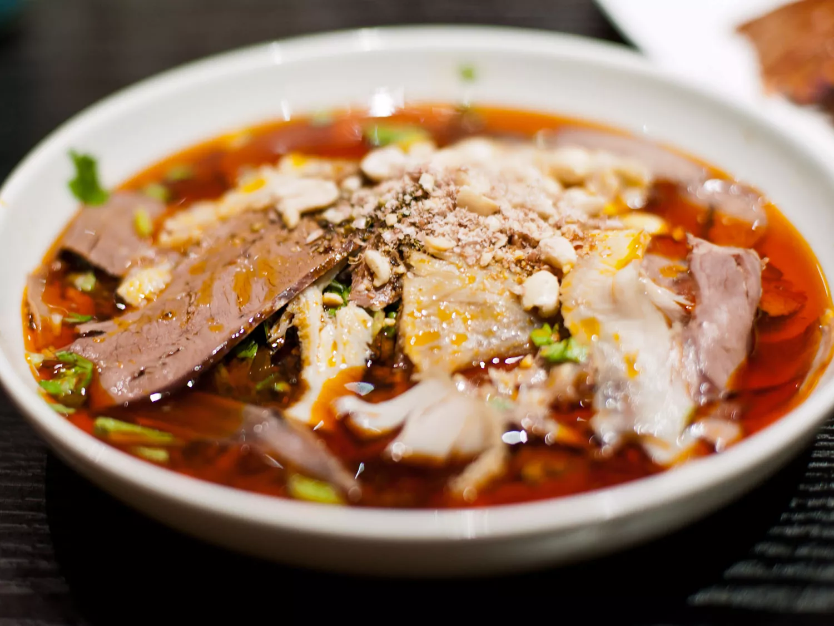
A bowl of Chilled Sichuan Beef
The story goes that a married couple in 1930s Chengdu made this classic Sichuan cold dish so well, it led to the preparation being named "husband-and-wife lung slices." Paper-thin poached beef and beef offal—ox heart, lung, and finely feathered tripe—are served liberally dressed with chili oil, Sichuan pepper, black vinegar, and sesame oil. A scattering of peanuts and finely sliced scallions adds crunch. The chilled meat and cooling cilantro are sharply contrasted by the searingly hot chili oil, with added complexity from numbing, citrusy Sichuan peppercorns and malty vinegar.
In Chengdu, the epicenter of Sichuan cuisine, you'll find this dish served as a prelude to a meal in many of the city's cangying guan (hole-in-the-wall or "fly" restaurants), where diners flock like flies for cheap, tasty eats.
- 玩转语法填空——你改编的语法填空题：

9.Hong Chang (Ha'erbin Pork Sausage)
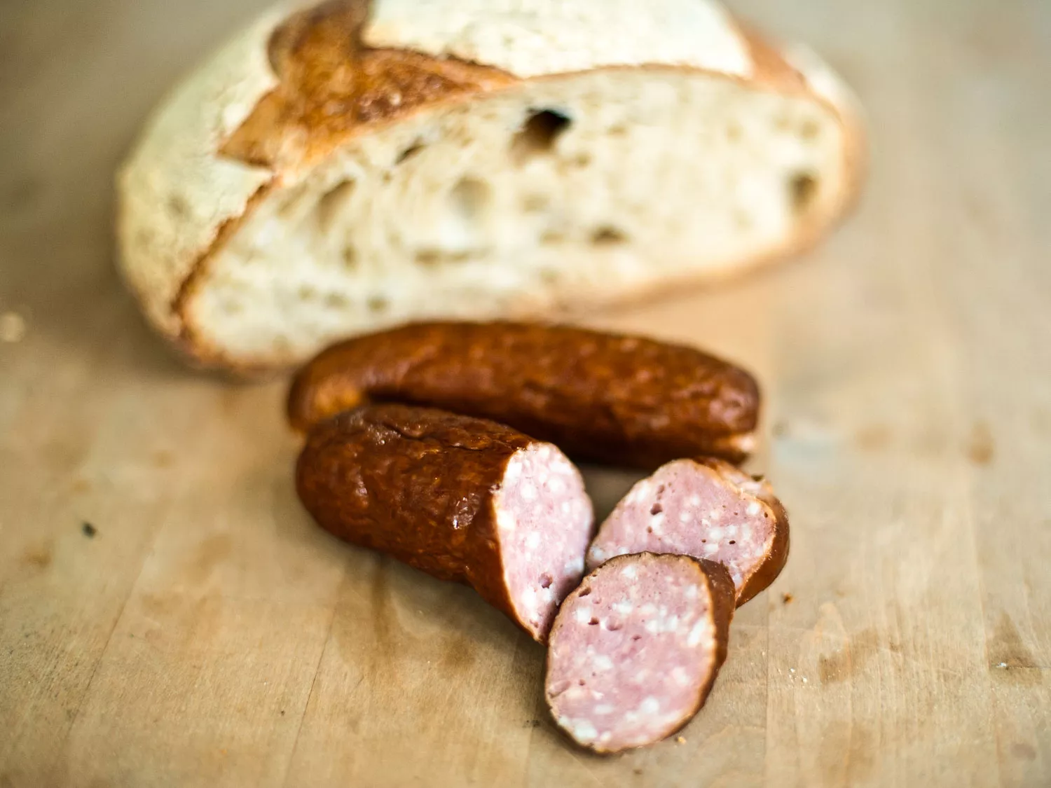
Ha'erbin Pork Sausage with bread
I know, I know, this doesn't look anything like Chinese food. Which goes to show the breadth of influences at play in the country's cuisine. In China's far-north province of Heilongjiang, bordering Russia, lies the city of Ha'erbin, famed for its annual ice festival. A century ago, Russian migrants fleeing the revolution found a safe haven in Ha'erbin, and, although few of their descendants remain, their food culture has left its indelible imprint on the city. This pork sausage, known as hong chang, or "red sausage," is smooth-textured and finely studded with fat, with a slightly sweet and pleasant smoky flavor. It's eaten with local dalieba sourdough bread and creamy Ha'erbin cow's milk butter—this is one of the few places in China outside the Tibetan regions where butter is eaten. It's a dish that feels somehow fitting in this remote part of China, as you're standing below the copper-green onion domes of the Saint Sophia Cathedral in the main square.
- 玩转语法填空——你改编的语法填空题：

10.Xue Doufu (Miao Blood Tofu)
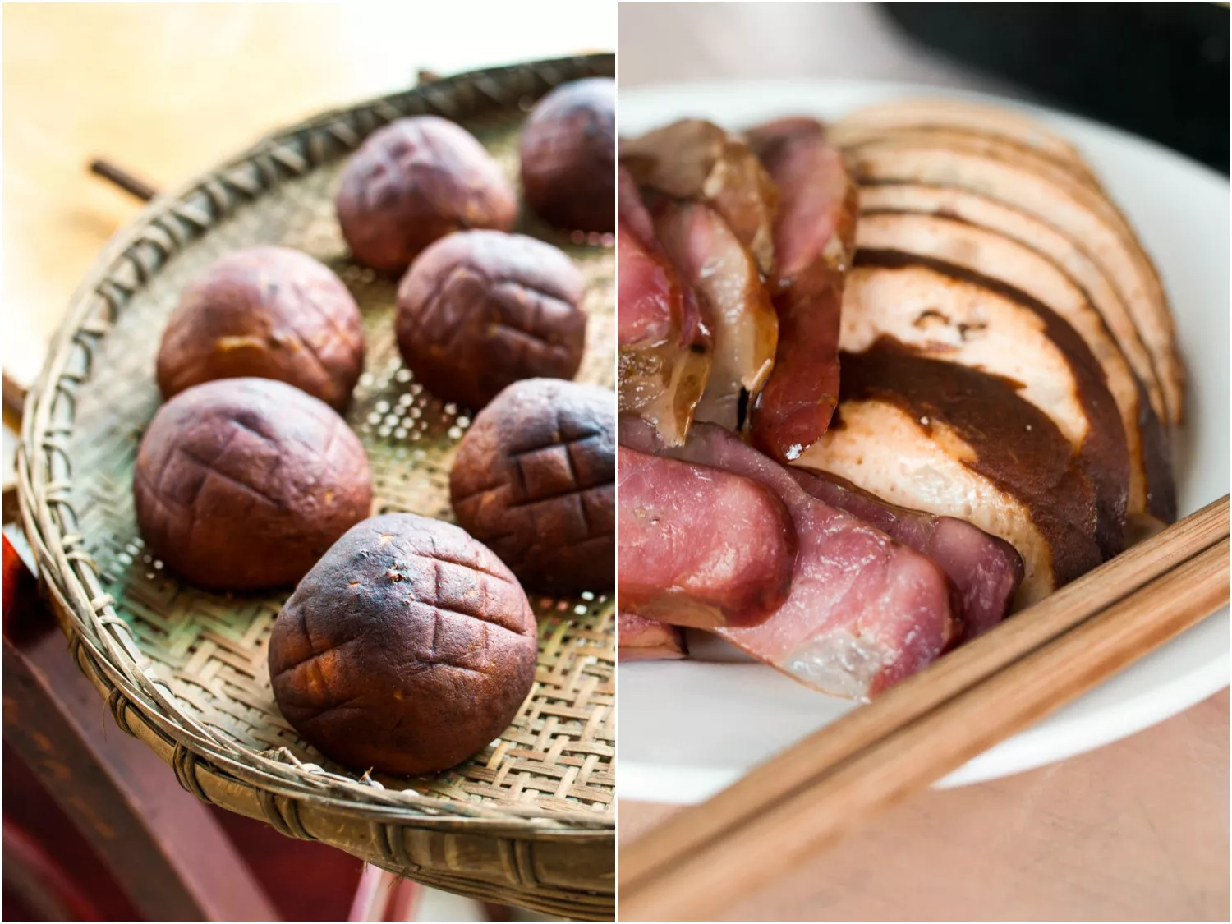
Xue Doufu or Miao Blood Tofu
In winter, when the Miao people of Guizhou province slaughter a pig for feasting, not a drop of blood is wasted. The blood is mixed with tofu and tiny pieces of bacon to make xue doufu, orange-sized balls that are air-dried on woven bamboo trays for several days, then lightly smoked indoors over the family fireplace and served in slices as an appetizer. The texture recalls a soft sausage like mortadella, with a smoky rind and mild pork flavor that suddenly intensifies when you bite into one of the salty pork belly pieces. It's a seasonal delicacy, usually eaten only at Miao New Year as part of a many-course feast that begins with sliced sausage and blood tofu; continues with fried fish, braised duck, duck blood congee, and stir-fried green peppers; then ends with fireworks and fiery rice liquor.
- 玩转语法填空——你改编的语法填空题：

11.Bamboo Shoots With Anhui Ham
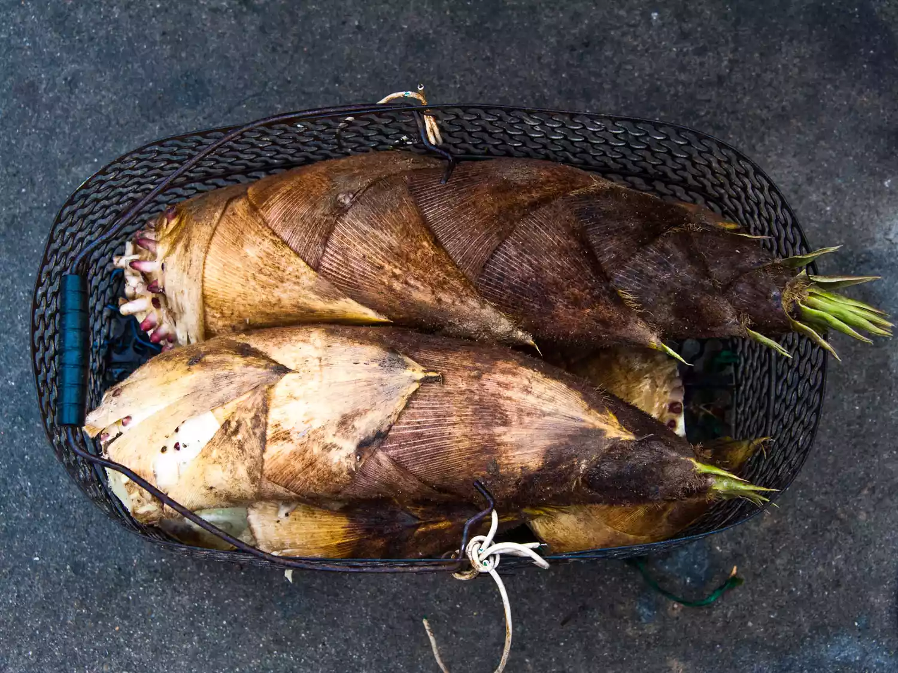
Anhui, in China's east, is famous for its bamboo forests—it's where the epic bamboo fight scenes from Crouching Tiger, Hidden Dragon were filmed. Bamboo forests mean bamboo shoots, fresh and green in early spring but larger and full-flavored in winter. Each shoot, the size of a rhino horn, is dug from deep under the earth on steep hillsides covered with feathered jade bamboo forests. Below the towering green bamboo canopy, a tiny visible tuft is often the only clue to the underground presence of a sizable shoot.
Bamboo is common in many of Anhui's dishes, and the region's cold mountain mists are dispelled with a warming bowl of bamboo shoot and ham stew, heated in a deep pot on a burner. Larou sun bao ("bao" meaning both the pot and the method of slow cooking over a low flame) features the local air-dried ham, pink and intensely flavored, and tender, finely sliced bamboo. Despite cooking, the bamboo shoots retain a slight crunch and taste like freshly cooked baby corn, while their starchiness lends a milky quality to the broth.
- 玩转语法填空——你改编的语法填空题：

12.Yang Mei (Chinese Bayberry)
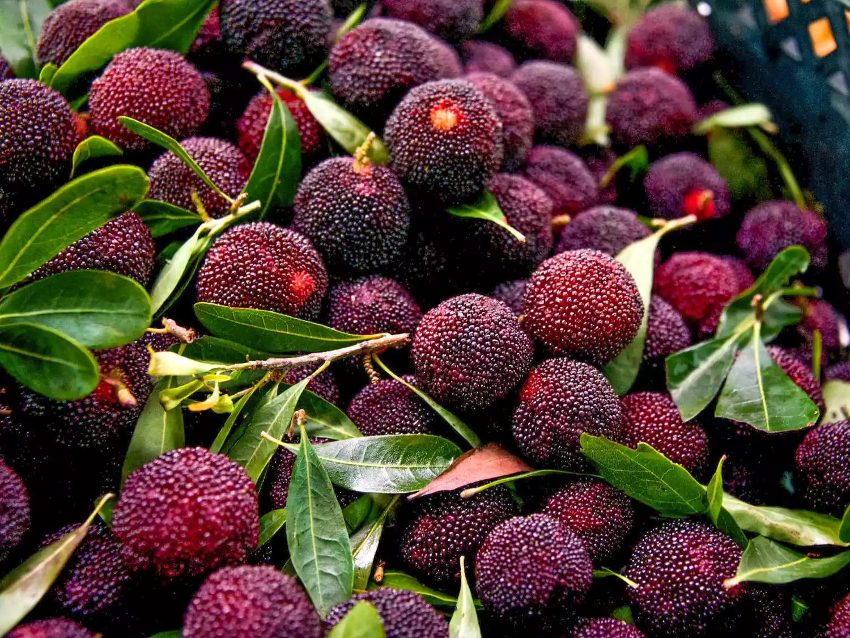
Yang mei, also known as Chinese bayberries.
Summer in China brings the yang mei, also known as the Chinese bayberry. They have grown in China's warmer mountainous provinces for over two thousand years, and I've plucked them wild from trees in Guangxi and Yunnan. With a color varying from dark red to deepest purplish black, the wild versions are tart and sour. The cultivated fruit, on the other hand, is sweet, with a taste most similar to a mulberry: luscious and a little tart. In the center is a soft seed, surrounded by thousands of tiny globules, each one bursting with juice in your mouth. The berries are used to flavor the local rice wine, or simply eaten fresh.
- 玩转语法填空——你改编的语法填空题：

13.Aged Pu'er Tea
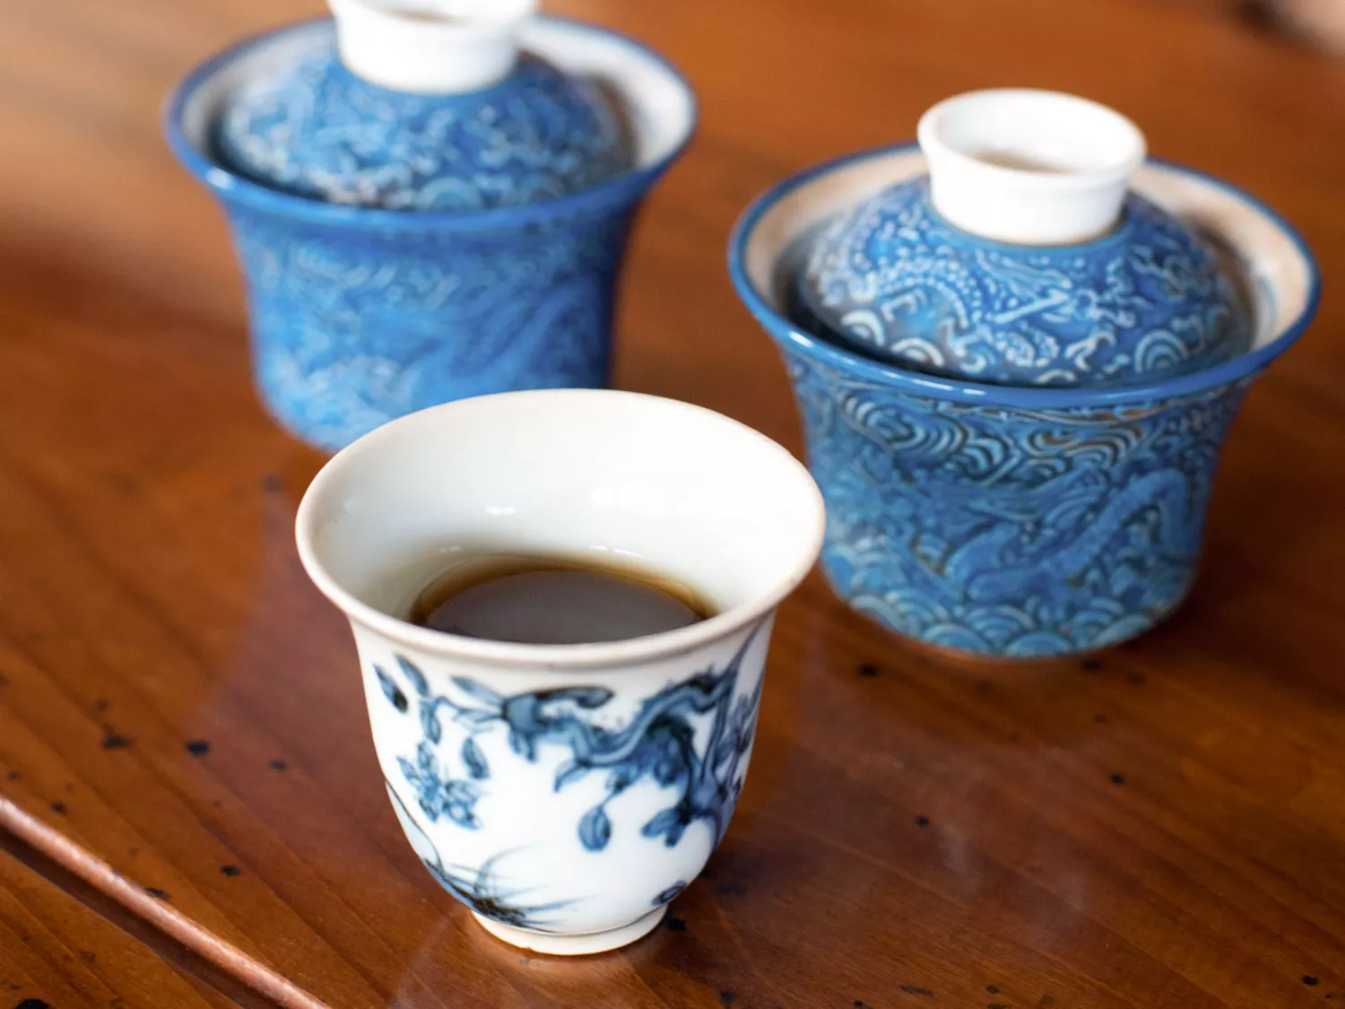
Drinking pu'er tea means you have come of age as a tea drinker in China—it's something you drink only after you've worked your way through white and green teas, then oolongs, to reach the fully fermented, fully oxidized tea of southern Yunnan. Pu'er's complex flavors and aromas—its hints of forest floor, wet leaves, stones after rain—are shaped by the altitude, soil composition, drainage, and amount of sunshine and rainfall in the place where it's grown. These earthy, mineral qualities are enhanced by aging the tea for anything from a year to more than a century.
And, like good aged wine, premium aged pu'er is something mere mortals like myself are unlikely to ever drink, except at the hand of a generous friend. I was fortunate enough to meet a pu'er grower in rural Yunnan who let me taste some of her collection of these extraordinary and complex aged teas, some of them 50 years old, and it was a gift I can never repay.
- 玩转语法填空——你改编的语法填空题：

14.Samsa (Uyghur Mutton-Stuffed Bread)
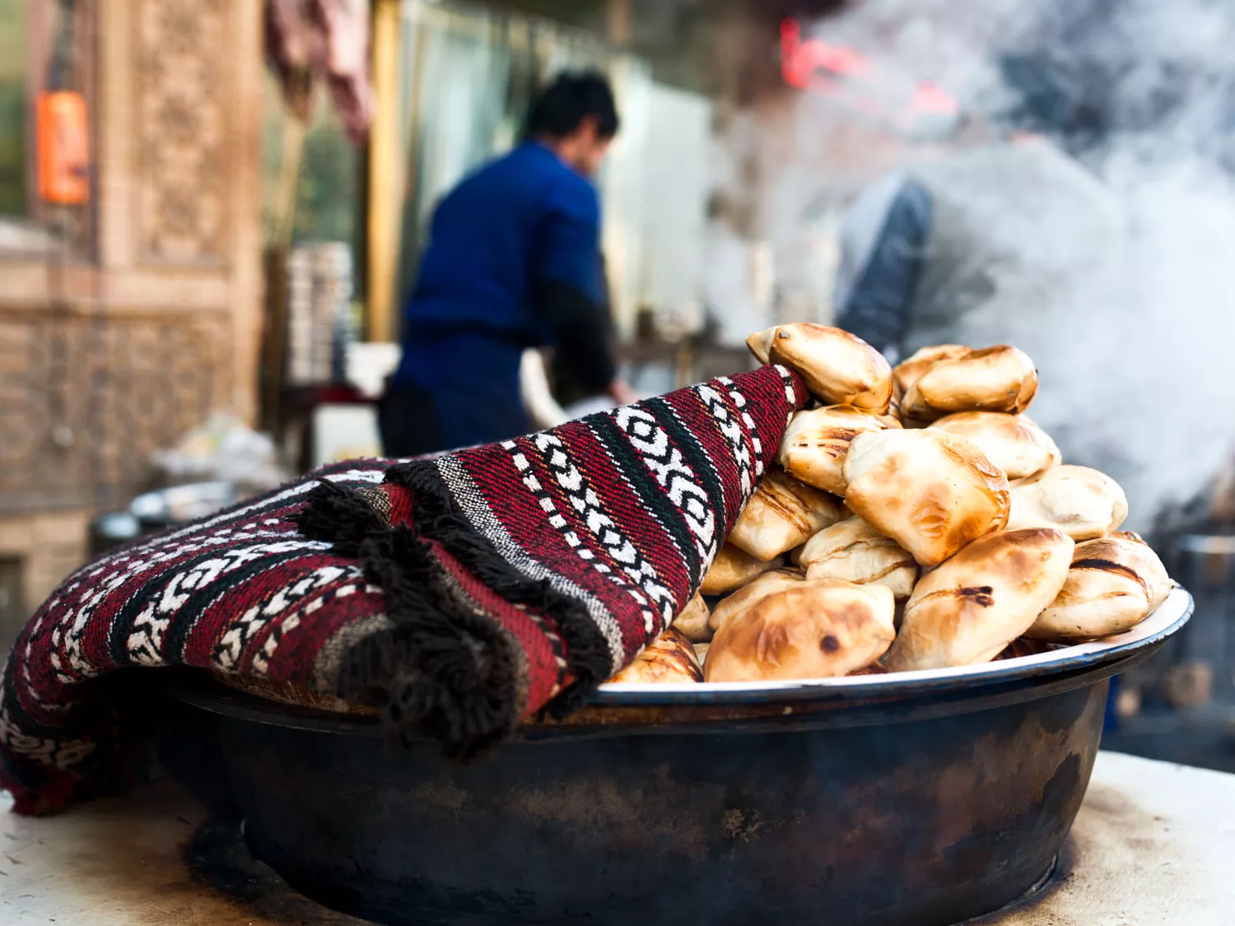
On my first visit to Kashgar, in far-west China, I sat down at a street stall where three Uyghur men were making samsas, unleavened pockets of wheat dough that are filled with mutton, folded over like envelopes, and then baked in a deep outdoor pit oven called a tanur. Unable to speak the local language, I held up my fingers for three and poured myself a bowl of saffron-colored tea. Nearby, a group of men wearing embroidered green prayer caps dug into an order of their own, breaking off pieces of salt-flecked crust to scoop out the meaty filling. When my samsas arrived, puffed and scorched from the tanur, I followed suit, tearing one open so the blistered brown skin crackled and steam shot out. Inside were small, tender pieces of mutton and glistening morsels of perfectly seasoned mutton fat, meltingly soft and deeply satisfying. Xiao long bao may be my favorite street food in China, but samsas are certainly the open-air highlight of Kashgar.
- 玩转语法填空——你改编的语法填空题：

15.Fangbian Mian (Instant Noodles)
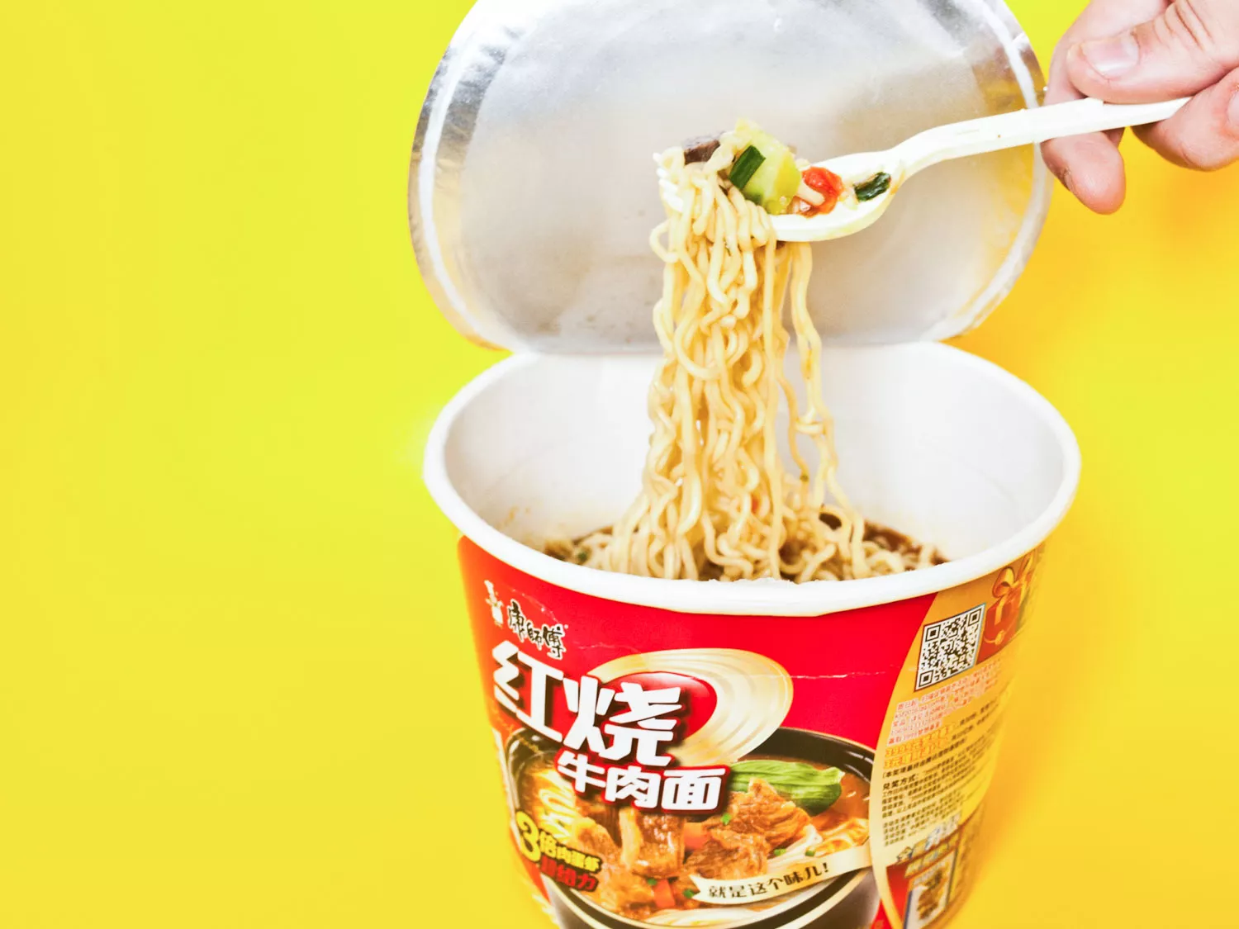
A styrofoam cup of Fangbian Mian, Instant Noodles
If you travel between any two points in China by plane, road, or rail, it's virtually inevitable that you'll encounter delays, complications, and a bowl of fangbian mian, or "convenience noodles." Travelers huddle together around the hot-water faucet in the gas station, or at the end of the railway carriage, each carrying a brightly colored cardboard container—red for spicy, green for vegetarian, or orange for seafood flavor.
I inevitably go for red, tearing the foil lid off a box to find three or four mysterious sachets atop crimped noodles. These I add one by one—dried vegetables and meat, chili oil, salted black beans, tallow, or MSG. There's a hiss as the boiling water hits the noodles before I'm enveloped by beefy, spicy aromas. As I wait for the noodles to soften, foil lid folded back over the rim to keep the heat in, I click and unclick the folded plastic fork and wonder for the millionth time why the packets don't come with chopsticks instead. The noodles taste of salt, mostly, and of new horizons. And I keep on eating them, because it wouldn't be a proper journey without.
- 玩转语法填空——你改编的语法填空题：

