Book 3 Unit 1 Festivals and Celebrations
---Reading for Writing
湖北卫视新栏目 《中国节日大会》 楚文化大使选拔现场
Activity 1. A quiz about festivals
elements | Festival knowledge | Useful expressions
(match)  Name&Time | Lantern Festival the 15th day of the 8th lunar month  Dragon Boat Festival the 15th day of the 1st lunar month  Mid-Autumn Festival the 5th day of the 5th lunar month | …takes place on…  …falls on…, ( lasting.....)
Celebrations  (activities) | What do people do to celebrate Mid-Autumn Festival?  _______________________________________________ | The celebrations involve....  It is a time of ... when... ...
Purpose | The following festivals are to honor people. Who are they ?  A. Dragon Boat Festival ___________  B. Columbus Day ___________  C. Teachers’ Day__________ | ... is in honor of …  ...is to look forward to...
Place | 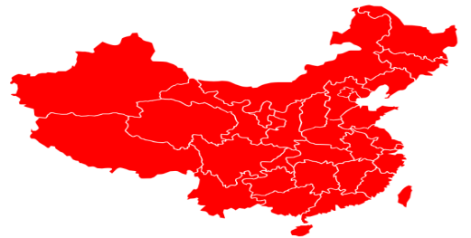  Circle the province where the following ethnic  festival is mainly celebrated.  A.the Water Splashing Festival （___族）  B. the Torch Festival（___族）  C. the Sanyuesan Festival (_____族）

Activity 2. Read for basic information of the festival and the structure of the text .
- Go through para1. and find out the basic information about the festival in this text.
Festival introduction | Basic information
Name of the festival
Where (place)
When (time)
How(celebrations)
2.Skim the whole passage for the structure of the whole passage.
Task: Underline the topic sentence of each paragraph and then answer.
Question1:In brief, what activities did the writer experience ? (Find answers from the topic sentences)
①________________ ②____________________ ③_________________ ④____________________
Question2: The activities were written in the order of __________.(Mark the key words in the topic sentences)

Activity3&4. Explore the experience & Spot writing skills
Scan the dairy for the experience descriptions and skills of writing a diary.
Question3: ( Para2:)What did the writer see when he arrived at the games?
“I saw a lot of people wearing fancy Mongolian robes. Some __________________, some ___________
archery, and others_____________ or taking photographs. ”
Question4: ( Para.3)The writer saw some wrestling competitors. How did they appear onto the green field?
After singing some songs, the competitors___________ onto the green field, ___________ their arms in the air
as if ___________.
Micro-writing 1: 场景描写仿写:(句式：some..... some...., and others.....)
美食街(The snack street)里挤满了来自五湖四海的游客。一些在品尝美食，一些
在忙于拍照，其他的一些在兴奋地挑礼品。
The snack street __________________tourists from all over the world. Some __________
delicious food , some ____________photos and others ____________gifts excitedly.
Micro-writing 2: 动作链描写+比喻：（After doing...., sb did..., doing as if......）
在发表完获奖感言后，张译和吴京分别举起左右手放头顶，做了个比心的动作，好像两
只可爱的小兔子在给大家送祝福。
After _____________ the acceptance speech in turn ,Zhang Yi and Wu Jing _______ their
hands ,_________a shape of heart on the head as if ________________________________.
Question5: How did the writer’s feelings develop in this experience? (underline the emotion descriptions)
He felt excited
(para1.) (performance) (wresting) (archery) (horse races)
but and (back home now)
Micro-writing 3: 情绪描写 （doing...， I was filled with .....)
看着开幕式上……的楚风楚韵的表演，我的内心充满着….。
When watching the _____ performances of Chu style in the opening ceremony, I was filled with _____.
Question6:(para5 )What did he think of his experience? Use some adjectives to remark on this experience.
His festival experience is ________ / __________ /_________/____________/.....
Micro-writing 4:全文中心句（第一段第一句） 升级：应用以上评价类的词语
1.I will never forget the experience of celebrating the Naadam Festival in China’s Inner Mongolia Autonomous Region, because it was truly __________________ .
总结段扩写升级：应用以上评价收获类句式
2.Celebrating the festival not only _______________, but also made me realize ______________.

Activity5. Integrated writing and Presentation
请观看节日视频再结合节日介绍，以一名参加者的视角写一篇日记来介绍首届楚文化节的经历以及感想，参加文化大使选拔。
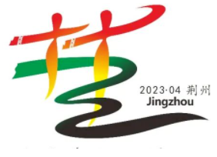
名称：首届楚文化节 The First Chu Culture Festival
举办时间：3月18日至4月9日
地点：湖北荆州 古城东门宾阳楼护城河
（By the moat of Binyang Tower at the East Gate of the ancient city）
主要活动：
1. 楚文化节开幕式： 4月8日晚各类楚风楚韵类文艺汇演
2. 2022中国电影大数据盛典（The ceremony of Chinese movie data）: 4月9日晚, 众多明星齐聚荆州，演员张译和吴京也上台领奖了，发表完获奖感言后，张译和吴京分别举起手放头顶，合做成了个心的形状，好像两只可爱的小兔子在给大家送祝福
3. 游历美食街 ：美食街The snack street里挤满了来自五湖四海的游客。一些在津津有味的尝美食，一些在忙于地标处拍照打卡，还有一些在兴奋地挑礼品。
Writing steps:
- Draw the structure by choosing elements for each paragraph first: （put the numbers in the chart）
① first person ②past tense & present tense ③time linking words
④general introduction to the whole experience ⑤ basic information of the festival （time; place …）
⑥topic sentence of the activity ⑦ scene description ⑧ emotion description
⑨ the ending of the experience ⑩comments

Title | My first Chu Culture Festival Experience
Diary features  ①②③ | Structure | Opening paragraph | ④⑤⑧
Diary features  ①②③ | Structure | Body paragraphs | ⑥⑦⑧
Diary features  ①②③ | Structure | Closing paragraph | ⑨⑩⑧
- Draft the content for each part according to the main information.
- Combine the parts using some linking words.
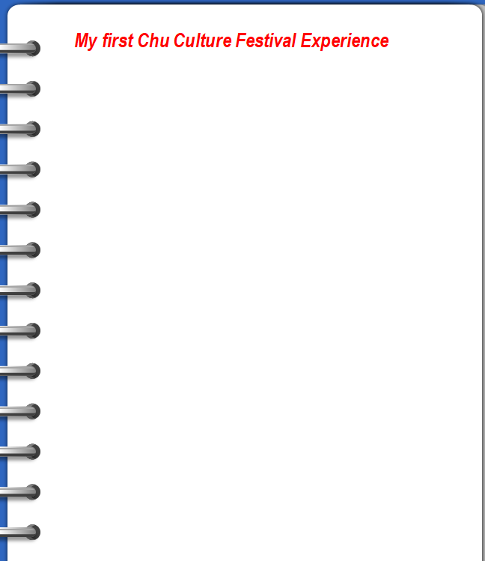
Activity 6: Summary
- What do festivals mean? What should we learn to do?
festivals

framework experience skills theme imitate value a__________ l_____ s__________
activity culture We should shoulder our _______
Activity 7: Homework
1.Complete your writing of the experience and revise the draft according to the checklist .
2.Explore more information about ethnic festivals as well as Chu culture.
Activity 8: Self-assessment
Yes or No | Learning aims
 | 1. enrich your knowledge about festivals
 | 2. figure out the structure and language features of a festival experience.
 | 3.write your own festival experience using the structure and skills of this passage.
 | 4.appreciate and treasure the colourful national cultures and cultivate the cultural awareness.

