读后续写微专题——衔接和连贯

教学目标：
本节课后，学生将能够：
- 掌握记叙文体的一些常见的顺序的语言素材积累。
- 掌握表达时间快慢，心理活动的常见词组和句式。

教学重难点：
学生能够掌握常见的表达顺序的语言素材，并且能运用在自己的写作中。

教学步骤：
Step 1:
Lead-in: Q: Why do we need coherence and logic while writing?
--- It can make our composition more logical and coherent.
Step 2: 几种不同的顺序
一、时间顺序：① 时间快慢 ②时间先后
时间慢: go slowly; drag on 很慢；日长似岁
after what seems an age/ a century 似乎过了一年、一个世纪
时间快
短语：
1.go fast/quickly
2. tick away (时间)一分一秒地过去
3. for/in an instant; in a spilt second; in a flash; in the blink of an eye; in the twinkling of an eye 刹那间
副词：
1.immediately/instantly 立刻；马上
2.shortly 不久，马上
句型
1.on/upon (doing) sth 一做某事
2. before 还没来得及，常见句式before sb knew what was happening;
3. The moment +句子； no sooner…than..; hardly/scarcely…when…
一…就…
Sentence-appreciation:
◆ The rest of the day went very slowly for Anne.
◆ Why do physics lessons always seem to drag?
◆He had to watch the minutes tick away while the emergency services tried to locate him.
◆In that split second, my surfing days as I had known them were over.
◆ Before I could finish my sentence, she burst into tears and began rocking back and forth.
◆ The moment he finished his speech in a magnetic voice, a storm of applause erupted from the audience.
紧接着、后来
句型：
1.时间（the following weeks/days…）witnessed/saw sth doing 接下来得时间，见证了某事得发生。
2. that’s when sth happened.
3. Everything settling down/everything ready, 主句。一切完成/就绪后，….
4. It 句型：it was /took +时间 before sb did sth 过了一段时间，某人开始做某事
短语：
the next minute; followed by; at that; with that; before doing ; after doing; subsequent to that; after that; then following …
副词：
subsequently; then; afterwards; later
恰好；不料；来不及
just in time to find/see 恰好发现、看到…
…only to do …结果
There is no time do to….
Just as /when sb did…., 主句
◆ The last five minutes saw his dashing to the finish line like wind.
◆ The following weeks saw me dashing home from school each day determined to earn a nickel or dime.
◆Everything ready, the news page was eventually in business.
◆I opened the door just in time to find him watching TV.
◆ With that, she rushed out of the room.
二、空间顺序
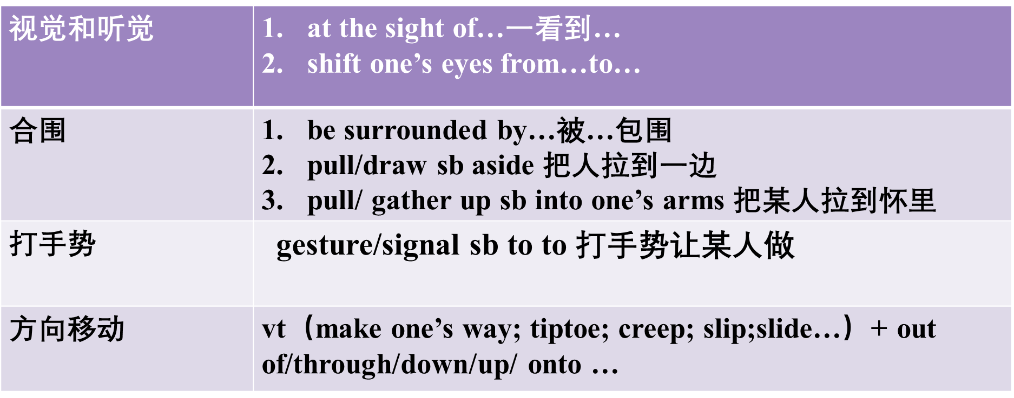
◆ His eyes shifted from face to face.
◆ She laughed, ignoring the stares of everyone around her.
◆She pulled out into the street.
◆ We followed him up the steps into a large hall.
三、意识流动顺序：思维活动推动故事发展
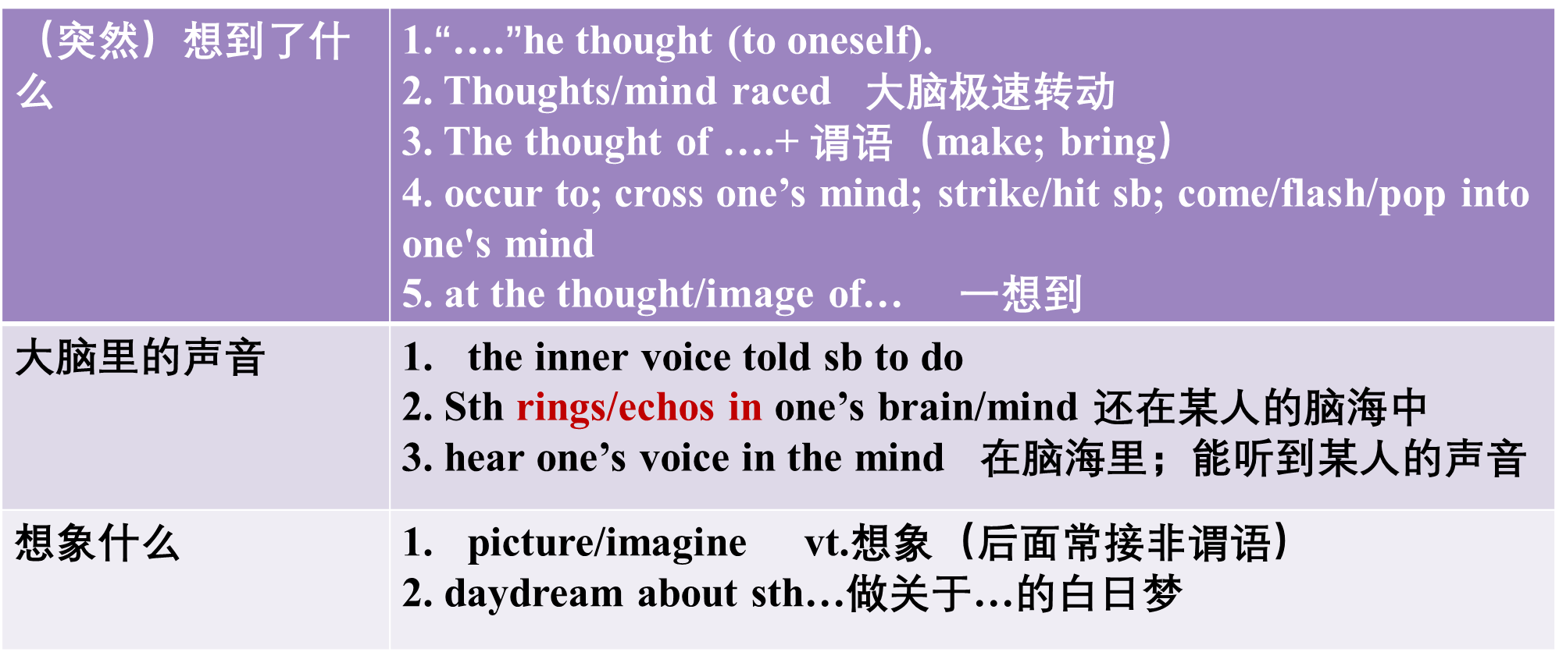
◆ “How strange!’ he thought to himself.
◆The thought of Nick made her throat tighten.
◆ My inner voice told me to be cautious.
◆All at once an idea popped into her head.
◆I said, picturing the fancy brick house that we passed on our way from schoo

四、场景的氛围：其他人群的反应
人群的反应 | - A murmur of （approval…） came from the crowd.  - …be greeted with cries of…  3. …produced /caused an awkward silence.  4. …found an echo in her own feelings. 引起了她的共鸣。  5. …struck a chord with his audience. 引起了听众的共鸣  6. A thunderous applause burst out from the audience.
一片  寂静 | 1.There was a moment of complete silence.  2. Silence falls/descends (on/upon sth)  3. …be met with silence/ …be followed by a very long silence, broken by…
◆ Her question was met with an uneasy silence.
◆A sudden silence fell over the room.
◆ His love for her found an echo in her own feelings.
◆Her remarks produced an awkward silence.
◆The speaker had obviously struck a chord with his audience.

Step 3: Consolidation: fill in the blanks.
1.时间慢慢地过去，我的状况越来越糟了。
As time ________ on, I gradually got worse.
2. 一眨眼的功夫就完成了。
It was done in a ________/in a ________ second.
3. 他们一路跑到转角处，正好看到公共汽车消失在街尽头。
They ran all the way to the corner just _____ ______ to see the bus disappearing up the street.
4. 我们穿过村庄来到了农场。
We made our way_________ the village to the farm.
5.奇怪的念头在他脑子里转动。
Strange thoughts________ around and around in his mind.
6. 那寒冷黑暗的大海，他想想都吓得发抖。
He trembled ____ the thought of the cold, dark sea.
7. 她脑子里有个小小的警钟响了。
A tiny alarm bell began to _______ in her brain.
8. 我试着想象我们像第一次诊断时那样努力与病魔作战。
I try to_____________ us fighting just as hard as we had during the diagnosis.

Step 4: Apply what we learn to continuation writing.
Step 5: Summary
