Worksheet
- Analyze para.3-7 and answer the following two questions. Then work in groups of four and finish the mind map.
- What new things does the author discover? （how? → descriptive words）
- What activities does the author do to explore? （how? → verb phrases）
Sentence pattern: Following in the footsteps of Xu Xiake enables us to explore/discover _____(what new things). ________(details)

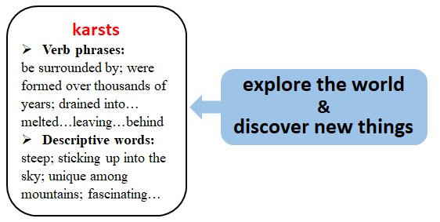

- Homework: Your American friend Peter is planning to visit China for sightseeing. Please write a letter to recommend Guilin to him.
__________________________________________________________________________________________________________________________________________________________________________________________________________________________________________________________________________________________________________________________________________________________________________________________________________________________________________________________________________________________________________________________________________________________________________________________________________________________________________________________________________

