REQUIRED BOOK 1

UNIT 4 NATURAL DISASTERS
DISCOVERING USEFUL STRUCTURES
DESCRIBE PICTURES OF DISASTERS

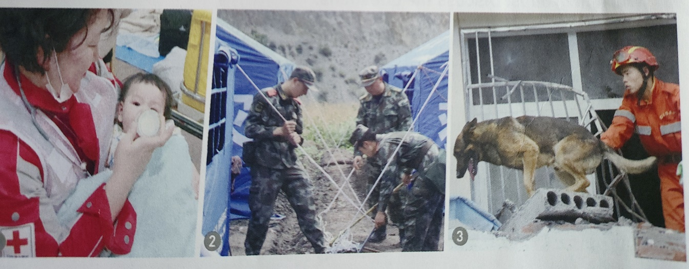

西安市东城第一中学
张秀茹

REQUIRED BOOK 1

UNIT 4 NATURAL DISASTERS
DISCOVERING USEFUL STRUCTURES
DESCRIBE PICTURES OF DISASTERS
Topic context: Man and nature
Topic group: Disaster prevention
Sub-topic: Natural disasters and prevention, safety common sense and self-protection
Type: Grammar
Duration: 1 class(40mins)
Design philosophy
As new senior English curriculum standard and “core competences”point out “in the process of developing the students’ language-using ability, teachers should focus on helping students improving their cultural awareness, thinking capacity and learning ability. This lesson is aimed at improving students’ language competence and cultural awareness.
Learning content analysis
This lesson is Discovering Useful Structures of required book 1, Unit 4. How to describe pictures of disasters is the teaching content. This grammar class is combined with the topic of this unit, Natural Disasters. Put grammar into topic fulfills the requirement of English Curriculum (2017).
This lesson is Discovering Useful Structures of required book 1, Unit 4. It requires students to master attributive clauses and use these attributive clauses in the description of specific things, so as to improve their language expression and application ability.
Students analysis
The type of this class is Discovering Useful Structures, describe pictures of disasters. Students of senior one have learned attributive clauses in junior middle school. Learning something new based on what they have learned makes learning easier. Situational teaching approach(methodology) makes it easier and more interesting for students to learn grammar. The key point of this class is to use restrictive attritive clauses guided by relative pronouns to describe characteristics of people, things, supplement information and describe natural disasters and other everyday things.
Teaching objectives
In this class, students will
- recognize the restrictive relative clauses and understand the use of relative pronouns;
- summarize the form and functions of restrictive relative clauses;
- use restrictive relative clauses to describe pictures of disasters.
Important points
- How to lead students to recognize the restrictive relative clauses and understand the use of relative pronouns;
- Help students summarize the form and functions of restrictive relative clauses
Difficult points
How to lead the students to use restrictive relative clauses to describe pictures related to disasters, supplement information and enrich language expression
Teaching approaches and learning strategies
Activity-based teaching approach
Situational teaching approach
Cooperative learning
Autonomous learning
Preparation for teaching
Teacher preparation: select some pictures of natural disasters
Student preparation: preview the content of this lesson
Teaching procedures
Steps | Teaching activities | Design purposes | Core competencies covered
Warming up (热身) 5mins
Step 1 Perceive  Lead in  8mins | Teacher invites students to enjoy a short clip about dogs rescue survivors in the earthquake. | Introduce the topic and get students engaged in the class | Language ability: the perception of restrictive relative clauses  Cultural awareness: show students’ views on love
Grammatical exploration（语法探究）30mins
Step 2  Discover the rules  5mins | 1.Find and underline the restrictive relative clause in the sentence.  - Underline the restrictive clauses in the sentences below.  2.Why do we use the restrictive relative clauses?  - What if these relative clauses are not used in these sentences?  3. Find more sentences with restrictive clauses from the text on page 50.  Observe the sentences and summarize the usage of the relative pronouns. | Get students to recognize the restrictive relative clauses master the function of restrictive relative clauses  Give ss the opportunity to actively experience, think and learn.  Make students understand and summarize the use of relative pronouns as well as strengthen the grammatical function of relative pronouns | Language ability: recognize restrictive relative clauses  Language ability: understand restrictive relative clauses  Ability to learn：summarize the usage of relative pronouns
Step 3  Practise the grammar  7 mins | Complete each sentence with relative pronouns. Then translate the sentences into Chinese. | Help ss understand the meaning and features of English sentences with their native language. | Cultural awareness: the differences in grammar and sentence patterns between English and Chinese
Step 4  Application  Describe pictures of disasters  10mins | Write one or two sentences with restrictive clauses to describe these pictures. | Get students to describe pictures of natural disasters and strengthen the grammatical function of restrictive relative clauses. | Cultural awareness: understand some major natural disasters at home and abroad from the perspective of historical events, and establish a sense of disaster prevention and self-protection.  Quality of thinking: cultivate students’ innovative thinking in the process of descripting pictures.
Step 5 deep thinking  Discover love and circulate love  8 mins | Love is a sniffing dog that helps find survivors.  Love is a bottle of milk that can feed the baby.  Love is also a tent that soldiers put up for victims | Stimulate students’ affection for sufferers  Have the awareness and attitude to actively respond to natura disasters and think positively from multiple angles as well as reduce psychological sufferings caused by disasters | Quality of thinking：Disasters are merciless but we Chinese have love  Quality of thinking：positive, helpful, supportive, self-healing
Assignment (Homework) 2mins
Compulsory assignment:
Write a short passage of 6 sentences to describe the rescue work after the natural disaster. At least 4 restrictive relative clauses must be used.
Blackboard design
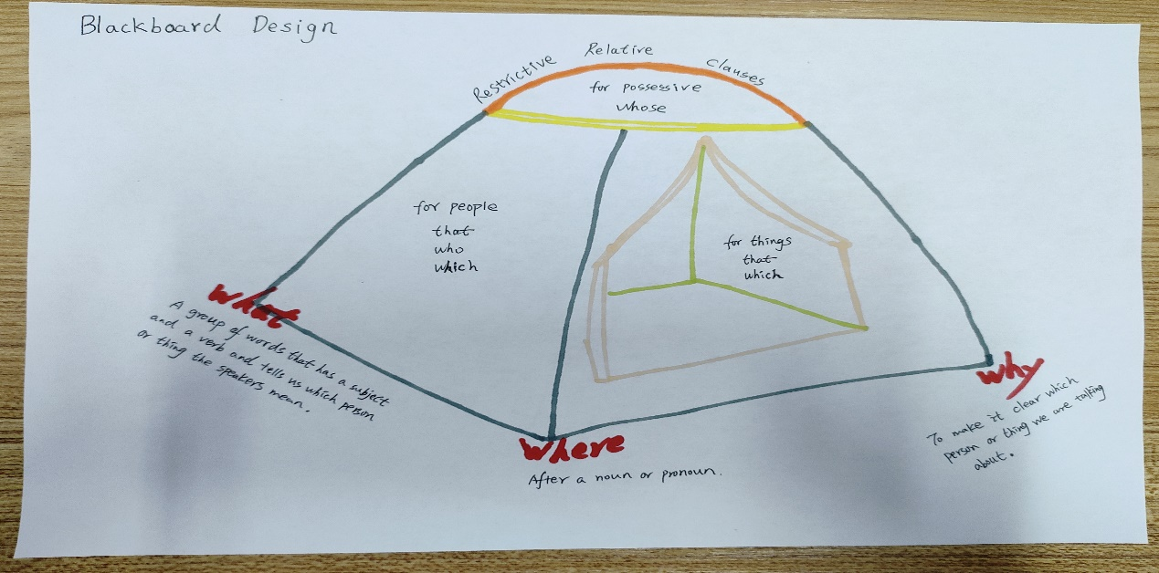
Teaching reflection
Highlights:
- In this period, I begin with an English song love and end with a Chinese song love, which a perfect circle. And also I implement the principle of using one situation.
- Execute the ideology and politics education in my class. Fully immerse students in love and guide them be a spreader of love.
- I use the activity chains to guide the students to grasp the grammar step by step.
- When the students finish my homework, I think they will be very happy to shoot the moving scenes about their family and upload it to Tiktok because they really act as the spreaders of love.
Improvements
Time permitting, I will let every student share their understanding about love because everyone wants to be heard.

