绍兴一模应用文讲评
——基于教材和读者意识
教学设计
暨阳分校 陈莹
- 教学目标
- 掌握建议信的常见结构和语言特征；
- 通过小组讨论，学会如何分析问题、解决问题；
- 能够运用得当的语言，恰当的语气合理地表达自己的理由和建议。
- 教学过程
- 导入
以绍兴一模的应用文为导入，初读题目，确定邮件类型，写作对象和写作话题。
假定你是李华，你的英国笔友David刚升入高中，但因一时无法适应新的校园生活而焦虑，写信向你倾诉他的烦恼。请你给他回复一封邮件，内容包括：
1.分析可能的原因；
2.给出合理的建议。
注意：
1. 词数80左右；
2. 请按如下格式在答题卡的相应位置作答。
Dear David,

Yours sincerely,
Li Hua
邮件类型：建议信
写作对象：笔友
写作话题：校园生活
- 与教材的联系
关于“校园生活”的话题，必修一第一单元就已学习过，而且写作板块就有一篇类似的建议信。
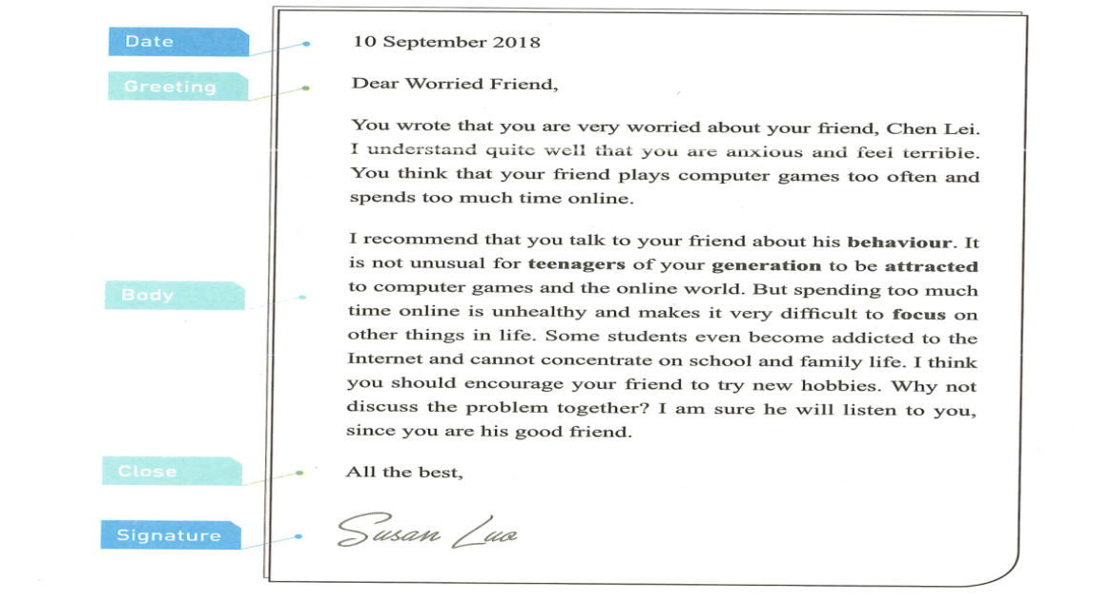
从结构、内容、语言、语气再次学习教材的语篇。
Q: What is the structure?
Q:What is mainly talking about in each part?
Q:Which expression impresses you most?
Q: What is the tone?
Part 1 problems
Part2 suggestions&reasons
Part3 wish
You wrote that......
I understand quite well that you are anxious and feel terrible.
I recommend that......
It is not unusual for teenagers of your generation to......
I think you should......
Why not......?
I am sure......
Tone: concerned, understanding
- 审题
教师引导学生从结构、内容、语言、语气四个维度审题。
- 结构
Para 1 purpose
Para 2 reasons+suggestions
Para 3 wish
- 第一段内容、语言、语气
Q:Besides purpose, what else should also be included?
做......很难
●have trouble/problem doing;
●find it hard/difficult to do;
●It is quite a challenge for sb to do;
适应
●adapt to;
●adjust to;
●fit in well;
焦虑
●anxiety/anxious/confused/at a loss
Tone:concerned&understanding
●I understand quite well that…;
●I feel terribly sorry to learn that…
- 第二段内容、语言、语气
Q: What makes it hard for a high school freshman to adapt to new school life?
Possible reasons: a tight study schedule
more subjects and homework to handle
higher academic requirements
fail to keep up with others
get insufficient sleep
no familiar friends around/ feel lonely
Discuss: put forward some practical suggestions accordingly.
Possible suggestions:adjust learning strategies
learn to manage time properly
turn to school advisors for guidance
take exercise
join a club to make friends with like-minded guys
participate in extra-curricular activities
stay positive/outgoing
提出建议的句型:
●Were I you, I would......;
●It would be a wise choice if you…...;
●Why not...…;
●…...is highly recommended/a good option;
●It is advisable that...…
Tone:concerned&understanding
●It is not unusual for a freshman like you to......;
●It is a common phenomenon that…...
- 第三段内容、语言、语气
●Hopefully, you will find my suggestions helpful and practical. All the best!
●I would be more than delighted to see that these suggestions are of help to you.
Tone:concerned&encouraging
●I will always be there for you.
- 范文赏析
学生佳作：
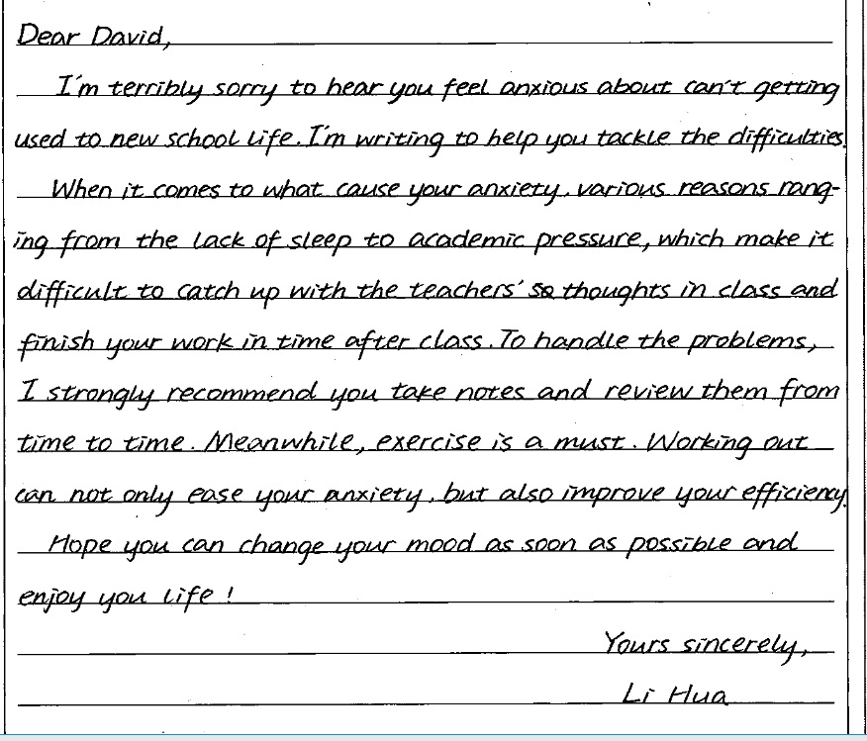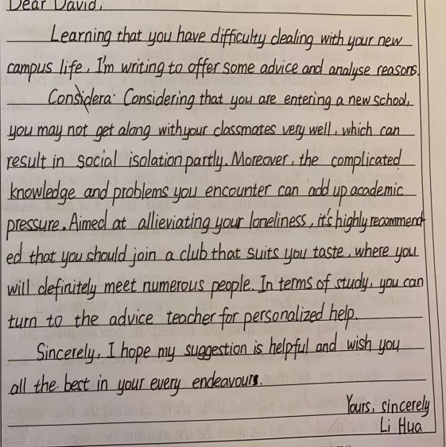
参考范文：
Dear David,
I'm sorry to hear that you feel confused and anxious as a freshman at senior high school. I truly understand your situation since I've been there.
Going to senior high school is really a big challenge, especially when you face the higher academic pressure and new interpersonal relationship. However, you can make it easier by good time management following some golden rules. First, work out an appropriate schedule helps reduce your stress. If necessary, turn to the school adviser for help, who is experienced in tackling tricky problems for students like you. Finally, stay positive all the time, because a positive attitude sparks extraordinary results.
I really hope the suggestions will be of benefit to you. All the best!
Yours, Li Hua

- 教学反思
能够客观、理性地分析青少年学习生活中的问题，并提出解决方案，树立良好心态，正确面对学习和生活中的困难和挫折，成就更好的自己。

