The World（1101-1115）材料分析和教学目标：
本次选用的材料：①New Scientist的AI brings John Lennon’s vocals to new Beatles’ song（人工智能复活约翰·列侬的声音 ）、②The Week Junior的How dust destroyed the dinosaurs（尘埃是如何毁灭恐龙）、③Scientific American 的Seal Team（海豹突击队）、④National Geographic 的Spotting an Advantage（黑脉金斑蝶的翅膀斑点）和⑤CNN的新闻报道。通过语法填空、阅读理解、分析长难句、翻译句子、听力填空和词汇拓展等方式，让学生从多角度提升学习兴趣，提高分析句子、运用词块和听力能力。外媒英语新闻可以让学生体验真实语境下的语言运用，拓展学生的国际视野，了解时事，逐步提升跨文化沟通能力，形成正确的世界观、人生观和价值观。

Part 1: News Report 1 New Scientist (4th November 2023 Page 9)
AI brings John Lennon’s vocals to new Beatles’ song
人工智能复活约翰·列侬的声音
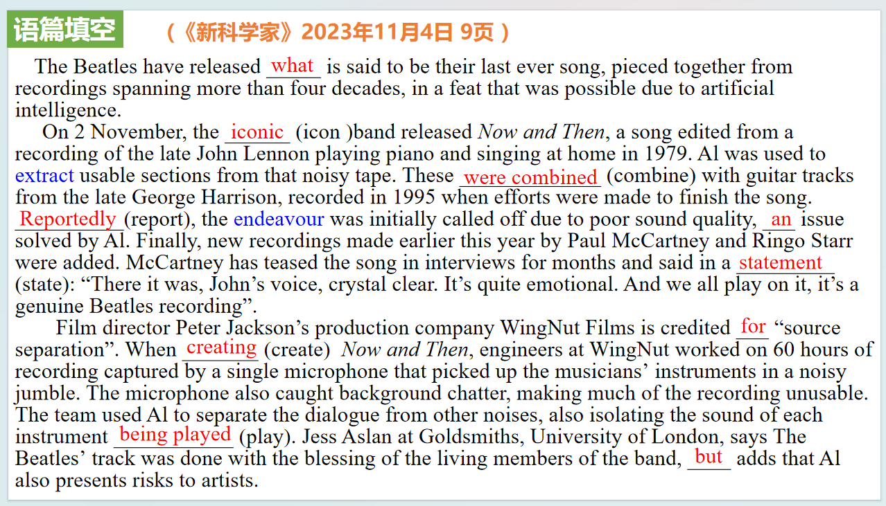
【设计意图】通过语篇填空的形式帮助学生理解新闻的主要内容，同时训练语言语法的运用能力：在语篇的视角下如何正确使用所给词汇，根据语法规则确定词汇的正确形式，使得文章通顺，激活学生的思维和语言。该新闻主题语境是关于“人与社会”中“影视、音乐等领域的概况及其发展”这一子主题，通过学习让学生了解人工智能复活约翰·列侬的声音的新闻。
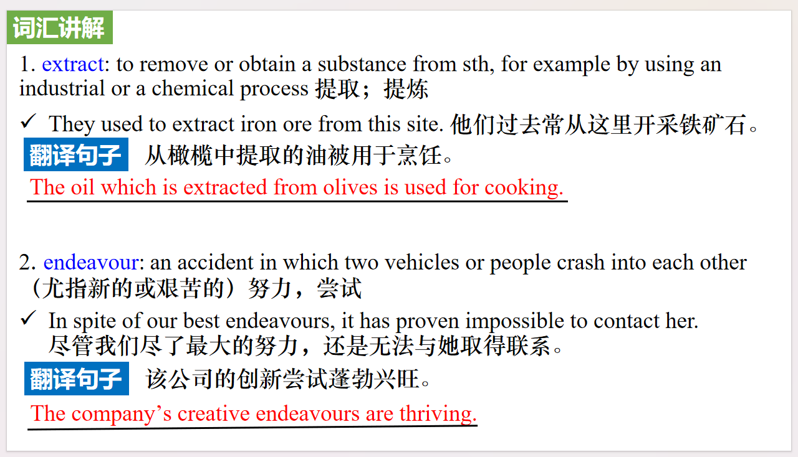
【设计意图】对文本中的词汇进行解读，并通过翻译句子对其进行巩固。

【设计意图】对文中的两个句子进行翻译练习，对其中单词、词组、句法进行巩固并关注句子结构。

Part 2: News Report 3 The Week Junior (11th November 2023 Page 14）
How dust destroyed the dinosaurs 尘埃是如何毁灭恐龙
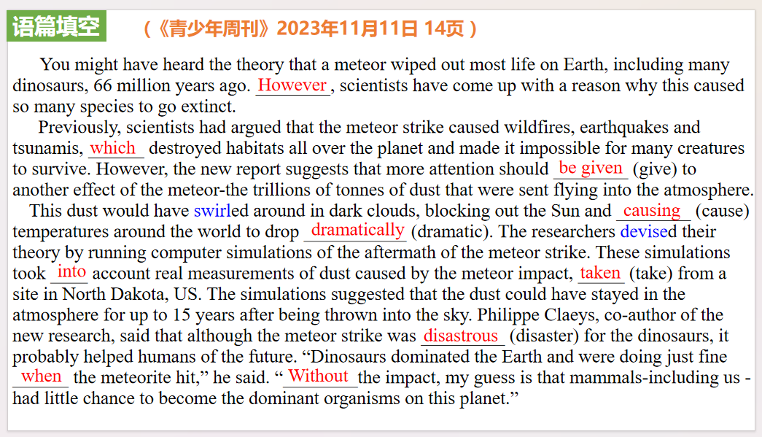
【设计意图】通过语篇填空的形式帮助学生理解新闻的主要内容，同时训练语言语法的运用能力：在语篇的视角下如何正确使用所给词汇，根据语法规则确定词汇的正确形式，使得文章通顺，激活学生的思维和语言。该新闻主题语境是关于“人与自然”中“自然科学研究成果”这一子主题，通过学习让学生了解流星撞击地球产生的尘埃与恐龙毁灭之间的关联。
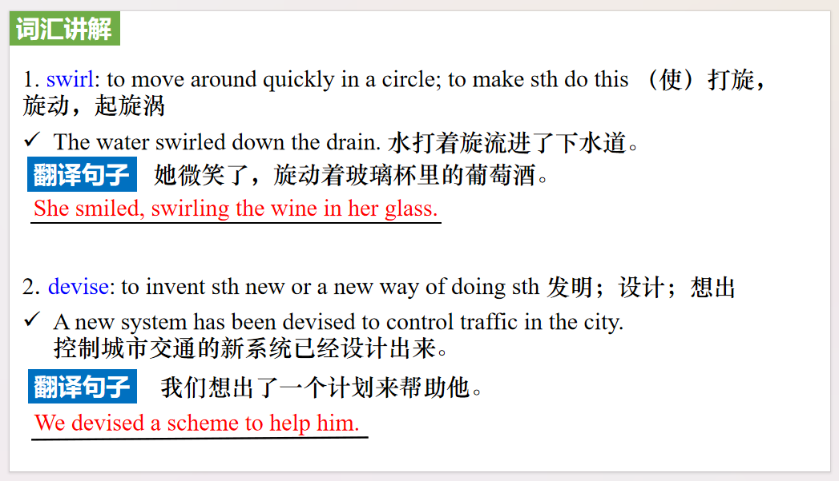
【设计意图】对文本中的词汇进行解读，并通过翻译句子对其进行巩固。
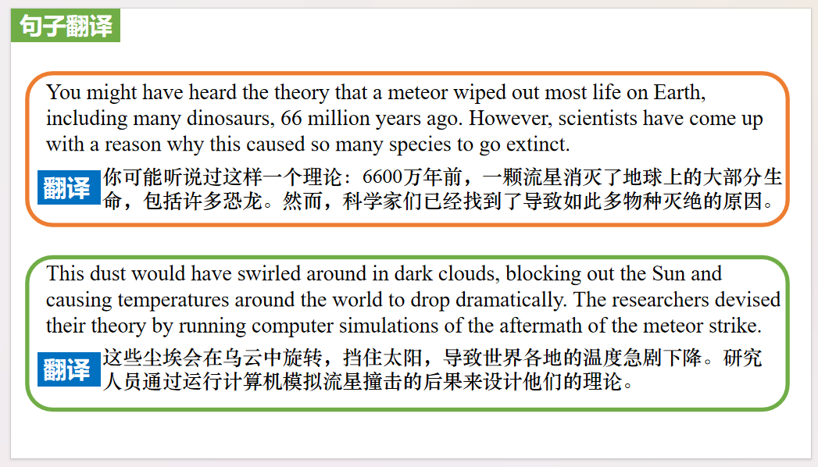
【设计意图】对文中的两个句子进行翻译练习，对其中单词、词组、句法进行巩固并关注句子结构。

教学思路：
Part 3: News Report 3 Scientific American (November 2023 Page 17)
Seal Team 海豹突击队
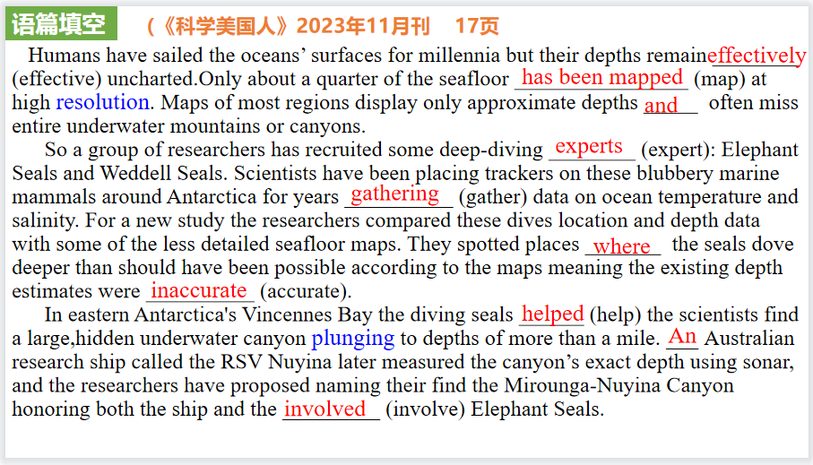
【设计意图】通过语篇填空的形式帮助学生理解新闻的主要内容，同时训练语言语法的运用能力：在语篇的视角下如何正确使用所给词汇，根据语法规则确定词汇的正确形式，使得文章通顺，激活学生的思维和语言。该新闻主题语境是关于“人与自然”中“自然科学研究成果”这一子主题，通过学习让学生了解海豹帮助研究人员绘制南极洲海底地图。
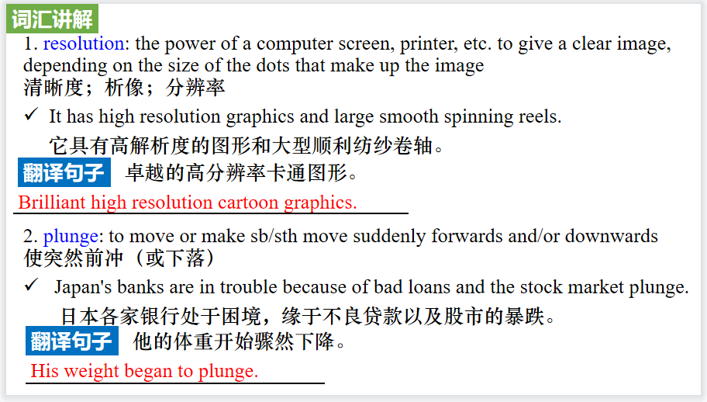
【设计意图】对文本中的词汇进行解读，并通过翻译句子对其进行巩固。
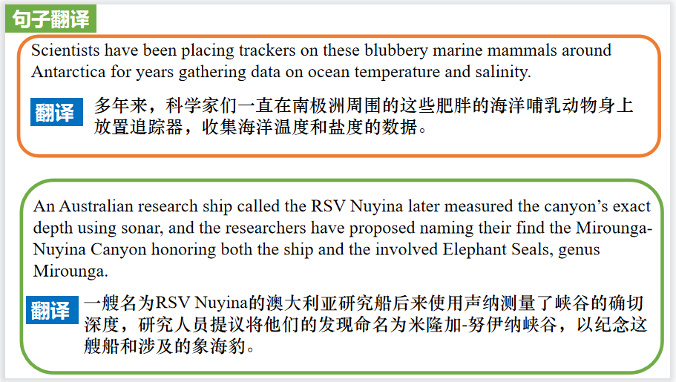
【设计意图】对文中的两个句子进行翻译练习，对其中单词、词组、句法进行巩固并关注句子结构。

Part 4: News Report 4 National Geographic (November 2023 BREAKTHROUGHS)
Spotting an Advantage 黑脉金斑蝶的翅膀斑点
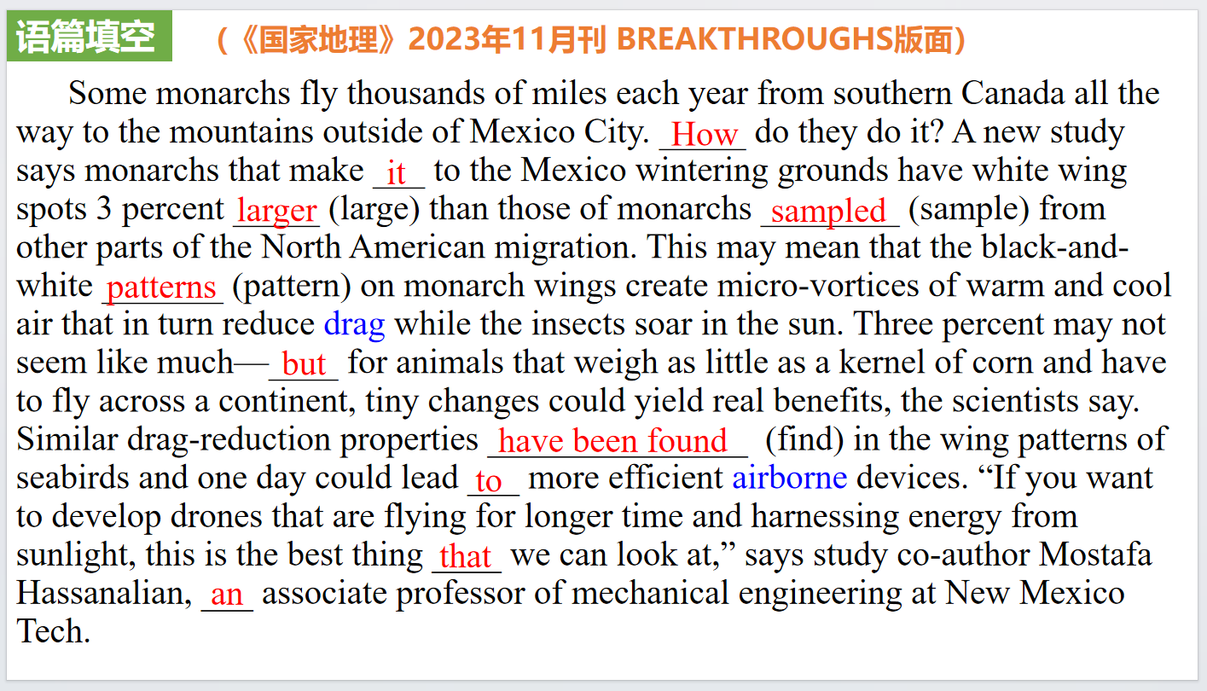
【设计意图】通过语篇填空的形式帮助学生理解新闻的主要内容，同时训练语言语法的运用能力：在语篇的视角下如何正确使用所给词汇，根据语法规则确定词汇的正确形式，使得文章通顺，激活学生的思维和语言。该新闻主题语境是关于“人与自然”中“自然科学研究成果”这一子主题，通过学习让学生了解黑脉金斑蝶的翅膀斑点在它们迁徙过程中的作用。
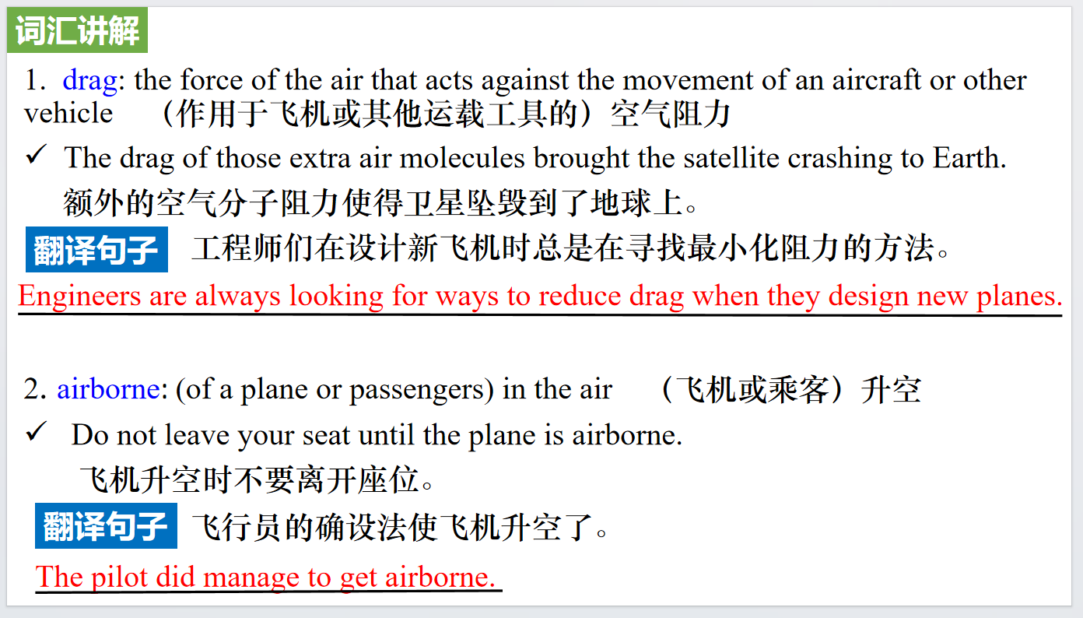
【设计意图】对文本中的词汇进行解读，并通过翻译句子对其进行巩固。
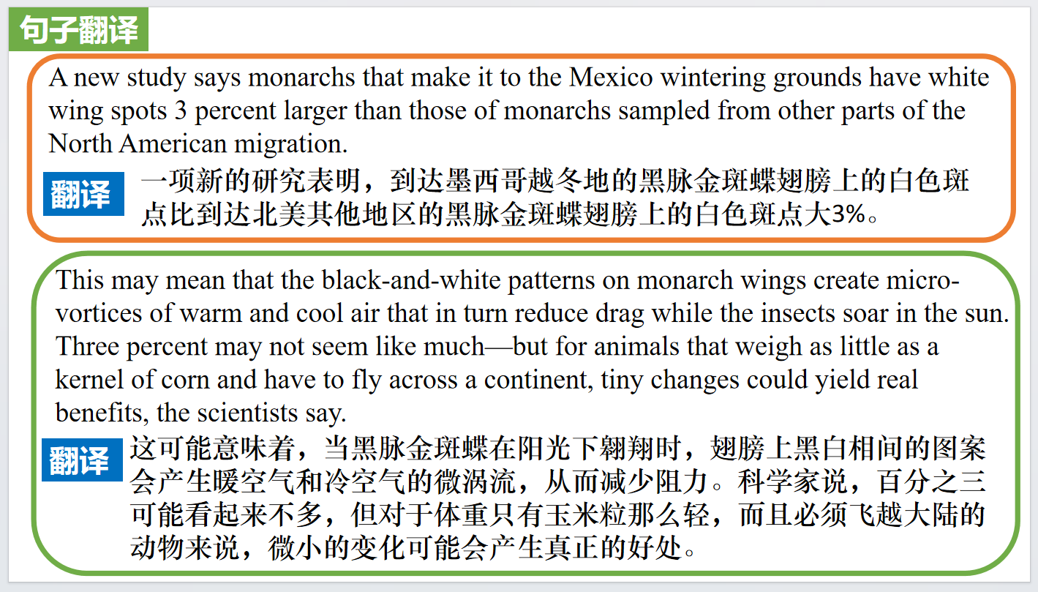
【设计意图】对文中的两个句子进行翻译练习，对其中单词、词组、句法进行巩固并关注句子结构。

Part 5: CNN News 11/04/2023
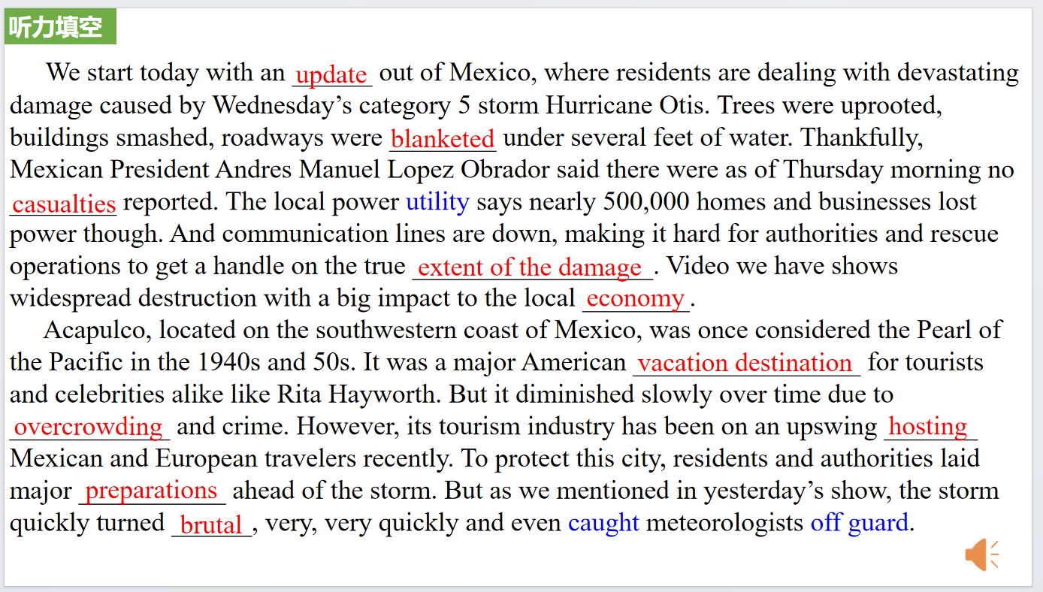
【设计意图】听一则材料，通过听力填空的方式理解文本，考察听力辨识词汇的能力。

【设计意图】对文本中的词汇进行解读，并通过翻译句子对其进行巩固。

【设计意图】对文中的两个句子进行翻译练习，对其中单词、词组、句法进行巩固并关注句子结构。

附：外刊原文
Part 1: News Report 1 New Scientist (4th November 2023 Page 9)
AI brings John Lennon’s vocals to new Beatles’ song
人工智能复活约翰·列侬的声音
The Beatles have released what is said to be their last ever song, pieced together from recordings spanning more than four decades, in a feat that was possible due to artificial intelligence.
On 2 November, the iconic band released Now and Then, a song edited from a recording of the late John Lennon playing piano and singing at home in 1979. Al was used to extract usable sections from that noisy tape.
These were combined with guitar tracks from the late George Harrison, recorded in 1995 when efforts were made to finish the song. Reportedly, the endeavour was initially called off due to poor sound quality, an issue solved by Al.
Finally, new recordings made earlier this year by Paul McCartney and Ringo Starr were added. The single bookends the band’s career by also including Love Me Do, their first single, as a B-side.McCartney has teased the song in interviews for months and said in a statement: “There it was, John’s voice, crystal clear. It’s quite emotional. And we all play on it, it’s a genuine Beatles recording”.
Film director Peter Jackson’s production company WingNut Films is credited for “source separation”. The firm also made the documentary Get Back, featuring footage of The Beatles recording Let it Be.
When creating Now and Then, engineers at WingNut worked on 60 hours of recording captured by a single microphone that picked up the musicians’ instruments in a noisy jumble. The microphone also caught background chatter, making much of the recording unusable.The team used Al to separate the dialogue from other noises, also isolating the sound of each instrument being played. Jess Aslan at Goldsmiths, University of London, says The Beatles’ track was done with the blessing of the living members of the band, but adds that Al also presents risks to artists.
“One significant issue is that generative Al is squeezing the already extremely narrow creative job market,” she says. “Another is that of ownership, in that these large-scale models are in effect by passing copyright laws and reconfiguring artists’ data without consent.

Part 2: News Report 2 The Week Junior (11th November 2023 Page 14）
How dust destroyed the dinosaurs 尘埃是如何毁灭恐龙
You might have heard the theory that a meteor (a giant rock from space) wiped out most life on Earth, including many dinosaurs, 66 million years ago. However, scientists have come up with a reason why this caused so many species to go extinct.
Previously, scientists had argued that the meteor strike caused wildfires, earthquakes and tsunamis (giant waves), which destroyed habitats all over the planet and made it impossible for many creatures to survive. However, the new report suggests that more attention should be given to another effect of the meteor-the trillions of tonnes of dust that were sent flying into the atmosphere.
This dust would have swirled around in dark clouds, blocking out the Sun and causing temperatures around the world to drop dramatically. Plants, which need sunlight to live and grow, would have died, leaving herbivores (animals that eat plants) without food. When the herbivores died, carnivores (animals that eat other animals) would have had no food either. This led to the extinction of 75% of species on Earth, including most dinosaurs-although the ones that survived later evolved to become birds. The researchers devised their theory by running computer simulations (when a computer creates versions of what could have happened) of the aftermath of the meteor strike. These simulations took into account real measurements of dust caused by the meteor impact, taken from a site in North Dakota, US. The simulations suggested that the dust could have stayed in the atmosphere for up to 15 years after being thrown into the sky. Philippe Claeys, co-author of the new research, said that although the meteor strike was disastrous for the dinosaurs, it probably helped humans of the future. “Dinosaurs dominated the Earth and were doing just fine when the meteorite hit,” he said. “Without the impact, my guess is that mammals-including us - had little chance to become the dominant organisms (living things) on this planet.”

Part 3: News Report 3 Scientific American (November 2023 Page 17)
Seal Team 海豹突击队
HUMANS HAVE SAILED the oceans’ surfaces for millennia but their depths remain effectively uncharted.Only about a quarter of the seafloor has been mapped at high resolution. Maps of most regions display only approximate depths and often miss entire underwater mountains or canyons.
So a group of researchers has recruited some deep-diving experts: Elephant Seals and Weddell Seals. Scientists have been placing trackers on these blubbery marine mammals around Antarctica for years gathering data on ocean temperature and salinity. For a new study the researchers compared these dives location and depth data with some of the less detailed seafloor maps. They spotted places where the seals dove deeper than should have been possible according to the maps meaning the existing depth estimates were inaccurate.
In eastern Antarctica's Vincennes Bay the diving seals helped the scientists find a large,hidden underwater canyon plunging to depths of more than a mile. An Australian research ship called the RSV Nuyina later measured the canyon’s exact depth using sonar, and the researchers have proposed naming their find the Mirounga-Nuyina Canyon honoring both the ship and the involved Elephant Seals, genus Mirounga.
“The seals discovered the canyon, and the ship confirmed it" says Clive MeMahon, a researcher at the lntegrated Marine Observing System in Australia and a co-author of the new study published in Communications Earth&Environment.
But seals can’t map the entire ocean floor. The trackers used in the study could pinpoint a seal’s geographical location only within about 1.5 miles, which allows for useful but not exactly
high-resolution data. Plus,because the seals don’t always dive to the bottom of the ocean, they can reveal only where the bottom is deeper than in existing maps —not shallower. McMahon notes that scientists could improve on these data by using more precise GPS trackers and analyzing the seals' diving patterns to determine whether they have reached the seafloor or simply stopped descending.
The current seal-dive data can still be valuable for an important task says Anna Wahlin, an oceanographer at the University of Gothenburg in Sweden, who was not involved in the new research.The deep ocean around Antarctica is warmer than the frigid waters at the surface, and sea-floor canyons can allow that warmer water to flow to the ice along the continent's coast, Wahlin explains. To predict how Antarctica’s ice will melt, scientists will need to know where those canyons are and how deep they go.

Part 4: News Report 4 National Geographic (November 2023 BREAKTHROUGHS)
Spotting an Advantage 黑脉金斑蝶的翅膀斑点
Some monarchs fly thousands of miles each year from southern Canada all the way to the mountains outside of Mexico City. How do they do it? A new study says monarchs that make it to the Mexico wintering grounds have white wing spots 3 percent larger than those of monarchs sampled from other parts of the North American migration. This may mean that the black-and-white patterns on monarch wings create micro-vortices of warm and cool air that in turn reduce drag while the insects soar in the sun. Three percent may not seem like much—but for animals that weigh as little as a kernel of corn and have to fly across a continent, tiny changes could yield real benefits, the scientists say. Similar drag-reduction properties have been found in the wing patterns of seabirds and one day could lead to more efficient airborne devices. “If you want to develop drones that are flying for longer time and harnessing energy from sunlight, this is the best thing that we can look at,” says study co-author Mostafa Hassanalian, an associate professor of mechanical engineering at New Mexico Tech. —JASON BITTEL

