The World（1116-1130）材料分析和教学目标：
本次选用的材料：①New Scientist的Hummingbirds have two ways to fly through tiny gaps （蜂鸟有两种方法可以穿过微小的缝隙）、②The Observer的 One in seven adults advised by NHS to go private（七分之一的成年人被NHS建议去私立医院）、③The Wall Street Journal 的Devices Aim to Make Brain Work Better（设备让大脑更好地工作）、④The Week的Dust is what killed the dinos（恐龙灭绝的罪魁祸首：尘埃）和⑤BBC的新闻报道。通过语法填空、阅读理解、分析长难句、翻译句子、听力填空和词汇拓展等方式，让学生从多角度提升学习兴趣，提高分析句子、运用词块和听力能力。外媒英语新闻可以让学生体验真实语境下的语言运用，拓展学生的国际视野，了解时事，逐步提升跨文化沟通能力，形成正确的世界观、人生观和价值观。

教学思路：
Part 1: News Report 1 New Scientist (18th November 2023 Page 14)
Hummingbirds have two ways to fly through tiny gaps
蜂鸟有两种方法可以穿过微小的缝隙
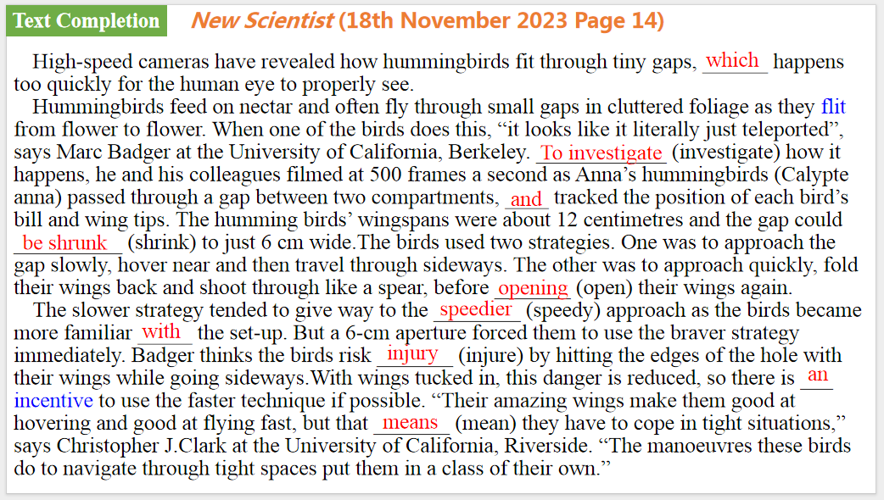
【设计意图】通过语篇填空的形式帮助学生理解新闻的主要内容，同时训练语言语法的运用能力：在语篇的视角下如何正确使用所给词汇，根据语法规则确定词汇的正确形式，使得文章通顺，激活学生的思维和语言。该新闻主题语境是关于“人与社会”中“自然科学研究成果”这一子主题，通过学习让学生了解蜂鸟穿过微小缝隙的两种方法。
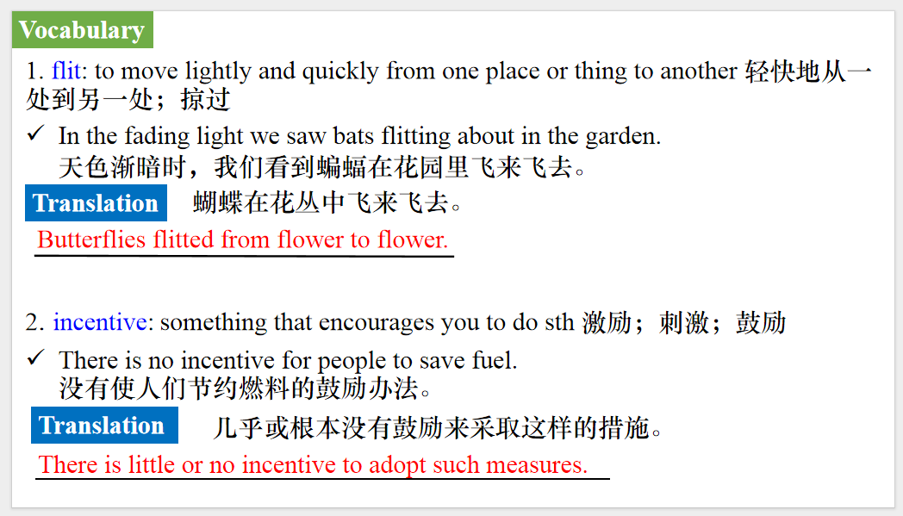
【设计意图】对文本中的词汇进行解读，并通过翻译句子对其进行巩固。
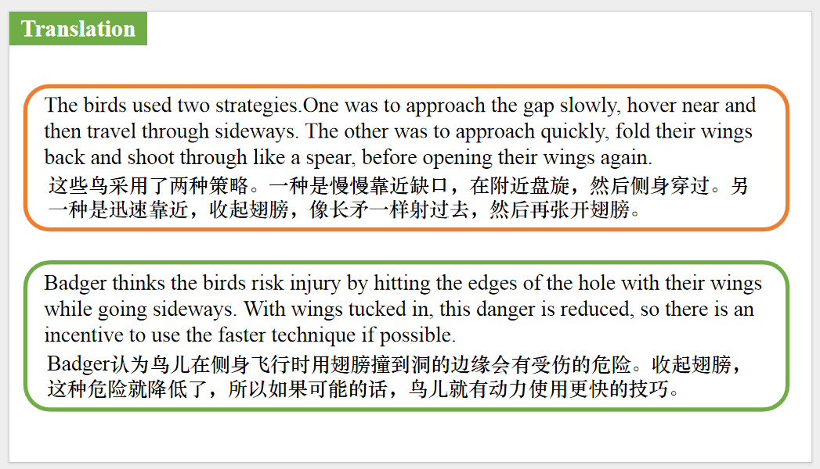
【设计意图】对文中的两个句子进行翻译练习，对其中单词、词组、句法进行巩固并关注句子结构。

Part 2: News Report 2 The Observer (26th November 2023 Page 2)
One in seven adults advised by NHS to go private
七分之一的成年人被NHS建议去私立医院
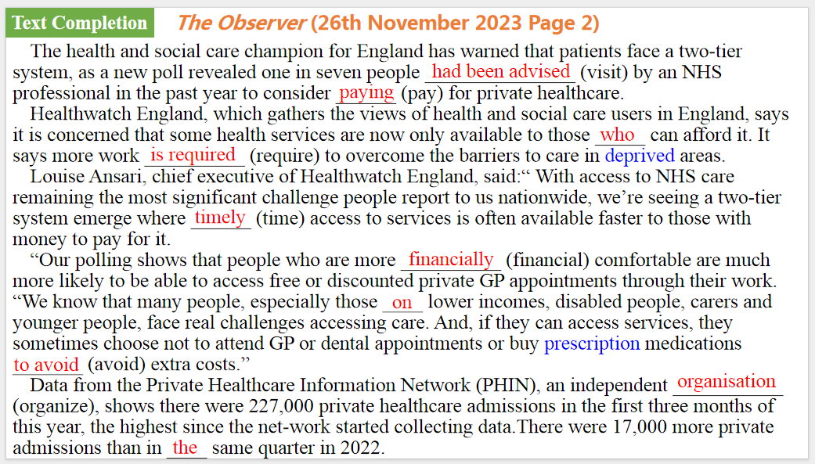
【设计意图】通过语篇填空的形式帮助学生理解新闻的主要内容，同时训练语言语法的运用能力：在语篇的视角下如何正确使用所给词汇，根据语法规则确定词汇的正确形式，使得文章通顺，激活学生的思维和语言。该新闻主题语境是关于“人与社会”中“社会热点问题”这一子主题，通过学习让学生了解英国目前的医疗系统面临的困境。
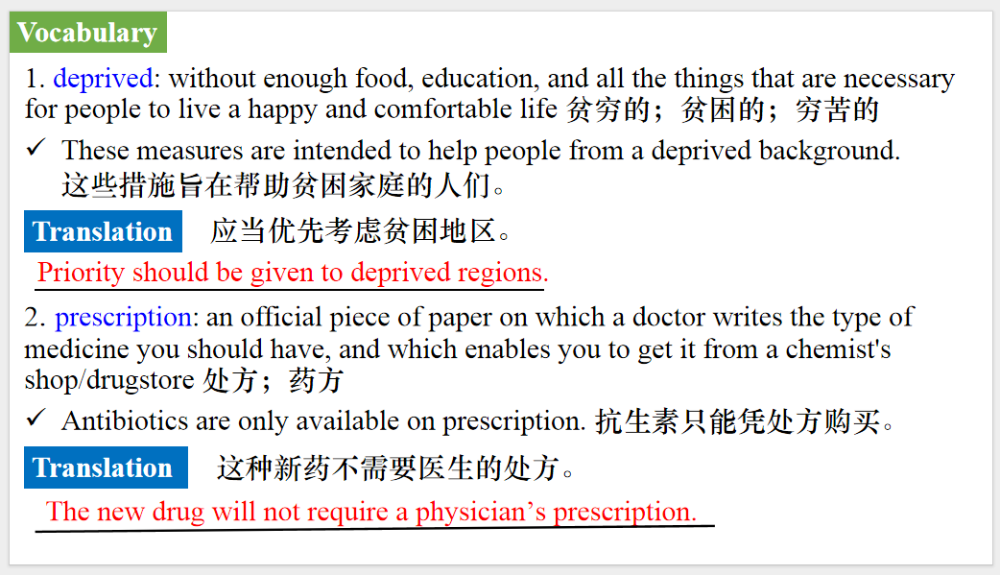
【设计意图】对文本中的词汇进行解读，并通过翻译句子对其进行巩固。
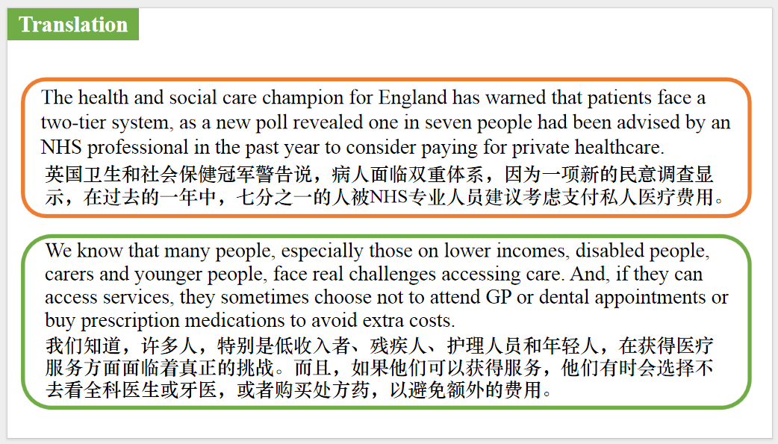
【设计意图】对文中的两个句子进行翻译练习，对其中单词、词组、句法进行巩固并关注句子结构。

Part 3: News Report 3 The Wall Street Journal (21st November 2023 B1 &B4)
Devices Aim to Make Brain Work Better 设备让大脑更好地工作
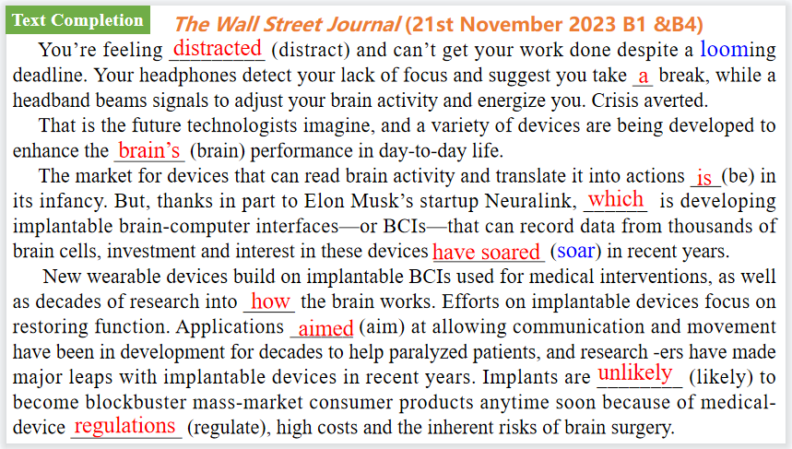
【设计意图】通过语篇填空的形式帮助学生理解新闻的主要内容，同时训练语言语法的运用能力：在语篇的视角下如何正确使用所给词汇，根据语法规则确定词汇的正确形式，使得文章通顺，激活学生的思维和语言。该新闻主题语境是关于“人与社会”中“科技发展与信息技术创新，科学精神，信息安全”这一子主题，通过学习让学生了解新的可穿戴设备有望提升大脑的工作功能。
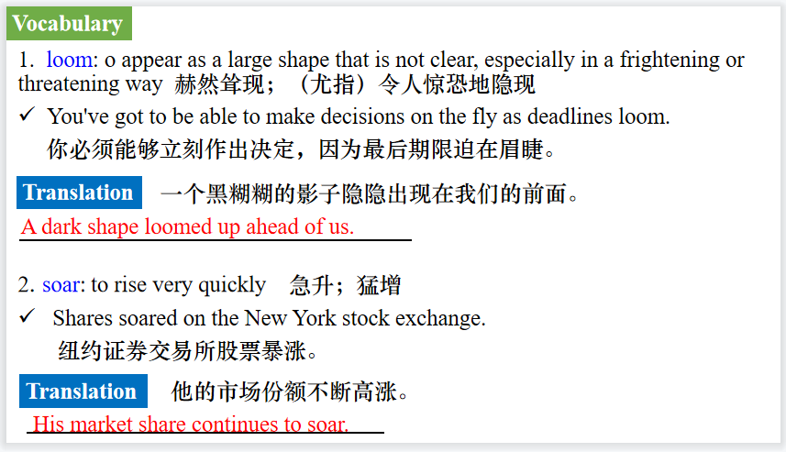
【设计意图】对文本中的词汇进行解读，并通过翻译句子对其进行巩固。
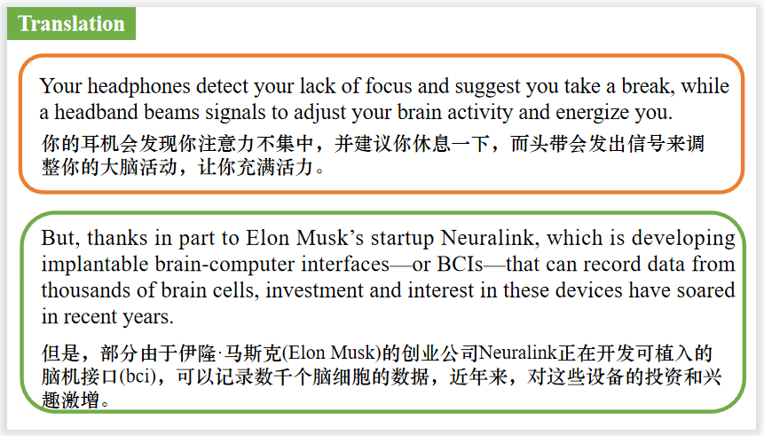
【设计意图】对文中的两个句子进行翻译练习，对其中单词、词组、句法进行巩固并关注句子结构。

Part 4: News Report 4 The Week (17th November 2023 Page 21)
Dust is what killed the dinos 恐龙灭绝的罪魁祸首：尘埃
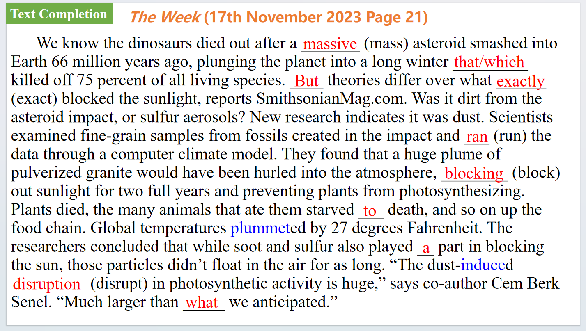
【设计意图】通过语篇填空的形式帮助学生理解新闻的主要内容，同时训练语言语法的运用能力：在语篇的视角下如何正确使用所给词汇，根据语法规则确定词汇的正确形式，使得文章通顺，激活学生的思维和语言。该新闻主题语境是关于“人与自然”中“自然科学研究成果”这一子主题，通过学习让学生了解恐龙灭绝的成因知识。
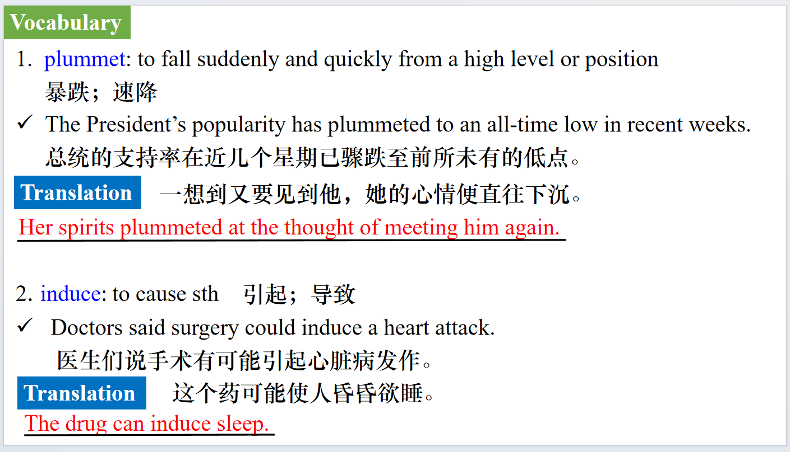
【设计意图】对文本中的词汇进行解读，并通过翻译句子对其进行巩固。
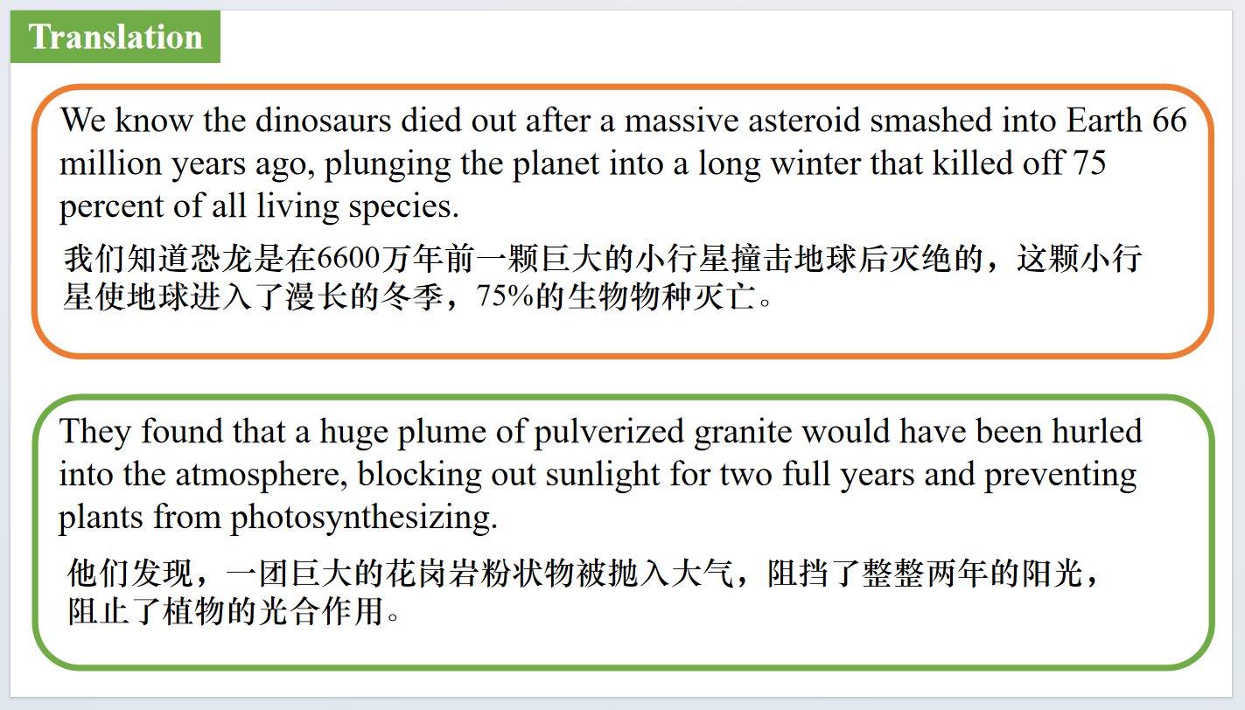
【设计意图】对文中的两个句子进行翻译练习，对其中单词、词组、句法进行巩固并关注句子结构。

Part 5: BBC News 11/28/2023
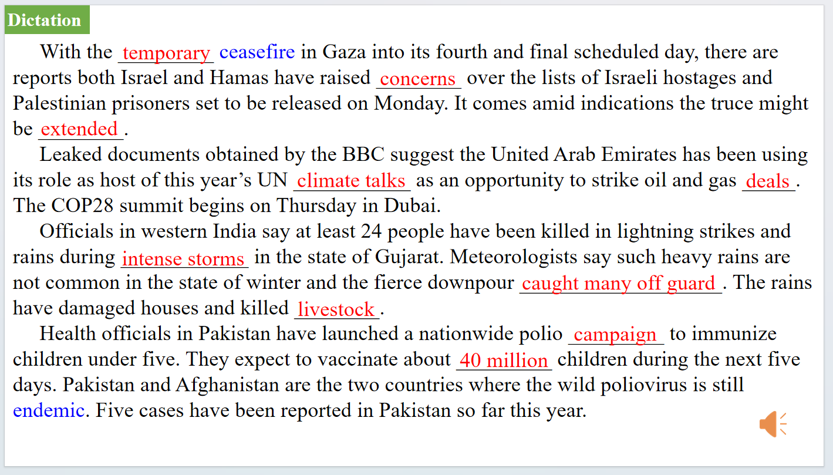
【设计意图】听一则材料，通过听力填空的方式理解文本，考察听力辨识词汇的能力。
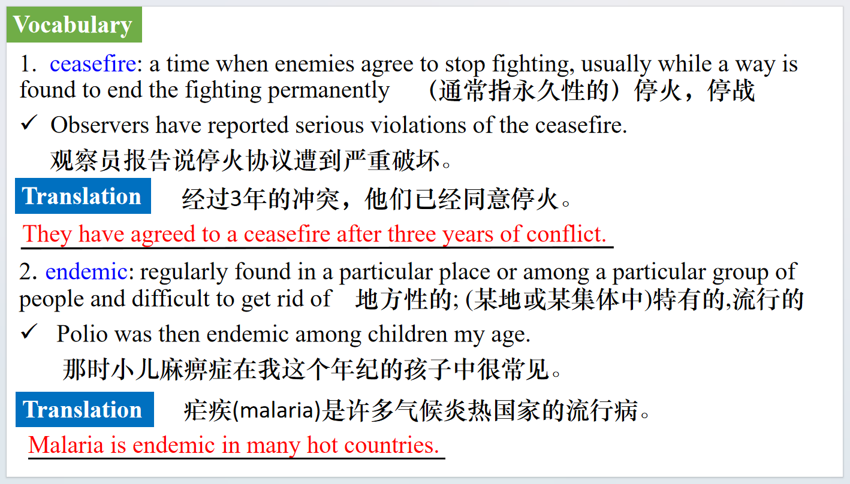
【设计意图】对文本中的词汇进行解读，并通过翻译句子对其进行巩固。
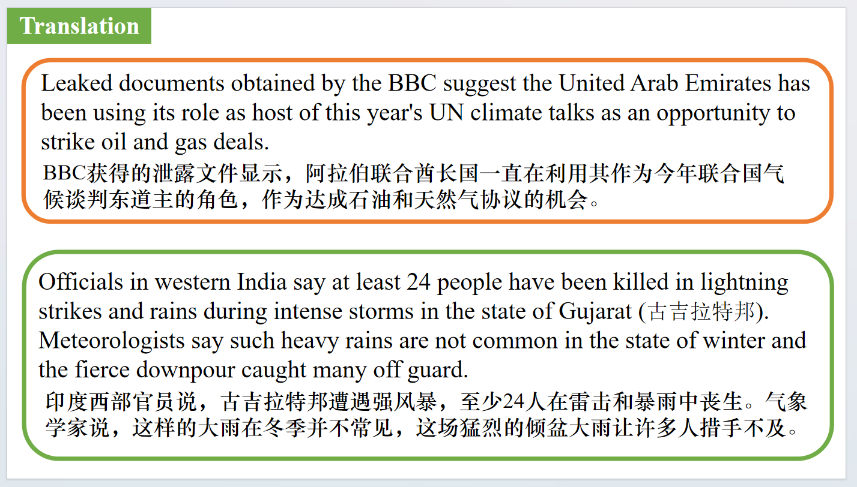
【设计意图】对文中的两个句子进行翻译练习，对其中单词、词组、句法进行巩固并关注句子结构。

附：外刊原文
Part 1: News Report 1 New Scientist (18th November 2023 Page 14)
Hummingbirds have two ways to fly through tiny gaps
蜂鸟有两种方法可以穿过微小的缝隙
High-speed cameras have revealed how hummingbirds fit through tiny gaps, which happens too quickly for the human eye to properly see.
Hummingbirds feed on nectar and often fly through small gaps in cluttered foliage as they flit from flower to flower. When one of the birds does this, “it looks like it literally just teleported”, says Marc Badger at the University of California, Berkeley. To investigate how it happens, he and his colleagues filmed at 500 frames a second as Anna’s hummingbirds (Calypte anna) passed through a gap between two compartments, and tracked the position of each bird’s bill and wing tips. The humming birds’ wingspans were about 12 centimetres and the gap could be shrunk to just 6 cm wide.The birds used two strategies. One was to approach the gap slowly, hover near and then travel through sideways. The other was to approach quickly, fold their wings back and shoot through like a spear, before opening their wings again.
The slower strategy tended to give way to the speedier approach as the birds became more familiar with the set-up. But a 6-cm aperture forced them to use the braver strategy immediately. Badger thinks the birds risk injury by hitting the edges of the hole with their wings while going sideways.With wings tucked in, this danger is reduced, so there is an incentive to use the faster technique if possible. “Their amazing wings make them good at hovering and good at flying fast, but that means they have to cope in tight situations,” says Christopher J.Clark at the University of California, Riverside.“The manoeuvres these birds do to navigate through tight spaces put them in a class of their own.”

Part 2: News Report 2 The Observer (26th November 2023 Page 2)
One in seven adults advised by NHS to go private
七分之一的成年人被NHS建议去私立医院
The health and social care champion for England has warned that patients face a two-tier system, as a new poll revealed one in seven people had been advised by an NHS professional in the past year to consider paying for private healthcare.
Healthwatch England, which gathers the views of health and social care users in England, says it is concerned that some health services are now only available to those who can afford it. It says more work is required to overcome the barriers to care in deprived areas.
A Savanta poll of 1,758 adults in England revealed that 14% had been advised to consider going private by an NHS professional. More than a quarter (28%) said they had accessed private healthcare in the past year,which included dentistry.
The most common reasons were that people considered they would receive better quality care(37%);that the NHS waiting list was too long(34%);or they wanted a procedure that was not available on the NHS in their region (22%).
Louise Ansari, chief executive of Healthwatch England, said:“ With access to NHS care remaining the most significant challenge people report to us nationwide, we’re seeing a two-tier system emerge where timely access to services is often available faster to those with money to pay for it.
“Our polling shows that people who are more financially comfortable are much more likely to be able to access free or discounted private GP appointments through their work. “We know that many people, especially those on lower incomes, disabled people, carers and younger people, face real challenges accessing care. And, if they can access services, they sometimes choose not to attend GP or dental appointments or buy prescription medications to avoid extra costs.”
Data from the Private Healthcare Information Network (PHIN), an independent organisation, shows there were 227,000 private healthcare admissions in the first three months of this year, the highest since the net-work started collecting data.There were 17,000 more private admissions than in the same quarter in 2022.

Part 3: News Report 3 The Wall Street Journal (21st November 2023 B1 &B4)
Devices Aim to Make Brain Work Better 设备让大脑更好地工作
You’re feeling distracted and can’t get your work done despite a looming deadline.Your headphones detect your lack of focus and suggest you take a break, while a headband beams signals to adjust your brain activity and energize you. Crisis averted.
That is the future technologists imagine, and a variety of devices are being developed to enhance the brain’s performance in day-to-day life.
The market for devices that can read brain activity and translate it into actions is in its infancy. But, thanks in part to Elon Musk’s startup Neuralink, which is developing implantable brain-computer interfaces—or BCIs—that can record data from thousands of brain cells, investment and interest in these devices have soared in recent years.
New wearable devices build on implantable BCIs used for medical interventions, as well as decades of research into how the brain works. Efforts on implantable devices focus on restoring function. Applications aimed at allowing communication and movement have been in development for decades to help paralyzed patients, and researchers have made major leaps with implantable devices in recent years.
Last year, Neuralink showed that a monkey could control a cursor with its mind and type out a message. A Neuralink competitor, Synchron, showed that paralyzed patients implanted with its brain-recording device could use their brain signals to text with an iPhone.
Implants are unlikely to become blockbuster mass-market consumer products anytime soon because of medical-device regulations, high costs and the inherent risks of brain surgery.
Technological constraints also now limit the amount of data that can be collected from the brain. For instance, implanted devices can get hot and damage brain tissue as more data is extracted. Putting too many needlelike sensors into the brain might also cause damage.
But wearable brain-sensing devices—as opposed to implanted—could offer a broader
swath of consumers cognitive feedback and other brain enhancements. That is already happening in labs. Several recent studies using simulators have shown that wearable BCIs can detect drowsiness and fatigue and give real-time, AI powered feedback to drivers.
This tech could begin going mainstream as soon as the next year. Among the initial goals: improving concentration and helping consumers boost productivity and reduce burnout by alerting users when their attention wanders. Boston-based neurotech startup Neurable expects to sell headphones with brain-activity monitors to track focus in early 2024.
Non-implantable BCIs with sensors called fNIRS—short for functional near-infrared spectroscopy—detect changes in blood oxygen levels, which serve as a proxy for brain activity. Labs have used fNIRS devices to measure the impact of music on the brain, as well as to assess professional skills.
Companies are working to make the devices easier to wear. Electroencephalogram, or EEG, sensors measure tiny differences in electrical activity at various points on the head. EEG sensors can be used to diagnose conditions like epilepsy or, as in Neurable’s case, to track focus. Brain cells, called neurons, produce billions of electrical signals that relay information across the brain and body.
Improved communication, collaboration, and social interactions are among the enhancements that BCI developers are working to realize in coming years by combining high-quality brain-activity recordings with information from activity sensors, food diaries, sleep logs, eye trackers and other data sources.
Santa Barbara, Calif.-based startup Cognixion is beginning to pair brain data with other biometrics in its augmentedreality headset, which has wearable brain-monitoring and head-motion sensors and is compatible with eye-tracking sensors, according to Andreas Forsland, the company’s chief executive. The device is now sold for research purposes, but the plan is for patients with motor and speech disorders to use it to communicate with people and their devices. Forsland says the headset can already link up with Amazon’s Alexa voice assistant.
“The most important thing is to get the data out,” said Matt Angle, CEO of Paradromics, which is developing implantable BCIs.
For consumer wearables, that is a big challenge because they don’t have direct access to the brain. They detect brain activity through the skull and hair, like microphones trying to listen through a wall. Companies are working on building better, smaller sensors and more powerful AI algorithms to decode those lower-quality signals.
Applications for the next generation of wearable BCIs could include diagnosing mood disorders, as well as providing feedback that enhances mindfulness, deciphering product and musical preferences, and enabling touch-free typing and controlling devices with our minds, experts said.
“It’s a new way of thinking about how we interact with technology,” said Nita Farahany, a neuroethicist at the Duke University School of Law, who says cognitive privacy rights are needed.
AI will fast-track this new brain-powered technological future, brain experts said. It could also supercharge the value of personal data, creating new concerns about cognitive privacy. The more information that is collected, the more efficient AI systems could become at decoding thoughts and intentions, Farahany and others said—an advance that could hold privacy risks.
“It’s a huge untapped market,” she said. “It’s not surprising that people are going after it.”

Part 4: News Report 4 The Week (17th November 2023 Page 21)
Dust is what killed the dinos 恐龙灭绝的罪魁祸首：尘埃
We know the dinosaurs died out after a massive asteroid smashed into Earth 66 million years ago, plunging the planet into a long winter that killed off 75 percent of all living species. But theories differ over what exactly blocked the sunlight, reports SmithsonianMag.com. Was it dirty from the asteroid impact, or sulfur aerosols? New research indicates it was dust. Scientists examined fine-grain samples from fossils created in the impact and ran the data through a computer climate model. They found that a huge plume of pulverized granite would have been hurled into the atmosphere, blocking out sunlight for two full years and preventing plants from photosynthesizing. Plants died, the many animals that ate them starved to death, and so on up the food chain. Global temperatures plummeted by 27 degrees Fahrenheit. The researchers concluded that while soot and sulfur also played a part in blocking the sun, those particles didn’t float in the air for as long. “The dust-induced disruption in photosynthetic activity is huge,” says co-author Cem Berk Senel. “Much larger than what we anticipated.”

