人教版新教材选择性必修三Unit1 Reading & Thinking导学案
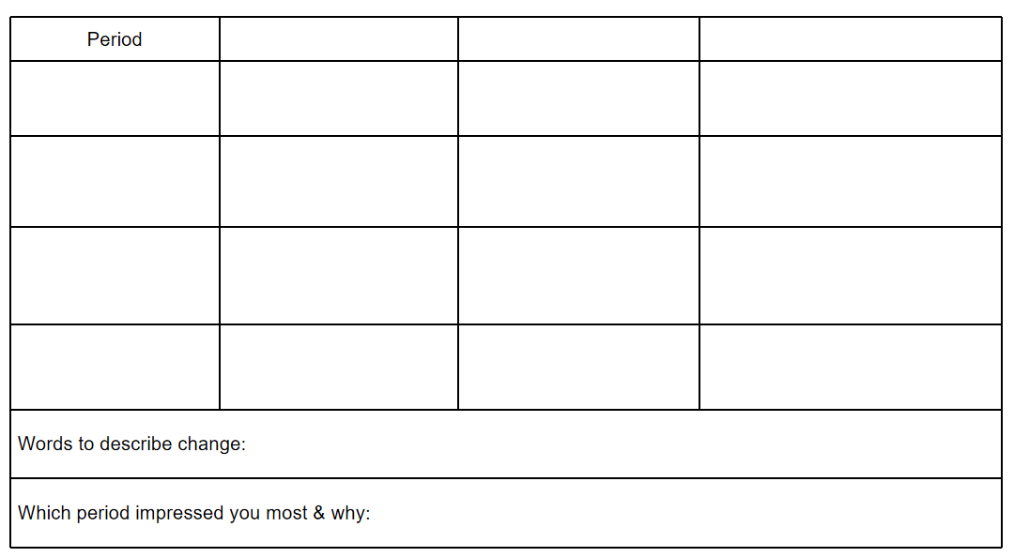
A short history of western painting
What has made art change over time?

What do we do next? What’s your idea about the future development of art?

What is art? What is the value or purpose of art?

