Text patterns of exposition
课前导学作业
Task：Please read the 2 texts. Divide each text into several parts.
Conclude the main idea of each part and complete the mind map.
（Tip: Underline the topic sentence of each paragraph. It can help you.）

Text1 (Book6 Unit3 Reading)
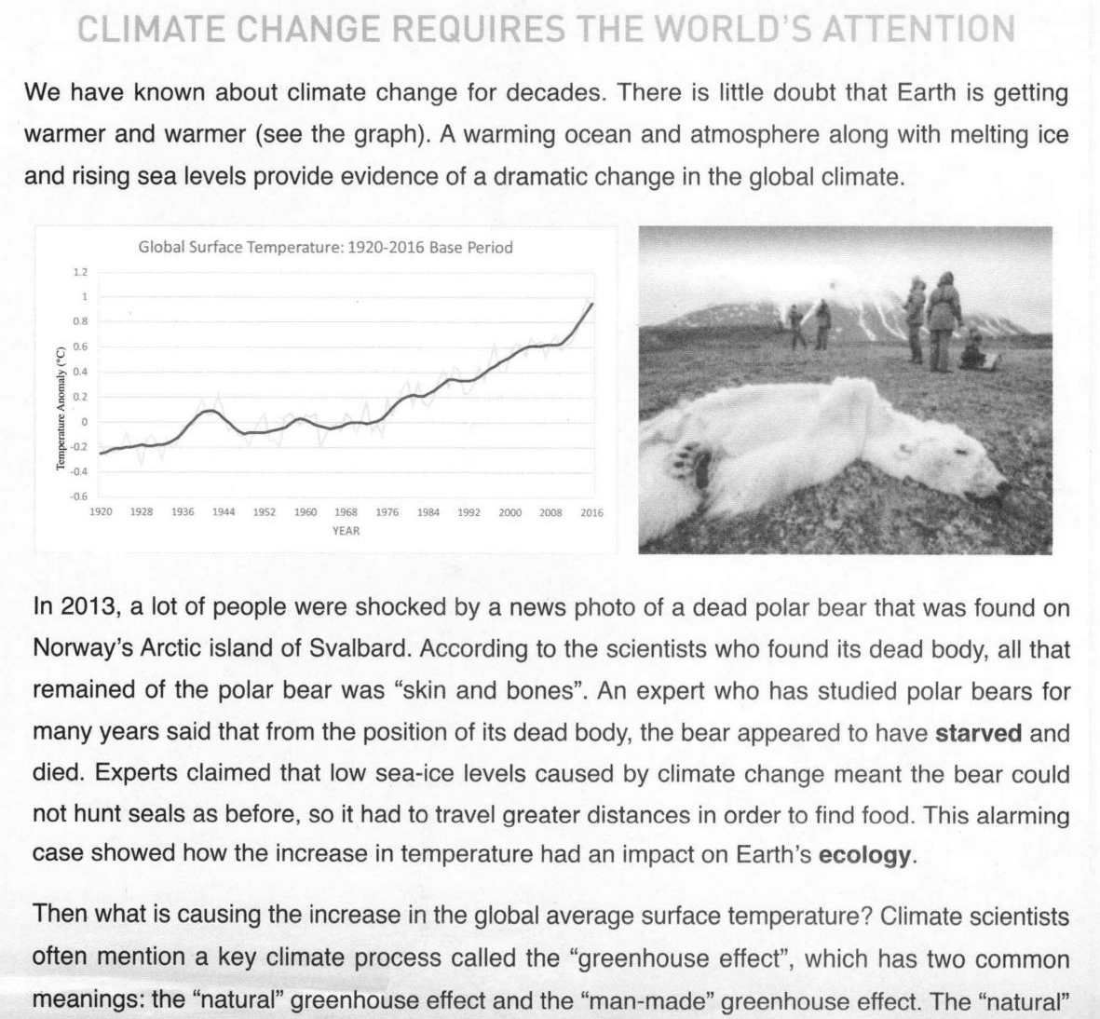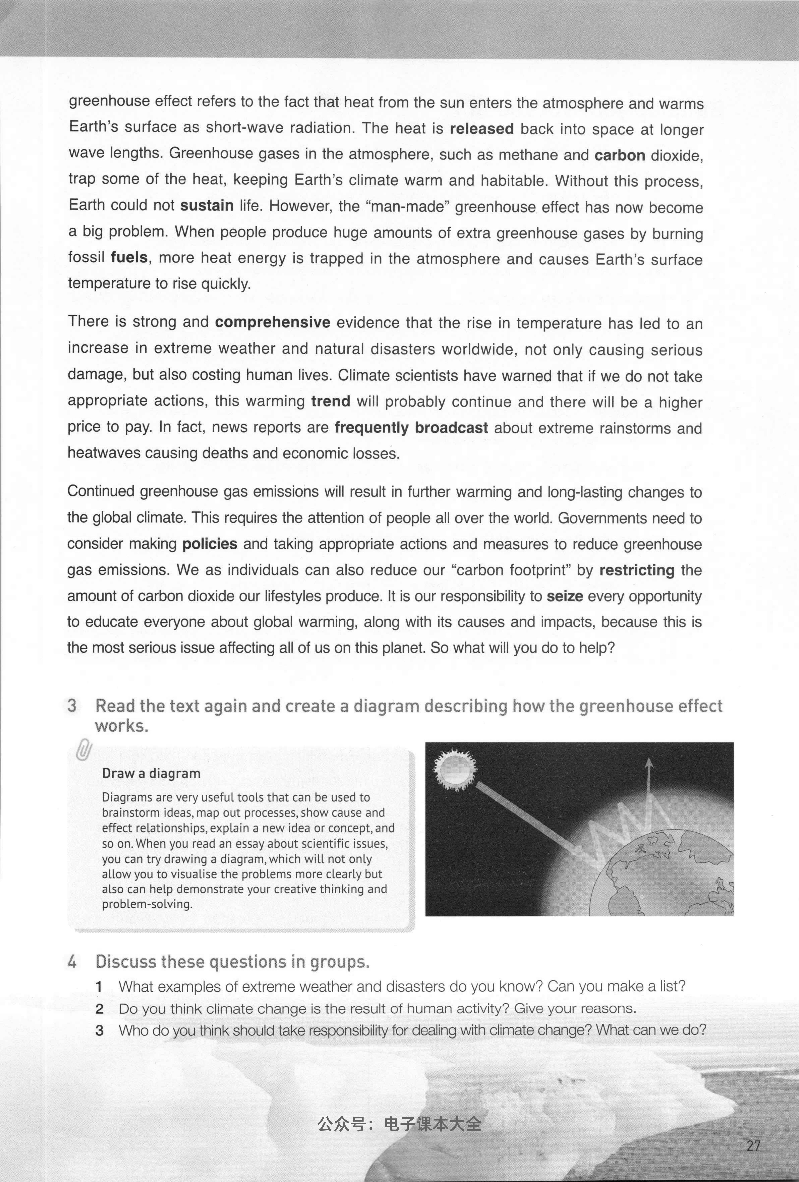

Mind Map:
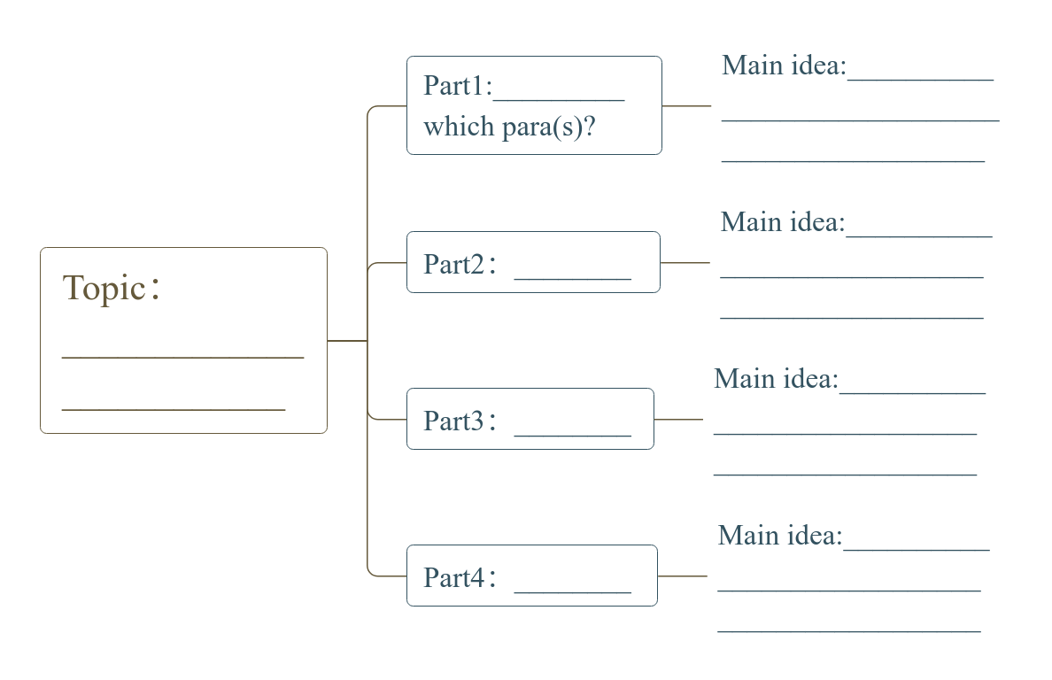

Text 3 (Book6 Unit2 Reading)
