Mosquito Bites
——语篇知识在科普说明文阅读中的应用
学 案
黄新 云南民大附中

- The theme context (主题语境)
What’s the theme context (主题语境)?
A. People and self B. Human and society C. Human and nature

- The Main idea (段落大意、文章大意)
What’s the main idea of Para.1? | Getting and mosquito bites can be uncomfortable, but can be simple. Luckily, mosquito bites can be .

- The structure (语篇结构)
Para. 2 | Mosquitoes are attracted to sweat... |  | Part 1  behind MB
Para. 3 | Mosquitoes are also attracted to dark colors. |  | Part 1  behind MB
Para. 4 | Additionally, there is ... blood type as a factor... |  | Part 1  behind MB
Para. 5 | What’s the best way to deal with the discomfort...? |  | Part 2  to deal with MB
Para. 6 | But, if..., you can apply a cold compress... |  | Part 2  to deal with MB
Para. 7 | “Using insect repellent can be pretty helpful,”... |  | Part 3  Ways to MB

- Finish the mind map (完成思维导图)
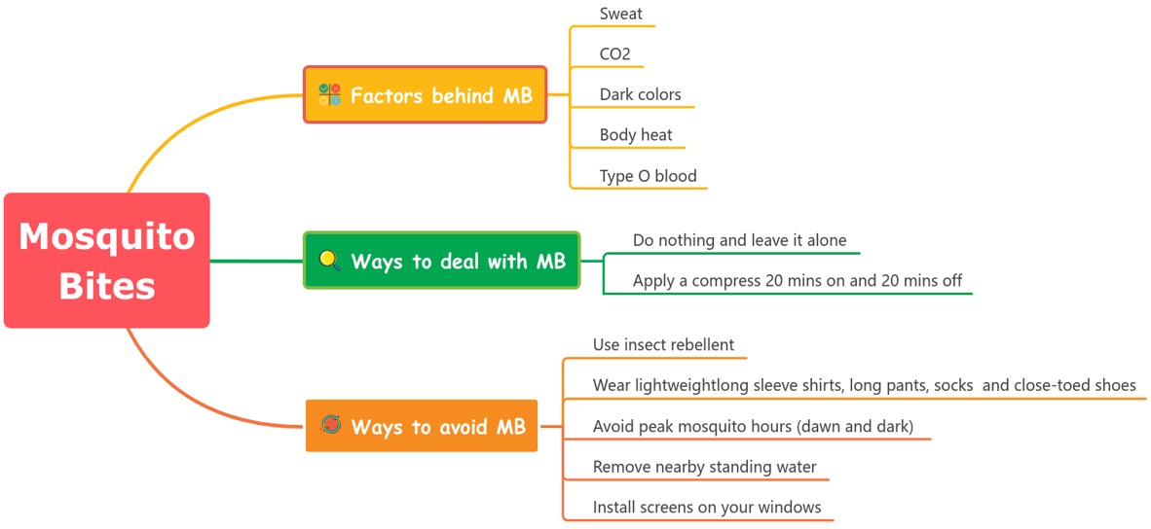


- The writing type (体裁)
What’s the writing type of the passage?
A. Narration B. Argumentative essay C. Expository writing D. Practical writing

- Methods of explanation (说明方法)
本文用了  打钩 | Methods of explanation  (说明方法) | Signposts (语言标志词)
 | Definition (定义法) | 定义是（is defined as）、意味着（means）、即（namely）
 | Example (举例说明法) | 例如（for example）、比如（such as）、具体而言（specifically）
 | Comparison and Contrast  (比较说明法) | 与……相比（compared to/with）、相似地（similarly）、  然而（however）、尽管如此（nevertheless）、  另一方面（on the other hand）、相比之下（in contrast）
 | Cause and Effect  (因果说明法) | 因为（because）、由于（due to）、结果是（as a result）、  导致（lead to）、造成（cause）
 | Quotation  (引用说明法) | 某某说（sb says/said）、研究确定（a study determined）、  据（according to）、在……看来（in the view of）

- Word meaning guessing (词义猜测)
- attract attracted, attractive Guess by word root (借助词根猜词义)

Practice: uncomfortable, discomfort
“uncomfortable” means:
“discomfort” means:

- Mosquitoes are attracted to sweat. They’re also drawn to when we breathe out CO2.
Guess by signposts (借助语言标志词猜词义)

Practice: ... they might be more drawn to you than say if you were wearing white or cream.
“cream” means:

- ... it’s important that you avoid peak mosquito hours (dawn and dusk),...
Guess by common knowledge (借助常识猜词义)

Practice: ... it’s important that you avoid peak mosquito hours (dawn and dusk), remove nearby standing water,... “standing” means:
- Self-reflection (自我反馈)
课堂学习反思评价表(Tick √)
Items For Reflection | Agree | Partly Agree | Disagree
I’ve known three theme contexts.
I’ve known how to quickly predict the main idea of an expository writing.
I can find some important nouns and verbs to help me get the main idea.
I can use a mind map to layout the structure.
I can find some signposts that imply the logic.
I know five common explanation method.
I know and I can use three word meaning guessing methods.
I was active in class.
I have tried to work with my partner.
What do I still need to practice in the future?

- Assignment(s)（课后任务）
选择作业1或作业1和2作为对课堂所学的巩固和拓展。
Option 1: Design a mind map for the given passage.
Option 2: Raise 2 to 4 questions for the given passage with reference to the follow questions.
Questions | Question types
1. Which of the following is most attractive for a mosquito? | 理解性问题
2. What does Cotter think of dealing with mosquito bites? | 分析性问题
3. What is the authors purpose of writing the text? | 评价性问题
4. Which can be the ending of the passage? | 创作性问题

