2025届11月绍兴市高考诊断性考试读后续写讲评

故事背景与主题分析：故事主要讲述了主人公从害怕游泳到敢于面对挑战的心理转变过程。通过学习游泳、适应水中环境，再到最终勇敢参赛，主人公一步步克服了自我怀疑和内心的障碍。这个故事不仅展示了如何在恐惧中找到力量，更体现了成长的主题，非常适合考生在续写中使用感官描写和细腻的动作链来塑造角色的心理变化。
Step 1 Read for the basic elements
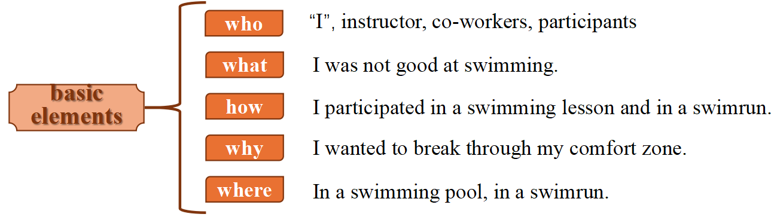
Step 2 Read for the key plots
My thought in my… The turning point My decision

My first swimming lesson My practice after … My struggle in…

Step3 Predict for the key plots
三个阶段：自我怀疑、尝试突破、克服挑战
Paragraph 1:
The thoughts of gliding through water effortlessly was what kept me going.
◉Did I make progress immediately?

◉ What did I do to improve myself in swimming?

◉ What changes happened then?
Step4 Discuss for the details
◉ What was my plateau? How did I feel?
» I was not able to ____________________________（在水中长时间屏住呼吸）.
» My obstacle was that I often _______________________（无法保持平衡）.
» The waving of my hands didn’t match my ____________________（蹬腿）.
» What troubled me was that I always _____________________ (划水节奏不对).
◉ How did I practice under the guidance of my instructor ?
» repeating thousands and thousands of _______________
» practice swimming and sinking
» interact with co-workers in effective skills
◉ What changes happened then?
» my swimming skills improved bit by bit
» I was expert at / grasped the trick of ______________________.
» I felt a wave/sense/surge of ____________________________ welled up in my body.
Step5 Appreciate a fine piece of writing

Step6 Predict for the key plots
Paragraph 2:
Regarding the swimrun, I eventually decided to participate.

◉What was it like at the beginning of the race?

◉ What was it like during the race?

◉ What was the result of the race? What did “I” learn from the race?
Step 7 Discuss for the details
Then came the big day. （过渡句）
◉ What was it like at the beginning of the race?
1._______________________________________________（随着发令枪的声音穿透空气）, the race began as expected.
2.I could feel that all the eyes were fixed on us. ______________________________
____________________ (一种强烈的紧张感涌上我的全身).
◉ What was it like during the race?
1. I found myself flexible like a dolphin in the water, _____________________
_________________ (快速向前推进自己）. （比喻）
2.Striking water and adjusting breath constantly, I _______________________. （我拼命地奋力向前游）。
3.____________and ____________, I was racing neck and neck.
手臂划水，腿脚踢水，Mike飞快地超过一个又一个人。
4.Swiftly adjusting my breath, I swam forward __________________________.(像离弦的箭）
◉ What was it like during the race?
1.150 meters covered, I was left behind by two competitors. In the last 50 meters, I
______________________________________（我竭尽所能游向终点线）, arms pushing forward fast and legs hitting the water hard.
2.Thunderous shouts of my name from the audience ___________________________
________（注入了活力和自信）. I sped up, like an energetic dolphin chasing after his prey ______________________________（用我最后一点力气）.
◉ What was the result of the race?
1.When the result was announced that I won first place, other players rushed to me and congratulated me, _________________________________________________（场馆里的观众爆发出雷鸣般的掌声）.
2. when the race finished, _______________________（做梦也没有想到） had I expected that I would win the first prize.
◉ What did “I” learn from the race?（观众的反应）
◈As the final whistle blew, the cheers from the crowd echoed/lingered in the stadium, and I couldn’t help but feel a rush of excitement as I ___________________ the glory of our victory.
人群的欢呼声回荡在体育场内，当我沉浸在胜利的荣耀中时，我不禁感到一阵兴奋。
◈ Despite the physical and mental exhaustion, I couldn’t wipe the smile off my face as I reflected on _____________________________________________________.
◈ It is my ______________________ that won me ___________________________.

结尾强调句回扣主题

Possible version:
The thought of gliding through water effortlessly was what kept me going. At a certain point, I hit a plateau, So, I decided to contact my swimming instructor for more swimming lessons. Under his guidance, I started to practice more by myself. Some days, I would come back seriously wondering if my body constitution was meant for swimming at all. On other days, I would feel fantastic while completing my laps. Still, there was one single thing that stood out during my practice sessions: while repeating thousands and thousands of crawling strokes(爬泳, 捷泳), I slowly but surely started to enjoy the process of swimming thoroughly.
Regarding the swimrun, I eventually decided to participate. For me, this challenge was pushing me to my limits, as I had been utterly scared to confront this weakness of mine. The race began, and soon I was completely breathless from the physical exertion. However, I solely focused on all the movements I had been practicing repetitively throughout the summer. Before I knew it, I had finished. The swimrun had been my end goal but I already knew by then that I was going to continue swimming. I wished my childhood self could meet my present-day self to see that I was not naturally bad at swimming. It was possible to change and surpass the boundaries of my comfort zone.

