- 课程标准解读
文化知识涵盖物质和精神两个方面。物质方面主要包括饮食、服饰、建筑、交通等，以及相关的发明与创造；精神方面主要包括哲学、科学、教育、历史、文学、艺术，也包括价值观念、道德修养、审美情趣、社会规约和风俗习惯等。学习中外优秀文化，有助于学生在对不同文化的比较、鉴赏、批判和反思的过程中，拓宽国际视野，理解和包容不同文化，增强对中华优秀传统文化、革命文化和社会主义先进文化的认识，形成正确的价值观和道德情感，成为有文明素养和社会责任感的人。
普通高中英语必修课程、选择性必修课程和选修课程（提高类）的文化知识内容要求摘录：
课程类别 | 文化知识内容要求
必修 | 1. 了解英美等国家的主要传统节日及其历史与现实意义；比较中外传统节日的异同，探讨中外传统节日对文化认同、文化传承的价值和意义；  - 了解英美等国家的主要习俗；对比中国的主要习俗，尊重和包容文化的多样性；  - 学习并初步运用英语介绍中国传统节日和中华优秀传统文化（如京剧、文学、绘画、园林、武术、饮食文化等），具有传播中华优秀传统文化的意识。
- 选择性必修 | 1.使用英语简述中华文化基本知识，包括中华传统节日、中华优秀传统文化的表现形式（如京剧、文学、绘画、园林、武术、饮食文化等）及其内涵，主动传播和弘扬中华优秀传统文化。
- 选修（提高类） | 1.运用中外典故和有代表性的文化标志表达意义和态度，有效进行跨文化沟通；  2.了解中国对外经济、政治、文化的积极影响，感悟中华文明在世界历史中的重要地位，树立中华文化自觉，坚定文化自信。
二．人教版教材有关中国传统文化教材内容汇编
所在单元主题内容 | 教材 | 语篇内容 | 文体
Festivals and Celebrations | 必修3U1  Reading for Writing | - My Amazing Naadam Experience | 记叙文
Art | 选择性必修3U1Reading—Using language | - Ancient Chinese Art on Show | 应用文（广告传单）
Food and Culture | 选择性必修2U3 | - Culture and cuisine | 议论文（夹叙夹议）
Languages Around the World | 必修1U5 Reading | - The Chinese Writing System:Connecting the Past and the Present | 说明文
Cultural Heritage | 必修2U1 Writing | - To write a news report about cultural heritage protection | 新闻报道
语篇一 必修3U1 Reading for Writing
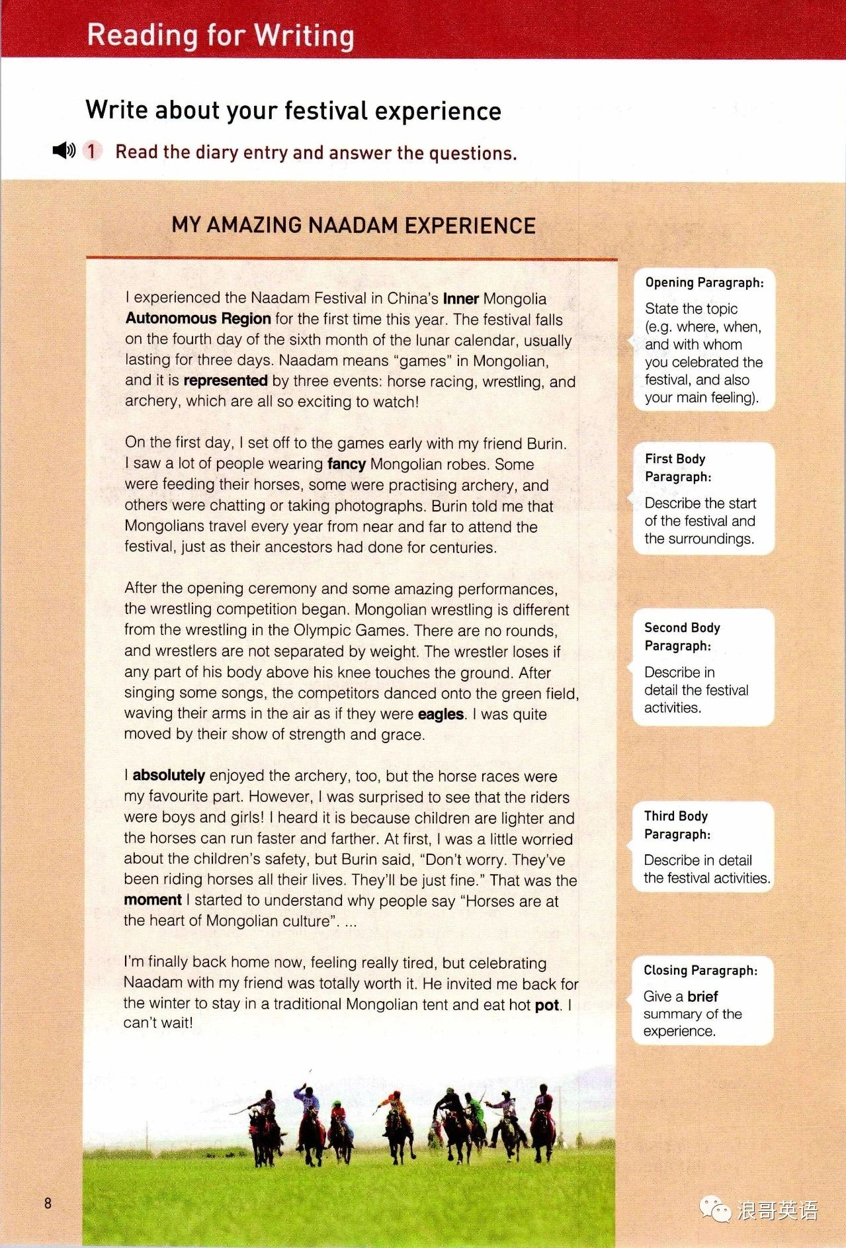
After the Naadam Festival

During the Naadam Festival
Before the Naadam Festival
Task 1 Review the important phrases/sentences and translate.
1.The festival falls on the fourth day of the six month of the lunar calendar, usually lasting for three days.
2.wear fancy Mongolian robes
3.Some others were feeding their horses, some were practising archery, and others were chatting or taking photographs.
4.After the opening ceremony and some amazing performances, the wrestling competition began.
5.After singing some songs, the competitors danced onto the green field, waving their arms in the air as if they were eagles.
6.I’m finally back home now, feeling really tired, but celebrating Naadam with my friend was totally worth it.
高考真题链接
题目六 2017年浙江卷
第一节 应用文写作（满分15分）
假定你是李华，得知外教Mr.Hall寒假不回国，想邀请他到你家过春节。请给他写一封信，内容包括：
1．时间；
2．一同过节的家人；
3．活动。
注意：
1．词数80左右；
2．可以适当增加细节，以使行文连贯。
语篇结构模仿:
春节前：贴春联、贴福字、放烟花；
除夕夜：全家人围在一起包饺子、吃大餐、看春晚、穿新衣
春节后：拜年、发红包、给小孩压岁钱、在街上看舞龙舞狮表演
课文典句摘抄 （阅读课文文本并翻译句子）
- 这个节日在农历六个月的第四天，通常持续三天。
______________________________________________________________________________________________________
仿写：春节在农历1月1号
______________________________________________________________________________________________________
2.一些人在喂马，一些人在练习射箭，还有一些人在聊天或拍照。
______________________________________________________________________________________________________
仿写：春节前一天，一些人将贴春联、一些人将贴福字，还有一些人将放烟花。

3.我现在终于回家了，感觉真的很累，但和朋友一起庆祝那达慕是完全值得的。
______________________________________________________________________________________________________
仿写：和我的家人一起过春节是完全值得的。
______________________________________________________________________________________________________
语篇二 选择性必修3U1Reading—Using language Ancient Chinese Art on Show
Task 1 Analyze the structure.
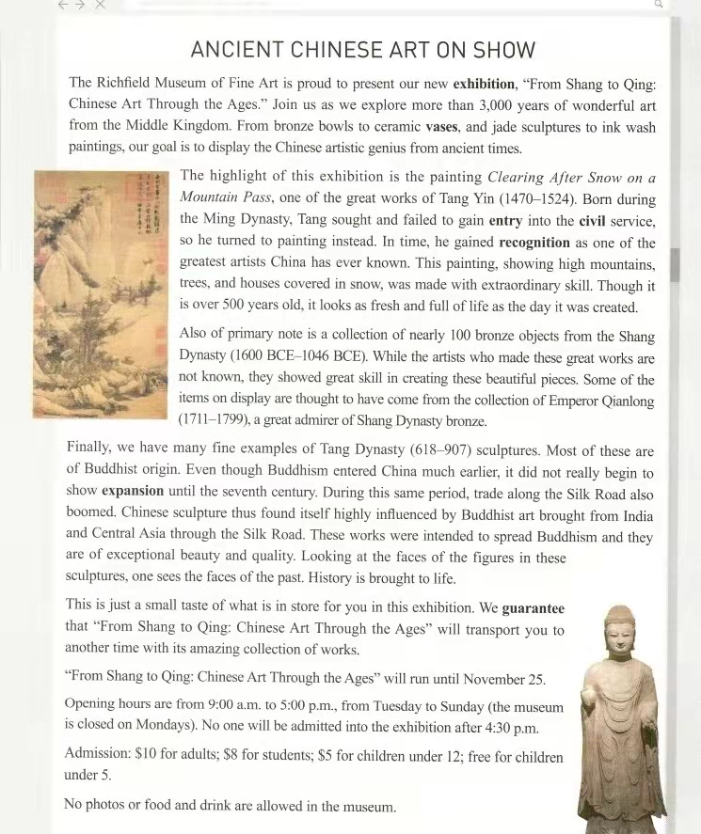
Para 2:
Para 6-9:
Para 4:
Para 5:
Para 1:
Para 3:
Task 2 Review the important phrases/sentences and translate.
1.“From Shang to Qing: Chinese Art Through the Ages.”
2.From bronze bowls to ceramic vases, and jade sculptures to ink wash paintings our goal is to display the Chinese artistic genius from ancient times
3.In time, he gained recognition as one of the greatest artists China has ever known. This painting, showing high mountains, trees, and houses covered in snow, was made with extraordinary skill. Though it is over 500 years old, it looks as fresh and full of life as the day it was created.
4. a collection of nearly 100 bronze objects from the Shang Dynasty
5.They showed great skill in creating these beautiful pieces
6.Buddhist origin
7.During this same period, trade along the Silk Road also boomed. Chinese sculpture thus found itself highly influenced by Buddhist art brought from India and Central Asia through the Silk Road. These works were intended to spread Buddhism and they are of exceptional beauty and quality. Looking at the faces of the figures in these sculptures, one sees the faces of the past.
- History is brought to life.
- We guarantee that"From Shang to Qing: Chinese Art Through the Ages" will transport you to another time with its amazing collection of works.
- No one will be admitted into the exhibition after 4: 30 p. m.
- admission n.
高考题链接
2021年 浙江卷

第一节 应用文写作（满分15分）
昨天你参观了学校举办的学生国画作品展。请给校英文报写一篇宣传稿，内容包括：
- 展览时间、地点； 2．观展感受； 3．推荐观展。
注意： 1．词数80左右； 2．可以适当增加细节，以使行文连贯。

从课文文本中学习描述观展感受和推荐观展
- 一些画描绘了高山、树木和白雪覆盖的房屋，是用非凡的技巧完成的。它们看起来新鲜和充满生机。

——————————————————————————————————————————————————
- 这些国画作品非常漂亮，质量上乘。看着这些国画作品中人物的脸，我看到了过去的面貌。

——————————————————————————————————————————————————
- 我保证这些作品将带您走进另一个时代。

——————————————————————————————————————————————————

语篇三 选择性必修2U3 Culture and cuisine
Task 1 Analyze the structure
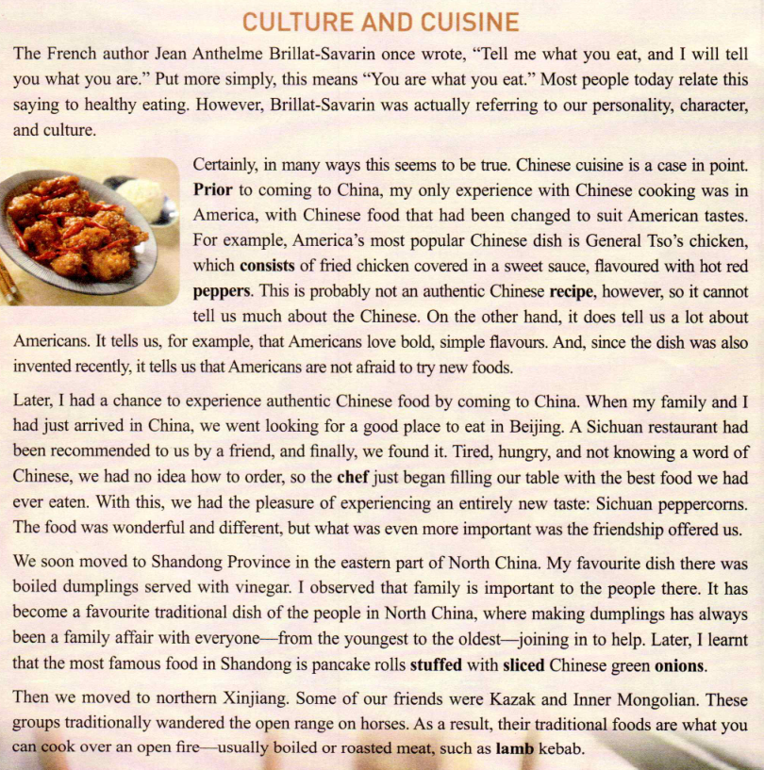
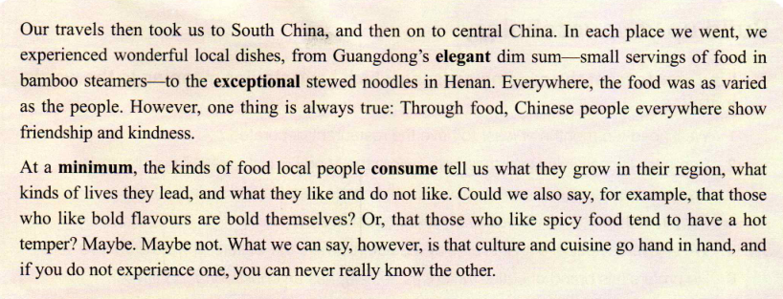
T
Para 2:

Para 1:
Para 7:

Para 6:

Para 5:

Para4:
Para 3:

Task 2 Review the important phrases/sentences and translate.
- Chinese cooking
- Culture and cuisine
- America's most popular Chinese dish is General Tso's chicken, which consists of fried chicken covered in a sweet sauce, favoured with hot red peppers.
4.an authentic Chinese recipe
5.With this, we had the pleasure of experiencing an entirely new taste: Sichuan peppercorns.
6.The food was wonderful and different, but what was even more important was the friendship offered us.
7.My favourite dish there was boiled dumplings served with vinegar
8.It has become a favourite traditional dish of the people in North China, where making dumplings has always been a family affair with everyone—from the youngest to the oldest—joining in to help.
9.Later, I learnt that the most famous food in Shandong is pancake rolls stuffed with sliced Chinese green onions.
10.boiled or roasted meat
11.central China
12.we experienced wonderful local dishes, from Guangdong's elegant dim sum—small servings of food in bamboo steamers—to the exceptional stewed noodles In Henan.
13. culture and cuisine go hand in hand.
Task 3 语法填空
According to the French author Jean Anthelme Brillat-Savarin,_______ we eat can show our personality, character, and culture. Chinese cuisine is a good example. Prior to ________ (come) to China, I only experienced Chinese food that _________________ (change) to suit American tastes. America's most popular Chinese dish is General Tso's chicken, which tells us a lot about us Americans.
When I came to Beijing, a friend recommended a Sichuan restaurant where we had the ________ (please) of experiencing an entirely new taste: Sichuan peppercorns. What was even _______ important was the friendship offered us.
In Shandong, I liked boiled dumplings _________________ (serve) with vinegar best. I observed that family is important to the people there. In northern Xinjiang, I enjoyed boiled or roasted meat.
___________ we went, we experienced wonderful local dishes. Although the food was as_________________ (vary) as the people, Chinese people everywhere show friendship and_________________ (kind) through food. From my experiences, I know that culture and cuisine go hand in hand, and if you do not experience one, you can never_________________ (real) know the other.
高考真题链接
2023年新课标I卷中华美食“小笼包”
试题1 阅读下面短文，在空白处填入1个适当的单词或括号内单词的正确形式。
Xiao long bao (soup dumplings), those amazing constructions of delicate dumpling wrappers, encasing hot, 56 (taste) soup and sweet, fresh meat, are far and away my favorite Chinese street food. The dumplings arrive steaming and dangerously hot. To eat one, you have to decide whether 57 (bite) a small hole in it first, releasing the stream and risking a spill (溢出)， 58 to put the whole dumpling in your mouth, letting the hot soup explode on your tongue.
Shanghai may be the 59 (recognize) home of the soup dumplings but food historians will actually point you to the neighboring canal town of Nanxiang as xiao long bao’s birthplace. There you will find them prepared differently — more dumpling and less soup, and the wrappers are pressed 60 hand rather than rolled.
Nanxiang aside, the best xiao long bao have a fine skin, allowing them 61 (lift) out of the steamer basket without tearing or spilling any of 62 (they) contents. The meat should be fresh with 63 touch of sweetness and the soup hot, clear and delicious.
No matter where I buy them, one steamer is 64 (rare) enough, yet two seems greedy, so I am always left 65 (want) more next time.
试题2 2024年全国甲卷短文改错改编 吃重庆火锅的经历
Last week, I saw a program about Chongqing hotpot on TV. I was curious and planned a special one-day trip there with a friend of_____________(me). Our fast train was _____________(pack)with passengers. _________ attendant gave us some travel _______________(brochure) about Chongqing. When we arrived, we went straight_________ a famous restaurant and ordered dishes, _________ tasted great. The atmosphere here made the meal all the more ________________(enjoy). Hotpot is meant for families and friends _____________(sit) together, dip everything they like in one pot, ____________ share friendship and love.

语篇四 人教版必修一Unit 5 Reading and Thinking
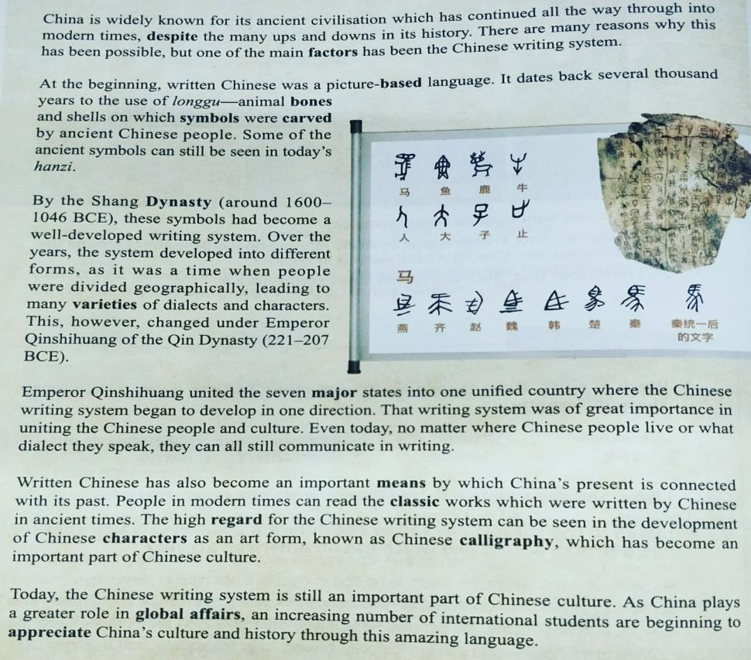
Task 1 Read passage quickly and find the main idea of each paragraph
A. The writing system became well-developed, and later developed into different forms.

B.Written Chinese was a pictured-based language at the beginning.
C. The Chinese writing system is one of the reasons why Chinese civilization has continued all the way through into modern times.

D. Written Chinese connects China’s present with its past, and has become an art form.

E. The Chinese language is helping to spread China’s culture and history to the world.

Para 2
Para 3
Para 1
Para 5
Para 6
Para 4
F.The writing system began to develop in one direction.

Task 2 Analyze the structure.

Task 3 Scan the text again and try to finish a time line about the development of Chinese writing system.
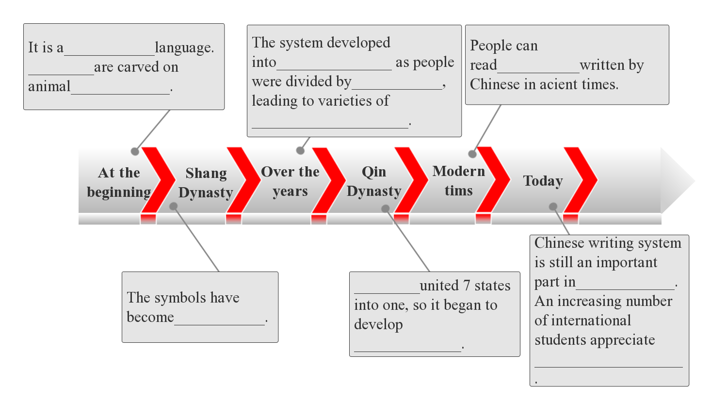
Task 4 Find the sentences that show the importance from the text(Para4 - Para6) and fill in the table .
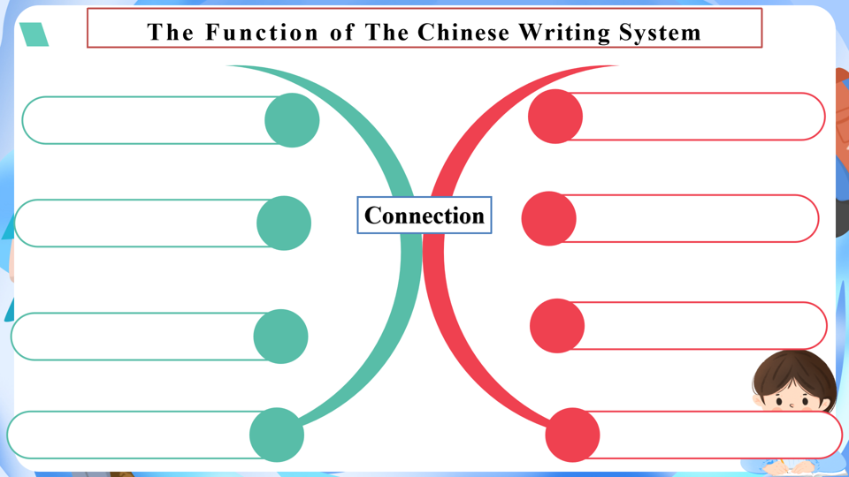
Task 5 Review the important phrases and translate.
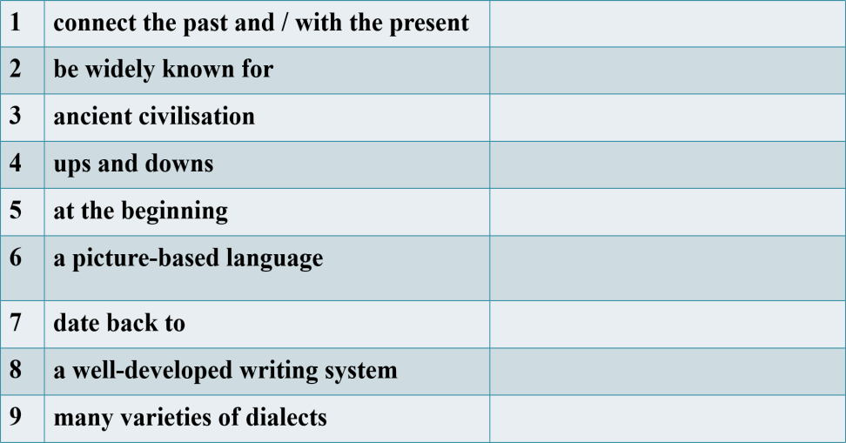 | 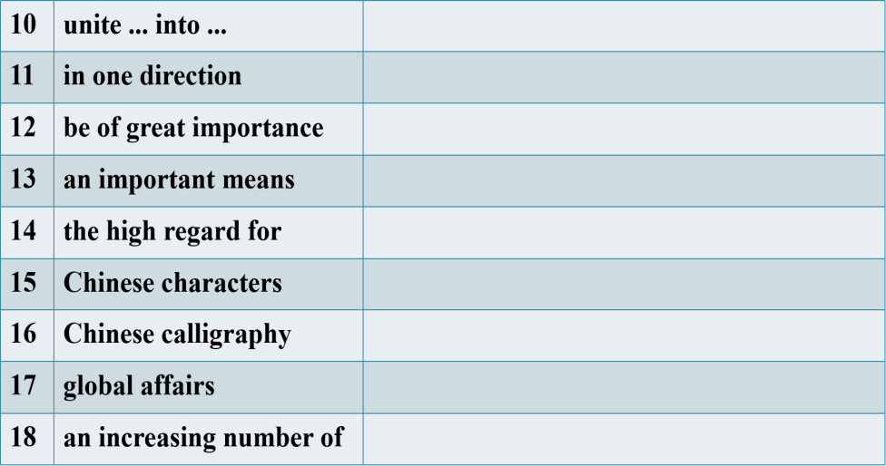

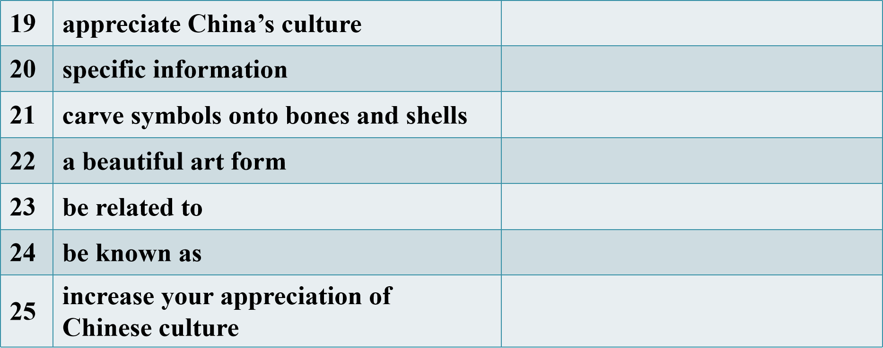
Task 6 课文语法填空
The Chinese Writing system: Connecting the Past and the Present
China is __________ (wide) known for its ancient civilization which has continued all the way through into modern times, __________ the many ups and downs in its history. There are many reasons __________ this has been possible, but one of the main factors __________ (be) the Chinese writing system.
At the beginning, written Chinese was a picture-based language. It dates back several thousand years __________ the use of longgu — animal bones and shells on __________ symbols were carved by ancient Chinese people. Some of the ancient symbols can still __________ (see) in today’s hanzi.
By the Shang Dynasty (around 1600-1046 BCE), these symbols __________ (become) a well-developed writing system. Over the years, the system developed into different forms, as it was a time __________ people were divided geographically, __________ (lead) to many __________ (variety) of dialects and characters. This, __________, changed under Emperor Qinshihuang of the Qin Dynasty (221-207BCE).
Emperor Qinshihuang united the seven major states into one unified country __________ the Chinese writing system began to develop __________ one direction. That writing system was of great __________ (important) in uniting the Chinese people and culture. Even today, no matter __________ Chinese people live or what dialect they speak, they can all still communicate in writing.
Written Chinese has also become an important means __________ which China’s present is connected with its past. People in modem times can read the classic __________ (work) which were written by Chinese in ancient times. The high regard __________ the Chinese writing system can be seen in the development of Chinese characters as __________ art form, known as Chinese calligraphy, __________ has become an important part of Chinese culture.
Today, the Chinese writing system is still an important part of Chinese culture. __________ China plays a greater role in global affairs, an __________ (increase) number of international students are beginning to appreciate China’s culture and history through this amazing language.

Task 7应用文写作（满分15分）
假定你是李华，学校正在举行“用英语讲中国文化”设计大赛，你准备制作一张介绍中国书法的海报。
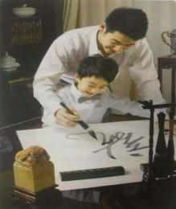
内容包括：1．书法的历史简介；
2．书法的意义和作用。
注意：1．写作词数应为80左右；
- 可以适当增加细节，以使行文连贯。

Chinese Calligraphy

语篇二B2U1Reading for Writing Promoting Culture through Digital Images

语篇五必修2U1 Writing To write a news report about cultural heritage protection 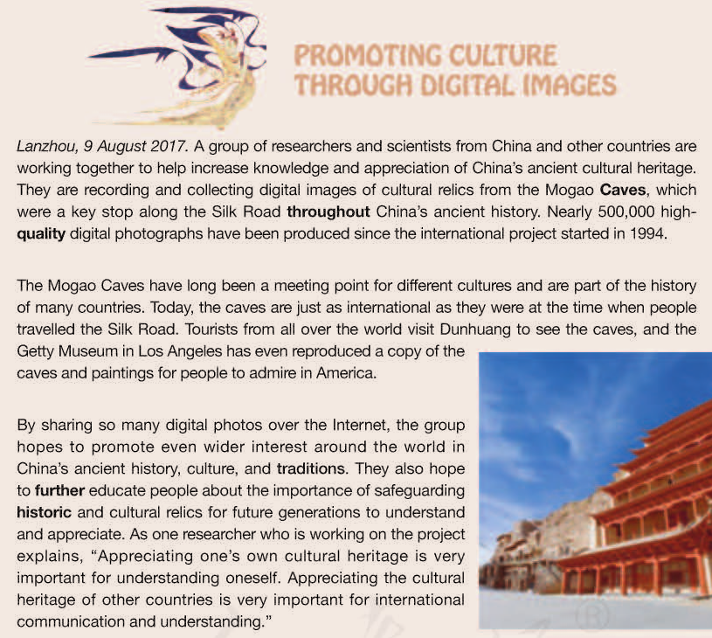
Beginning
(Lead Sentence
+paraphrase)

Body：(tell the reader the facts, details, examples)
background information+
detailed information

Ending：(Write a short summary to help the readers remember the main idea.)

Headline
Task 1 Review the important phrases and translate.
1.increase knowledge and appreciation of China’s ancient cultural heritage
2.cultural relics
3.the Mogao Caves
4.a key stop along the Silk Road
5.throughout China’s ancient history
6.promote even wider interest around the world in China’s ancient history, culture, and traditions
7.further educate people about the importance of safeguarding historic and cultural relics
8.Appreciating the cultural heritage of other countries is very important for international communication and understanding.
Task 2课文语法填空
A group of researchers and scientists from home and abroad are working together 1.___________________ （record） and collect digital images of cultural relics from the Mogao Caves， in an effort to promote 2.__________________ （appreciate） of China’s ancient cultural heritage. Nearly 500，000 high-quality digital photographs 3.__________________（produce） since the international project started in 1994.
The Mogao Caves, as 4.__________________key stop along the Silk Road throughout China’s ancient history， have long been a meeting point for different cultures and now， they are just 5.__________________ international as they were at the time 6.__________________ people travelled the Silk Road.
The group hopes to promote even 7.__________________（wide） interest around the world in China’s ancient history， culture and traditions. They also hope to further educate people about the importance of 8.__________________ （safeguard） historic and cultural relics for future generations to understand and appreciate. As one researcher who is working 9.__________________ the project explains，“Appreciating one’s own cultural heritage is very important for understanding oneself. Appreciating the cultural heritage of other countries is very important for international 10.__________________ （communicate） and understanding.”
Task 3
第三部分 写作（满分15分）
假如你是一名高中学生李华，在浏览网页时发现，世界上很多文化遗产遭到了人类活动、自然灾害等的破坏，对此你深感痛惜，决定给联合国教科文组织世界文化遗产中心的负责人写一封关于如何保护全球文化遗产的建议信。内容包括：
1．大力宣传保护文化遗产；
2．倡导环保旅游，避免破坏文化遗产；
3．筹集资金对遗产进行维修和维护。
注意：
1．词数80左右；
2．可以适当增加细节，以使行文连贯；
3．信的开头和结尾已写好，不计入总词数。
Dear Sir/Madam,
I'm sorry to see that so much cultural heritage in the world is being destroyed nowadays.
_____________________________________________________________________________________________________________________________________________________________________________________________________________________________________________________________________________________________________________________________________________________________________________________________________
I hope you can take my suggestions into consideration.
Yours sincerely,
Li Hua

三．有关中国传统文化主题历年高考真题汇编

（一）应用文写作题目
年份 | 试卷 | 体裁 | 语篇内容
2023年 | 全国甲卷 | 投稿 | 向学校“用英文讲中国故事”主题征文活动投稿
2021年 | 浙江卷 | 宣传稿 | 宣传学校举办的学生国画作品展
2021年 | 全国甲卷 | 邮件 | 给外国朋友写邮件，了解哪些中国传统文化更吸引外国友人
2019年 | 全国I卷 | 邮件 | 申请做中国画展览的志愿者
2017年 | 全国I卷 | 告知信 | 告知英国朋友下次上课的计划
2017年 | 浙江卷 | 邀请信 | 邀请外教一起过春节
2016年 | 北京卷 | 邮件 | 介绍一位你喜欢的中国历史人物
题目一2023年全国甲卷应用文

第二节 书面表达（满分25分）
你们学校正举办主题为“用英文讲中国故事”的征文活动。请你以一位中国历史人物为题写一篇短文投稿，内容包括：
1. 人物简介及事迹；
2. 意义或启示。
注意：
1. 词数100左右；
2. 题目已为你写好。
The Historical Figure in China
____________________________________________________________________________________________________________________________________________________________________________________________________________
题目二2021年 浙江卷

第一节 应用文写作（满分15分）
昨天你参观了学校举办的学生国画作品展。请给校英文报写一篇宣传稿，内容包括：
- 展览时间、地点； 2．观展感受； 3．推荐观展。
注意： 1．词数80左右； 2．可以适当增加细节，以使行文连贯。

题目三 2021年 全国甲卷
第二节 书面表达（满分25分）
假定你是李华。你校计划举办介绍中国传统文化的主题班会，并在英文网站展示。请你写一封邮件给外国朋友Chris，向他了解哪些中国传统文化更吸引外国友人。邮件内容包括：
1. 阐明写信事由；
2. 征求建议；
3. 表示感谢。
注意：
1. 词数100左右；
2. 可以适当增加细节，以使行文连贯。

题目四 2019年 全国I卷
第二节 书面表达（满分25分）
假定你是李华，暑假在伦敦学习，得知当地美术馆要举办中国画展览。请写一封信申请做志愿者，内容包括：
1．写信目的；
2．个人优势；
3．能做的事情。
注意：
1．词数100左右；
2．可以适当增加细节，以使行文连贯；
3．结束语已为你写好。
题目五 2017年全国I卷
第二节 书面表达 (满分25分)
假定你是李华，正在教你的英国朋友Leslie学习汉语。请你写封邮件告知下次上课的计划。内容包括：
1．时间和地点；
2．内容：学习唐诗；
3．课前准备：简要了解唐朝的历史。
注意：
1．词数100左右；
2．可以适当增加细节，以使行文连贯。

题目六 2017年浙江卷
第一节 应用文写作（满分15分）
假定你是李华，得知外教Mr.Hall寒假不回国，想邀请他到你家过春节。请给他写一封信，内容包括：
1．时间；
2．一同过节的家人；
3．活动。
注意：
1．词数80左右；
2．可以适当增加细节，以使行文连贯。

题目七2016年 北京卷
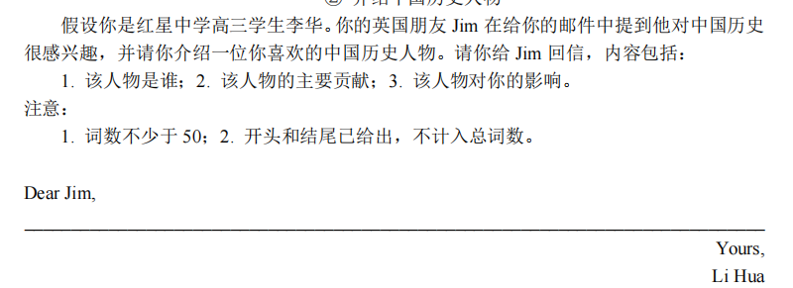
（二）阅读理解题目
2024年 新课标I卷阅读理解B篇
①“I am not crazy,” says Dr. William Farber, shortly after performing acupuncture (针灸) on a rabbit. “I am ahead of my time.” If he seems a little defensive, it might be because even some of his coworkers occasionally laugh at his unusual methods. But Farber is certain he’ll have the last laugh. He’s one of a small but growing number of American veterinarians (兽医) now practicing “holistic” medicine – combining traditional Western treatments with acupuncture, chiropractic (按摩疗法) and herbal medicine.
②Farber, a graduate of Colorado State University, started out as a more conventional veterinarian. He became interested in alternative treatments 20 years ago when he suffered from terrible back pain. He tried muscle-relaxing drugs but found little relief. Then he tried acupuncture, an ancient Chinese practice, and was amazed that he improved after two or three treatments. What worked on a veterinarian seemed likely to work on his patients. So, after studying the techniques for a couple of years, he began offering them to pets.
③Leigh Tindale’s dog Charlie had a serious heart condition. After Charlie had a heart attack, Tindale says, she was prepared to put him to sleep, but Farber’s treatments eased her dog’s suffering so much that she was able to keep him alive for an additional five months. And Priscilla Dewing reports that her horse, Nappy, “moves more easily and rides more comfortably” after a chiropractic adjustment.
④Farber is certain that the holistic approach will grow more popular with time, and if the past is any indication, he may be right: Since 1982, membership in the American Holistic Veterinary Medical Association has grown from 30 to over 700. “Sometimes it surprises me that it works so well,” he says. “I will do anything to help an animal. That’s my job.”

24. What do some of Farber’s coworkers think of him?
A. He’s odd. B. He’s strict.
C. He’s brave. D. He’s rude.
25. Why did Farber decide to try acupuncture on pets?
A. He was trained in it at university.
B. He was inspired by another veterinarian.
C. He benefited from it as a patient.
D. He wanted to save money for pet owners.
26. What does paragraph 3 mainly talk about?
A. Steps of a chiropractic treatment.
B. The complexity of veterinarians’ work.
C. Examples of rare animal diseases.
D. The effectiveness of holistic medicine.
27. Why does the author mention the American Holistic Veterinary Medical Association?
A. To prove Farber’s point.
B. To emphasize its importance.
C. To praise veterinarians.
D. To advocate animal protection.
Task 2 Analyze the structure
语篇类型
主题语境
语篇结构 | “holistic” medicine practiced by a veterinarian  Para 1:  Para 2:  Para 3:  Para 4:
Task 3 Review the important phrases/sentences and translate.
1. performing acupuncture |  | 22.have a serious heart condition
2.defensive adj. |  | 23.ease her dog’s suffering
3. coworker n. |  | 24.additional adj.
4.occasionally adv. |  | 25.comfortably adv.
6.have the last laugh |  | 26.adjustment n.
7.practice “holistic” medicine |  | 27. approach n.
8. combine …… with …… |  | 28.indication n.
9.traditional adj. |  | 29.membership n.
10.treatment n. |  | 30.association n.
11.herbal adj.& n. |  | 31.odd adj.
12.graduate n. |  | - train vt.
13.conventional adj. |  | - inspire
14.alternative adj.& n. |  | - benefit from
15. suffer from terrible back pain |  | - patient
16.muscle-relaxing drugs |  | - complexity n.
17.relief n. ________________v. |  | - effectiveness n.
18.an ancient Chinese practice |  | - emphasize its importance
19.practice n.(熟词生义) |  | - praise
20.technique n. |  | - advocate animal protection.
21.pet n. |  | - prove

