The World（1216-1231）材料分析和教学目标：
本次选用的材料：①The Wall Street Journal 的Blood-Pressure Inaccuracies Mask Heart Health Risks（血压值不准确掩盖心脏健康风险）、②The New York Times的Party City Chain Closing Its 748 Stores by February (Party City连锁店将于2月关闭其748家门店)、③Psychology Now的The Brain Is Mostly Water and Fat (大脑主要由水和脂肪组成)、④The Times的DIY spending down in favour of experiences (DIY消费减少，更倾向于体验)和⑤BBC的新闻报道。通过语法填空、阅读理解、分析长难句、翻译句子、听力填空和词汇拓展等方式，让学生从多角度提升学习兴趣，提高分析句子、运用词块和听力能力。外媒英语新闻可以让学生体验真实语境下的语言运用，拓展学生的国际视野，了解时事，逐步提升跨文化沟通能力，形成正确的世界观、人生观和价值观。

教学思路：
Part 1: News Report 1 The Wall Street Journal (December 18 2024 A6)
Blood-Pressure Inaccuracies Mask Heart Health Risks
血压值不准确掩盖心脏健康风险
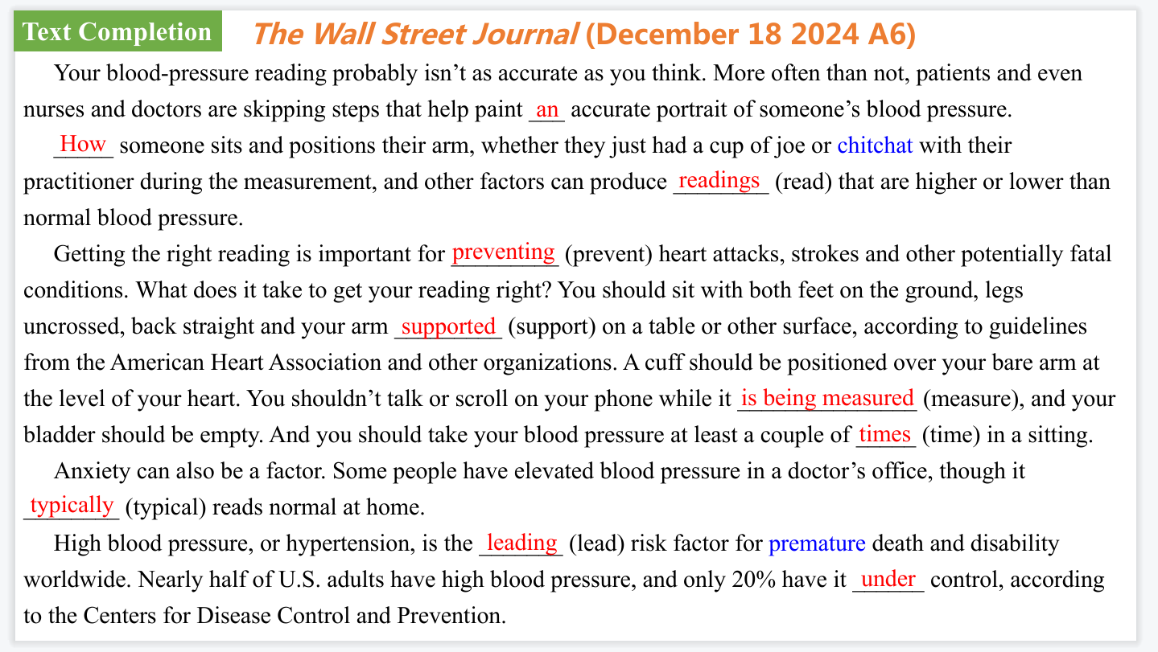
【设计意图】通过语篇填空的形式帮助学生理解新闻的主要内容，同时训练语言语法的运用能力：在语篇的视角下如何正确使用所给词汇，根据语法规则确定词汇的正确形式，使得文章通顺，激活学生的思维和语言。该新闻主题语境是关于“人与社会”中“科学与技术”这一子主题，通过学习让学生了解血压值不准确掩盖心脏健康风险。
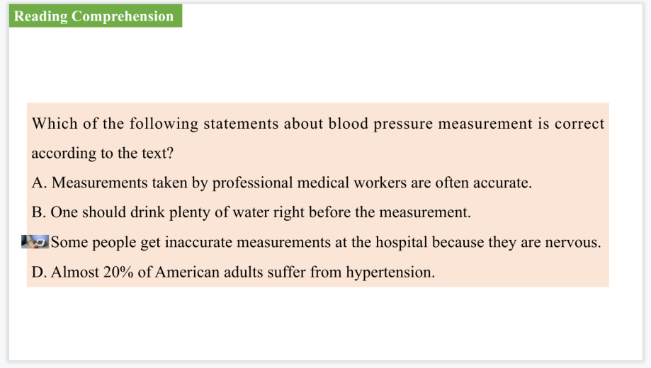
【设计意图】通过阅读理解的形式帮助学生理解新闻的主要内容。
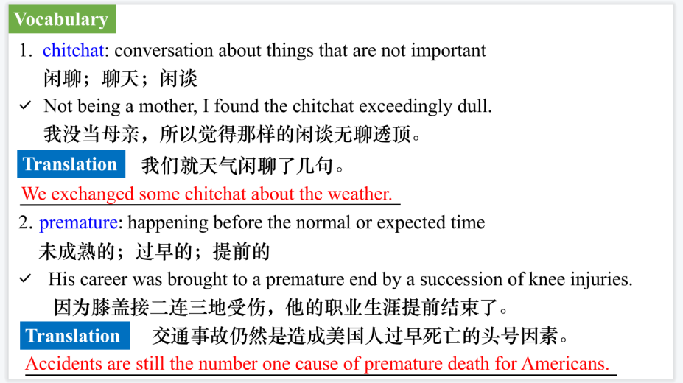
【设计意图】对文本中的词汇进行解读，并通过翻译句子对其进行巩固。
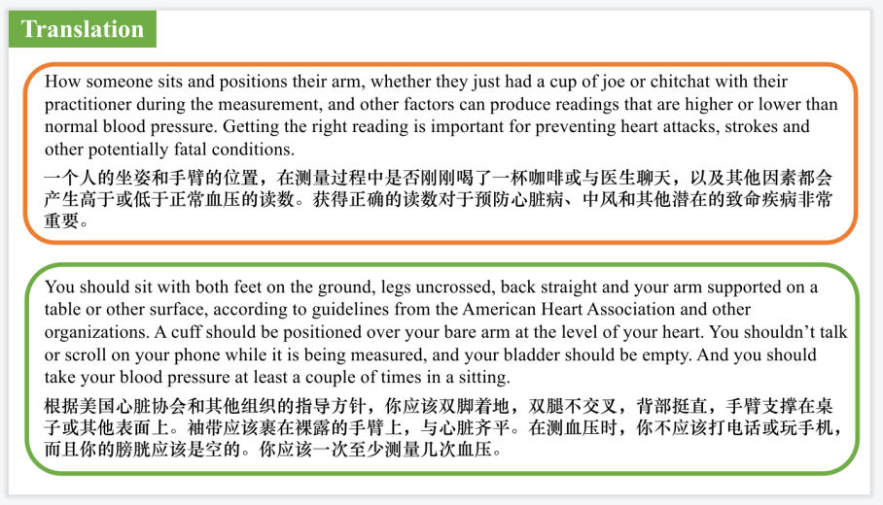
【设计意图】对文中的两个句子进行翻译练习，对其中单词、词组、句法进行巩固并关注句子结构。

Part 2: News Report 2 The New York Times（December 23, 2024 B5)
Party City Chain Closing Its 748 Stores by February
Party City连锁店将于2月关闭其748家门店
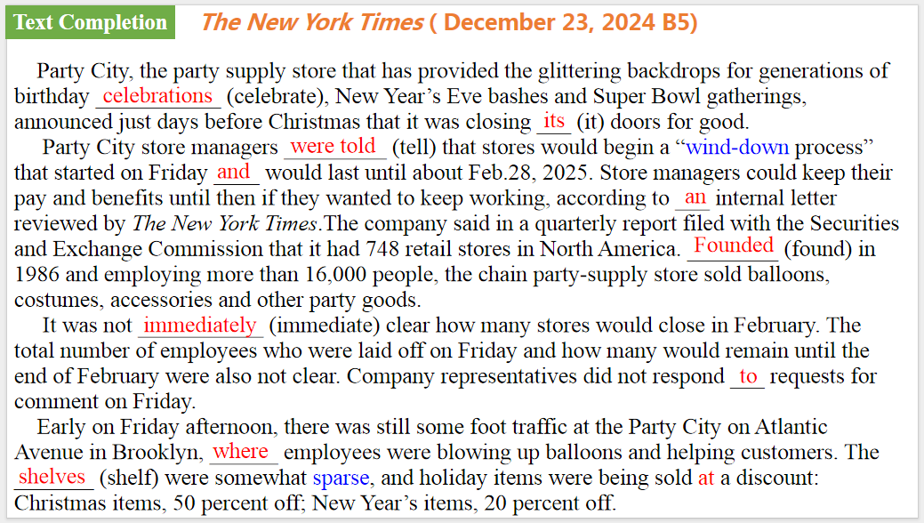
【设计意图】通过语篇填空的形式帮助学生理解新闻的主要内容，同时训练语言语法的运用能力：在语篇的视角下如何正确使用所给词汇，根据语法规则确定词汇的正确形式，使得文章通顺，激活学生的思维和语言。该新闻主题语境是关于“人与社会”中“社会热点问题”这一子主题，通过学习让学生了解Party City连锁店将于2月关闭其748家门店的新闻。
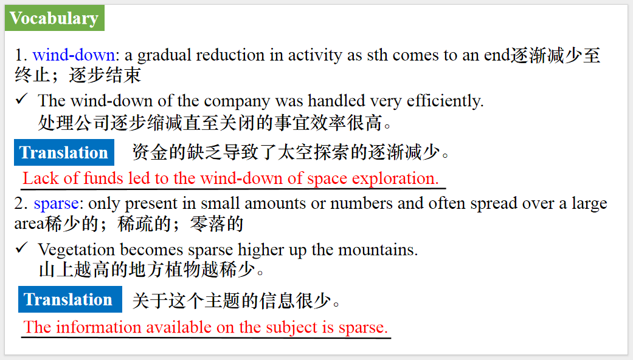
【设计意图】对文本中的词汇进行解读，并通过翻译句子对其进行巩固。
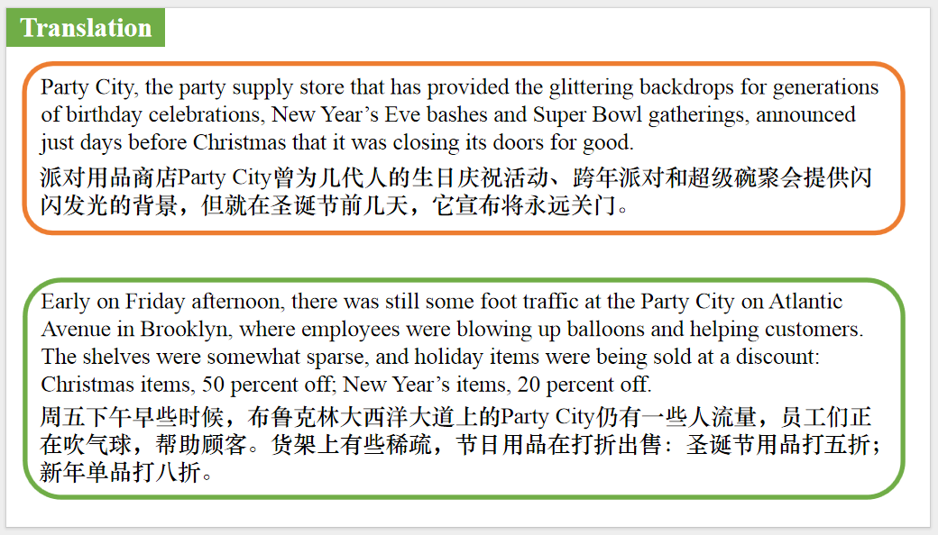
【设计意图】对文中的两个句子进行翻译练习，对其中单词、词组、句法进行巩固并关注句子结构。

Part 3: News Report 3 Psychology Now（December 19, 2024 P10)
The Brain Is Mostly Water and Fat
大脑主要由水和脂肪组成
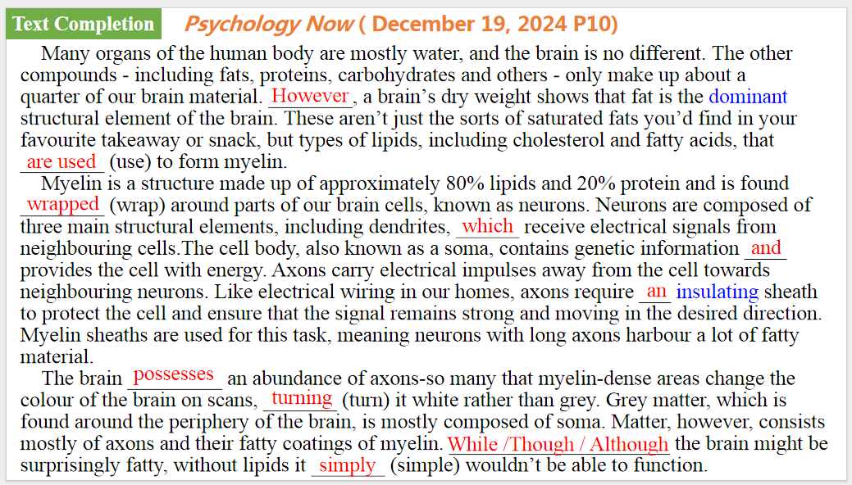
【设计意图】通过语篇填空的形式帮助学生理解新闻的主要内容，同时训练语言语法的运用能力：在语篇的视角下如何正确使用所给词汇，根据语法规则确定词汇的正确形式，使得文章通顺，激活学生的思维和语言。该新闻主题语境是关于“人与社会”中“科学与技术”这一子主题，通过学习让学生了解大脑主要由水和脂肪组成的科学知识。
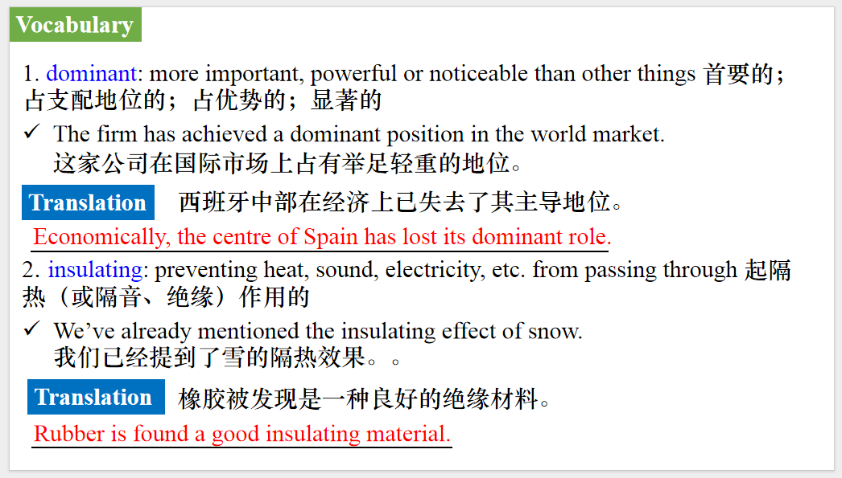
【设计意图】对文本中的词汇进行解读，并通过翻译句子对其进行巩固。
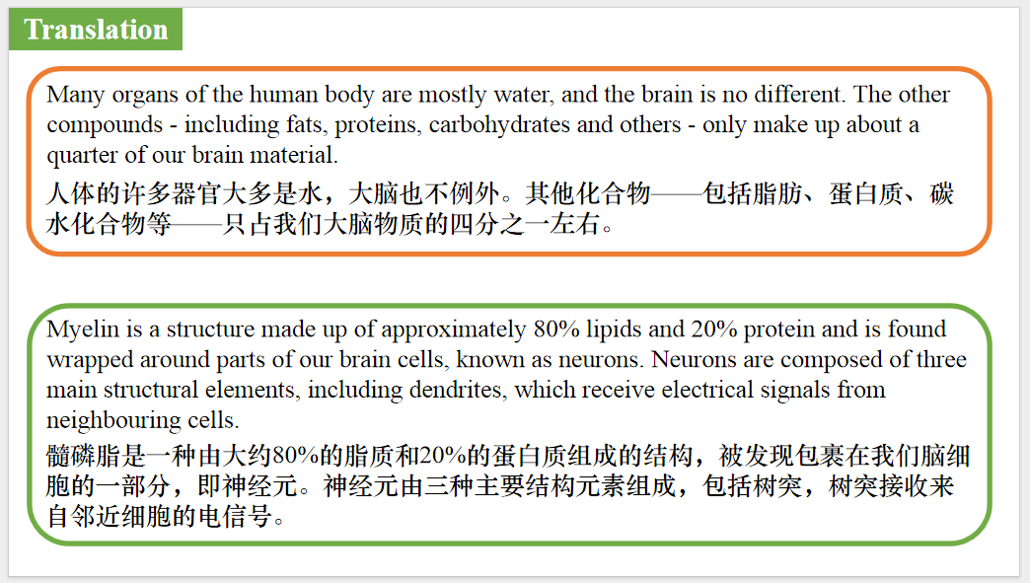
【设计意图】对文中的两个句子进行翻译练习，对其中单词、词组、句法进行巩固并关注句子结构。

Part 4: News Report 4 The Times（December 31, 2024 P11)
DIY spending down in favour of experiences
DIY消费减少，更倾向于体验
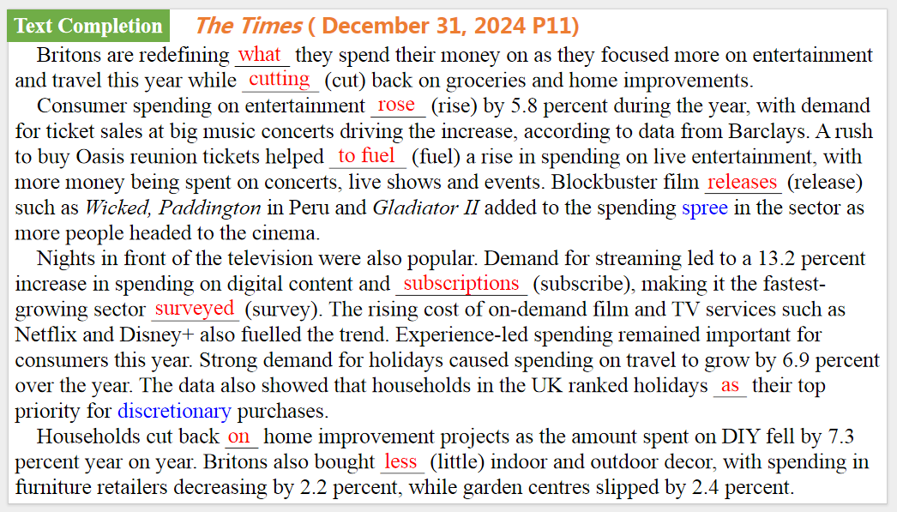
【设计意图】通过语篇填空的形式帮助学生理解新闻的主要内容，同时训练语言语法的运用能力：在语篇的视角下如何正确使用所给词汇，根据语法规则确定词汇的正确形式，使得文章通顺，激活学生的思维和语言。该新闻主题语境是关于“人与社会”中“社会热点问题”这一子主题，通过学习让学生了解英国人DIY消费减少，更倾向于体验的生活方式。
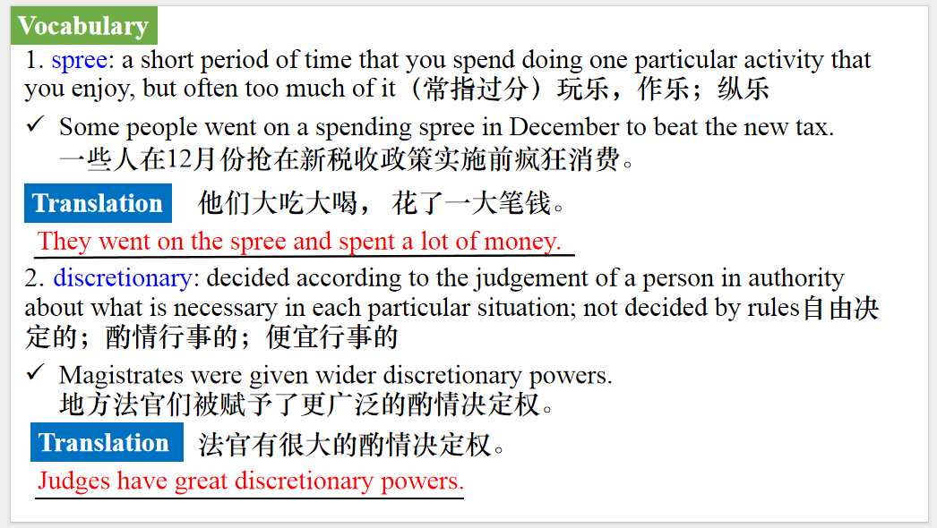
【设计意图】对文本中的词汇进行解读，并通过翻译句子对其进行巩固。
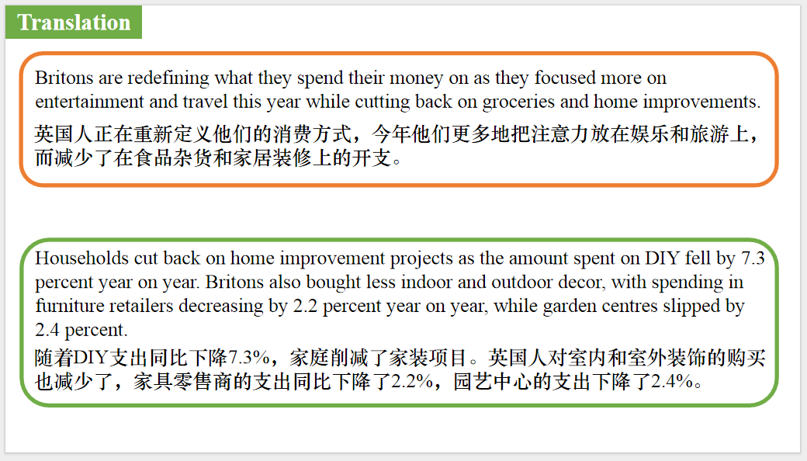
【设计意图】对文中的两个句子进行翻译练习，对其中单词、词组、句法进行巩固并关注句子结构。

Part 5: BBC News 12/20/2024
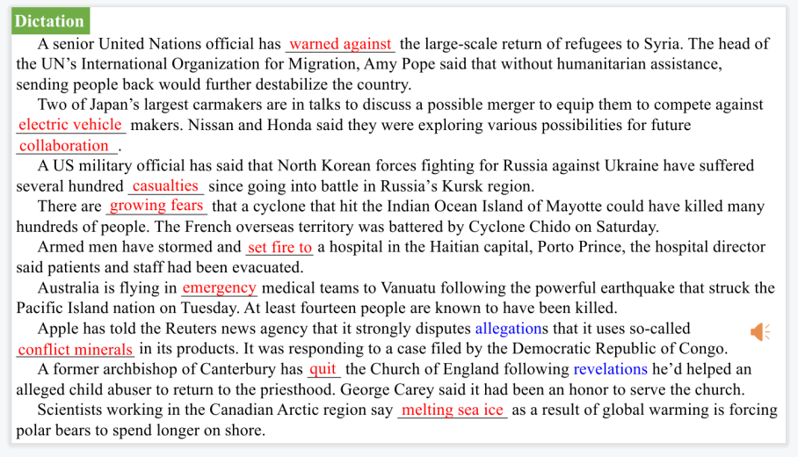
【设计意图】听一则材料，通过听力填空的方式理解文本，考察听力辨识词汇的能力。
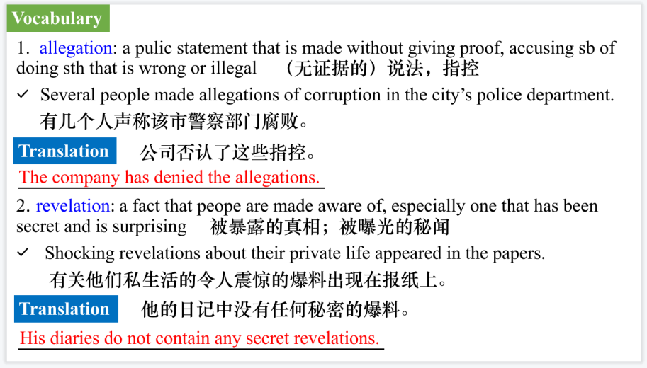
【设计意图】对文本中的词汇进行解读，并通过翻译句子对其进行巩固。
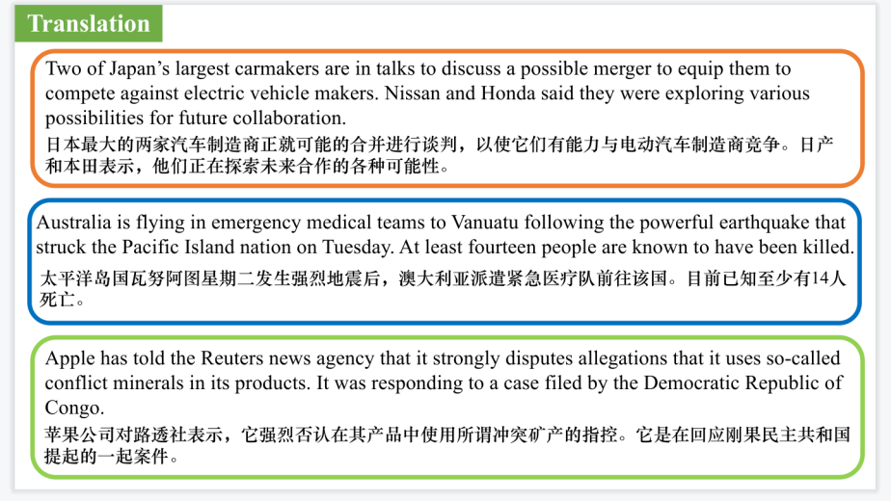
【设计意图】对文中的三个句子进行翻译练习，对其中单词、词组、句法进行巩固并关注句子结构。

附：外刊原文

Part 1: News Report 1 The Wall Street Journal (December 18 2024 A6)
Blood-Pressure Inaccuracies Mask Heart Health Risks
血压值不准确掩盖心脏健康风险
Your blood-pressure reading probably isn’t as accurate as you think.
More often than not, patients and even nurses and doctors are skipping steps that help paint an accurate portrait of someone’s blood pressure.
How someone sits and positions their arm, whether they just had a cup of joe or chitchat with their practitioner during the measurement, and other factors can produce readings that are higher or lower than normal blood pressure.
“To really make a dent at improving people’s cardiovascular health, we need to screen and treat people for hypertension, but we need to do it correctly,” said Dr. Tammy Brady, a pediatric nephrologist at the Johns Hopkins Children’s Center in Baltimore who studies blood-pressure measurement and cardiovascular health in children and adults. Getting the right reading is important for preventing heart attacks, strokes and other potentially fatal conditions.
What does it take to get your reading right? You should sit with both feet on the ground, legs uncrossed, back straight and your arm supported on a table or other surface, according to guidelines from the American Heart Association and other organizations. A cuff should be positioned over your bare arm at the level of your heart. You shouldn’t talk or scroll on your phone while it is being measured, and your bladder should be empty. And you should take your blood pressure at least a couple of times in a sitting.
Anxiety can also be a factor. Some people have elevated blood pressure in a doctor’s office, though it typically reads normal at home.
A blood-pressure reading indicates the pressure of blood pushing against artery walls when the heart beats (systolic) and relaxes (diastolic). It fluctuates with exercise and other activities. The goal is to capture a person’s usual blood pressure over time, without those fluctuations.
High blood pressure, or hypertension, is the leading risk factor for premature death and disability worldwide. Nearly half of U.S. adults have high blood pressure, and only 20% have it under control, according to the Centers for Disease Control and Prevention.
Left uncontrolled, it can lead to heart attacks, strokes, chronic kidney disease, heart failure and dementia, said Dr. Michael Rakotz, group vice president for improving health outcomes at the American Medical Association.
James Young II found out he was measuring his blood pressure wrong, a realization that potentially saved his life. At age 40, he developed shortness of breath and headaches. He started checking his numbers at home, which were abnormal but not worrisome, he thought. A doctor’s appointment led him to a surprising discovery: His blood pressure was dangerously high.
What had gone wrong? He had the wrong cuff size, and the blood-pressure device was old, Young learned. He was diagnosed with congestive heart failure and other conditions. “I was really playing Russian roulette with my life,” he said.
Taking blood pressure inaccurately can often produce a reading that is too high rather than too low. Resting an arm in a lap overestimated the systolic reading by 3.9 millimeters of mercury, a measure of arterial pressure, and diastolic reading by 4 mmHg, in a study of 133 adults published by Brady and colleagues in October. Blood pressures taken on a dangling arm were even higher.
A 2023 study, also by Brady and colleagues, found that a cuff that is too small made blood pressure readings high, while a cuff too large made readings low.
Even small errors in blood pressure measurement likely affect how millions of Americans are diagnosed and treated, said Paul Muntner, who is a visiting professor of epidemiology at the University of Alabama at Birmingham. “We wouldn’t tolerate this when they measure your cholesterol levels,” he said.

Part 2: News Report 2 The New York Times（December 23, 2024 B5)
Party City Chain Closing Its 748 Stores by February
Party City连锁店将于2月关闭其748家门店
Party City, the party supply store that has provided the glittering backdrops for generations of birthday celebrations,New Year’s Eve bashes and Super Bowl gatherings,announced just days before Christmas that it was closing its doors for good.
Party City store managers were told that stores would begin a “wind-down process” that started on Friday and would last until about Feb.28,2025. Store managers could keep their pay and benefits until then if they wanted to keep working, according to an internal letter reviewed by The New York Times.
Store employees said they were told that all stores in the United States would close by the end of February.CNN reported news of the company’s closing on Friday.
Corporate employees and workers at a distribution center were told on Friday that they would be laid off that day, according to an employee who shared a video of her being laid off.
The company said in a quarterly report filed with the Securities and Exchange Commission that it had 748 retail stores in North America. Founded in 1986 and employing more than 16,000 people, the chain party-supply store sold balloons,costumes, accessories and other party goods.
It was not immediately clear how many stores would close in February. The total number of employees who were laid off on Friday and how many would remain until the end of February were also not clear.Company representatives did not respond to requests for comment on Friday.
The letter, on a Party City Holdco letterhead, cited “inflationary pressures on costs and consumer spending” as some of the challenges that forced the company to close its doors.
Early on Friday afternoon,there was still some foot traffic at the Party City on Atlantic Avenue in Brooklyn,where employees were blowing up balloons and helping customers.The shelves were somewhat sparse, and holiday items were being sold at a discount: Christmas items, 50 percent off; New Year’s items, 20 percent off.

Part 3: News Report 3 Psychology Now（December 19, 2024 P10)
The Brain Is Mostly Water and Fat
大脑主要由水和脂肪组成
Many organs of the human body are mostly water, and the brain is no different. The other compounds-including fats, proteins, carbohydrates and others-only make up about a quarter of our brain material. However, a brain’s dry weight shows that fat is the dominant structural element of the brain. These aren’t just the sorts of saturated fats you’d find in your favourite takeaway or snack, but types of lipids, including cholesterol and fatty acids, that are used to form myelin.
Myelin is a structure made up of approximately 80%lipids and 20% protein and is found wrapped around parts of our brain cells, known as neurons. Neurons are composed of three main structural elements, including dendrites, which receive electrical signals from neighbouring cells. The cell body, also known as a soma, contains genetic information and provides the cell with energy. Axons carry electrical impulses away from the cell towards neighbouring neurons. Like electrical wiring in our homes, axons require an insulating sheath to protect the cell and ensure that the signal remains strong and moving in the desired direction. Myelin sheaths are used for this task,meaning neurons with long axons harbour a lot of fatty material.
The brain possesses an abundance of axons-so many that myelin-dense areas change the colour of the brain on scans, turning it white rather than grey. Grey matter, which is found around the periphery of the brain, is mostly composed of soma. Matter, however, consists mostly of axons and their fatty coatings of myelin. While the brain might be surprisingly fatty, without lipids it simply wouldn’t be able to function.

Part 4: News Report 4 The Times（December 31, 2024 P11)
DIY spending down in favour of experiences
DIY消费减少，更倾向于体验
Britons are redefining what they spend their money on as they focused more on entertainment and travel this year while cutting back on groceries and home improvements.
Consumer spending on entertainment rose by 5.8 percent during the year, with demand for ticket sales at big music concerts driving the increase, according to data from Barclays.
A rush to buy Oasis reunion tickets helped to fuel a rise in spending on live entertainment, with more money being spent on concerts, live shows and events.
Blockbuster film releases such as Wicked, Paddington in Peru and Gladiator II added to the spending spree in the sector as more people headed to the cinema.
Nights in front of the television were also popular. Demand for streaming led to a 13.2 percent increase in spending on digital content and subscriptions,making it the fastest-growing sector surveyed.The rising cost of on-demand film and TV services such as Netflix and Disney+ also fuelled the trend.
Experience-led spending remained important for consumers this year.Strong demand for holidays caused spending on travel to grow by 6.9 percent over the year. The data also showed that households in the UK ranked holidays as their top priority for discretionary purchases.
A large number of consumers continued to rein in their budget in various sectors.The figures showed that total consumer card spending rose by only 1.6 percent year on yearin2024, a slow-down from a 4.1 per cent increase the previous year.
Households cut back on home improvement projects as the amount spent on DIY fell by 7.3 per cent year on year. Britons also bought less indoor and outdoor decor, with spending in furniture retailers decreasing by 2.2 percent year on year, while garden centres slipped by 2.4 percent.

