Chapter 9-10
词汇赏析：
What goes around comes around.善有善报，恶有恶报。
You reap what you sow.种瓜得瓜，种豆得豆
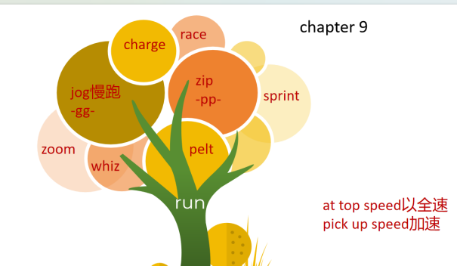

- He slapped Jake on the back.
slap /slæp/ ( -pp- )
1.to hit sb/sth with the flat part of your hand（用手掌）打，拍，掴
•She slapped his face hard.她狠狠给了他一个耳光。

Underline sentences indicating Kevin’s arrogance.
- He was still boasting to anyone who would listen
- One moment, Beadle was bragging about how easy the race had been.
boast /bəʊst/ 1. too much pride about sth that you have or can do自夸；自吹自擂
•She is always boasting about how wonderful her children are.她总是夸耀她的孩子们多么出色。
- to have sth that is impressive and that you can be proud of有（值得自豪的东西）
Chunhui High school boasts many amazing sites.

brag /bræɡ/ ( -gg- ) ~ to sb (about/of sth)
to talk too proudly about sth you own or sth you have done吹嘘；自吹自擂
•He bragged to his friends about the crime.他向朋友炫耀他的罪行。

- with a dazed look一脸茫然地 on his face, he staggered away in his socks
stagger v. /ˈstæɡə(r)/ 摇摇晃晃地走
1. [ + adv./prep.]to walk with weak unsteady steps, as if you are about to fall
摇摇晃晃地走；蹒跚；踉跄
•The injured woman staggered to her feet.受伤的女人摇摇晃晃地站起身来。
•He staggered home, drunk.他喝醉酒，踉跄着回了家

- The trainers hopped up into his arms. 跳到他怀里
hop /hɒp/ ( -pp- )
1.[ + adv./prep.] ( of a person/animal ) to move by jumping on one foot/both feet单脚跳行
He hurt one leg and had to hop everywhere.
A robin was hopping around on the path.一只知更鸟在小路上跳来跳去。

- Jake pulled a face and Anna grinned.做鬼脸=make a face

