2025年嘉兴市高三测试 应用文 学案
- 审题与谋篇布局
你校英文报“Campus Culture”栏目正在开展关于是否设立涂鸦墙（graffiti wall）的讨论，请你写一篇短文投稿，内容包括：你的见解；（2）你的建议。
Para.1___________________ Para.2______________________ Para.3________________________

二、分段构写
P1. 引出背景+明确观点+理由
语料1 直接引出话题+直接表达观点
1.When it comes to ______, people have taken/adopted different attitudes/opinions are divided. As far as I am concerned /From my perspective, I prefer _____based on the following reasons.
2.When it comes to/ In terms of…, I firmly believe/ I’m firmly convinced that it makes great sense/ it is of great significance.
客观陈述背景+直接表达观点+引起下文
1.Currently/Recently, there is a widespread/ growing concern over (the issue/phenomenon that …/heated discussion on (讨论议题). Personally, the answer is yes/no. Here are my reasons/ Reasons are as follows.
2.Recently the rise in the problem/phenomenon of...has caused /aroused/captured public/popular/wide
/worldwide concern. I believe/I hold the view (belief) that…/it makes great sense/ it is of great significance.
对比引出话题+委婉表达否定（让步状从）
1.Beneficial and rewarding as it is/While /although /though ....,, it would be unwise to …
鼓动性提出观点（祈使句）
1.Imagine working out everyday , feeling refreshed and satisfied
2.Grab a sprayer, and color the Graffiti Wall.

语料2：“设立涂鸦墙”的好处
- 作为一个展示创意的平台 _________________________________________
- 作为一个创意的发泄途径 _________________________________________
- 一种表达学生自我的方式 _________________________________________
- 缓解学术压力 _________________________________________
- 逃离学业奋斗 _________________________________________
- 美化校园 _________________________________________
- 用色彩和声音丰富校园文化 _________________________________________
- 鼓励积极交流 _________________________________________
“设立涂鸦墙”的弊端
- 有引入/传播冒犯性或有害内容的风险 _________________________________________
- 损坏学校其他财产/造成潜在损失 _________________________________________
- 影响学校的和谐 _________________________________________
- 导致学习时注意力不集中 _________________________________________
- 占用一些额外的时间 _________________________________________

- 直接引出话题+直接表达观点
- 当谈到学校是否应该建立涂鸦墙时，我坚定地认为这是很有意义的。涂鸦墙通常包含各种风格的绘画和留言，它可以成为学生展示艺术才华的活力平台，或是帮助他们将压力转化为多彩设计的宣泄途径。 （主句+which从句并列）
_________________________________________________________________________________________
_________________________________________________________________________________________
_________________________________________________________________________________________
- 客观陈述背景+直接表达观点+引起下文
- 最近，关于是否要建校园涂鸦墙的讨论引起广泛关注。从我的角度来看，答案是肯定的。学校里的涂鸦墙不仅能够可以成为学生自由表达的平台，而且（成为）从学业压力中解脱的途径，保障学生的心理健康。（主句并列+doing 后缀)
_________________________________________________________________________________________
_________________________________________________________________________________________
_________________________________________________________________________________________
- 对比引出话题+委婉表达否定（让步状从）
- 虽然在校园里设立涂鸦墙这个想法可能很有吸引力，但我认为这不是最佳选择/不是一个明智的选择。涂鸦，即使本意是作为艺术，可能会出现冒犯他人的不当内容。此外，它还可能会促使学生在其他学校财物上作画，从而造成潜在破坏。
_________________________________________________________________________________________
_________________________________________________________________________________________
_________________________________________________________________________________________
- 鼓动性提出观点（祈使句）
- 拿起喷漆(sprayer)，为涂鸦墙添彩，这不仅是一项活动，更是点燃学生热爱艺术和生活热情的重要一课。虽然这可能会占用一些额外时间，但它肯定会激发我们的想象力，并在长时间的学习过程中充当缓解压力的好帮手。
_________________________________________________________________________________________
_________________________________________________________________________________________
_________________________________________________________________________________________
- 想象一下，你拿起画笔，在画布上快速挥动，（在上面）自由地表达他们的创造力和多样的观点，为原本单调的校园角落注入生机。
_________________________________________________________________________________________
_________________________________________________________________________________________
_________________________________________________________________________________________

P2. 建议+理由

语料3：利用好衔接词: firstly, secondly, moreover, additionally...增强条理性
使用which非限定从和非谓语结构连词成句
常用表达：
- Firstly, considering /given that…，主句.... ; What' s more/Additionally, not only......, but also…
- 中间拓展部分，常用which定语从句/ allowing sb. to do/ making it possible for sb. to do/ leading to/ contributing to/to do 等表达
- 关于“建议”：1）I suggest doing sth. 2）I strongly recommend that/ It’s strongly recommended that...
- Doing sth. is a must 4） Why not…? 5）Were I you, I would …

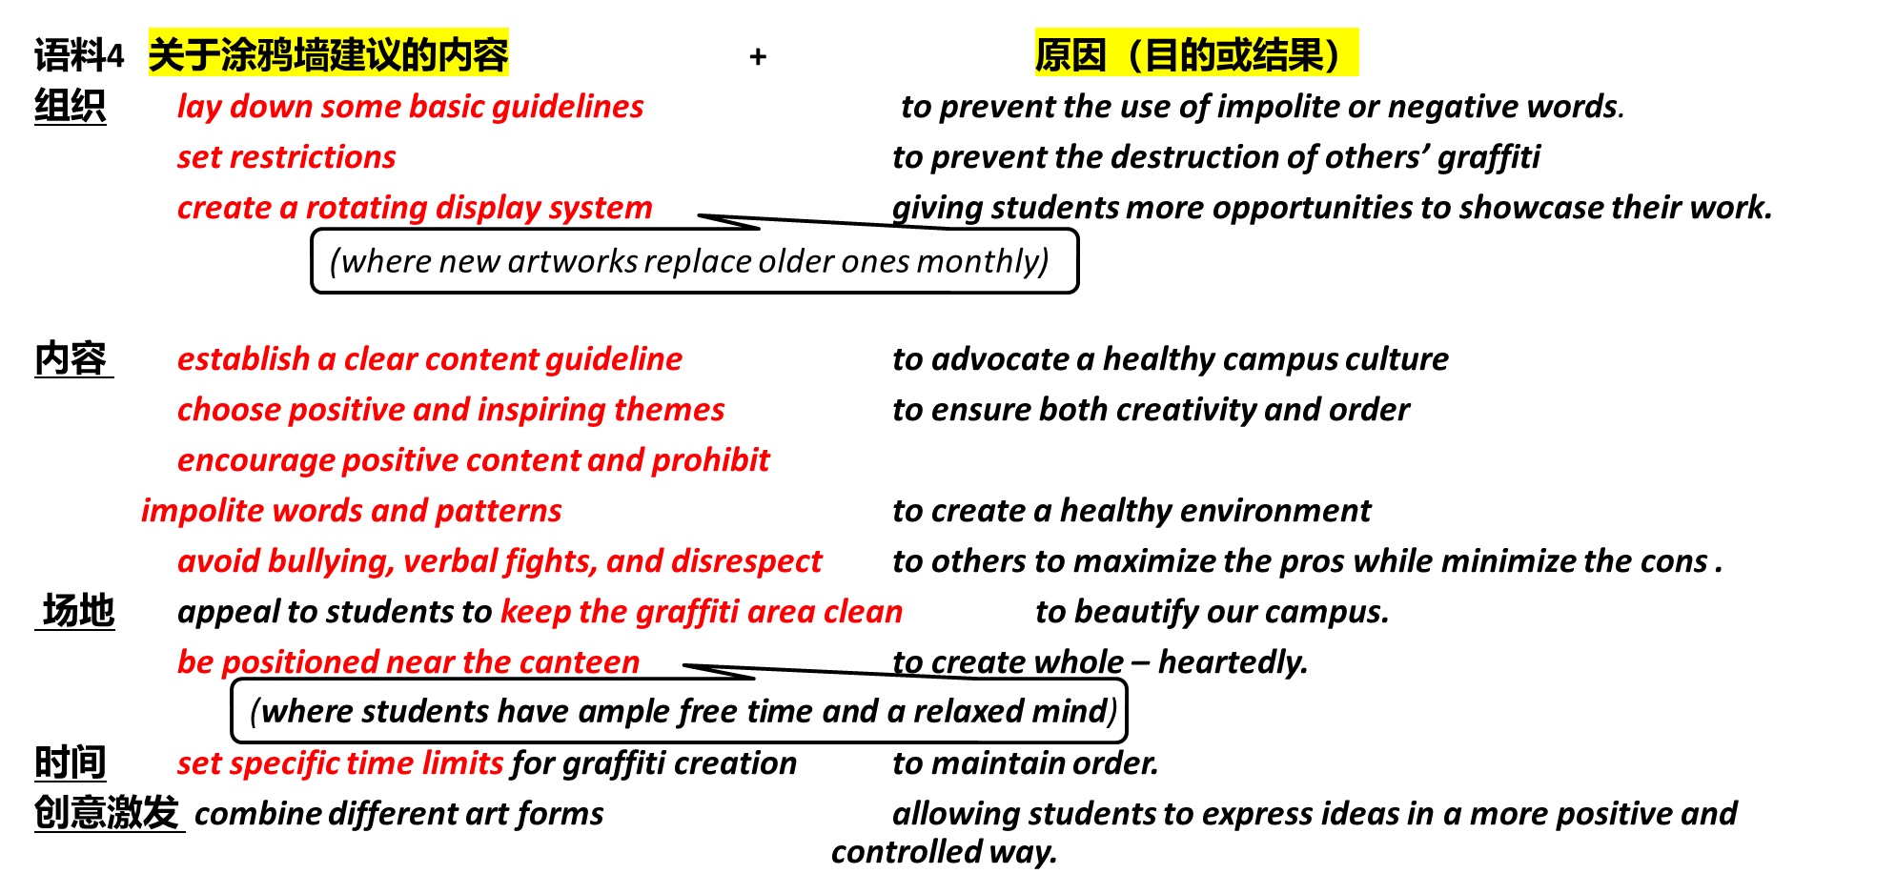

- 为确保涂鸦墙能良好运作，我建议我们学校制定一些基本准则。例如，我们可以为墙的不同区域设定指定主题。此外，应鼓励积极的内容，比如励志名言和令人振奋的艺术作品，以倡导健康的校园文化。
_________________________________________________________________________________________
_________________________________________________________________________________________
_________________________________________________________________________________________
2.我建议将其设置在食堂附近，学生在那里有充足的空闲时间，心情放松，能够全身心投入创作。 同时，学校应该制定一些规则，避免欺凌、言语冲突和对他人的不尊重。
_________________________________________________________________________________________
_________________________________________________________________________________________
_________________________________________________________________________________________
3.要建立一个美丽和健康的涂鸦墙，最好能制定一套明确的内容指导方针，由教师和学生代表共同制定，强调积极的主题，同时允许艺术创作上的灵活性。同样重要的是设定限制措施，防止他人的涂鸦被破坏，以及禁止使用不文明或负面的文字。
_________________________________________________________________________________________
_________________________________________________________________________________________
_________________________________________________________________________________________

P3. 重申观点

语料5
1. Hence/Accordingly/ In conclusion/To sum up, 再次阐明个人观点, which +意义(not only… but also…)
2. To sum up/In a word, we should….. Only in this way/through... can we …
+表结果：therefore, thus, as a result, so (that), consequently

1. 总之，通过精心设计和合适的策划，涂鸦墙一定会成为我们翱翔天际的艺术地标。
_________________________________________________________________________________________
_________________________________________________________________________________________
2. 总之，建立涂鸦墙不仅能够激发创造力，而且能够丰富校园生活。让我们把它变成现实（祈使句）。
_________________________________________________________________________________________
_________________________________________________________________________________________
3. 希望，一旦这些问题得到解决，涂鸦墙的建立能为我们学校注入新的活力，成为我们丰富多彩、美好的青春的一个充满活力的地标（once从句+主句+后缀doing）。
_________________________________________________________________________________________
_________________________________________________________________________________________

参考范文背诵：
1. 拿起喷漆罐，为涂鸦墙增添色彩。这不仅是一项活动，更是点燃学生热爱艺术、热爱生活热情的重要一课。尽管它可能会占用一些课余时间，但无疑能激发我们的想象力，还能在漫长的学习过程中起到缓解压力的作用。
要打造一面美观且健康的涂鸦墙，最好制定清晰的内容准则，由教师和学生代表共同制定，既要强调积极主题，又要给予艺术创作一定灵活性。同样重要的是设置限制措施，防止他人的涂鸦作品被破坏，避免使用不礼貌或消极的言辞，杜绝霸凌、言语冲突和对他人的不尊重行为。
总之，设立涂鸦墙不仅能激发创造力，还能丰富校园生活。让我们行动起来吧。
_________________________________________________________________________________________
_________________________________________________________________________________________
_________________________________________________________________________________________
_________________________________________________________________________________________
_________________________________________________________________________________________
_________________________________________________________________________________________
_________________________________________________________________________________________
_________________________________________________________________________________________
_________________________________________________________________________________________
_________________________________________________________________________________________
_________________________________________________________________________________________
_________________________________________________________________________________________
2. 设立一面涂鸦墙会是个很棒的主意。涂鸦墙通常包含各种风格的绘画和留言。它可以成为学生展示艺术才华的活力平台，或是帮助他们将压力转化为多彩设计的一个宣泄途径。
为确保涂鸦墙能良好发挥作用，我建议学校制定一些基本准则。例如，我们可以为墙的不同区域设定指定主题。此外，应鼓励积极的内容，比如励志名言和振奋人心的艺术作品，以此倡导健康的校园文化。
Should We Establish a Graffiti Wall?（支持版：背诵）
Establishing a graffiti wall on campus would be a fantastic idea. A graffiti wall usually contains various styles of paintings and messages. It could serve as a dynamic platform for students to showcase their artistic talents, or an outlet that helps them transform pressures into colorful designs.
To ensure the graffiti wall functions well, I suggest our school lay down some basic guidelines. For instance, we could have designated themes for different sections of the wall. Furthermore, positive content, such as motivational quotes and uplifting artworks, should be encouraged to advocate a healthy campus culture.

Should We Establish a Graffiti Wall?（反对版：赏析）
While the idea of establishing a graffiti wall on campus may seem appealing, I believe it is not the best choice. Graffiti, even when intended as art, could lead to inappropriate messages offending others. It may also encourage students to paint on other school property, leading to potential damage.
I suggest creating an art zone where students display pre-approved artworks, ensuring both creativity and order. Alternatively, organizing teacher-guided collaborative art projects, like painting on large canvases, could channel students’ energy into structured creations. These alternatives balance freedom and responsibility, fostering a vibrant yet orderly campus culture.

