The World（0416-0430）材料分析和教学目标：
本次选用的材料：①Reader’s Digest的Write Your Own Nature Prescription（大自然疗愈法）、②The Times 的 Walking groups help Gen Zers give loneliness the muddy boot （步行团体帮助z世代摆脱孤独）、③BBC Wildlife的Salamanders have blood-powered toes（蝾螈有血液驱动的脚趾）、④Scientific American 的Graceful Flop（高速摄像揭示蟋蟀蛙水面运动机制）和⑤BBC的新闻报道。通过语法填空、阅读理解、分析长难句、翻译句子、听力填空和词汇拓展等方式，让学生从多角度提升学习兴趣，提高分析句子、运用词块和听力能力。外媒英语新闻可以让学生体验真实语境下的语言运用，拓展学生的国际视野，了解时事，逐步提升跨文化沟通能力，形成正确的世界观、人生观和价值观。

教学思路：
Part 1: News Report 1 Reader’s Digest (May/June, 2025 P63)
Write Your Own Nature Prescription 大自然疗愈法
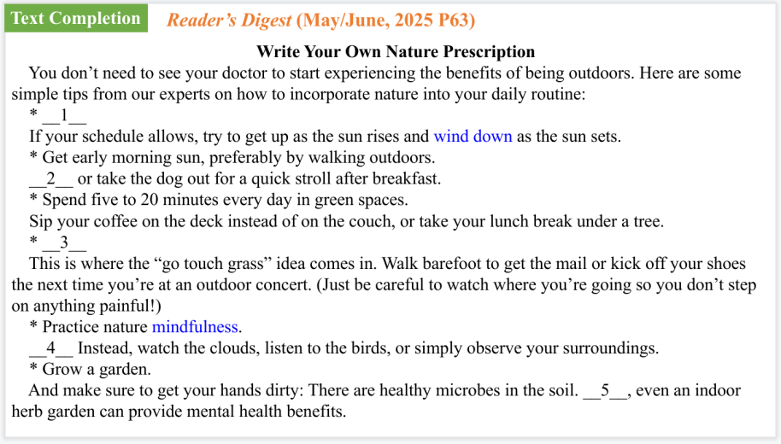
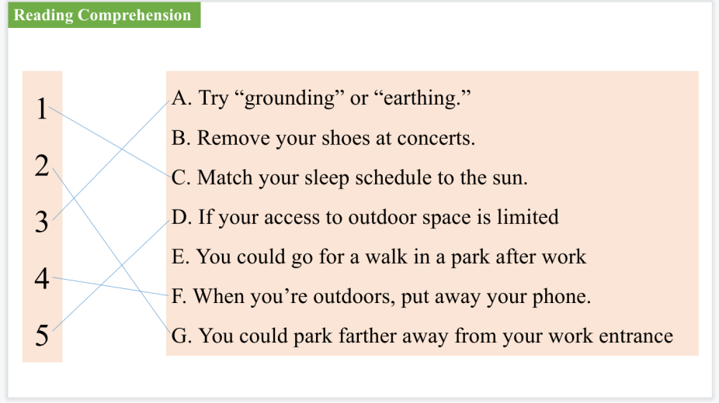
【设计意图】通过阅读七选五的形式帮助学生理解文章的主要内容。该文章主题语境是关于“人与自然”这一主题，通过学习让学生了解大自然疗愈法。
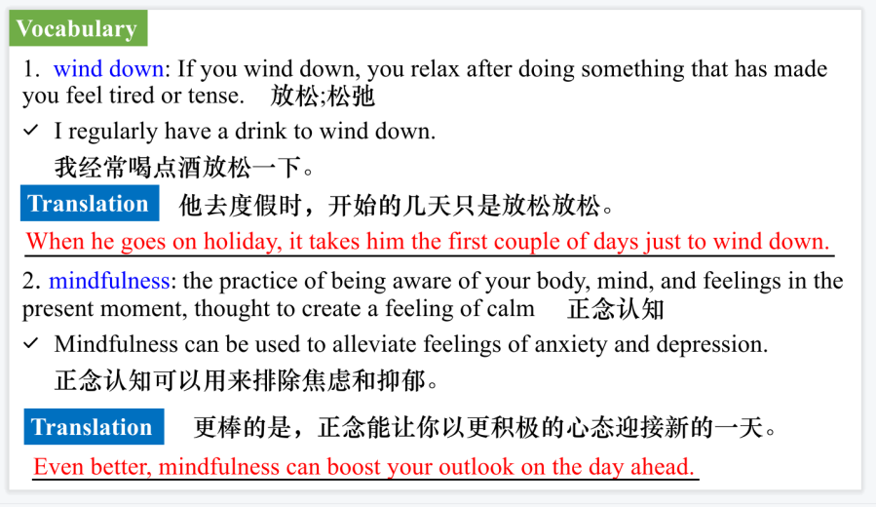
【设计意图】对文本中的词汇进行解读，并通过翻译句子对其进行巩固。

Part 2: News Report 2 The Times (April 24, 2025 P11 )
Walking groups help Gen Zers give loneliness the muddy boot
（步行团体帮助z世代摆脱孤独）
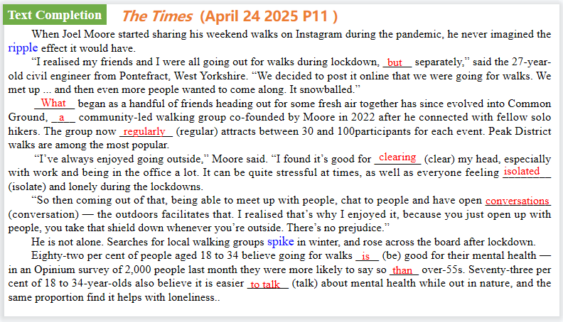
【设计意图】通过语篇填空的形式帮助学生理解新闻的主要内容，同时训练语言语法的运用能力：在语篇的视角下如何正确使用所给词汇，根据语法规则确定词汇的正确形式，使得文章通顺，激活学生的思维和语言。该新闻主题语境是关于“人与社会”中“体育活动、大型休育赛事、休育与健康、体育精神”这一子主题，通过学习让学生了解步行团体帮助z世代摆脱孤独。
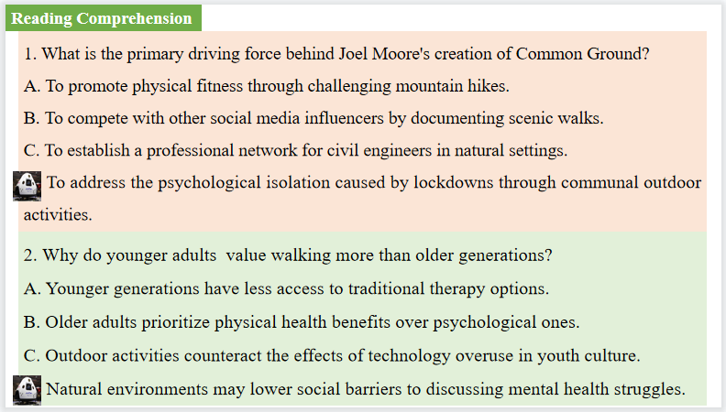
【设计意图】通过阅读理解的形式帮助学生理解新闻的内容的细节，提升学生的根据上下文的猜词能力。
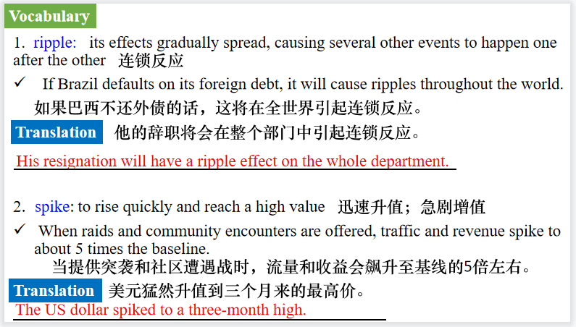
【设计意图】对文本中的词汇进行解读，并通过翻译句子对其进行巩固。
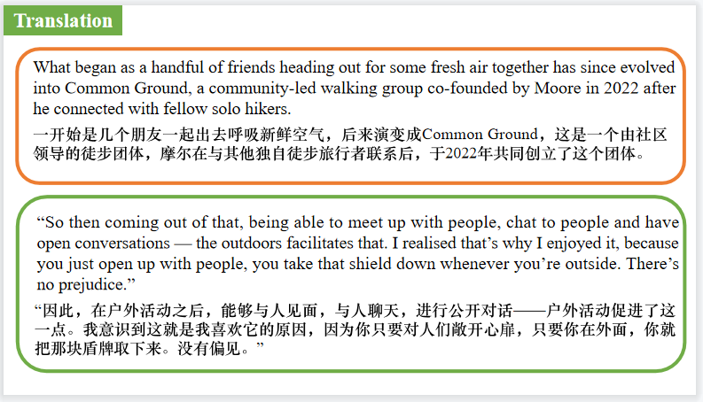
【设计意图】对文中的两个句子进行翻译练习，对其中单词、词组、句法进行巩固并关注句子结构。

Part 3: News Report 3 BBC Wildlife（April, 2025 P15)
Salamanders have blood-powered toes蝾螈有血液驱动的脚趾
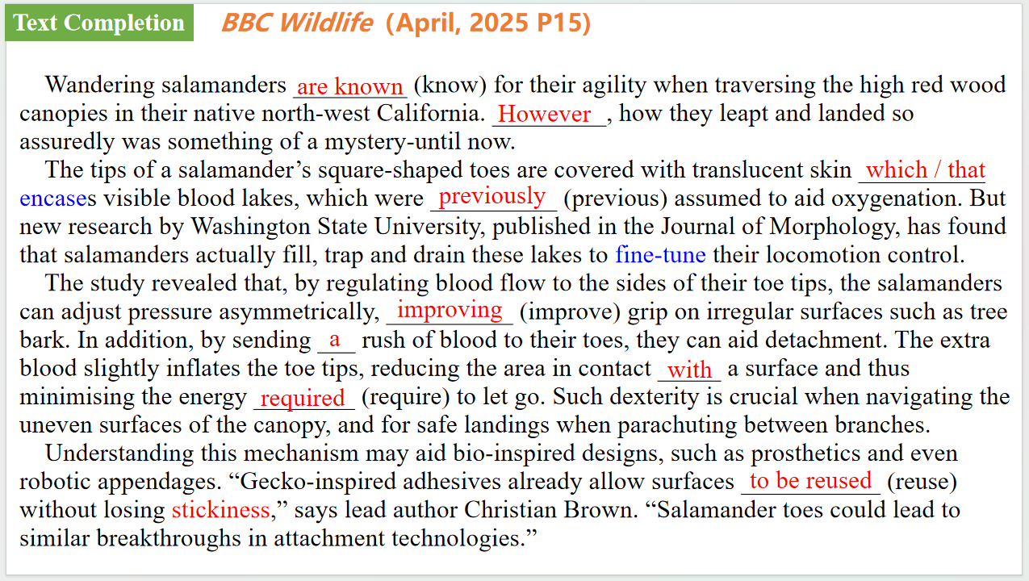
【设计意图】通过语篇填空的形式帮助学生理解新闻的主要内容，同时训练语言语法的运用能力：在语篇的视角下如何正确使用所给词汇，根据语法规则确定词汇的正确形式，使得文章通顺，激活学生的思维和语言。该新闻主题语境是关于“人与自然”中“自然科学研究成果”这一子主题，通过学习让学生了解蝾螈有血液驱动的脚趾的科学发现。

【设计意图】对文本中的词汇进行解读，并通过翻译句子对其进行巩固。
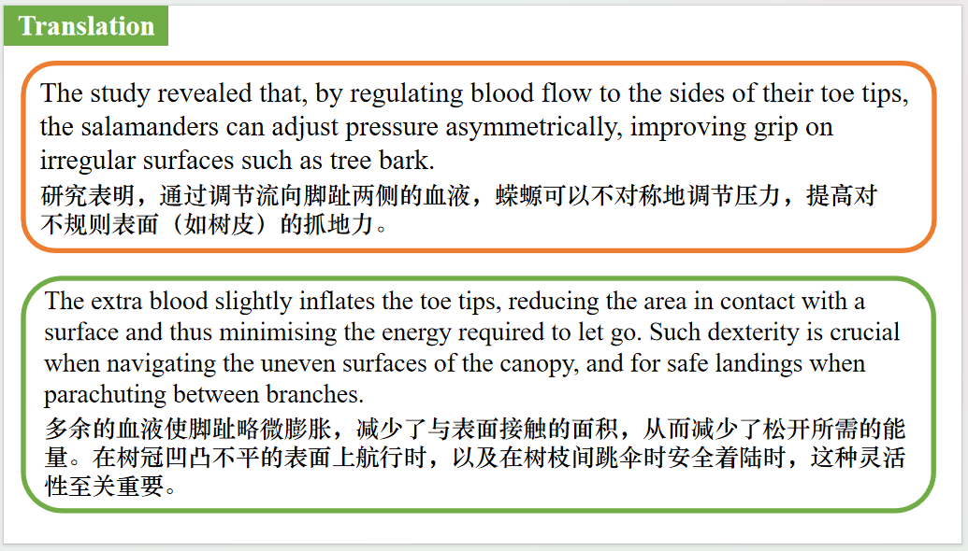
【设计意图】对文中的两个句子进行翻译练习，对其中单词、词组、句法进行巩固并关注句子结构。

Part 4: News Report 3 Scientific American（April , 2025 P13)
Graceful Flop 高速摄像揭示蟋蟀蛙水面运动机制
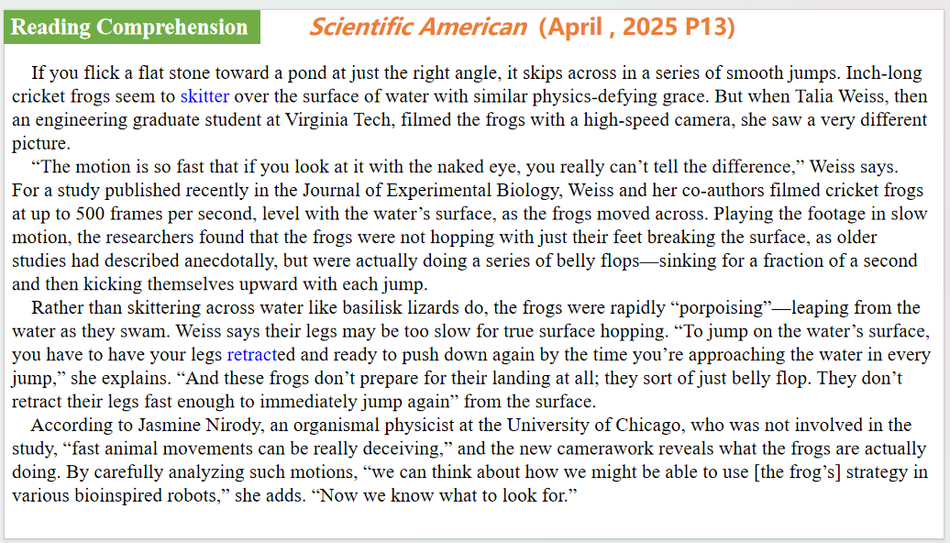
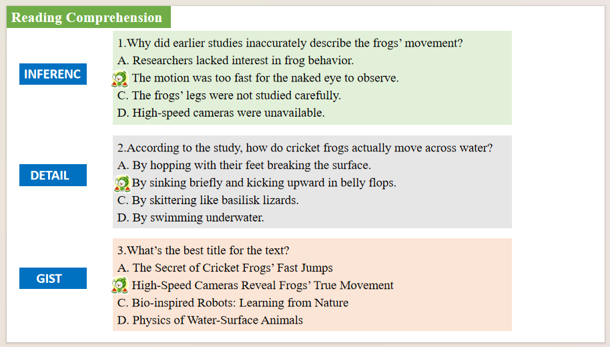
【设计意图】通过阅读理解的形式帮助学生理解新闻的内容的细节，提升学生的根据上下文的猜词能力。该新闻主题语境是关于“人与自然”中“自然科学研究成果”这一子主题，通过学习让学生了解高速摄像揭示蟋蟀蛙水面运动机制的科学发现。

【设计意图】对文本中的词汇进行解读，并通过翻译句子对其进行巩固。
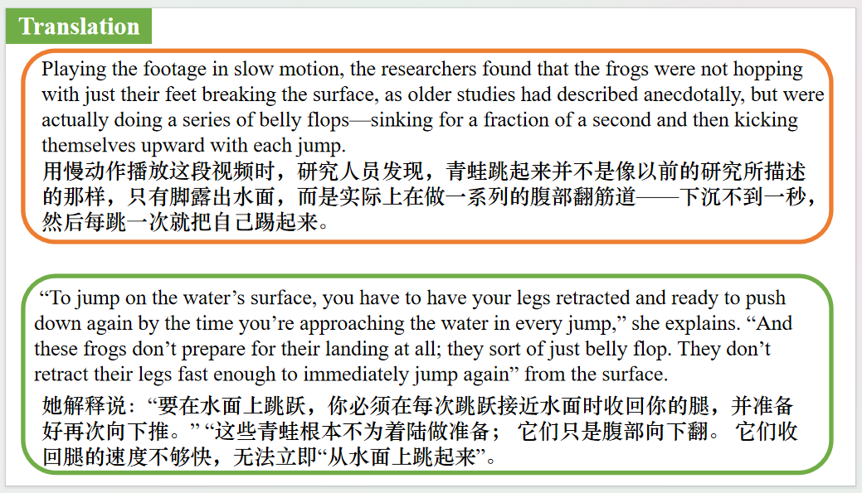
【设计意图】对文中的两个句子进行翻译练习，对其中单词、词组、句法进行巩固并关注句子结构。

Part 5: BBC News 04/28/2025

【设计意图】听一则材料，通过听力填空的方式理解文本，考察听力辨识词汇的能力。
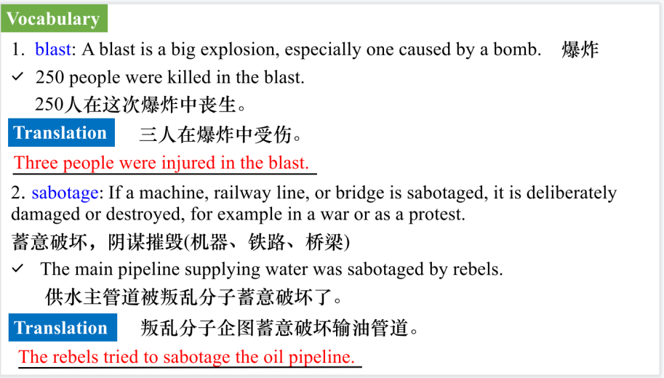
【设计意图】对文本中的词汇进行解读，并通过翻译句子对其进行巩固。

【设计意图】对文中的两个句子进行翻译练习，对其中单词、词组、句法进行巩固并关注句子结构。

附：外刊原文

Part 1: News Report 1 Reader’s Digest (May/June, 2025 P63)
Write Your Own Nature Prescription 大自然疗愈法
Write Your Own Nature Prescription
You don’t need to see your doctor to start experiencing the benefits of being outdoors. Here are some simple tips from our experts on how to incorporate nature into your daily routine:
* Match your sleep schedule to the sun.
If your schedule allows, try to get up as the sun rises and wind down as the sun sets.
* Get early morning sun, preferably by walking outdoors.
You could park farther away from your work entrance or take the dog out for a quick stroll after breakfast.
* Spend five to 20 minutes every day in green spaces.
Sip your coffee on the deck instead of on the couch, or take your lunch break under a tree.
* Try “grounding” or “earthing.”
This is where the “go touch grass” idea comes in. Walk barefoot to get the mail or kick off your shoes the next time you’re at an outdoor concert. (Just be careful to watch where you’re going so you don’t step on anything painful!)
* Practice nature mindfulness.
When you’re outdoors, put away your phone. Instead, watch the clouds, listen to the birds, or simply observe your surroundings.
* Grow a garden.
And make sure to get your hands dirty: There are healthy microbes in the soil. If your access to outdoor space is limited, even an indoor herb garden can provide mental health benefits.

Part 2: News Report 2 The Times (April 24, 2025 P11 )
Walking groups help Gen Zers give loneliness the muddy boot
（步行团体帮助z世代摆脱孤独）
When Joel Moore started sharing his weekend walks on Instagram during the pandemic, he never imagined the ripple effect it would have.
“I realised my friends and I were all going out for walks during lockdown, but separately,” said the 27-year-old civil engineer from Pontefract, West Yorkshire. “We decided to post it online that we were going for walks. We met up ... and then even more people wanted to come along. It snowballed.”
What began as a handful of friends heading out for some fresh air together has since evolved into Common Ground, a community-led walking group co-founded by Moore in 2022 after he connected with fellow solo hikers. The group now regularly attracts between 30 and 100
participants for each event. Peak District walks are among the most popular.
“I’ve always enjoyed going outside,” Moore said. “I found it’s good for clearing my head, especially with work and being in the office a lot. It can be quite stressful at times, as well as everyone feeling isolated and lonely during the lockdowns.
“So then coming out of that, being able to meet up with people, chat to people and have open conversations — the outdoors facilitates that. I realised that’s why I enjoyed it, because you just open up with people, you take that shield down whenever you’re outside. There’s no prejudice.”
He is not alone. Searches for local walking groups spike in winter, and rose across the board after lockdown.
Eighty-two per cent of people aged 18 to 34 believe going for walks is good for their mental health — in an Opinium survey of 2,000 people last month they were more likely to say so than over-55s. Seventy-three per cent of 18 to 34-year-olds also believe it is easier to talk about mental health while out in nature, and the same proportion find it helps with loneliness.
These findings suggest that walking groups could be a simple but powerful tool in tackling Britain’s loneliness epidemic.
A new generation is reclaiming walking as more than a step-counting exercise. From LGBTQ hiking collectives and women-led rambling clubs to Whats App-based meets, these groups offer a way to connect with others,often free of charge.
Others are taking notice. A Common Ground walk in Box Hill, Surrey, hosted with Southern Rail and the mental health charity Mind, issued 200 free tickets in a matter of hours.
Hayley Jarvis, head of physical activity at Mind, said: “Walking groups can help us to build social connections and social support.
“That, in turn, can reduce loneliness, improve our self-esteem and provide a sense of motivation. Unlike working out in the gym or other indoor activities, the colours, sounds and smells we find outdoors stimulate our senses in a different way and can boost our mood.”
Southern Rail said that it wanted to encourage people to “reset in nature via the rail network”.
Moore suggests the cost of living plays a role too. “It’s affordable. You can make it as cheap or expensive as you want. And it’s accessible — you can just walk out your front door,” he said.
Hannah da Silva, 25, founded Gorp Girls, a women-only hiking group, in 2021. Its members now regularly depart from London Victoria to hiking spots across the country. “I’m able to clear my head easier when out in nature, and it’s easier to talk about mental health,” da Silva said. “Community is really important for Gen Z and millennials. People are looking for ways to escape city life.”
With demand rising and groups continuing to grow, what started as a lockdown hobby is fast becoming a movement.

Part 3: News Report 3 BBC Wildlife（April, 2025 P15)
Salamanders have blood-powered toes蝾螈有血液驱动的脚趾
Wandering salamanders are known for their agility when traversing the high red wood canopies in their native north-west California. However, how they leapt and landed so assuredly was something of a mystery-until now.
The tips of a salamander’s square-shaped toes are covered with translucent skin that encases visible blood lakes, which were previously assumed to aid oxygenation. But new research by Washington State University, published in the Journal of Morphology, has found that salamanders actually fill, trap and drain these lakes to fine-tune their locomotion control.
The study revealed that, by regulating blood flow to the sides of their toe tips, the salamanders can adjust pressure asymmetrically, improving grip on irregular surfaces such as tree bark. In addition, by sending a rush of blood to their toes, they can aid detachment. The extra blood slightly inflates the toe tips, reducing the area in contact with a surface and thus minimising the energy required to let go. Such dexterity is crucial when navigating the uneven surfaces of the canopy, and for safe landings when parachuting between branches.
Understanding this mechanism may aid bio-inspired designs, such as prosthetics and even robotic appendages. “Gecko-inspired adhesives already allow surfaces to be reused without losing stickiness,” says lead author Christian Brown. “Salamander toes could lead to similar breakthroughs in attachment technologies.”

Part 4: News Report 3 Scientific American（April , 2025 P13)
Graceful Flop 高速摄像揭示蟋蟀蛙水面运动机制
If you flick a flat stone toward a pond at just the right angle, it skips across in a series of smooth jumps. Inch-long cricket frogs seem to skitter over the surface of water with similar physics-defying grace. But when Talia Weiss, then an engineering graduate student at Virginia Tech, filmed the frogs with a high-speed camera, she saw a very different picture.
“The motion is so fast that if you look at it with the naked eye, you really can’t tell the difference,” Weiss says.
For a study published recently in the Journal of Experimental Biology, Weiss and her co-authors filmed cricket frogs at up to 500 frames per second, level with the water’s surface, as the frogs moved across. Playing the footage in slow motion, the researchers found that the frogs were not hopping with just their feet breaking the surface, as older studies had described anecdotally, but were actually doing a series of belly flops—sinking for a fraction of a second and then kicking themselves upward with each jump.
Rather than skittering across water like basilisk lizards do, the frogs were rapidly “porpoising”—leaping from the water as they swam. Weiss says their legs may be too slow for true surface hopping. “To jump on the water’s surface, you have to have your legs retracted and ready to push down again by the time you’re approaching the water in every jump,” she explains. “And these frogs don’t prepare for their landing at all; they sort of just belly flop. They don’t retract their legs fast enough to immediately jump again” from the surface.
According to Jasmine Nirody, an organismal physicist at the University of Chicago, who was not involved in the study, “fast animal movements can be really deceiving,” and the new camerawork reveals what the frogs are actually doing. By carefully analyzing such motions, “we can think about how we might be able to use [the frog’s] strategy in various bioinspired robots,” she adds. “Now we know what to look for.”

