“OBE”教育理念与逆向设计在读后续写教学中的应用
A Leap of Courage: Wings of Hope
—咸阳市2025年高考模拟检测二读后续写
礼泉县教育局教研室 高小聪
一、课程背景与设计依据
（一）读后续写存在问题
高三学生已掌握基本语言知识，但续写中存在以下问题：情节发展逻辑松散，与原文情境衔接不足；语言表达单一，缺乏情感描写与细节刻画；对评分标准中的 “内容完整性”、“语法多样性”、与上下文的衔接和全文的连贯性”理解模糊。
（二）读后续写理论依据
根据《普通高中英语课程标准（2017年版2020年修订）》之规定，普通高中学生要想参加高考，就必须做到以下之要求： 1．能在书面表达中有条理地描述自己或他人的经历，阐述观点，表达情感态度；能描述事件发生、发展的过程；能描述人或事物的特征、说明概念；能概述所读语篇的主要内容或续写语篇。 2．能在表达过程中有目的地选择词汇和语法结构，确切表达意思，体现意义的逻辑关联性；能使用多模态语篇资源，达到特殊的表达效果。 第一条是高考书面表达的内容要求，第二条是语言质量的要求。
成果导向教育（OBE）：以 “学生最终能写出符合高分标准的续写” 为目标，逆向设计教学活动。
逆向教学设计：按 “确定预期效果→设计评价方法→规划教学活动” 三阶段实施。
二、预期学习成果（OBE 导向）
阶段1——预期学习成果
参照目标：
《普通高中英语课程标准（2017年版2020年修订）》
能在书面表达中有条理地描述自己或他人的经历，阐述观点，表达情感态度；能描述事件发生、发展的过程；能描述人或事物的特征、说明概念；能概述所读语篇的主要内容或续写语篇。
能在表达过程中有目的地选择词汇和语法结构，确切表达意思，体现意义的逻辑关联性；能使用多模态语篇资源，达到特殊的表达效果。
第一条是高考书面表达的内容要求，第二条是语言质量的要求。
理解：  学生将理解：  1.原文大意，捕捉关键语言特征并在续写中模仿运用。  2.能识别原文情节逻辑链条（Sam 的恐惧→救助雨燕的动机→飞行的决定），并构建与之连贯的续写框架。  3.准确使用高级词汇（如 “flutter”“soar”）和复杂句型（状语从句、非谓语动词）。  4.运用直接引语、心理描写等手法增强故事感染力。 | 基本问题：  - What’s the text type?  - What’s the discourse pattern?  - What’s the thematic context?  - What’s the main idea(5W+1H)?  - Why did the story happen?  (Intention /values）  - What’s the ending of the story?
学生将知道:  - 原文情节逻辑链条（Sam 的恐惧→救助雨燕的动机→飞行的决定），并构建与之连贯的续写框架。  - 原文运用的各种写作技巧。 | 学生将能够：  At the end of the class, you will be able to  1. learn to make the given text and the continued-writing part keep in harmony.  2. Correct problems and explore highlights.  3. Develop a review plan for continuation writing.
阶段2——评估证据
表现任务：
确保续写部分与所给文本保持情节连贯性和情感一致性。
你的任务是：
阅读下面材料,根据其内容和所给段落开头语续写两段,使之构成一篇完整的150词左右的短文。
高考读后续写评分程序、原则及标准：
- 评分程序
- 初定档次：根据主题、结构和情节确定所属档次
- 调整分数：从内容完整性、语言准确性、连贯性等维度细化评分
- 评分原则
1. 总分25分，分5档评分
2. 单段续写最高12.5分
3. 词数130-170词，超出范围扣2分
4. 书写差影响交际降一档
5. 英美拼写均可接受
三、评分标准
第五档 (优) (21-25分）内容完整新颖，逻辑完全一致，语言高级多样，衔接自然流畅
第四档 (良) (16-20分) 内容合理连贯，逻辑一致，语言较多样准确，衔接有效
第三档 (中) (11-15分) 内容基本完整，逻辑基本一致，语言简单正确，衔接基本清晰
第二档 (差 ) ( 6-10分)内容不完整，逻辑混乱，语言错误多，衔接差
第一档 (极差) (1-5分)内容严重脱节，逻辑断裂，语言无法理解，无衔接
0分 未作答/无关内容/全抄原文
注：评分重点关注三点：
- 内容与原文的连贯性（情节发展、人物性格、情感逻辑）
- 语言准确性（语法、词汇、拼写）
3. 篇章衔接（段落过渡、句间连接）
阶段3——学习计划
Learning Plan
- 介绍读后续写存在的问题、本课的最终目标和量规。
- 重析2025年咸阳市二模英语读后续写。
- 依据读后续写评分标准，采用人机协同（机评+师评+自评）来分析评价学生的考场作文。
- 依据评价结果，让学生反思、改进提升。
- 二轮复习读后续写建议
阶段4. 教学活动设计
Ⅰ. Clarify the teaching objectives of this class.
Ⅱ.Read the scoring principles and standards for continuation writing carefully.
Ⅲ.Carry out the learning plan
Step1. (Analyse)回归续写文本
第二节 (满分 25 分) （咸阳市2025年高考模拟检测二读后续写）
阅读下面材料,根据其内容和所给段落开头语续写两段,使之构成一篇完整的短文。
I burst into Mom's study, waving a brilliant feather like a tiny treasure, “Mom, look what I found! It's a feather from a Vaux's swift (沃氏雨燕) I've been looking for this one for ages!” I bounced on my toes, unable to contain my excitement.
Mom glanced up from her books and smiled, “ it's beautiful!” she said, then took a deep breath“Sam , next week I will be flying a biplane in the airshow, Would you like to join me?”
I froze. Even the slightest thought of flying made my stomach twist and turn , let alone flying in a biplane—with an open cockpit (驾驶舱) where you could look down and see how far you were from the ground. “No thanks, Mom. Sorry.” I replied as I headed upstairs to my room. With each heavy step, I tried to convince myself—planes are safe, Mom is an amazing pilot and she deserves a brave son. But no matter how much I repeated it, the fear clung to me like a shadow.
That afternoon, while walking home from school, my best friend, Emily, called out, holding a birdcage. “Sam, look! It's a Vaux's swift! I think it got hurt during migration—maybe its natural enemy tried to catch it. The injury isn't too bad, and it should heal in about a week. But the problem is... its all alone. Its flock is gone." My chest tightened. “We have to help it find its flock again.” I said worriedly, “If it doesn't, it won't survive the winter. " Emily nodded , “It's so heartbreaking to see it left behind.”
As the days passed and the little bird grew stronger, I couldn't stop thinking about how to help it. Then, like a flash of light , a thought sparked in my head. No matter how scary or impossible it seemed , l was going to make sure this tiny bird caught up with its flock.
On the morning of the airshow, I found Mom. I took a deep breath to steady my pounding heart and declared with determination, “Mom, I'm ready to fly with you today.”
注意:1.续写词数应为150左右;
2.请按如下格式在答题卡的相应位置作答。
Mom's eyes widened in surprise , but a proud smile quickly spread across her face. ______________________________________________
As the biplane rose into the sky, I held the birdcage tightly in my arms._______________________________________________________
Read the writing task to finish the tasks below.
- Extract the key clues, filter out the useful information
Draw out the story mountain of the given article (见图1）
- What’s the main idea of the given text?
Sam, fond of birds but afraid of 1______ , he 2_______ to fly a biplane with his pilot mother in an air show. Later, to help an 3_______Vaux's swift (沃氏雨燕)with his friend , he 4_________ his psychological barrier in the end. On the day of the air show, he 5_____a biplane together with his mother and led the little bird 6________(catch) up with the migrating bird flock.
3.What’s its theme?
Courage and ___________
Love and ______________
Harmonious ____________ between Humans and Animals
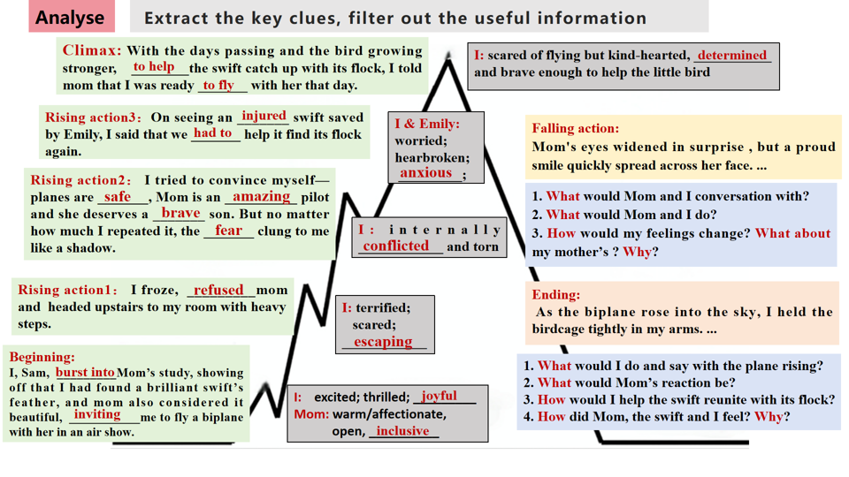

（图1）
Step2. (Evaluate)评价考场作文
According to the scoring criteria for continuation writing after, please
grade and score the following composition, focusing on the harmony of the given text and continued writing (continuation of the plot, inheritance of the language, consistency of the characters).
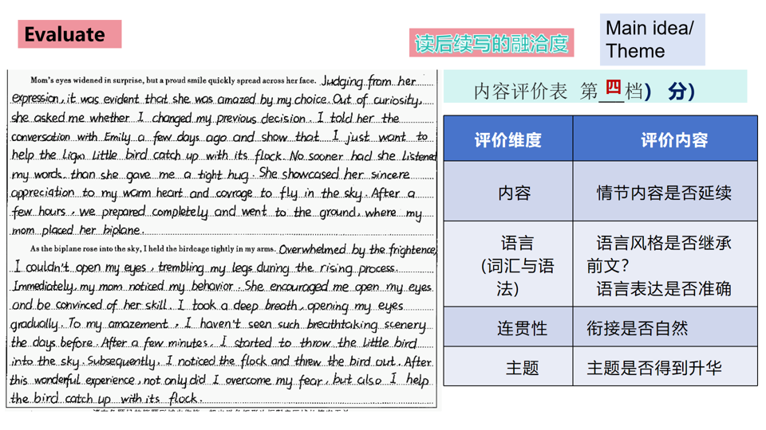
Step3 .(Improve)改进提升优化
★续写改进提升任务表
要求 | 内容
续写第1段和第2段 | 改正习作中的单词拼写、语法错误
第一段③句和④句改写成直接引语言 | "________________" asked mother _________but excitedly, I stammer in slightly nervous tone,"_____________."
改写第一段⑤句 | 非谓语动词作状语  ___________________, she gave me a tight hug.  介词短语做状语  ________________, she gave me a tight hug.
Coherence：  续写第1段最后一句与续写第2段第①句衔接自然 | 微技能5（句式）: with复合结构/ 独立主格结构，主语+谓A +谓B +谓C.  Afterwards, _____________, we ________the birdcage, _______ the hardstand and ___________the open cockpit.
Coherence：  续写第2段第②句与第①句衔接自然；  改写续写第2段第②句  （增强细节描写，丰富情感与画面感。） | 句式1. 倒装句（用...so...that...引导的结构状语从句）  So frightened was I that I wasn’t afraid to open my eyes, my legs trembling with the plane rising.
句式2. 用...too ...to...改写
I was too frightened to open my eyes with the plane rising.
句式3. 两个形容词短语作状语
Frightened and panicked, I didn’t dare to open my eyes with the plane rising.
句式4. 巧用无灵主句
A wave of fright/panic overwhelmed me so suddenly that I didn’t open my eyes with the plane rising.
句式5. 利用五感法
The continuous roar of the biplane during the rising process made my legs trembling and eyes closed tightly.
改写续写第2段第③、④、⑤句 | Immediately my mom noticed my_____________, encouraging me,“__________________________________.”  I _________ (breath) deeply and tried to calm ______  (I) down.
续写第2段第⑥句 (景色是什么？） | To my amazement, I had never seen such breathtaking scenery before：_____________，_______________ and _______________
第二段第⑦句和第⑧句改写 | At that time, “Look, there flies a flock of swifts!” cried mother merrily. I quickly I _________the birdcage, and it hesitated for a while, burst into the air and joined its family with a cheerful cry.
你的续写结尾（主题升华） | Courage and growth  During the process of helping the swift catch up with its flock in the biplane, I picked up my _________, faced the challenge and achieved inner. _________.  Love and Responsibility  By helping the swift, I come to realized that ______ and _____________ can strengthen our courage and ______________.  Harmonious Coexistence between Humans and Animals  Helping the bird return to its family makes me regain courage and confidence. So only when humans and animals _______harmoniously, will we be able to have a _________life.
★ 重新构思续写部分
Mom’s eyes widened in surprise, but a proud smile quickly spread across her face. Judging from her expression, she 1____________(astonish) by my choice. "Why have you changed your idea?" asked mother 2__________(gentle), I stammered ," Emily saved an injured swift the other day, and... and I’m 3__________(help) it catch up with its flock. 4_________hearing my words, she gave me a tight hug. She showcased her sincere 5_________________(appreciate) for my warm heart and courage to fly in the sky. Afterwards, everything 6___________(prepare), we carried the birdcage, headed for the hardstand (停机坪) and climbed into the open cockpit (驾驶舱).
As the biplane rose into the sky, I held the birdcage tightly in my arms. Frightened and 7___________(panic) panicked, I felt my legs trembling with the plane 8________(rise). Immediately, my mom noticed my scare and 9___________(anxious) , comforting me , “ Take it easy, trust me and we’ll make ______.” I tried to calm myself down. Just then, An V-shaped formation in the sky 11__________( catch) our eye—the flock! I opened the birdcage with care and the swift hesitated for a while, 12_________(burst) into the air and reunited with its family with a 13____________ (cheer) cry. Mother and I also exchanged a 14__________(know) and proud smile. After this wonderful experience, not only did I overcome my fear, but I also helped the bird catch up with its flock.
Step4 (Develop) 制定续写计划
Level1. 整理读后续写前文和续写部分的词汇、句型。
Level2. 画出这篇文章的故事山(情节、情感、人物)。
Lever3. 重新构思完成写作任务。

