Book1 Unit1
Expanding your world-Teenage Life around the World
Learning Objectives
- Understand key information about teenagers from Tanzania, Bangladesh, and Germany.
- Appreciate different teenage lifestyles across cultures.
- Reflect on one’s own life and develop empathy, responsibility, and global awareness.

Teaching Key Points
- Extract and compare details from the texts.
- Express personal teenage life using learned structures.

Teaching Difficulties
- Cultural understanding and comparison.
- Writing a coherent and personal paragraph in English.
Teaching Procedure

Activity1: Lead-in (5 minutes)
Ask students:
What is your school life like?
How do you feel?
What is your hobby?
I like/enjoy _____ because_________.
What do you want to do in the future?
I want to _________ because ______________.
Activity2: Raise questions
What do you want to learn from the text?
Raise questions start with“wh-”
Activity3: Deep explaraion
What kind of person do you think Asha is?
Try to find out which aspects(方面）are mentioned when introducing Samika and Frieder?
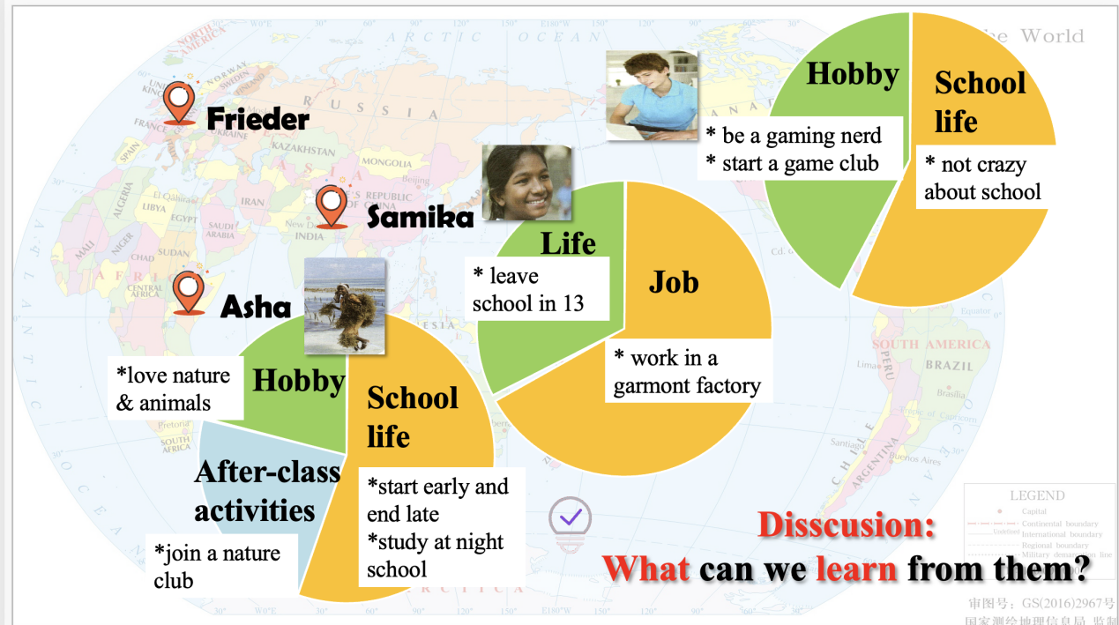
Discussion：What can we learn from them?
care for nature
cherish（珍惜） school life
hold a positive attitude to life
know the importance of education
Activity4: Reflecting
What is your teenage life like?
How do you plan your own teenage life in the years that follow?
Try to tell teenagers from another country about your teenage life in China. How do you plan your own teenage life in the years that follow?
Hi, there! My name is _______ and I’m from China. Like most teenagers, ______________(School life)I love _____________________________. ( Hobby)
_________________________________________________.(After-class activities)
_________________(your goal/plan in the years that follow) because___________
(reasons why you set that goal)
Sentence pattern for reference
1) school life
- Like most teenagers, I start my day...and end it ...
- I study... to prepare for the university entrance exam.
2) hobby
- When I have time off, I prefer to...
- I love... so much that...
3)after-class activities
- I volunteer to... and I’m a member...
4)attitude
- Although ..., we still find time to play and laugh together.
- At times like these, the world feels like a wonderful place.
- It's very difficult for ...to do...

