Book1 unit2 expanding your world 教学设计
Learning Objectives

By the end of the lesson, students will be able to:
- Understand the descriptive features of the passage about Pisa.
- Identify key details about the Leaning Tower, Italian architecture, and cultural figures.
- Infer author's tone and purpose.
- Appreciate Italian cultural elements like poetry and improvisation.
- Write a short descriptive paragraph using the same writing techniques.

Teaching Focus and Difficulties
Key Points:
- Extracting detailed information from a non-fiction passage.
- Understanding descriptive language and its effects.
Difficult Points:
- Understanding historical and cultural references (e.g., Improvisatori).
- Applying descriptive techniques in their own writing.
Teaching Procedure
Activity1: Lead in
- What do you think of your hometown?
- What is the landmark(地标性建筑) of your hometown?
- What do you think the people in your hometown?
Activity2: Prediction
What do you expect to know from the text?
raise questions with “wh-”
Activity3：Explore the text
- General impression:
- What’s his first impression of Pisa?
- Where did he visit?
- Who did he meet?
- Why is it a fine city?
- Why does the author use so many “well-”adjectives?
- What rhetorical device (修辞手法) is used?
- Tip1: use descriptive words (描述性语言) and repetition to paint a vivid(生动的） picture.
- Landmark:
- Which sentence does the writer use to show how “leaning” the tower is?
- Why is it beautiful?
- Why are the people interesting?
- Why does the author use figures to describe leaning tower?
- Tip2: use figures(数字) to make the description easy to understand and more convincing.
People:
Tip3：reflect regional(区域) culture when introducing people.
Activity3: Form mind-map
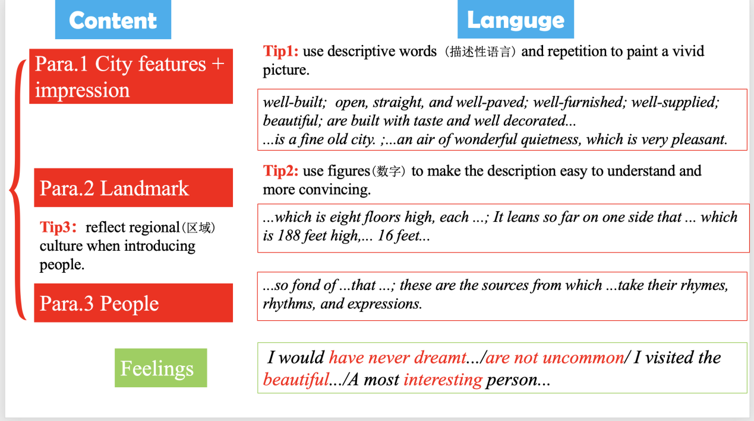
Activity4: Post-reading
Imagine that Tobias Smollet came to your hometown. Try to describe experience visiting your hometown.
Content:
- The beautiful scenery of ...
- Landmarks ...
- People ...

