China to the Rescue! 教学设计
Teaching Objectives
Understand key information about CISAR’s formation, missions, and challenges.
Cultivate empathy for disaster victims and admiration for rescue workers.
Foster a sense of global responsibility and pride in China’s international humanitarian efforts.
Enhancing Cultural Confidence and Loving Our Motherland
Teaching Procedures
Activity1: Lead in
What are they doing?
Where are they?
What information can you get from the picture?
If you have a chance to ask them a question, what would you like to ask?
Read the whole text and try to find out the answers to the questions.
Activity2: Explore the text
Para. 1 Form & aim
Para.2-3 What do the numbers show?
By using numbers, the writer wants to show how severe/terrible/serious/…
the natural disasters were and how important the CISAR’s missions are.
Tips: Numbers speak louder than words!
Para.4-5 Mission & work & requirements
What kind of work will they do?
Activity3: Discussion
Discussion:
What is in their big hearts?
（Hints: qualities）
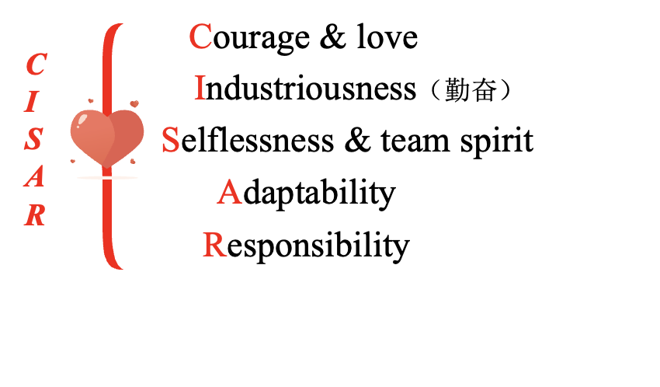
Discussion:
Is it necessary to risk their life to save the people from other countries?
What do you think of the work that CISAR had done?
Activity4: Explore the theme
China to the rescue! Why does the author use exclamation point ！
Assignment
1. Write a passage about “What I have learnt from CISAR?”
2. Search the Internet to learn more about rescue teams.

