The World（0901-0915）材料分析和教学目标：
本次选用的材料：①The Wall Street Journal 的 Uber and Self-Driving Firm Team Up（优步与自动驾驶公司联手合作）、②Los Angeles Times 的 L.A. buys Griffith Park carousel, where Disney dreamed up theme park （洛杉矶市购得格里菲斯公园旋转木——马迪士尼构想主题公园的地方）、③The Times的Households most likely to splash the cash on a holiday（最舍得为度假挥金如土的家庭）、④BBC Wildlife的Ash trees fight back（白蜡树奋起反抗）和⑤BBC的新闻报道。通过语法填空、阅读理解、分析长难句、翻译句子、听力填空和词汇拓展等方式，让学生从多角度提升学习兴趣，提高分析句子、运用词块和听力能力。外媒英语新闻可以让学生体验真实语境下的语言运用，拓展学生的国际视野，了解时事，逐步提升跨文化沟通能力，形成正确的世界观、人生观和价值观。

教学思路：
Part 1: News Report 1 The Wall Street Journal (September 9, 2025 PB4)
Uber and Self-Driving Firm Team Up
优步与自动驾驶公司联手合作
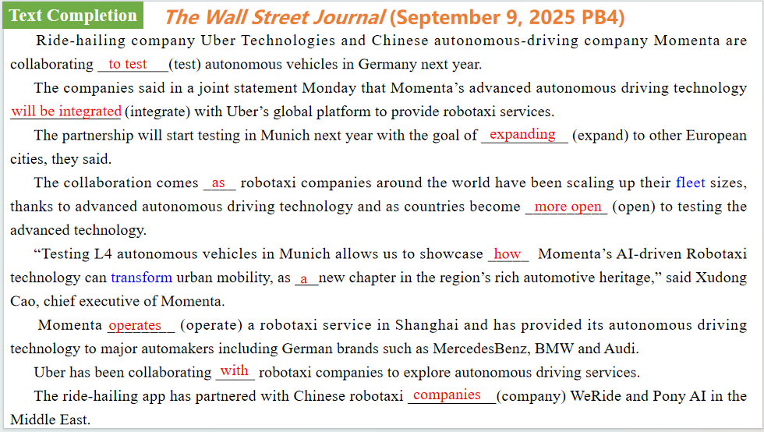
【设计意图】通过语篇填空的形式帮助学生理解新闻的主要内容，同时训练语言语法的运用能力：在语篇的视角下如何正确使用所给词汇，根据语法规则确定词汇的正确形式，使得文章通顺，激活学生的思维和语言。该新闻主题语境是关于“人与社会”中“社会热点问题”这一子主题，通过学习让学生了解互优步与自动驾驶公司联手合作情况。
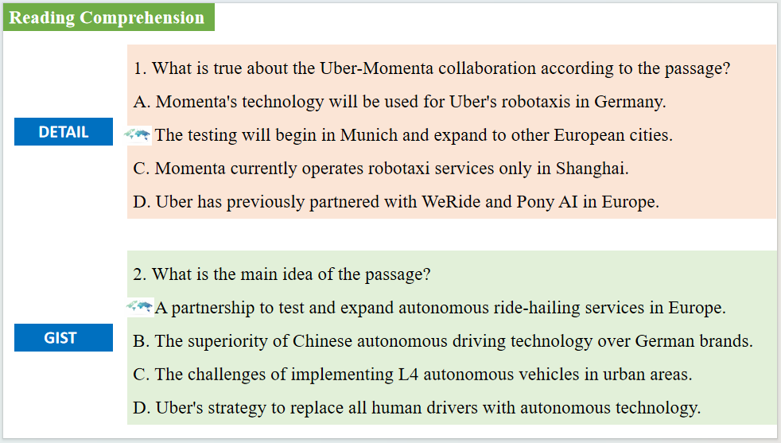
【设计意图】通过阅读理解的形式帮助学生理解新闻的主要内容。
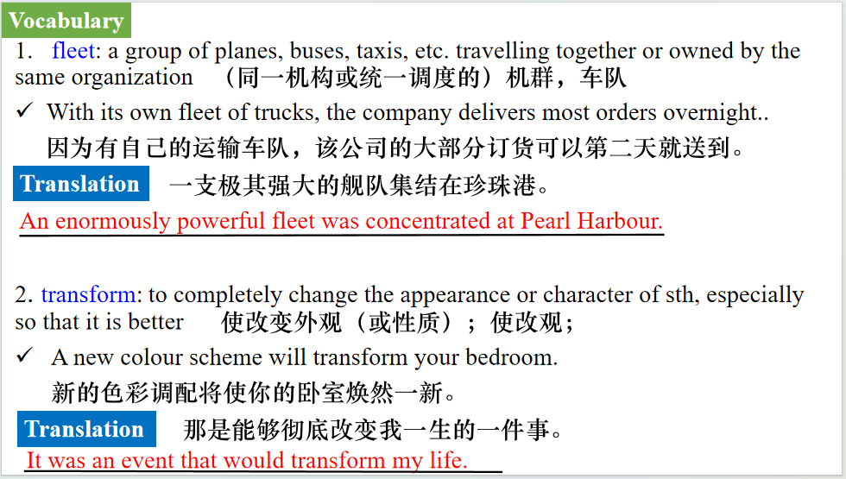
【设计意图】对文本中的词汇进行解读，并通过翻译句子对其进行巩固。

【设计意图】对文中的两个句子进行翻译练习，对其中单词、词组、句法进行巩固并关注句子结构。

Part 2: News Report 2 Los Angeles Times (September 9, 2025 PB1,B5)
L.A. buys Griffith Park carousel, where Disney dreamed up theme park
洛杉矶市购得格里菲斯公园旋转木——马迪士尼构想主题公园的地方
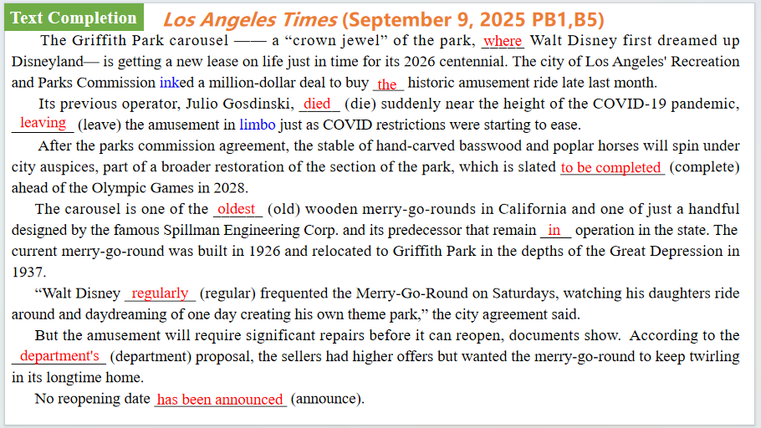
【设计意图】通过语篇填空的形式帮助学生理解新闻的主要内容，同时训练语言语法的运用能力：在语篇的视角下如何正确使用所给词汇，根据语法规则确定词汇的正确形式，使得文章通顺，激活学生的思维和语言。该新闻主题语境是关于“人与社会”中“社会热点问题”这一子主题，通过学习让学生了解互洛杉矶市购得格里菲斯公园旋转木——马迪士尼构想主题公园的地方的情况。
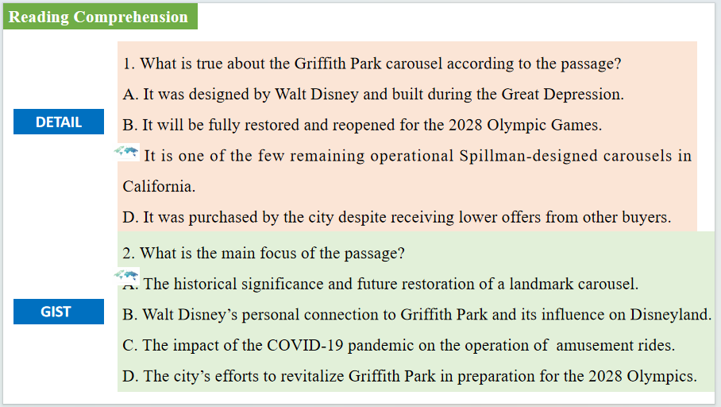
【设计意图】通过阅读理解的形式帮助学生理解新闻的主要内容。
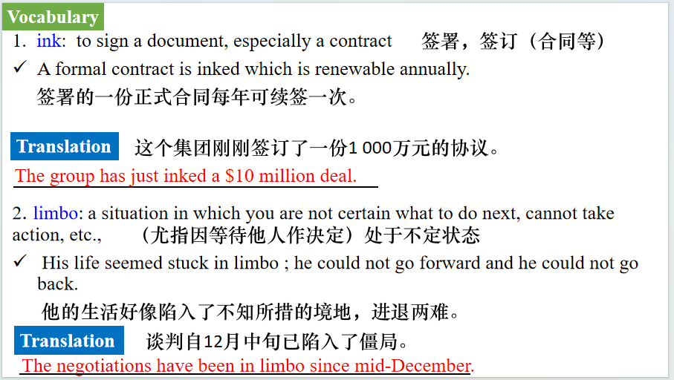
【设计意图】对文本中的词汇进行解读，并通过翻译句子对其进行巩固。
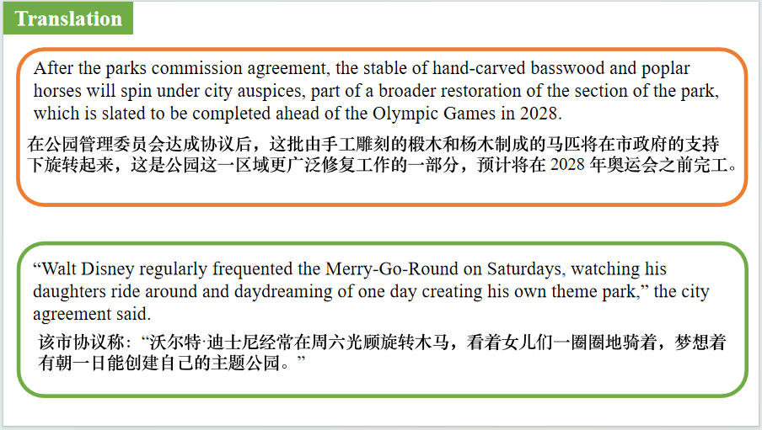
【设计意图】对文中的两个句子进行翻译练习，对其中单词、词组、句法进行巩固并关注句子结构。

Part 3: News Report 3 BBC Wildlife（September, 2025 P17)
Ash trees fight back白蜡树奋起反抗
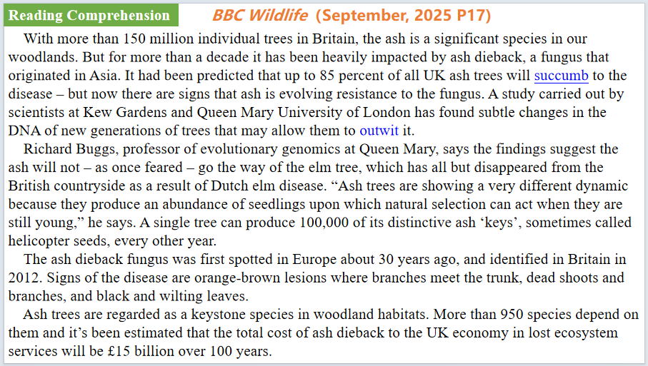
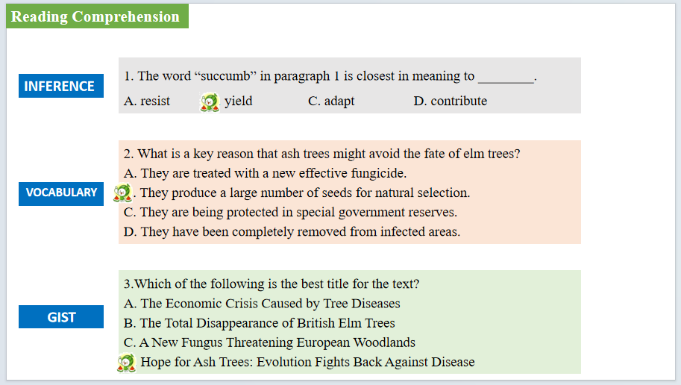
【设计意图】通过阅读理解的形式帮助学生理解新闻的主要内容。该新闻主题语境是关于“人与自然”中“自然科学研究成果”这一子主题，通过学习让学生了解英国白蜡树所面临的枯梢病 危机及其转机。


【设计意图】对文本中的词汇进行解读，并通过翻译句子对其进行巩固。
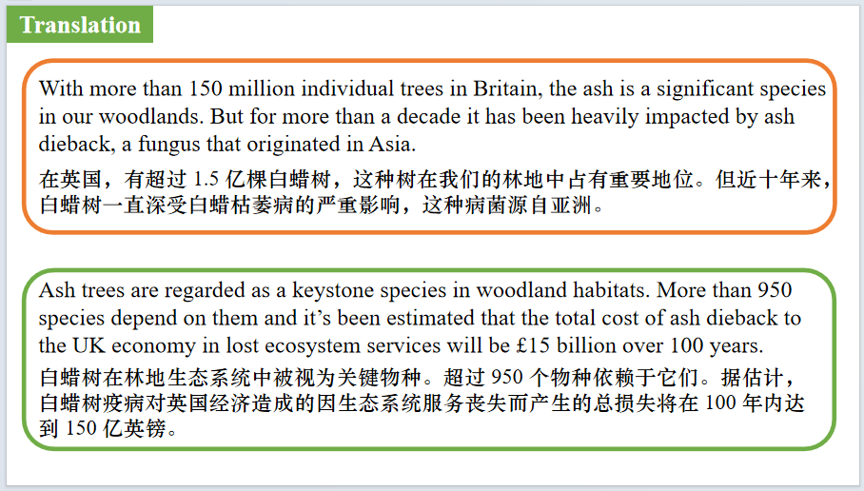
【设计意图】对文中的两个句子进行翻译练习，对其中单词、词组、句法进行巩固并关注句子结构。

Part 4: News Report 4 The Times（ September 8, 2025 P13)
Households most likely to splash the cash on a holiday
最舍得为度假挥金如土的家庭
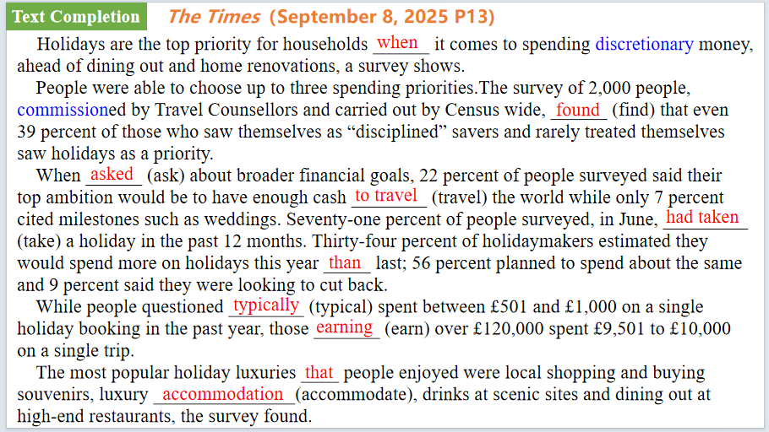
【设计意图】通过语篇填空的形式帮助学生理解新闻的主要内容，同时训练语言语法的运用能力：在语篇的视角下如何正确使用所给词汇，根据语法规则确定词汇的正确形式，使得文章通顺，激活学生的思维和语言。该新闻主题语境是关于“人与社会”中“社会热点问题”这一子主题，通过学习让学生了解度假是英国家庭自由支配开支的最优先项，其重要性超过了外出就餐、服装消费和家居装修等。

【设计意图】对文本中的词汇进行解读，并通过翻译句子对其进行巩固。
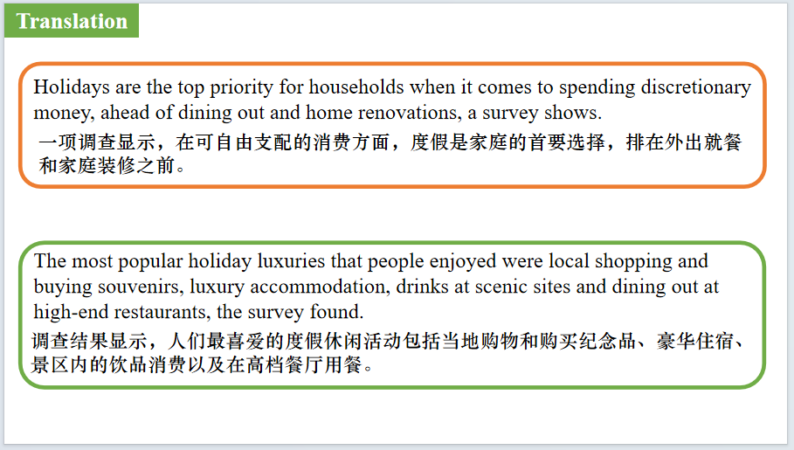
【设计意图】对文中的两个句子进行翻译练习，对其中单词、词组、句法进行巩固并关注句子结构。

Part 5: BBC News 09/12/2025

【设计意图】听一则材料，通过听力填空的方式理解文本，考察听力辨识词汇的能力。
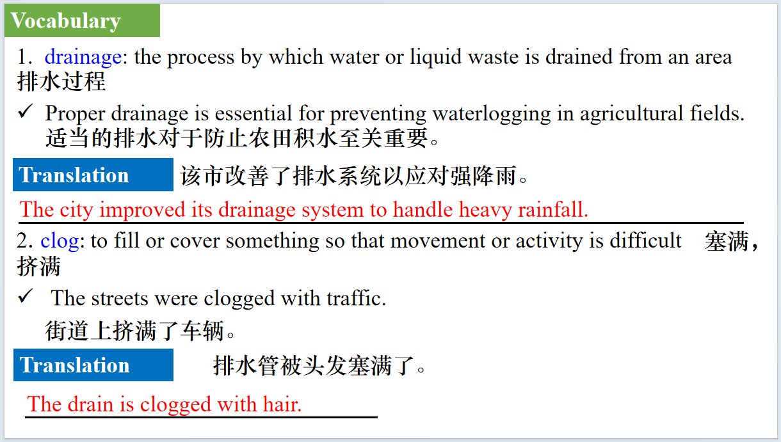
【设计意图】对文本中的词汇进行解读，并通过翻译句子对其进行巩固。
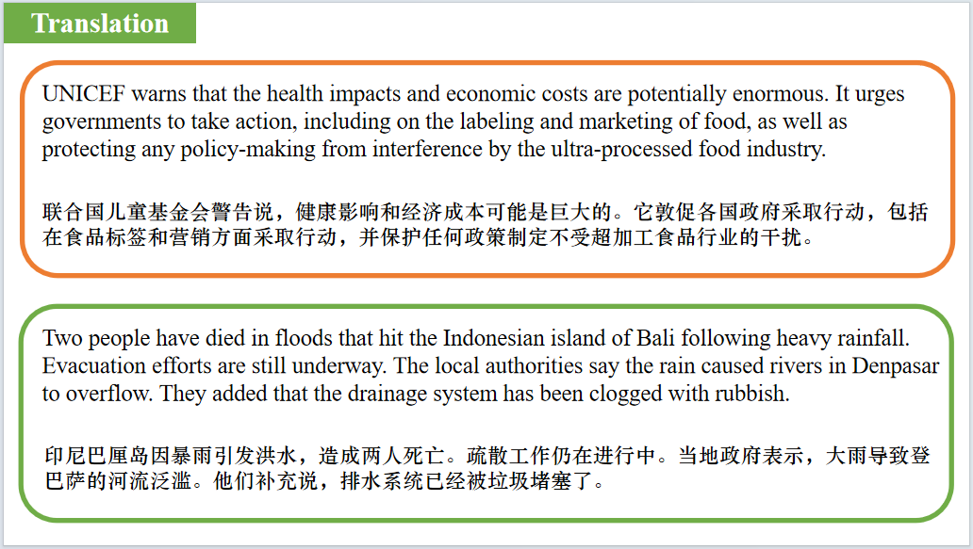
【设计意图】对文中的两个句子进行翻译练习，对其中单词、词组、句法进行巩固并关注句子结构。

附：外刊原文
Part 1: News Report 1 The Wall Street Journal (September 9, 2025 PB4)
Uber and Self-Driving Firm Team Up
优步与自动驾驶公司联手合作
Ride-hailing company Uber Technologies and Chinese autonomous-driving company Momenta are collaborating to test autonomous vehicles in Germany next year.
The companies said in a joint statement Monday that Momenta’s advanced autonomous driving technology will be integrated with Uber’s global platform to provide robotaxi services.
The partnership will start testing in Munich next year with the goal of expanding to other European cities, they said.
The collaboration comes as robotaxi companies around the world have been scaling up their fleet sizes, thanks to advanced autonomous driving technology and as countries become more open to testing the advanced technology.
“Testing L4 autonomous vehicles in Munich allows us to showcase how Momenta’s AI-driven Robotaxi technology can transform urban mobility, as a new chapter in the region’s rich automotive heritage,” said Xudong Cao, chief executive of Momenta.
Momenta operates a robotaxi service in Shanghai and has provided its autonomous driving technology to major automakers including German brands such as MercedesBenz, BMW and Audi.
Uber has been collaborating with robotaxi companies to explore autonomous driving services.
The ride-hailing app has partnered with Chinese robotaxi companies WeRide and Pony AI in the Middle East.

Part 2: News Report 2 Los Angeles Times (September 9, 2025 PB1,B5)
L.A. buys Griffith Park carousel, where Disney dreamed up theme park
洛杉矶市购得格里菲斯公园旋转木——马迪士尼构想主题公园的地方
The Griffith Park carousel —— a “crown jewel” of the park, where Walt Disney first dreamed up Disneyland— is getting a new lease on life just in time for its 2026 centennial. The city of Los Angeles' Recreation and Parks Commission inked a million-dollar deal to buy the historic amusement ride late last month.
Beloved by Disney, who snapped up a similar historic wooden ride to serve as the King Arthur Carrousel at his Anaheim theme park, the Griffith Park merry-go-round took its last twirl in 2022.
Its previous operator, Julio Gosdinski, died suddenly near the height of the COVID-19 pandemic, leaving the amusement in limbo just as COVID restrictions were starting to ease.
It was reopened briefly in the spring of 2021 but was closed again a year later, in need of repairs and without a clear owner to make them.
Gosdinski's stake in the amusement remains tied up in Los Angeles County probate court, where Gosdinski's mother and sister are vying with another owner for control, records show.
After the parks commission agreement, the stable of hand-carved basswood and poplar horses will spin under city auspices, part of a broader restoration of the section of the park, which is slated to be completed ahead of the Olympic Games in 2028.
The carousel is one of the oldest wooden merry-go-rounds in California and one of just a handful designed by the famous Spillman Engineering Corp. and its predecessor that remain in operation in the state.
Others are operated at the Pike in Long Beach, San Francisco's Golden Gate Park, Balboa Park in San Diego and Tilden Park in Berkeley, where Griffith Park's original merry-go-round remains the state's fastest wooden spinner.
The current merry-go-round was built in 1926 and relocated to Griffith Park in the depths of the Great Depression in 1937. Like others of its ilk and era, the carousel includes horses carved by the famous artist Charles Looff, creator of the Santa Monica Pier.
“Walt Disney regularly frequented the Merry-Go-Round on Saturdays, watching his daughters ride around and daydreaming of one day creating his own theme park,” the city agreement said.
But the amusement will require significant repairs before it can reopen, documents show.
Today, the merry-go-round cannot even be moved by hand.
Still, L.A. could be getting the carousel for a song. It is among the dwindling number of four-across merry-go-rounds of its type still in existence, and still retains nearly all its original features, according to appraisals commissioned by the city.
According to the department's proposal, the sellers had higher offers but wanted the merry-go-round to keep twirling in its longtime home.
No reopening date has been announced.
Part 3: News Report 3 BBC Wildlife（September, 2025 P17)
Ash trees fight back白蜡树奋起反抗
With more than 150 million individual trees in Britain, the ash is a significant species in our woodlands. But for more than a decade it has been heavily impacted by ash dieback, a fungus that originated in Asia. It had been predicted that up to 85 percent of all UK ash trees will succumb to the disease – but now there are signs that ash is evolving resistance to the fungus. A study carried out by scientists at Kew Gardens and Queen Mary University of London has found subtle changes in the DNA of new generations of trees that may allow them to outwit it.
Richard Buggs, professor of evolutionary genomics at Queen Mary, says the findings suggest the ash will not – as once feared – go the way of the elm tree, which has all but disappeared from the British countryside as a result of Dutch elm disease. “Ash trees are showing a very different dynamic because they produce an abundance of seedlings upon which natural selection can act when they are still young,” he says. A single tree can produce 100,000 of its distinctive ash ‘keys’, sometimes called helicopter seeds, every other year.
The ash dieback fungus was first spotted in Europe about 30 years ago, and identified in Britain in 2012. Signs of the disease are orange-brown lesions where branches meet the trunk, dead shoots and branches, and black and wilting leaves.
Ash trees are regarded as a keystone species in woodland habitats. More than 950 species depend on them and it’s been estimated that the total cost of ash dieback to the UK economy in lost ecosystem services will be £15 billion over 100 years.

Part 4: News Report 4 The Times（September 8, 2025 P13)
Households most likely to splash the cash on a holiday
最舍得为度假挥金如土的家庭
Holidays are the top priority for households when it comes to spending discretionary money, ahead of dining out and home renovations, a survey shows.
Forty-six percent of people surveyed voted holidays a top spending priority, ahead of spending on clothes, shoes and accessories (35 percent), dining and drinking out (33 percent), home and garden renovations (32 percent) and leisure activities (25 percent).
People were able to choose up to three spending priorities.The survey of 2,000 people, commissioned by Travel Counsellors and carried out by Census wide, found that even 39 percent of those who saw themselves as “disciplined” savers and rarely treated themselves saw holidays as a priority.
When asked about broader financial goals, 22 percent of people surveyed said their top ambition would be to have enough cash to travel the world while only 7 percent cited milestones such as weddings. Seventy-one percent of people surveyed, in June, had taken a holiday in the past 12 months. Thirty-four percent of holidaymakers estimated they would spend more on holidays this year than last; 56 percent planned to spend about the same and 9 percent said they were looking to cut back.
While people questioned typically spent between £501 and £1,000 on a single holiday booking in the past year, those earning over £120,000 spent £9,501 to £10,000 on a single trip.
The most popular holiday luxuries that people enjoyed were local shopping and buying souvenirs, luxury accommodation, drinks at scenic sites and dining out at high-end restaurants, the survey found.

