教学设计
课程基本信息
学科 | 英语 | 年级 | 高二 | 学期 | 秋季
课题 | U3 Fascinating Parks（period4）Using Language（1）: Listening and speaking
教科书 | 书名：普通高中教科书英语选择性必修第一册  出版社：人民教育出版社 出版日期：2019年11月
教学目标
By the end of the class, the students will be able to
- know what a city park is and what people can do there.
- comprehend and grasp relevant information according to the key words of directions.
- learn to read a map and draw the route of a trip on the map by listening to a conversation.
- make up a conversation about asking for and giving directions.
教学内容
教学重点：
1.Grasping some useful expressions of directions.
2. Practicing what they have learnt by having a conversation asking for and giving directions.
教学难点：
1. Listening for the directions through a natural conversation.
2. Drawing the route on the map according to the relevant information they get from listening.
教学过程
Step1 Lead in
Lead in the topic by a picture of Beijing Olympic Forest Park and introduce some background information about this park. Ask the students:
Q1: What’s the difference between a national park and a city park?
Q2:What can people do in a city park?

Step2 Pre-listening---Activity1
1. Guide the ss to learn some new words (rent, cycle, corridor, fountain, ride) and the phrases in this part before doing the task.
2.The students finish the task in activity 1 independently.
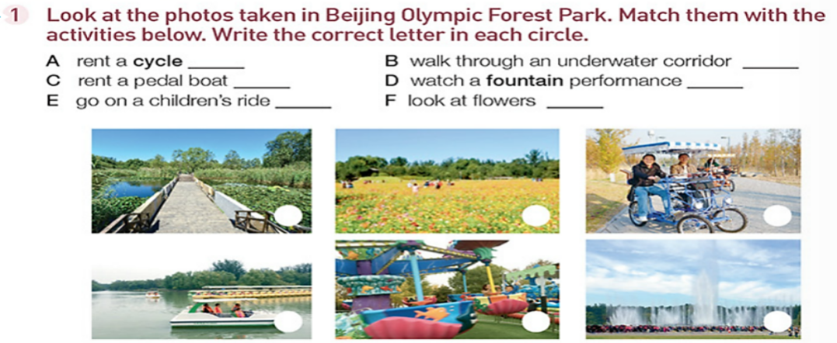
3. Check the answers together.

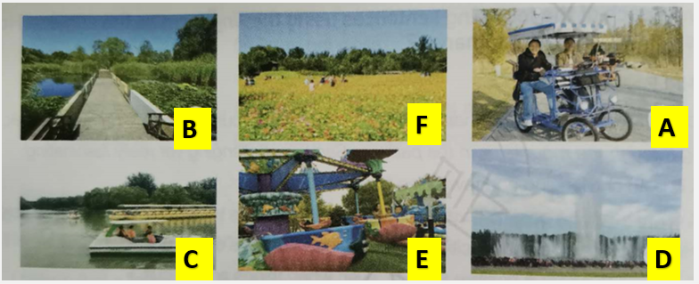

Step3 Listening
I. Activity2
1. The students listen to the conversation for one time and tick their choices. Then they are asked to listen again, check their answers, and make revises when listening if necessary.
2. The students check answers with the teacher.

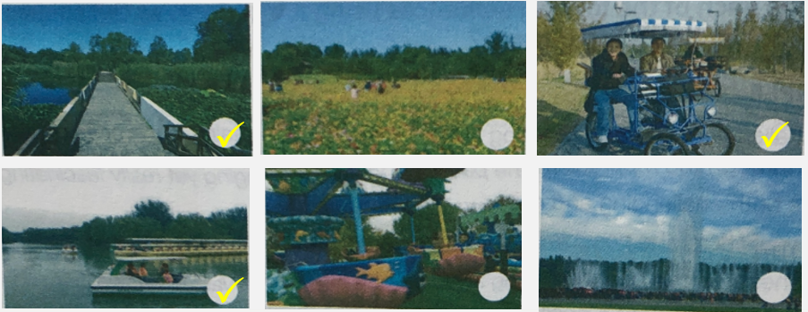
II. Activity 3
- Tips on listening for directions.
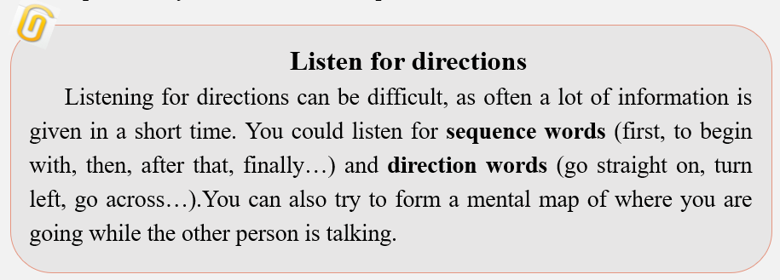
- Direction words
Ask the students to give directions according to the following pictures so that they can
activate their prior knowledge and learn some new direction words. In this way, they can finish the task in activity 3 better.

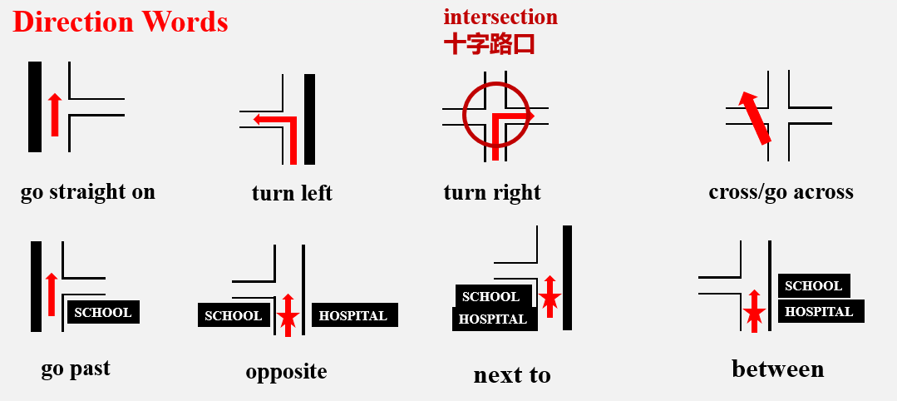
- Read the map
Guide the students to learn to read a map, including directions, main spots, and main roads.

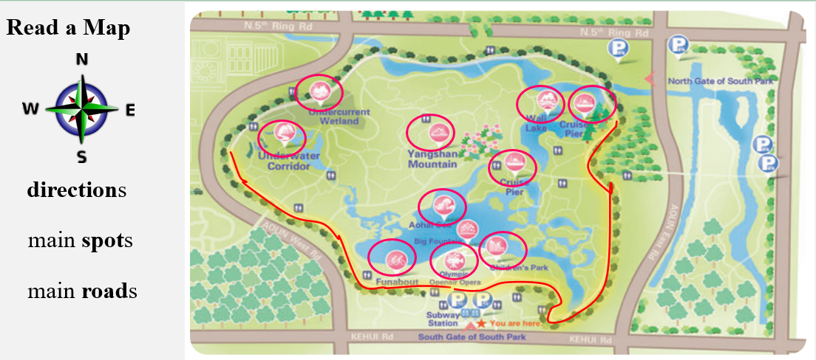
- The students listen and finish the tasks in this part.
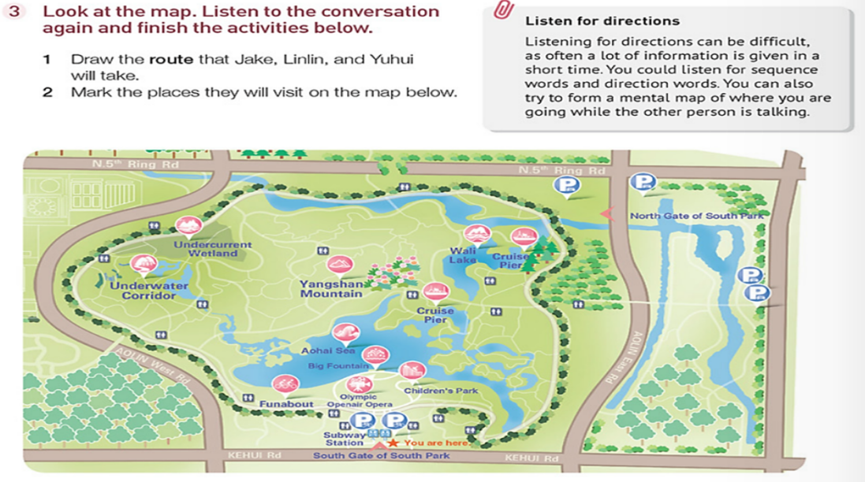
- Ask a student to draw on the ppt and the other students evaluate their peer’s performance.
- The teacher corrects their mistakes if any.
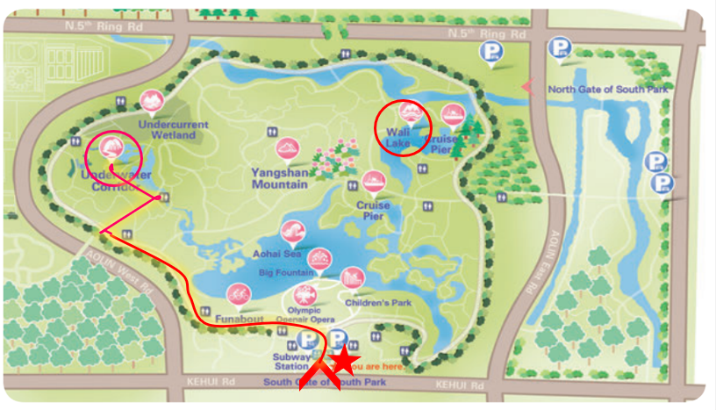
- Emphasize the importance of sequence words and direction words.
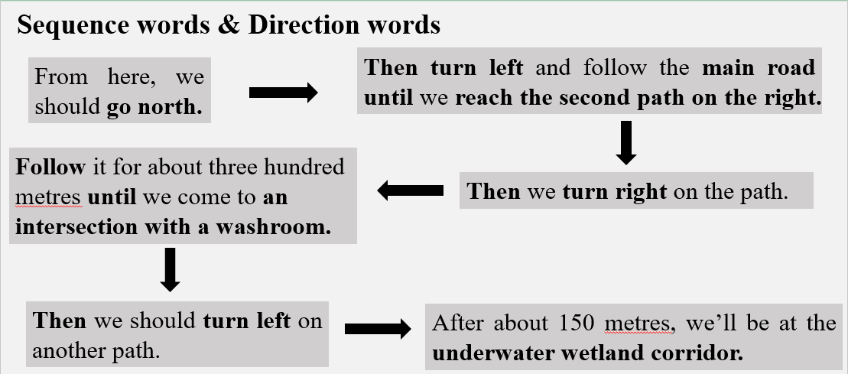
Step 4 Speaking—Activity 4
Work in pairs. Role-play visiting the park. The words and phrases are for the students’ reference.
- Learn the expressions about asking for and giving directions below.
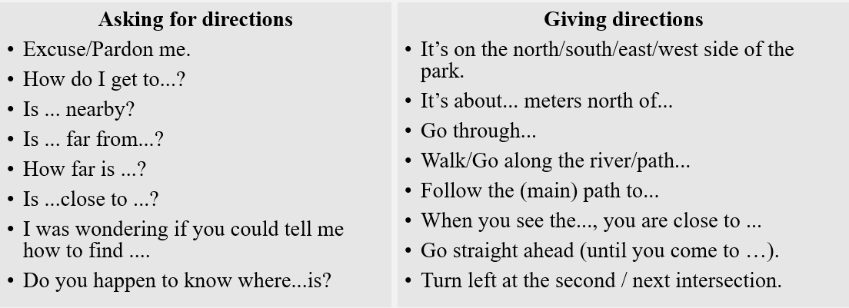
- Speaking—Group work
Ask the students to make up a conversation with their partners (in groups of three) according
to the map in activity 3.
Q: Linlin, Yuhui and Jake are now at Underwater Corridor, how can they get to the next destination, Wali Lake?
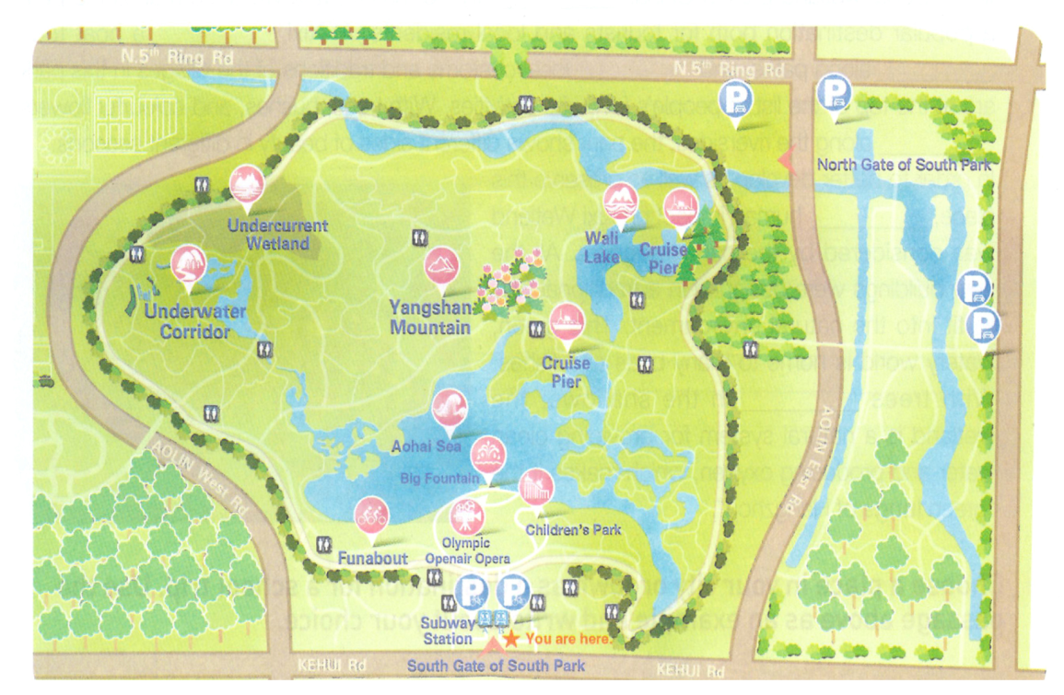
Step 5 Homework
1. Review the expressions of asking for and giving directions.
2. Make up a conversation of asking for and giving directions according to the map in activity 3 (from Wali Lake back to the South Gate of South Park).
注：
本课所引用地图来自人教版 《普通高中教科书英语选择性必修第一册》 page30 activity 3.
备注：教学设计应至少含教学目标、教学内容、教学过程等三个部分，如有其它内容，可自行补充增加。

