学习任务单
课程基本信息
学科 | 英语 | 年级 | 高二 | 学期 | 秋季
课题 | U3 Fascinating Parks（period4）Using Language（1）: Listening and speaking
教科书 | 书 名：普通高中教科书英语选择性必修第一册  出版社：人民教育出版社 出版日期：2019年11月
学生信息
姓名 | 学校 |  | 班级 |  |  | 学号
学习目标
By the end of the class, you are supposed to:
- know what a city park is and what people can do there.
- comprehend and grasp relevant information according to the key words of directions.
- learn to read a map and draw the route of a trip on the map by listening to a conversation.
- make up a conversation about asking for and giving directions.
课前学习任务
Search online to find some information about national parks and city parks and think about their differences.
课上学习任务
【学习任务一】Pre-listening
1. Learn some useful words and expressions of the activities that people do in a city park.
2. Match these activities with the photos in activity 1.
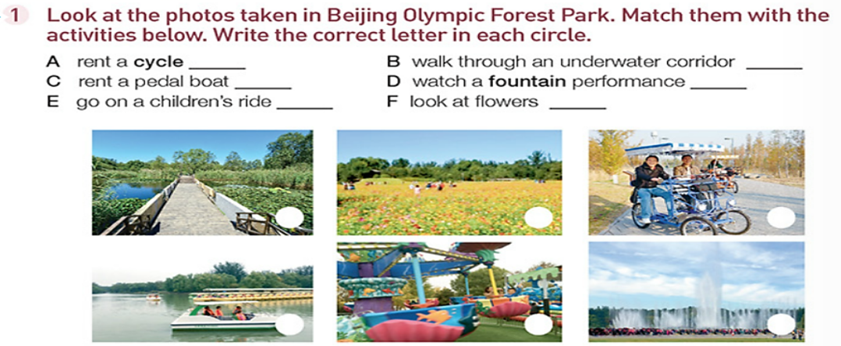
【学习任务二】Listening
I. Activity2
Listen to the conversation for one time and tick your choices. Then listen again, check your
answers, and make revises when listening if necessary.

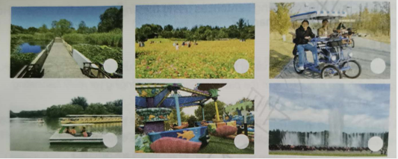
II. Activity 3
- Tips on listening for directions.
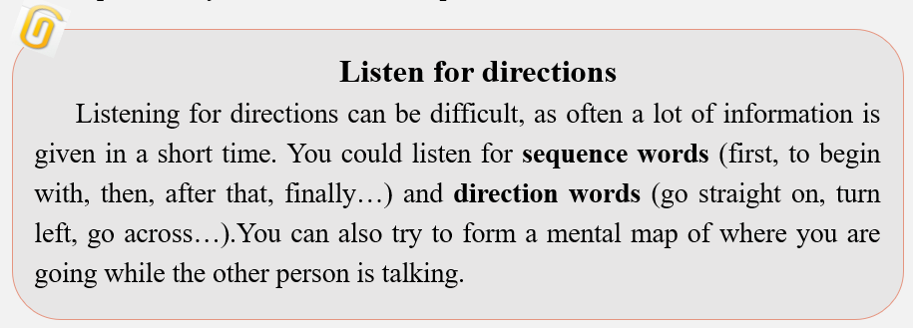
2. Direction words
Give directions according to the following pictures and learn some new direction words.
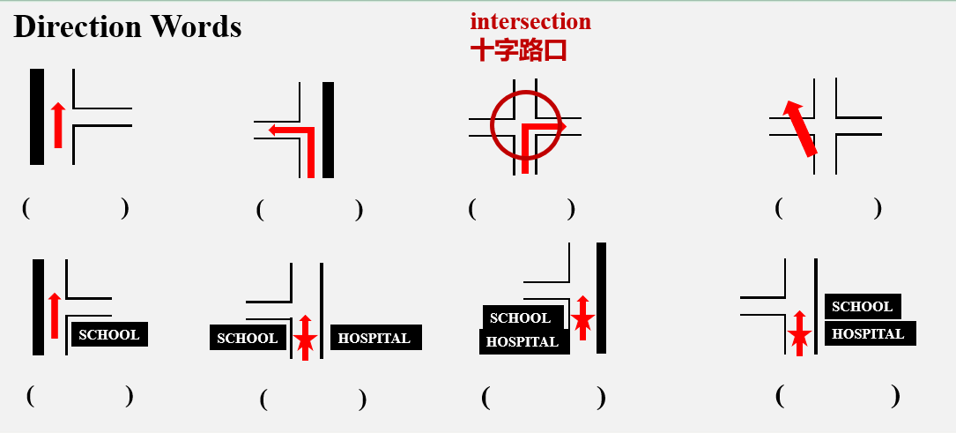
3. Read the map
Learn to read a map, including directions, main spots, and main roads.

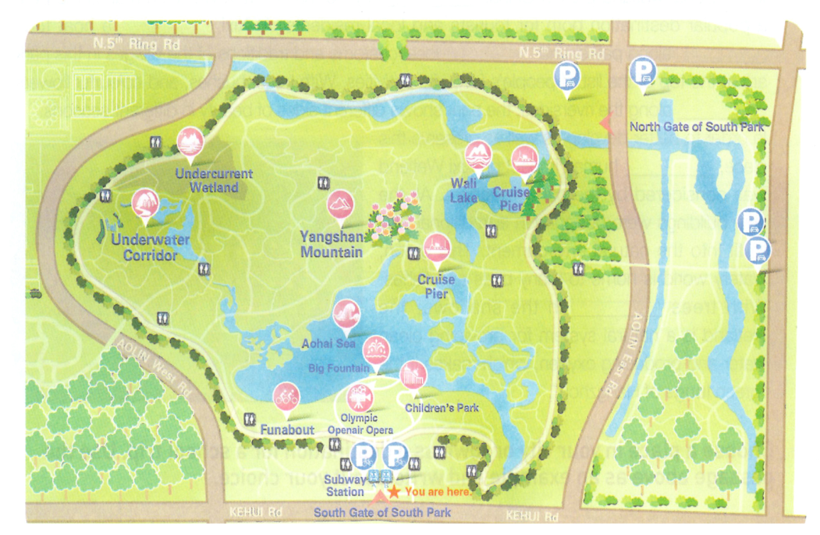
4. Listen to the conversation and finish the tasks in this part.
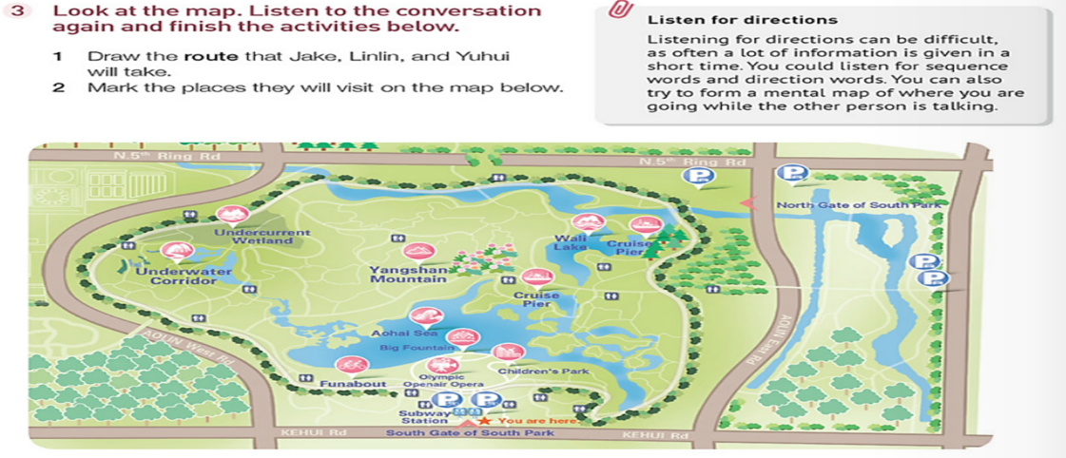
- Draw on your own map and be prepared to draw on the ppt, or you’ll be required to evaluate your peer’s performance.

【学习任务三】Speaking—Activity 4
Work in pairs. Role-play visiting the park. The words and phrases are for your reference.
- Learn the expressions about asking for and giving directions below.

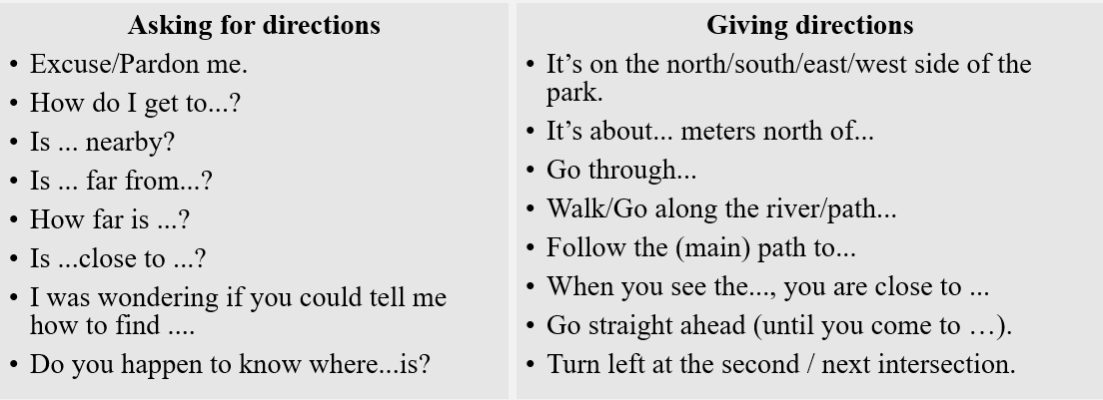
- Speaking—Group work
Make up a conversation with your partners (in groups of three) according to the map in activity 3.
Q: Linlin, Yuhui and Jake are now at Underwater Corridor, how can they get to the next destination, Wali Lake?
推荐的学习资源
- The passage about Xixi National Wetland Park in activity 3 on page 29.
- Website:
- https://baike.baidu.com/item/%E5%9B%BD%E5%AE%B6%E5%85%AC%E5%9B%AD/11086?fr=aladdin
- https://baike.baidu.com/item/%E5%9F%8E%E5%B8%82%E5%85%AC%E5%9B%AD/3098193?fr=aladdin
注：本课所引用地图来自人教版 《普通高中教科书英语选择性必修第一册》 page30 activity

