浙江强基联盟 2025 年10月高三联考读后续写导学案
阅读下面短文，根据所给情节进行续写，使之构成一个完整的故事。
When I was ten, my parents told me we were going to China for our summer holiday. I was over the moon—I had only ever seen the Great Wall and the Forbidden City in books, and now I would actually get to walk through history!
For weeks, I imagined the towering palaces, the red-and-gold gates, and the stories hidden in every corner. Finally, the day arrived, and there I was, standing in the heart of Beijing, staring up at the most magnificent buildings I had ever seen.
The Forbidden City was even more incredible in real life. The golden roofs shone under the sun, the delicate carvings told silent tales of emperors and warriors, and the vast courtyards made me feel like I had stepped into a fairy tale. Every turn revealed something new—a dragon statue, a marble staircase, a hidden garden—and I couldn't stop taking pictures, desperate to capture every detail. My parents laughed as I dragged them from one spot to another, insisting on yet another photo.
What struck me most were the colors. The imperial yellow of the rooftops against the deep red walls looked brighter than any picture could show. Even the stone pathways seemed to glow with centuries of footsteps. I remembered running my fingers along a carved marble railing, wondering how many hands had touched that same spot over six hundred years.
The place was packed with tourists, all murmuring in different languages, their faces filled with the same amazement as mine. Some pointed at the architecture, others posed for pictures, and a few just stood quietly, taking it all in. The energy was infectious—everyone seemed to feel the magic of this ancient place.
As the afternoon wore on, we followed the crowd toward the exit. The sea of people was overwhelming, and I, being small for my age, grasped my father's hand tightly, afraid to get lost in the rushing crowd. The noise, the heat, and the excitement made everything feel like a blur—until suddenly, I looked down at the large hand I was holding—the wrong watch, the wrong-colored ring.
注意：续写词数应为 150 左右；
请按如下格式在答题卡的相应位置作答。

My blood turned to ice.

There he was, just three people away.

1.在原文中语义连贯标词，然后可视化快速构思，完成下列表格：
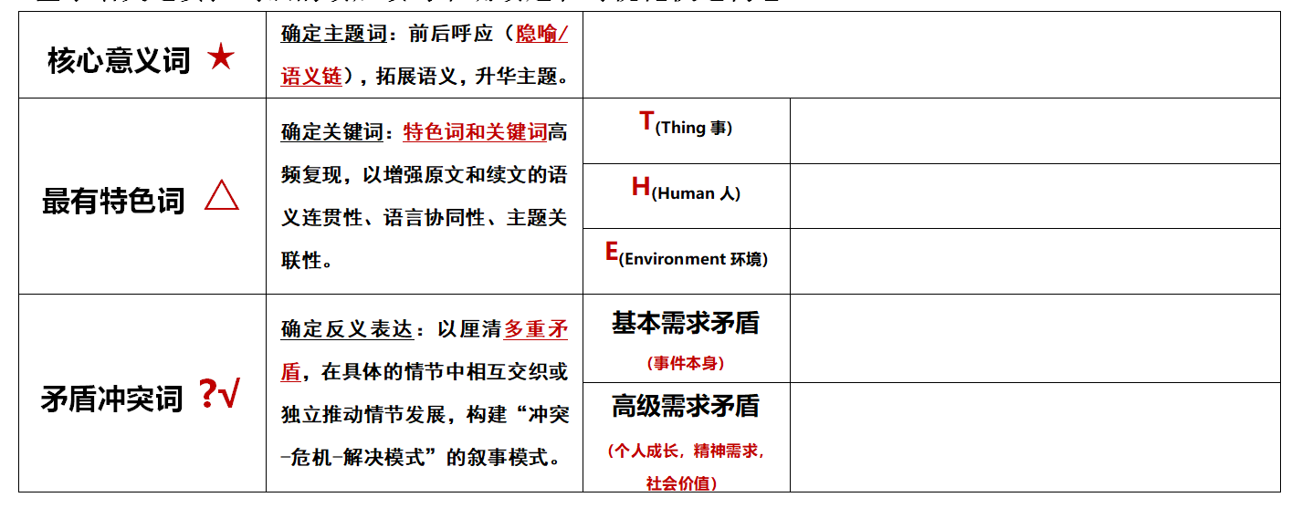
- 基于语义连贯标词扩展法，完成读后续写的协同生成

语义连贯方式 | 原文解读标词 | 续文协同写作
同词复现↓
同义复现→
←反义复现
语义扩展→→
主题升华↑

3.完成读后续写习作
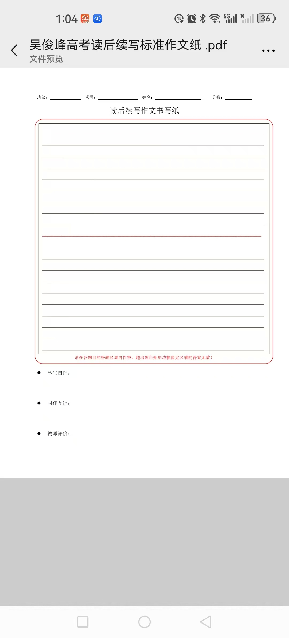

4.赏析范文：
My blood turned to ice. My heart pounded violently when I realized I was holding a stranger's hand. I looked up at the man—he had kind eyes and a gentle smile. "Are you lost?" he asked, crouching down to my height. I nodded, fighting back tears. Without hesitation, he asked a nearby guard for help, describing my parents and keeping me calm. Though he was a stranger, his patience and warmth made the terrifying moment feel a little safer. Then I heard Dad's voice calling my name.
There he was, just three people away. He came rushing toward me through the crowd, his face pale with worry. The second he saw me, his shoulders relaxed, and he pulled me into a tight hug. He thanked the kind stranger again and again, his voice shaking. As we walked away, I glanced back at the man, already lost in the crowd. That day, I learned something—Beijing's beauty wasn't just in its golden rooftops or ancient walls, but in people like him, who stopped to help a scared little child.

