选择性必修一第5单元WORKBOOK：Reading and Writing

Teaching Objectives

By the end of this lesson, students will be able to:
- Understand the reasons why some university graduates choose to return to their hometowns.
- Analyze the benefits of rural life and the support provided by the government.
- Express personal opinions about career choices between big cities and rural areas.
- Create a script introducing a successful case of rural construction.

Teaching Procedure

I. Warm-up

Show the title: Better, Greener Lives Away from the City
  - If you were a university graduate, would you choose to start a career in a big city or in the country? Why?
- Encourage brief pair discussions and share answers.

II. Pre-Reading
- Look at the title and picture.
- What do you expect to read in the text?
- Start your questions with “wh-”
- Who
- What
- Why...

III. While-Reading

Answer the questions they have raised and extract the important details

Who choose to live a live away from the city?

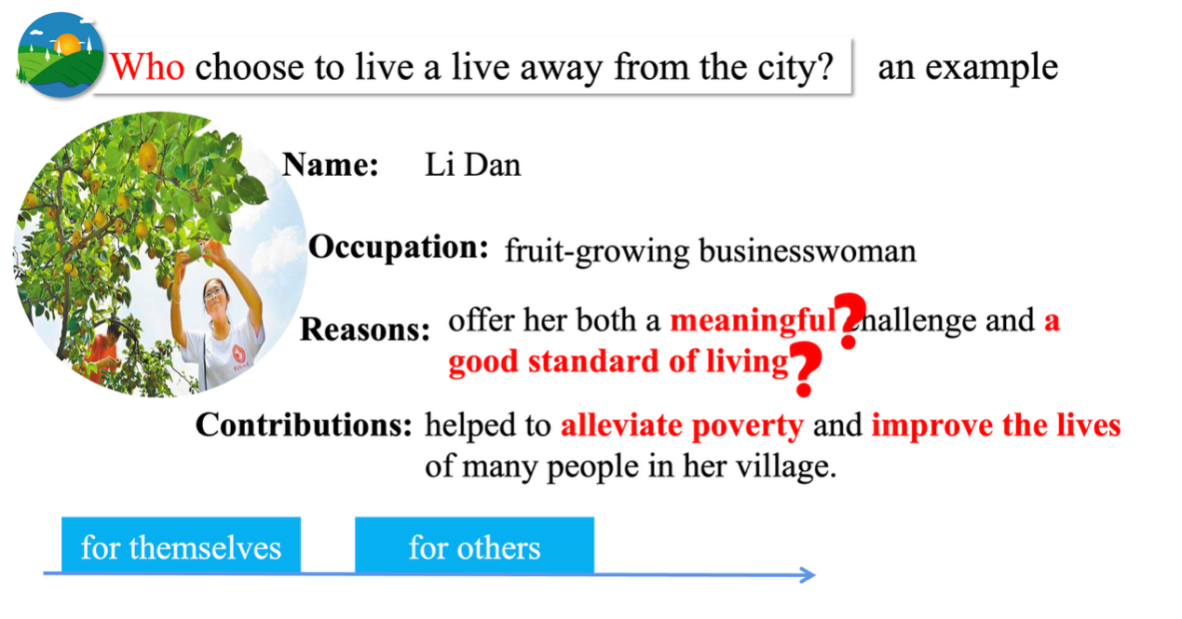

Why do they choose to live a live away from the city?

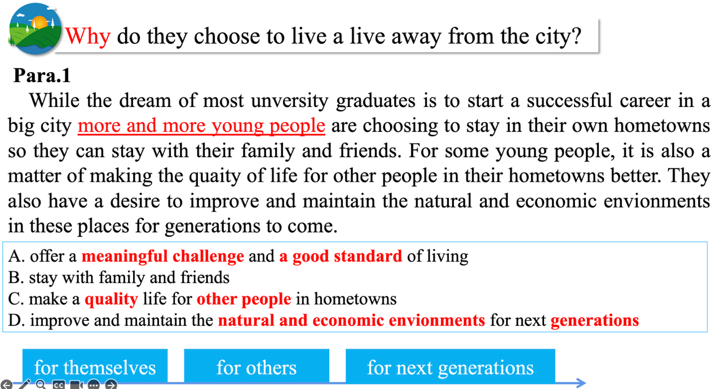

How does government support them? Why?

What are the advantages of life in the country?

A strong network support

IV. Post-Reading (10 minutes)
- Group Discussion:
What are the advantages of life in the city? Disadvantages of life in the country?
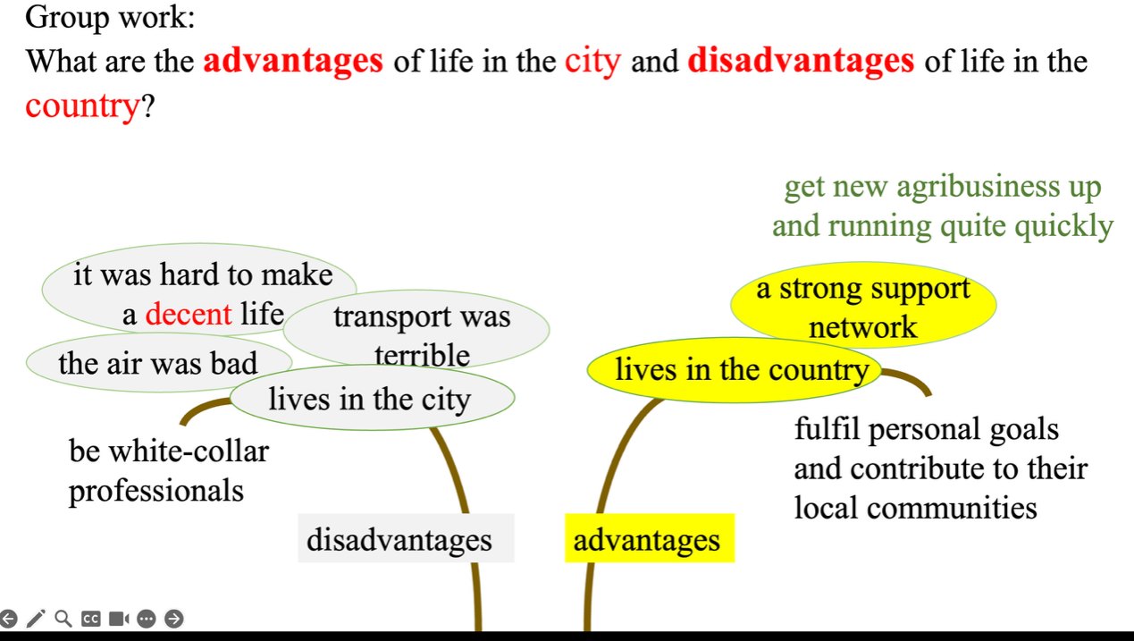

Why does the author write this article?

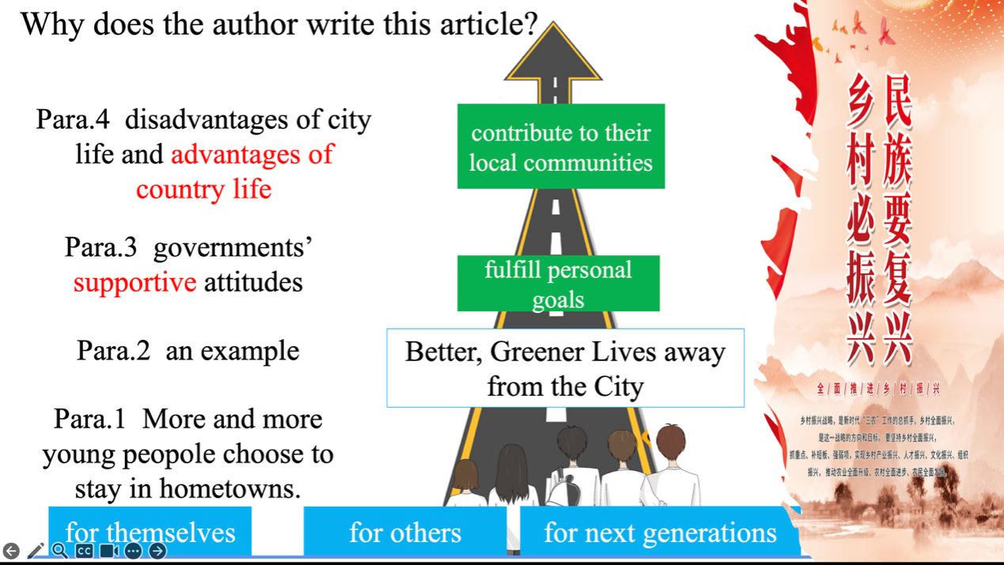

V. Role Model & Reflection (5 minutes)
- Introduce Zhu Wenqian (torreya business in Pujiang).
- Ask students:
  - If you choose your hometown, what could you do to help?
  - What are you good at? What does your hometown need?
- Example: “I am good at teaching. My hometown needs educational support. I can tutor students.”

VI. Creative Task: Script Writing (5 minutes)
- Students work in pairs or small groups.
- Task: Write a short script for a video titled “New Rural Construction”
- Include:
  - A person who returned to their hometown
  - What they do
  - How they help the community
  - Use vocabulary from the text

Homework Assignment
- Complete the script and record a 1-minute video (optional).
- Write a short paragraph: “Would you choose to work in a big city or your hometown? Why?”

