强基联盟高二十月阶段性测试B卷应用文学案

- 题目呈现
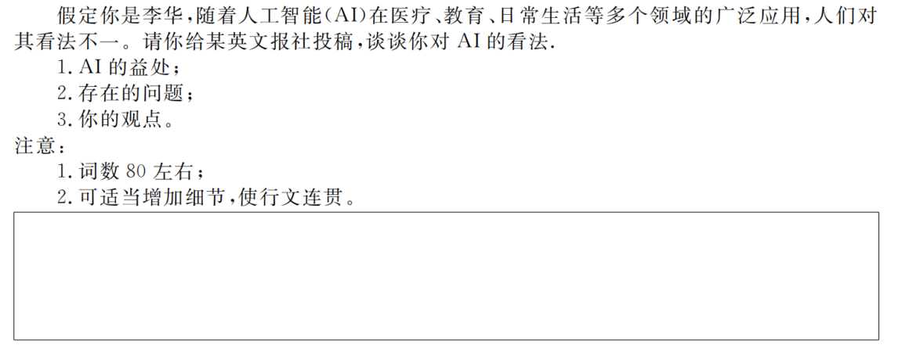

- SDL应用文写作模式
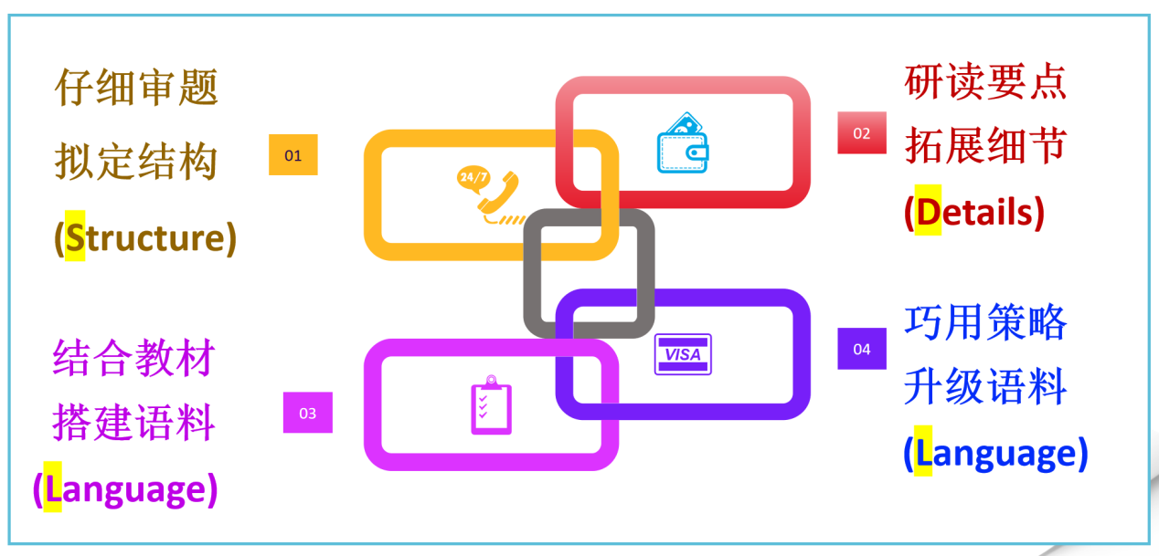
第一步：仔细审题，拟定结构
体裁
人称
时态
结构

第二步：研读要点，拓展细

advantages
disadvantages
opinion

第三步：结合教材，搭建语料
- Advantages for technology
______________________________________________
______________________________________________
______________________________________________
______________________________________________
______________________________________________
______________________________________________
______________________________________________
______________________________________________
______________________________________________
- Disadvantages for technology
______________________________________________
______________________________________________
______________________________________________
______________________________________________
______________________________________________
______________________________________________
- Personal opinion towards technology
______________________________________________
______________________________________________
______________________________________________
______________________________________________
______________________________________________
______________________________________________

第四步：巧用策略，升级语料
- Para 1: AI is important and applied widely in our life. People have different opinions towards it.

- Para 2: AI can answer students’ questions instantly and helps them learn better.

- Para 2: In healthcare, AI can help doctors detect diseases and get immediate treatments.

- Para 2: But AI may lead to some problems.

- Para 2: For examle, some people may lose their jobs due to the rapid development of AI. And people’s personal information may be leaked.

- Para 2: Some people may depend on AI too much and lose their own abilities.

(7)Para 3: In my opinion, we should be cautious when we use AI in our life.

