2026届广州市高三年级调研考零模英语试卷
应用文和读后续写讲义
一、作文题目
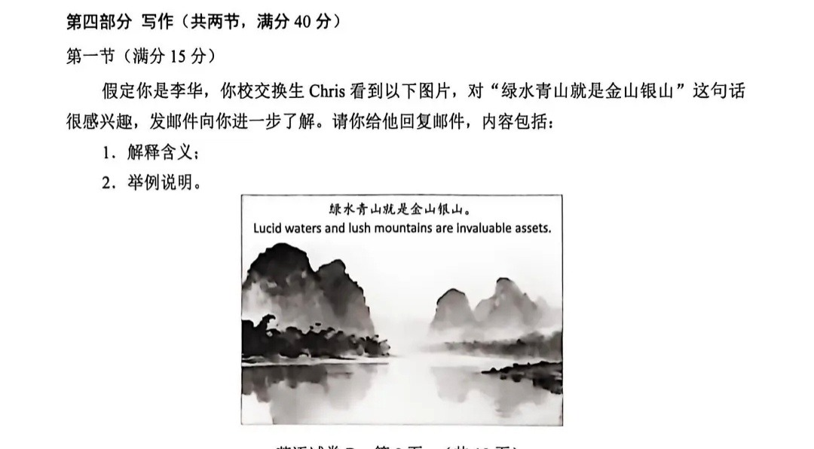
二、写作思路
第一段：礼貌回应 + 引入主题
先感谢 Chris 的来信，点明他感兴趣的 “绿水青山就是金山银山” 是中国的环保理念，自然引出下文的解释。
第二段：主体部分 1：解释含义
核心逻辑：这句话是说 “良好的生态环境（清澈的水、繁茂的山）不是无价值的，而是像‘金山银山’一样，能带来长远的经济与生活价值”，既强调保护自然，也说明生态能转化为发展优势。
主体部分 2：举例说明
选一个典型案例（比如桂林阳朔）：过去当地过度开发影响环境，后来保护山水、发展生态旅游，现在游客增多，村民靠民宿、特色产业增收，既保住了美景，也赚到了收益，体现 “生态 = 财富”。
第三段：互动收尾
邀请 Chris 有机会一起体验这类生态美景，让内容更自然。

三、写作高级表达
第一段：礼貌衔接
高级短语：
be intrigued by（对…… 很感兴趣）
shed light on（详细解释）

高级句子：
1.I’m glad you’re intrigued by the phrase “Lucid waters and lush mountains are invaluable assets”. 很高兴你对 “绿水青山就是金山银山” 这句话很感兴趣。
2.Let me shed light on its meaning and share a real-life example.我来详细解释它的含义，并分享一个真实案例。

第二段：含义解释和举例说明
高级短语：
ecological well-being（生态福祉）
translate...into tangible benefits（将…… 转化为实际收益）
overexploit natural resources（过度开发自然资源）
thrive on eco-tourism（依靠生态旅游蓬勃发展）

高级句子：
1.It links ecological well-being to long-term economic prosperity.它将生态福祉与长远的经济繁荣联系起来。
2.It means protecting nature isn’t a cost, but a way to translate natural beauty into tangible benefits.它意味着保护自然不是一种消耗，而是将自然之美转化为实际收益的方式。
3.Rather than seeing nature as a resource to exploit, this concept frames lucid waters and lush mountains as precious “assets” that support sustainable development.这个理念不是把自然视为可掠夺的资源，而是将绿水青山定义为支撑可持续发展的珍贵 “资产”。
4.Take Yangshuo, Guilin: Years ago, locals overexploited natural resources for short-term gains.以桂林阳朔为例：多年前，当地人曾为短期利益过度开发自然资源。
5.After protecting its landscapes, the area now thrives on eco-tourism—villagers run homestays and sell local crafts to visitors.在保护好山水后，这片区域如今依靠生态旅游蓬勃发展 —— 村民们经营民宿，向游客售卖当地手工艺品。
6.What was once a struggling area now balances scenic beauty with economic growth: tourists come for the mountains and rivers, and locals earn stable incomes without harming the environment.这个曾经发展艰难的区域，如今实现了美景与经济增长的平衡：游客因山水而来，当地人在不破坏环境的前提下获得了稳定收入。

第三段：结尾互动
高级短语：
witness...firsthand（亲身体验……）
1.If you have time, we can visit such places together and witness the concept in action.如果你有空，我们可以一起探访这类地方，亲身体验这个理念的实践。

四、范文赏析
Dear Chris,
I’m glad you’re intrigued by “Lucid waters and lush mountains are invaluable assets”. Let me shed light on it.
This concept links ecological well-being to long-term prosperity—protecting nature isn’t a cost, but a way to turn natural beauty into tangible benefits.Take Yangshuo, Guilin: Years ago, locals overexploited resources for short-term gains. Now, by preserving its landscapes, the area thrives on eco-tourism—villagers run homestays and sell crafts, earning stable incomes without harming the environment.
Want to visit such places together and witness this firsthand?
Li Hua

2026届广州市高三年级调研考零模英语试卷
读后续写讲义
一、续写题目
第二节（满分 25 分）
阅读下面材料，根据其内容和所给段落开头语续写两段，使之构成一篇完整的短文。
This was only Amy's first year at SunRay Tech, yet she already felt like an old hand.
She read market reports on the subway, ate salad at her desk, and even practised her presentation while brushing her hair. Her small apartment, a thousand miles from home, witnessed all her efforts: notes, charts and presentation drafts covered the living-room table.
"Amy, you're on fire!" her manager laughed one Monday. The words kept Amy smiling all afternoon. Then a company e-mail arrived:
Amy, congratulations! You are this year's Outstanding New Employee. Please give an eight-minute speech at the company's annual meeting on Sunday morning.
Amy's heart jumped. She read the message again and again. That night she sat at her desk and wrote about the coffee that grew cold, the code that finally worked at 2 a.m., and the pride she felt when her first project helped the team win a new client.
Yet, from time to time, a faint guilt brushed her heart. She remembered her mother's soft voice in their last video call: "Don't work too hard, sweetheart. You're already great. Come home for a rest." Each time Amy whispered to herself, "Next month, Mum — on your birthday."
She spent the next evenings perfecting every word and gesture. On Saturday evening she felt ready. Then the phone rang. It was Dad.
"Amy, tomorrow's your mum's fiftieth birthday. We're planning a simple lunch. When are you coming home?"
Mum's birthday! How could I forget? Shame washed over Amy. She opened her mouth, but no words came out. The meeting, the carefully prepared speech and her colleagues' proud smiles all suddenly felt heavy in her chest.
"Dad, the company's annual meeting is also tomorrow... I was supposed to give a speech as the Outstanding New Employee..." Her voice was tight with conflict.
"Oh, congratulations, sweetie. I understand — it's a big day. Your mum will be so proud..."
Amy remained frozen for a moment, not knowing how the call ended. Then her eye fell on her family photo on the desk, with her parents on either side.
注意：
续写词数应为 150 左右；
请按如下格式在答题卡的相应位置作答。
Para 1: Seeing the happy smiles on their faces, she knew what she had to do.

Para 2: With a light heart, Amy booked the earliest flight home.

二、写作思路
这个续写题的核心是 “职场荣誉与家庭陪伴的选择”，思路可分两段展开：
第一段（承接 “她知道自己该做什么了”）
抉择与行动：先写 Amy 放弃演讲的决定 —— 给主管发消息说明 “妈妈 50 岁生日是无法替代的时刻”，主管的理解让她卸下心理负担；
情感转折：通过 “胸口的沉重感消散” 呼应前文的纠结，用全家福的细节（父母的笑容）强化 “陪伴更重要” 的选择。
第二段（承接 “订了最早一班回家的机票”）
场景与互动：写 Amy 赶回家后的温馨画面 —— 妈妈看到她时的惊喜、爸爸递上她爱吃的菜；
主旨升华：通过 Amy 分享 “杰出新员工” 的消息，妈妈回应 “你回来就是最好的礼物”，点出 “陪伴比职场荣誉更珍贵” 的核心，用生日午餐的细节（笑声、蛋糕）烘托圆满结局。

三、高级表达
情感表达类
高级短语：
- a tangle of guilt and anticipation（愧疚与期待交织）
- a wave of relief crashed over her（一阵释然席卷了她）
- eyes welling up with unspoken joy（眼眶里盈满未言说的喜悦）
- swell with quiet warmth（暗自涌起暖意）

高级句子：
1.The “prestigious opportunity” that had once lit up her days now felt trivial—nothing could outshine the quiet longing to be by her mother’s side.（曾让她雀跃的 “殊荣机会” 此刻变得微不足道，没有什么能胜过陪在母亲身边的朴素渴望。）
2.What she’d feared as a “regret” now felt like the only choice that could mend the faint ache in her heart.（她曾害怕的 “遗憾”，此刻成了唯一能抚平心底隐痛的选择。）

动作描写类
高级短语：
- hover over the keyboard（在键盘上犹豫）
- tap out a message with resolve（坚定地敲出消息）
- burst through the door in a hurry（匆忙撞进门）
- reach out to brush a strand of hair（伸手拂开一缕头发）

高级句子：
1.She paused for a split second, then pressed “send” — her fingers steady, as if finally aligning with what her heart had long wanted.（她停顿了一瞬，随即按下发送键 —— 手指稳稳的，仿佛终于与心底的渴望同频。）
2.Her mother set down the cake knife, and before Amy could speak, pulled her into a hug that smelled of vanilla and the comfort of home.（妈妈放下蛋糕刀，没等艾米开口，就把她拥 进怀里 —— 拥抱里是香草味，是家的安稳。）

场景描写类
高级短语：
- sunlight dappling the dining table（阳光斑驳地落在餐桌上）
- the hum of laughter weaving through the room（笑声的轻响在房间里交织）
- crumbs of cake scattered across the tablecloth（蛋糕屑散落在桌布上）

高级句子：
1.The small kitchen, bathed in morning light, was cluttered with half-poured tea and a plate of her favorite cookies—every detail a quiet invitation to “be home”.（晨光笼罩的小厨房，散落着半倒的茶和一盘她最爱的饼干 —— 每个细节都是 “回家” 的温柔邀约。）
2.Steam curled from the soup bowl, wrapping the room in a soft haze that blurred the line between “missed opportunity” and “perfect moment”.（汤碗的热气袅袅升起，把房间裹进轻柔的薄雾里，模糊了 “错失的机会” 与 “完美的时刻” 的界限。）

主旨升华类
高级短语：
- outshine professional accolades（胜过职场荣誉）
- the true essence of fulfillment（圆满的真谛）
- anchor oneself in what matters（扎根于真正重要的事）

高级句子：
1.Awards fade, speeches are forgotten, but the way her mother’s smile crinkled at the corners of her eyes—this was the memory that would anchor her long after the meeting ended.（奖项会褪色，演讲会被遗忘，但妈妈眼角漾开的笑纹 —— 这是年会结束后会长久支撑她的记忆。）
2.She learned then that success isn’t measured by a stage or a title, but by the moments you choose to be present—for the people who make your life feel whole.（她此刻明白，成功不是舞台或头衔定义的，而是你选择参与的瞬间 —— 为了那些让你生活完整的人。）

四、赏析范文
Seeing the happy smiles on their faces, she knew what she had to do. The “prestigious speech” that had consumed her nights suddenly felt trivial—nothing could outshine her mother’s 50th birthday. She hovered over the keyboard for a split second, then tapped out a message to her manager with resolve: “I need to be with my family today.” A wave of relief crashed over her when the reply came: “No apology needed. Go make the moment count.” The weight that had clung to her chest lifted, and she traced the edge of the family photo—their grins felt like a quiet nod.
With a light heart, Amy booked the earliest flight home. She burst through the door in a flurry just as her mother set down a cake; sunlight dappled the table, gilding the woman’s eyes welling up with joy. Before Amy could speak, her mother pulled her into a hug that smelled of vanilla and home. When she mentioned the “Outstanding New Employee” award, her father laughed: “This—you here—is the real prize.” The hum of laughter wove through the room, and as they bit into the cake, Amy realized: success isn’t a stage or a title. It’s these quiet, warm moments that anchor you in what truly matters.

