济南市2026届高三第二次模拟考试英语
应用文和读后续写讲义
一、写作题目
第一节（满分 15 分）
每年 5 月 8 日为世界微笑日。假定你是李华，你校英文报现征集相关庆祝活动的标识图案，请你投稿，内容包括：(1) 图案描述；(2) 设计解读。
注意：(1) 写作词数应为 80 个左右；
- 若有需要，请在答题卡指定区域使用 2B 铅笔或黑色签字笔作图；
- 请按如下格式在答题卡的相应位置作答。
（作图处）
This is my logo for World Smile Day activities. ______________________________________

Li Hua from Class 2, Senior 3

二、写作思路

第一段：开门见山 + 图案描述（开篇引入）
核心任务：回应题目，清晰描述标识的样子，给读者画面感。写作要点：
- 承接题干句 This is my logo for World Smile Day activities.
- 描述图案的核心元素（比如：笑脸、书本、太阳、爱心、握手等）、形状、颜色、布局。
- 用简单的方位词 / 连接词串起来，比如 In the center..., Surrounding it..., Below it...
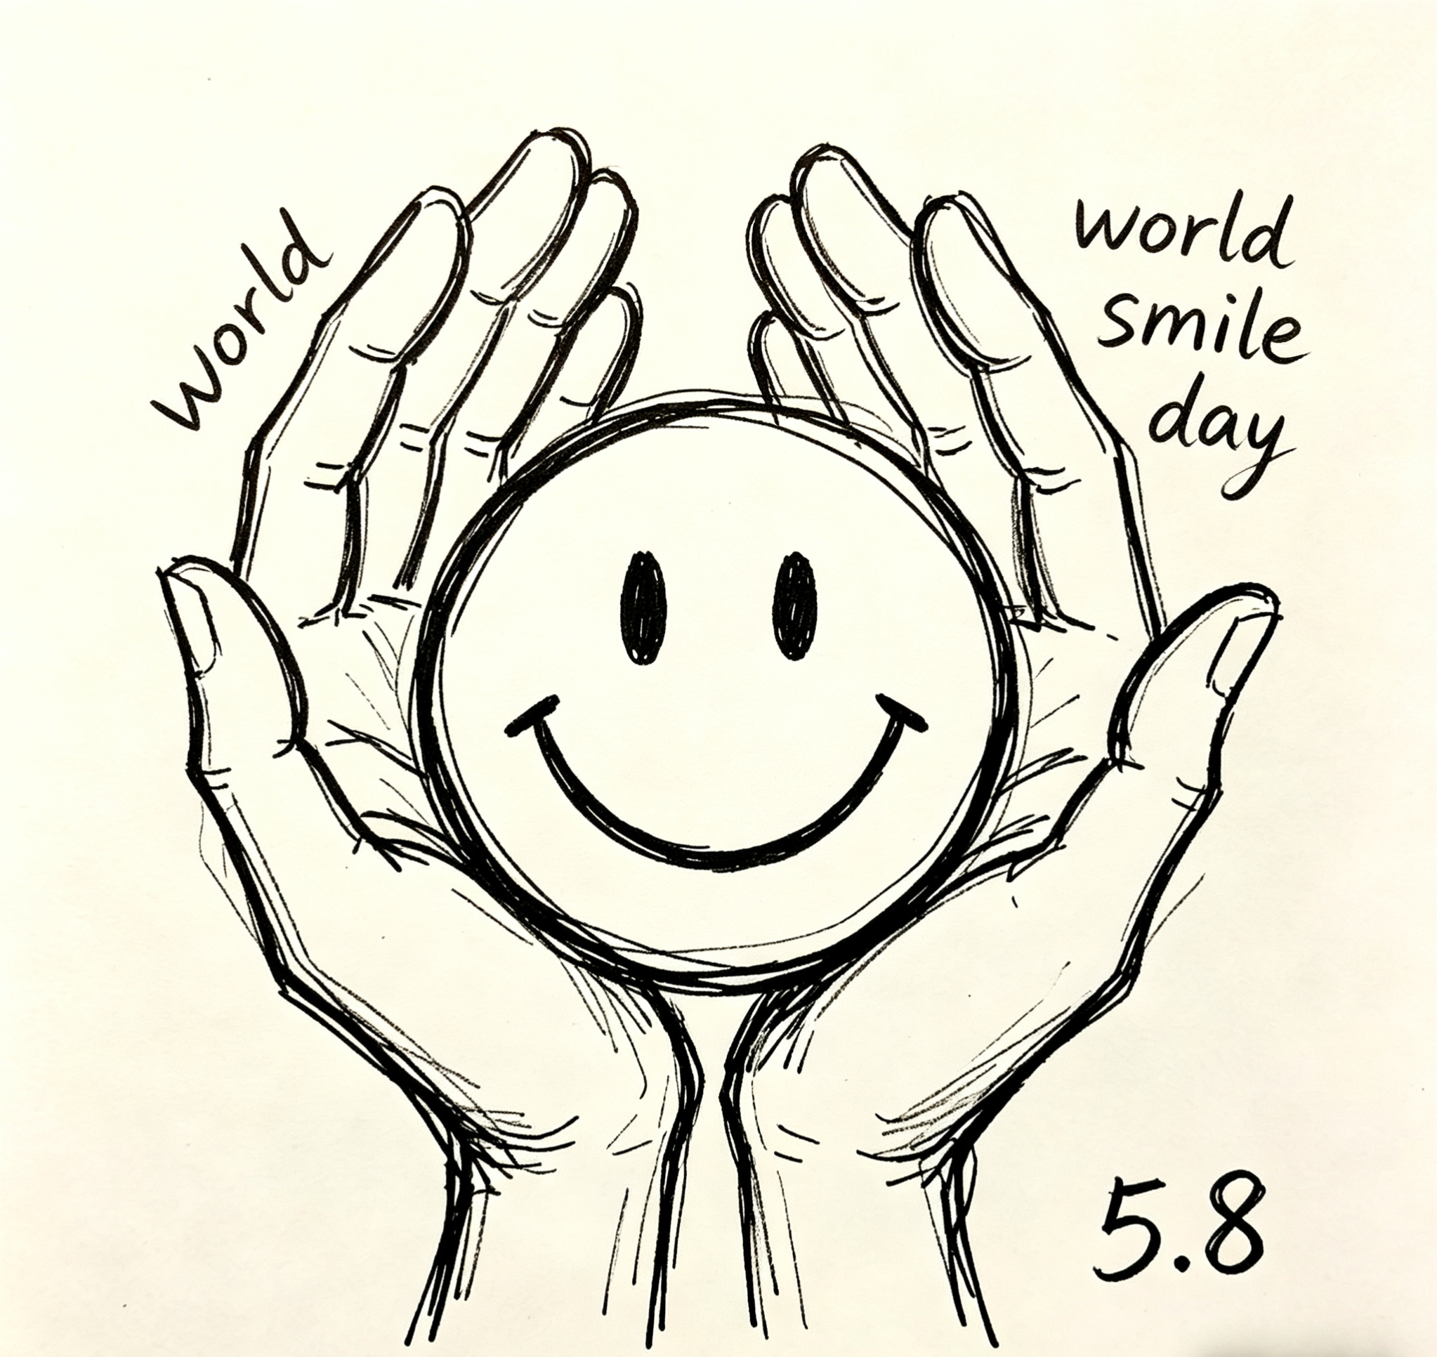
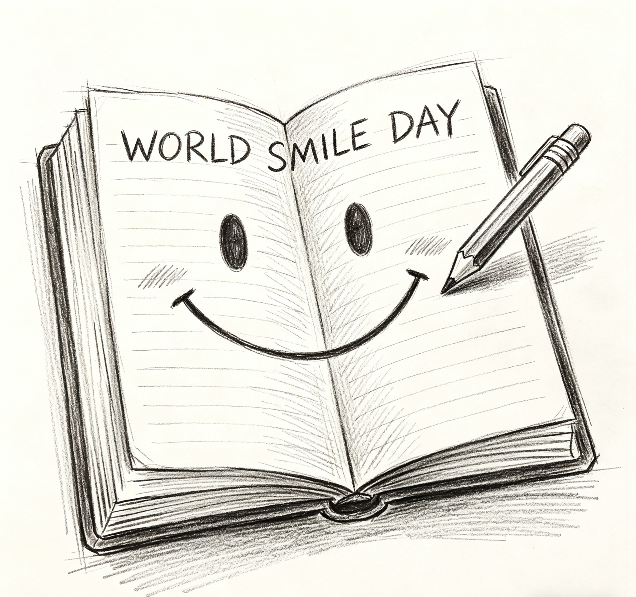


第二段：设计解读 + 寓意阐释（主体核心）
核心任务：解释每个元素的含义，点明设计的初衷，体现对 “微笑日” 的理解。
写作要点：
- 对应第一段的元素，逐个解读寓意（笑脸 = 快乐 / 善意，手 = 连接 / 温暖，颜色 = 活力 / 包容）。
- 点出微笑的意义：消除隔阂、传递善意、校园氛围、积极心态。
- 升华主题：微笑是通用语言，能拉近人与人的距离。

第三段：收尾表态 + 投稿诚意（结尾收束）
核心任务：表达对设计的信心，呼应投稿目的，简短有力收尾。
写作要点：
- 表达设计的初衷（希望传递微笑的力量、活跃校园氛围）。
- 礼貌收尾，表达对采用的期待。
- 贴合 “李华” 的学生身份，语气真诚自然。

三、写作高级表达

图 1：双手捧护笑脸

开头段（图案描述）

高级短语
- be gently cupped in two pairs of hands 被两双手温柔捧护
- take the shape of a simple round smiley face 呈简约圆形笑脸造型
- feature the date “5.8” marked at the bottom 底部标注 “5.8” 日期

高级句子
- At the center of the design is a simple round smiley face, gently cupped in two pairs of hands drawn with soft pencil lines.设计的中心是一个简约的圆形笑脸，被两双以柔和铅笔线条勾勒的手温柔捧护着。
- The words “World Smile Day” curve above the hands, while the date “5.8” is clearly marked at the bottom right corner. “World Smile Day” 的字样在双手上方呈弧形排列，“5.8” 的日期清晰标注在右下角。
- The sketch uses clean, simple strokes to highlight the warm, caring feel of the logo.这幅手绘以干净利落的线条，凸显标识温暖治愈的质感。

主体段（设计解读）

高级短语
- stand for the care we give to small joys 代表我们对微小快乐的珍视
- represent the warmth of shared kindness 代表善意传递的暖意
- convey the message of cherishing every smile 传递珍视每一份微笑的理念

高级句子
- The hands cupping the smile stand for the care we give to small joys, showing that every smile deserves to be protected and shared.托举笑脸的双手代表着我们对微小快乐的珍视，说明每一份微笑都值得被呵护与分享。
- The smiley face itself represents the warmth of shared kindness, a simple act that can brighten both the giver’s and receiver’s day.笑脸本身代表着善意传递的暖意，这一简单举动足以点亮给予者与接收者的一天。
- The date “5.8” conveys the message of cherishing every smile, reminding us to celebrate this day with kindness in our hearts.“5.8” 的日期传递着珍视每一份微笑的理念，提醒我们心怀善意庆祝这个特别的日子。

结尾段（收尾表态）

高级短语
- reflect the spirit of care and connection 体现关怀与联结的精神
- bring a warm touch to the school’s celebration 为校园庆祝活动增添暖意
- wish to spread kindness across the campus 愿善意传遍校园

高级句子
- This design reflects the spirit of care and connection, aiming to make every student feel the warmth of a shared smile.这个设计体现了关怀与联结的精神，旨在让每一位同学都感受到共享微笑的暖意。
- It is my hope that this simple logo will bring a warm touch to our school’s World Smile Day celebration.我希望这个简约的标识能为我们学校的世界微笑日庆祝活动增添一抹暖意。
- I truly wish this design will help spread kindness across the campus, one smile at a time.我由衷希望这个设计能以一抹微笑为起点，让善意传遍整个校园。

图 2：爱心眨眼笑脸

开头段（图案描述）

高级短语
- take the form of a winking heart-shaped smile 呈眨眼爱心笑脸造型
- be surrounded by delicate star sparkles 被精致星芒环绕
- feature blushing cheeks for a cute touch 带有腮红增添俏皮感

高级句子
- The logo takes the form of a winking heart-shaped smile, drawn with soft pencil strokes for a gentle feel.这个标识以眨眼爱心笑脸为造型，用柔和的铅笔线条勾勒，质感温柔。
- Delicate star sparkles surround the heart, adding a magical and lively touch to the simple sketch.精致的星芒环绕着爱心，为这幅简约的手绘增添了灵动的魔力。
- Blushing cheeks on the heart give it a cute, approachable look, with “World Smile Day” written below in cursive.爱心上的腮红让它显得俏皮亲切，下方还用手写体标注着 “World Smile Day” 的字样。

主体段（设计解读）

高级短语
- symbolize the warmth of love and joy 象征爱与快乐的暖意
- represent a lighthearted and playful attitude 代表轻松俏皮的生活态度
- stand for the magic a smile can bring 代表微笑能带来的魔力

高级句子
- The heart shape symbolizes the warmth of love and joy, showing that a smile comes from the heart.爱心的造型象征着爱与快乐的暖意，说明微笑源自内心。
- The winking smile represents a lighthearted and playful attitude, reminding us not to take life too seriously.眨眼的笑脸代表着轻松俏皮的生活态度，提醒我们不必把生活过得太严肃。
- The surrounding stars stand for the magic a smile can bring, turning ordinary moments into something special.周围的星芒代表着微笑能带来的魔力，将平凡的瞬间变得格外特别。

结尾段（收尾表态）

高级短语
- capture the cheerful atmosphere of the day 捕捉这个日子的欢快氛围
- add a sweet and lively touch to the event 为活动增添甜美灵动的气息
- hope to inspire smiles in every student 希望唤起每一位同学的笑容

高级句子
- This design captures the cheerful vibe of World Smile Day, turning a simple heart into a symbol of joy.这个设计捕捉了世界微笑日的欢快氛围，将一颗简单的爱心化作快乐的象征。
- I believe it will add a sweet and lively touch to our school’s event, making the celebration more memorable.我相信它能为我们学校的活动增添甜美灵动的气息，让这次庆祝更加难忘。
- My wish is that this cute logo will inspire smiles in every student, making our campus a brighter place.我希望这个可爱的标识能唤起每一位同学的笑容，让我们的校园变得更加明亮。

图 3：书本笑脸

开头段（图案描述）

高级短语
- center on an open book with a smile 以带笑脸的翻开书本为中心
- have the words written on the book’s pages 书页上印着活动主题字样
- feature a pencil placed beside the book 书本旁搭配一支铅笔

高级句子
- At the heart of the design is an open book with a big smile drawn across its pages, paired with a pencil on the right.设计的核心是一本翻开的书，书页上画着大大的笑脸，右侧搭配着一支铅笔。
- The words “WORLD SMILE DAY” are written at the top of the book, making the theme clear at first glance.“WORLD SMILE DAY” 的字样写在书本的顶部，让主题一目了然。
- The sketch uses soft shading to give the book a three-dimensional look, adding depth to the simple drawing.这幅手绘用柔和的阴影让书本显得立体，为简约的画面增添了层次感。

主体段（设计解读）

高级短语
- represent the joy of learning and sharing 代表学习与分享的快乐
- stand for the warmth of knowledge and kindness 象征知识与善意的暖意
- convey the idea of writing happy stories 传递书写快乐故事的理念

高级句子
- The open book represents the joy of learning and sharing, showing that knowledge and happiness can go hand in hand.翻开的书本代表着学习与分享的快乐，说明知识与快乐可以相伴而行。
- The smile on the book stands for the warmth of knowledge and kindness, encouraging students to spread joy through their words.书本上的笑脸象征着知识与善意的暖意，鼓励同学们用文字传递快乐。
- The pencil beside the book conveys the idea of writing happy stories, inviting everyone to create their own smiles every day.书本旁的铅笔传递着书写快乐故事的理念，邀请每个人每天都创造属于自己的微笑。

结尾段（收尾表态）

高级短语
- echo the spirit of learning and joy 呼应学习与快乐的精神
- bring a book-themed touch to the celebration 为庆祝活动增添书本主题气息
- hope to connect learning with positive energy 希望将学习与正能量联结

高级句子
- This design echoes the spirit of learning and joy, perfect for a school event that celebrates both knowledge and kindness.这个设计呼应了学习与快乐的精神，非常适合这场同时庆祝知识与善意的校园活动。
- It will bring a book-themed touch to our school’s celebration, making it feel meaningful and fun for all students.它将为我们学校的庆祝活动增添书本主题的气息，让所有同学都觉得既有趣又有意义。
- I truly hope this logo will help connect learning with positive energy, encouraging students to smile more as they study.我由衷希望这个标识能将学习与正能量联结起来，鼓励同学们在学习的同时多展露笑容。

四、范文赏析

范文一 双手捧护笑脸
My design for World Smile Day is simple but full of warmth. At the center of the logo is a lovely round smiley face, gently cupped in two pairs of hands drawn with soft pencil lines. The words “World Smile Day” curve above the hands, and the important date “5.8” is marked clearly at the bottom right corner.
Clean and simple pencil strokes make the whole design look caring.In this design, the hands stand for our care for small joys in life, while the smile represents the warmth of sharing kindness with others. The special date reminds us to cherish every beautiful smile around us.
I hope this design can show the spirit of care and connection, bring a warm touch to our school’s celebration and spread kindness to every corner of our campus.

译文
我的世界微笑日设计简约却饱含暖意。标识正中央是一个可爱的圆形笑脸，被两双以柔和铅笔线条勾勒的双手温柔捧护。“世界微笑日” 的字样在双手上方呈弧形排布，重要的 “5.8” 日期清晰标注在右下角。
干净简洁的铅笔线条，让整个设计尽显温情。在这款设计中，双手代表我们对生活中微小快乐的珍视，笑脸则象征着与他人分享善意的温暖。这个特殊的日期，提醒我们珍惜身边每一抹美好的笑容。
我希望这份设计能传递关怀与联结的精神，为学校的庆祝活动增添暖意，让善意传遍校园的每一个角落。

范文一 深度赏析
1.结构工整，逻辑闭环
采用「图案描写 — 寓意解读 — 升华期许」标准三段式，层层递进，完全适配校园海报类作文考场格式，条理清晰。
例句：At the center of the logo is a lovely round smiley face...（首段描写画面）In this design, the hands stand for our care...（中段解读内涵）I hope this design can show the spirit of care and connection...（尾段升华主旨）
2.高级词汇精准适配主题
活用考场加分短语，用词温柔贴合微笑日温暖氛围，不堆砌、不生硬。加分短语：be cupped in、stand for、cherish、the spirit of care and connection
例句：The hands stand for our care for small joys in life.
动词短语替换基础表达，表意细腻高级。
3.句式丰富，语法亮眼
开篇运用倒装句提升文采，中段用 while 引导对比状语从句，句式长短结合，读起来流畅自然。例句：At the center of the logo is a lovely round smiley face.
地点状语前置倒装，是书面表达经典高分句型。
4.立意贴合校园场景
紧扣友善、陪伴、校园温情，立意朴素正向，贴合中学生写作要求。
例句：spread kindness to every corner of our campus.
落脚校园生活，紧扣题目任务，现实感强。

范文二 爱心眨眼笑脸
Here is my design for World Smile Day. It takes the form of a cute winking heart-shaped smile, outlined with gentle pencil strokes. Delicate star sparkles surround the heart, and light blushing cheeks make the whole logo look lively and approachable. The words “World Smile Day” are written in beautiful cursive below the heart.
The heart shape symbolizes the warmth of love and joy, proving that smiles come from our hearts. The winking smile shows a lighthearted and positive attitude to life. The stars stand for the magic that a small smile brings to our ordinary days.
I hope this design can catch the cheerful vibe of World Smile Day, inspire every student to smile and make our campus a brighter and happier place.

译文
这是我为世界微笑日设计的作品。标识以俏皮的眨眼爱心笑脸为造型，用柔和的铅笔线条勾勒轮廓。精致的星芒环绕着爱心，淡淡的腮红让整个标识显得灵动又亲切，爱心下方还用优美的手写体标注着 “世界微笑日”。
爱心造型象征着爱与欢乐的温暖，印证了微笑源自内心。眨眼的笑脸展现了轻松积极的生活态度，星芒则代表一抹浅浅的微笑，能为平凡日子带来的奇妙魔力。
我希望这份设计能捕捉世界微笑日的欢快氛围，激励每一位同学展露笑容，让我们的校园变得更明亮、更温馨。

范文二 深度赏析
1.描写生动，画面感极强
侧重细节刻画，神态、装饰、线条描写细腻，把手绘图案写得鲜活灵动，避免干瘪流水账。
例句：Delicate star sparkles surround the heart, and light blushing cheeks make the whole logo look lively and approachable.
细节描写丰富，画面立体，感染力强。
2.寓意解读层层递进
分别解读爱心、眨眼表情、星芒三种元素，一一对应内涵，逻辑清晰，解读全面。加分词汇：symbolize、lighthearted、cheerful vibe、inspire
例句：The winking smile shows a lighthearted and positive attitude to life.
用词高级，精准表达乐观积极的生活态度。
3.句式简洁优美，容错率高
多用简单复合句与 with 伴随结构，句式简洁易懂，适合考场快速写作，同时兼具美感。
例句：It takes the form of a cute winking heart-shaped smile, outlined with gentle pencil strokes.
过去分词作后置定语，句式简洁高级。
4.情感积极，主题鲜明
围绕 “发自内心的微笑、积极生活、校园活力” 展开，主旨明确，正能量十足。
例句：inspire every student to smile and make our campus a brighter and happier place.
结尾升华简洁有力，回扣写作主题。

范文三 书本笑脸
My design for World Smile Day centers on an open book with a big bright smile on its pages, and a slim pencil is placed right beside the book. The words “World Smile Day” are printed at the top of the book, and soft shading makes the book look three-dimensional and vivid.
The open book represents the joy of learning and sharing, while the smile on it stands for the warmth of knowledge and kindness. The pencil beside it conveys the idea that we can write our own happy stories every day.This design echoes the spirit of learning and joy.
I hope it can connect study with positive energy, make our school’s celebration meaningful and encourage students to keep smiling while gaining knowledge.

译文
我的世界微笑日设计，以一页印着灿烂笑容的翻开书本为核心，书本旁还摆放着一支纤细的铅笔。“世界微笑日” 的字样印在书本上方，柔和的阴影让书本显得立体又生动。
翻开的书本代表学习与分享的快乐，书上的笑容象征知识与善意的温暖。旁边的铅笔传递出一种理念：我们每一天都可以书写属于自己的快乐故事。这份设计呼应了学习与欢乐的精神。
我希望它能将学习与正能量联结，让学校的庆祝活动更有意义，鼓励同学们在汲取知识的同时，始终保持微笑。

范文三 深度赏析
1.结合学生身份，选材新颖独特
以书本、铅笔为核心元素，贴合校园学习生活，区别于普通笑脸设计，立意更有新意。
例句：My design for World Smile Day centers on an open book with a big bright smile on its pages.
紧扣学生日常，设计意象贴合校园作文语境。
2.高分抽象动词加持，文采突出
大量运用书面高级动词，如 convey、echo、represent，替换基础词汇，提升作文档次。
例句：This design echoes the spirit of learning and joy.
echo 替代普通 reflect /show，表达凝练高级，是考场高频加分词。
3.语法运用娴熟
熟练使用 while 对比从句、同位语从句，语法结构丰富，体现扎实的英语基础。
例句：The pencil beside it conveys the idea that we can write our own happy stories every day.
that 引导同位语从句，语法结构进阶，容易拿下高分。
4.主旨升华贴合教育内核
将微笑与学习、成长、正能量结合，立意深刻，升华自然，思想内涵更丰富。
例句：encourage students to keep smiling while gaining knowledge.
把微笑日常和校园学习结合，立意深刻，贴合校园活动主题。

读后续写讲义
一 、续写材料
阅读下面材料，根据其内容和所给段落开头语续写两段，使之构成一篇完整的短文。
When Mum told me to stay with Grandpa for a couple of hours, I was extremely unwilling deep down. “He doesn’t like me,” I said. “Oh, of course he likes you. He’s just sad since Grandma passed away,” Mum replied. We drove straight to Grandpa’s in an uncomfortable silence.
After dropping me off at Grandpa’s apartment, Mum headed to her appointment, promising to come to pick me up soon. Spotting me, Grandpa motioned for me to sit. We glanced up at each other now and then but didn’t say anything. “Want to watch television?” he asked. I nodded. But nothing was on. Two minutes later, he turned the TV off. We sat there, Grandpa patting his legs restlessly, and me trying to find a comfortable position on his old, soft couch.
Suddenly, I felt something hard on the floor beneath the couch. I reached down and pulled it out. It was a wooden box with fancy designs carved into the sides. “Chess?” I said, surprised. “Yeah, I used to play. Do you play?” Grandpa asked. “Never,” I answered. Grandpa fell quiet for a moment, staring at the window and still tapping his legs. Then he suggested that since we had time, he could teach me how to play. I agreed casually.
Grandpa opened the box, a smell of wood polish rising from inside. He taught me about all the pieces and showed me how they moved: the king could move one square in any direction, and the game was won by trapping him; pawns (兵) moved straight forward; knights (马) moved in an L-shape and could leap over other pieces… I was amazed at how patient he was.
We practiced a bunch of times. He just corrected me and had me try again. Finally, when he was satisfied that I knew what to do with all the pieces, he said we were ready to play for real.
注意：(1) 续写词数应为 150 左右；(2) 请按如下格式在答题卡的相应位置作答。
Paragraph 1: Our first game began, and I played with full attention.
Paragraph 2: We were really enjoying ourselves when Mum returned.

二、故事情节梳理

核心背景
- 人物关系：“我”（起初抗拒爷爷的孩子）、爷爷（因奶奶离世情绪低落，和 “我” 关系疏离）、妈妈（连接 “我” 与爷爷的纽带）
- 核心矛盾：“我” 误以为爷爷不喜欢自己，抗拒独处；爷爷沉浸在丧偶的悲伤中，和 “我” 缺乏交流，祖孙间气氛尴尬冰冷。

原文情节脉络（按时间线梳理）

1. 开端：抗拒与尴尬僵局
- 妈妈告知 “我” 要去陪爷爷几小时，“我” 内心极度不情愿，直言 “他不喜欢我”。
- 妈妈解释爷爷只是因奶奶离世而悲伤，两人开车前往爷爷家，全程气氛压抑沉默。
- 妈妈离开后，“我” 和爷爷独处，全程无话，电视开了又关，两人无所适从，尴尬到坐立难安。

2. 转折：破冰的意外契机
- “我” 在沙发底下意外发现一个刻有精美花纹的旧木盒 —— 里面是爷爷珍藏的国际象棋。
- 爷爷主动提出教 “我” 下棋，“我” 随口答应，这是两人关系缓和的第一个突破口。

3. 发展：耐心教学与隔阂消融
- 爷爷打开盒子，木蜡的清香飘出，他耐心教 “我” 所有棋子的走法（王、兵、马的移动规则）。
- 面对 “我” 的失误，爷爷全程温和纠正，没有一丝不耐烦，让 “我” 第一次感受到爷爷的温柔，打破了 “他不喜欢我” 的误解。
- 经过多次练习，爷爷确认 “我” 已掌握规则，提出可以来一盘正式的对局，两人的关系明显升温。

续写节点（原文结尾）
故事停在祖孙二人即将开启第一盘正式对局的瞬间，衔接两段续写的开头句：
- 第一段开头：Our first game began, and I played with full attention.
- 第二段开头：We were really enjoying ourselves when Mum returned.

续写情节的核心逻辑锚点
- 情感主线：从疏离尴尬 → 破冰互动 → 温情升温，最终达成祖孙和解，呼应开头的矛盾。
- 道具线索：旧象棋盒可承载爷爷对奶奶的回忆（比如爷爷下棋是以前和奶奶的共同爱好，教 “我” 下棋也是在延续这份温暖）。
- 场景对比：妈妈回来时的热闹温情，要和开头 “一路沉默、气氛冰冷” 的场景形成强烈反差，突出祖孙关系的转变。

三、续写思路

1. 核心主题
以旧象棋盒为情感纽带，展现祖孙二人从「疏离误解」到「温情和解」的转变：既用下棋的互动治愈了爷爷因奶奶离世的悲伤，也让 “我” 读懂了爷爷沉默背后的温柔。

2. 核心冲突与解决
- 初始矛盾：“我” 误以为爷爷不喜欢自己，抗拒独处；爷爷沉浸在丧偶的悲伤中，封闭内心，祖孙间气氛尴尬冰冷。
- 解决契机：教棋过程中的耐心互动打破了沉默，让彼此重新认识对方。
- 情感落点：通过正式对局和妈妈回来时的场景对比，化解误解，达成祖孙和解。

3. 关键道具与伏笔呼应
- 旧象棋盒：承载爷爷与奶奶的回忆，也是祖孙破冰的契机（呼应原文 “wooden box with fancy designs”“smell of wood polish”）。
- 爷爷的沉默与耐心：呼应原文 “sad since Grandma passed away”，通过教棋细节展现他隐藏的温柔。

分段写作思路

第一段：Our first game began, and I played with full attention.

核心目标
通过对局中的互动细节，打破尴尬沉默，展现祖孙关系的初步升温，完成 “我” 对爷爷的情感转变。

情节推进逻辑
- 承接开头，铺垫状态：写 “我” 对局时的紧张与专注，比如手微微出汗、盯着棋盘不敢走神，呼应 “full attention”。
- 打破沉默，双向互动：描写爷爷不再沉默，会笑着提醒我走棋、夸我进步，甚至故意 “放水” 让我一步，展现他的温柔；我也不再拘谨，主动搭话，问他以前是不是常和奶奶下棋。
- 情感转折，细节呼应：爷爷听到 “奶奶” 时，眼神柔和下来，笑着说起以前和奶奶下棋的小事，让我理解了他之前的落寞，也感受到他的亲切；可加入 “他摩挲着棋子，指尖带着木蜡的清香” 这类细节，呼应原文伏笔。

情感层次
紧张拘谨 → 放松投入 → 理解与亲近（初步消解误解）

第二段：We were really enjoying ourselves when Mum returned.

核心目标
通过妈妈的视角形成场景对比，完成情感升华，化解所有矛盾，留下温暖的收尾。

情节推进逻辑
- 承接开头，场景对比：妈妈推门进来，看到我们凑在棋盘前说说笑笑的样子，和她离开时的尴尬沉默形成强烈反差，眼神里满是惊讶。
- 收尾互动，情感落地：我舍不得走，主动和爷爷约好下次再来下棋；爷爷把旧象棋盒递给我，说 “给你留着，下次来和我下”，或 “你奶奶要是知道你会下棋，肯定很高兴”，呼应他的悲伤与温柔。
- 首尾呼应，升华主题：和开头 “我极不情愿来” 的心情形成对比，此刻我反而期待下次见面；我终于明白，爷爷不是不喜欢我，只是太想念奶奶，而这份温柔，一直都在。

情感层次
沉浸互动 → 不舍告别 → 理解与和解（完成主题升华）

四、续写高级表达

情感表达类

高级短语
- melt the long-standing awkwardness 消融长久以来的尴尬
- ease the weight of Grandpa’s sorrow 减轻爷爷心中的悲伤
- bridge the gap between two hearts 拉近两颗心的距离
- spark a warm bond between us 点燃我们之间温暖的联结
- erase the misunderstanding deep in my heart 消除我心底的误解
- fill the room with genuine warmth 让房间充满真挚的暖意

高级句子
- The quiet exchange over the chessboard slowly melted the long-standing awkwardness between us. 棋盘边的安静互动，慢慢消融了我们之间长久以来的尴尬。
- As Grandpa spoke of Grandma, his eyes softened, easing the heavy sorrow that had hung over him for so long. 当爷爷说起奶奶时，他的眼神柔和下来，那萦绕已久的沉重悲伤也随之淡去。
- Hearing me mention Grandma, Grandpa’s eyes lingered with deep longing, making me finally understand his loneliness. 听到我提起奶奶，爷爷的眼眸里满是深深的思念，我终于读懂了他的孤独。
- What began as an uncomfortable silence soon turned into a warm connection that bridged the gap between our hearts. 起初令人不适的沉默，很快变成了温暖的联结，拉近了我们两颗心的距离。
- Mum pushed open the door silently and froze in surprise, totally shocked to see us chatting and laughing happily over the chessboard.妈妈悄然推门进来，愕然驻足，完全没想到会看见我们围坐棋盘、谈笑风生的模样。
- The harmonious scene before her contrasted sharply with the awkward silence when she left, leaving her lost in amazement.眼前和睦融洽的画面，与她离开时的死寂尴尬形成鲜明对比，让她满心讶异。

动作描写类

高级短语
- lean forward with eyes fixed on the chessboard 倾身向前，目光紧紧锁在棋盘上
- tap his fingers gently on the edge of the table 手指轻轻叩着桌沿
- reach out to adjust a misplaced pawn 伸手摆正一枚放歪的兵棋
- rub the worn chess piece between his thumb and forefinger 拇指和食指摩挲着磨损的棋子
- hold my breath, hesitating over which piece to move 屏住呼吸，犹豫着该走哪一步棋
- lean back in his chair, a soft smile tugging at his lips 靠回椅背上，嘴角勾起一抹温柔的笑
- brush a strand of hair from my forehead with a light laugh 轻笑着拨开我额前的碎发
- cup the wooden chess box in his hands like a treasure 像捧着珍宝般捧着那只木棋盒

高级句子
- I leaned forward, eyes fixed on the chessboard, my fingers hovering uncertainly over a knight as I tried to recall its L-shaped move. 我倾身向前，目光紧紧锁在棋盘上，手指在一枚马棋上方迟疑地悬着，努力回忆它 L 形的走法。
- Grandpa leaned back in his chair, rubbing a worn pawn between his thumb and forefinger, a soft smile tugging at the corners of his lips as he watched me fumble. 爷爷靠回椅背上，拇指和食指摩挲着一枚磨损的兵棋，看着我手忙脚乱的样子，嘴角勾起一抹温柔的笑。
- When I finally made a clever move, he clapped his hands lightly, tapping his fingers gently on the edge of the table to praise me. 当我终于走出一步妙棋，他轻轻拍了拍手，手指在桌沿上轻叩着，像是在为我喝彩。
- As the game went on, I no longer held my breath; instead, I leaned in eagerly, asking Grandpa for hints with a bright smile. 随着棋局推进，我不再屏住呼吸，反而热切地凑上前，带着明亮的笑容向爷爷讨教提示。
- Seeing me hesitate for long, he made a careless move on purpose to give me a chance to gain the upper hand. 看我久久犹豫，他故意走了一步失误的棋，给我领先的机会。
- Grandpa reached out to adjust a misplaced rook for me, his weathered fingers brushing mine lightly as he murmured, “Careful, don’t rush.” 爷爷伸手帮我摆正一枚放歪的车棋，布满老茧的手指轻轻擦过我的手，低声说：“慢慢来，别急。”·
- Mum pushed the door open quietly, staring at us with surprise written all over her face. 妈妈轻轻推开房门，满脸惊讶地看着其乐融融的我们。
- Grandpa held the chess box out gently, promising to keep it for my next chess game. 爷爷缓缓递来棋盒，承诺会留着它等我下次再来下棋。

场景描写类

高级短语
- bathed in the soft golden afternoon light 沐浴在午后柔和的金色阳光里
- cast long, gentle shadows across the worn wooden floor
在老旧的木地板上投下悠长柔和的影子
- fill the air with the faint scent of old wood polish 空气中弥漫着淡淡的旧木蜡香气
- the faint ticking of the wall clock breaking the quiet 墙上时钟微弱的滴答声打破了宁静
- sunlight filtering through the kitchen window onto the chessboard
阳光透过厨房的窗户洒在棋盘上
- the worn couch and chipped coffee table framing the warm scene
老旧沙发和掉漆的茶几衬出温馨的画面

高级句子
- The living room, once heavy with silence, was now bathed in the soft golden afternoon light, with the faint scent of old wood polish lingering in the air. 这间曾被沉默笼罩的客厅，此刻沐浴在午后柔和的金色阳光里，空气中萦绕着淡淡的旧木蜡香气。
- Sunlight filtered through the kitchen window onto the chessboard, casting long, gentle shadows across the worn wooden floor as we leaned over the pieces. 阳光透过厨房的窗户洒在棋盘上，在老旧的木地板上投下悠长柔和的影子，我们俯身对着棋子的身影也被拉得长长的。
- The faint ticking of the wall clock and the soft rustle of moving chess pieces were the only sounds, framing a warm, peaceful scene far from the awkwardness of earlier. 墙上时钟微弱的滴答声和棋子移动的轻响是屋里仅有的声音，衬出一幅温暖安宁的画面，和之前的尴尬截然不同。
- When Mum stood at the door in astonishment, the two of us leaning over the chessboard formed a warm family picture. 妈妈惊讶地站在门口，俯身棋盘前的我们构成了一幅温馨的亲情画面。

主旨升华类

高级短语
- find warmth in the quietest of moments 在最安静的瞬间找到温暖
- turn a tense afternoon into a cherished memory 把紧张的午后变成珍贵的回忆
- understand love hidden in silence 读懂藏在沉默里的爱
- weave a new bond through shared stories 通过共同的回忆编织新的联结
- let the old chess set carry new warmth 让旧棋盘承载新的暖意
- see love in small, patient acts 在耐心的小事里看见爱

高级句子
- That afternoon, I learned that love isn’t always loud—it hides in the quiet patience of teaching a game, in the stories shared over an old chess set. 那天下午我才明白，爱并不总是轰轰烈烈的，它藏在教我下棋的耐心里，藏在旧棋盘边分享的故事里。
- What started as an awkward afternoon turned into a cherished memory, where an old chess set carried not just Grandma’s memories, but new warmth between Grandpa and me. 起初尴尬的午后，变成了一段珍贵的回忆，旧棋盘里装着的不仅是奶奶的过往，还有我和爷爷之间新的暖意。
- I finally understood that Grandpa never disliked me; his silence was just grief, and in the quiet game of chess, we found a way to connect, healing each other’s hearts. 我终于明白，爷爷从来都不讨厌我，他的沉默只是悲伤的外壳，而在这场安静的棋局里，我们找到了联结彼此的方式，也治愈了彼此的心。

五、范文赏析
Our first game began, and I played with full attention. Staring steadily at the chessboard, I hesitated repeatedly and weighed every move cautiously, my palms wet with slight sweat. Instead of being strict, Grandpa guided me patiently with soft smiles, even deliberately making small concessions to build my confidence. Encouraged, I plucked up courage to ask if he once played chess with Grandma. At the mention of her, Grandpa’s eyes softened. Stroking the old chess pieces with faint wood fragrance, he shared their sweet old days in a gentle voice. The original awkwardness faded away, and we soon bonded closely.
We were really enjoying ourselves when Mum returned. She froze at the doorway, greatly astonished at the warm scene, which stood in sharp contrast to the cold silence before leaving. Unwilling to leave, I made an appointment to visit him again. Grandpa kindly handed me the wooden chess box, saying Grandma would be delighted to see me learn chess. This precious afternoon completely cleared up my misunderstanding. I finally realized his silence was just sorrow, and endless tenderness was always hidden in his quiet company.

翻译
第一局棋局正式开始，我全程专心致志。我稳稳凝视棋盘，反复犹豫，慎重斟酌每一步落子，手心渗出细密薄汗。爷爷没有严苛对待，反倒面带温和笑意耐心指引，甚至特意小幅退让，帮我树立信心。受到鼓舞，我鼓起勇气询问他是否曾和奶奶一同下棋。提及奶奶，爷爷的目光瞬间柔和。他轻抚带着淡淡木香的老旧棋子，轻声诉说着二人往日的温馨时光。原本的尴尬荡然无存，我们很快拉近了彼此的距离。
妈妈归来时，我们正沉浸在棋局、其乐融融。她驻足门口，望着眼前温暖的一幕无比诧异，这与她离开时冷清死寂的氛围形成鲜明对比。我满心不舍，主动约定下次再来探望。爷爷温柔地将木棋盒递给我，坦言倘若奶奶知晓我学会下棋，定会十分欣慰。这个珍贵的午后彻底化解了我所有的误解。我终于明白，他的沉默只是源于悲伤，无言的陪伴之中，一直藏着无尽的温柔。

范文赏析要点：

1. 结构逻辑：紧扣情节，衔接自然
严格贴合原文脉络与两段开头，从专注对弈→温情互动→回忆奶奶→母亲归来→不舍告别→主旨醒悟层层推进，情节完整，首尾呼应。
例句：This precious afternoon completely cleared up my misunderstanding. I finally realized his silence was just sorrow.
完美回扣开篇 “我认为爷爷不喜欢我” 的核心矛盾，闭环完整。

2. 细节描写丰富，画面感极强
融合动作、神态、环境、心理多重细节，贴合高考续写高分要求，摆脱流水账。
动作细节
例句：Stroking the old chess pieces with faint wood fragrance, he shared their sweet old days in a gentle voice.
神态细节
例句：At the mention of her, Grandpa’s eyes softened.
以细微刻画凸显爷爷的柔软与思念，人物形象饱满。

3. 高级词汇与短语，提升文采
巧用考场高频加分短语，用词精准地道，摆脱基础词汇。加分词汇：deliberately make concessions、pluck up courage、fade away、bond closely、stand in sharp contrast、clear up misunderstanding
例句：The original awkwardness faded away, and we soon bonded closely.
简洁高级，生动体现祖孙关系的转变。

4. 句式多变，长短结合
灵活运用分词作伴随状语、非限制性定语从句、独立主格，句式错落有致，语法功底扎实。
长难句
例句：She froze at the doorway, greatly astonished at the warm scene, which stood in sharp contrast to the cold silence before leaving.
非限制性定语从句衔接对比画面，句式高级流畅。

5. 情感升华自然，主旨深刻
以棋局为纽带，诠释沉默的爱、亲情和解、温柔陪伴的核心主题，情感真挚不生硬。
主旨例句：I finally realized his silence was just sorrow, and endless tenderness was always hidden in his quiet company.
凝练点题，升华全文立意，契合读后续写情感考查核心。

