The World（0501-0515）材料分析和教学目标：
本次选用的材料：①The Washington Post 的90,000 people are waiting for an organ that can’t be bought（9万人在等待无法用金钱购买的器官）、②The Wall Street Journal 的Apple, Intel Set Chip-Making Deal（苹果与英特尔达成芯片制造协议）、③BBC Countryfile的Scientists Discover Heartbreaking Reason For Mass Whale Stranding（科学家发现鲸鱼大规模搁浅的令人心碎的原因）、④Outside USA的Earl Swift（厄尔·斯威夫特）和⑤BBC的新闻报道。通过语法填空、阅读理解、分析长难句、翻译句子、听力填空和词汇拓展等方式，让学生从多角度提升学习兴趣，提高分析句子、运用词块和听力能力。外媒英语新闻可以让学生体验真实语境下的语言运用，拓展学生的国际视野，了解时事，逐步提升跨文化沟通能力，形成正确的世界观、人生观和价值观。

教学思路：
Part 1: News Report 1 The Washington Post (May 10, 2026 A17)
90,000 people are waiting for an organ that can’t be bought
9万人在等待无法用金钱购买的器官
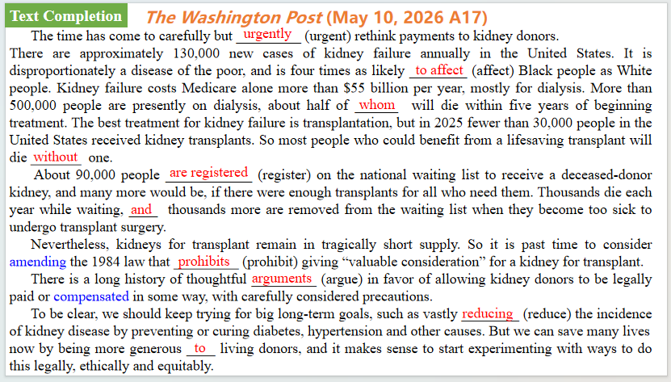
【设计意图】通过语篇填空的形式帮助学生理解新闻的主要内容，同时训练语言语法的运用能力：在语篇的视角下如何正确使用所给词汇，根据语法规则确定词汇的正确形式，使得文章通顺，激活学生的思维和语言。该新闻主题语境是关于“人与社会”中“社会热点”这一子主题，9万人登记在等待接受死者捐献肾脏的名单上，如果有足够的移植来满足所有需要的人，这个数字还会更多。
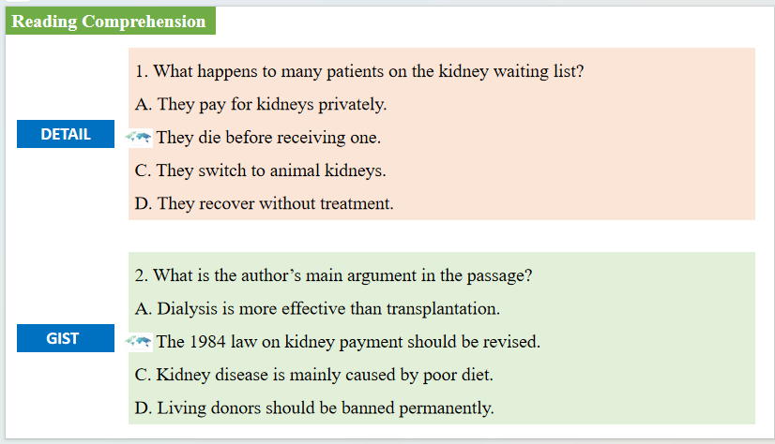
【设计意图】通过阅读理解的形式帮助学生理解新闻的主要内容。
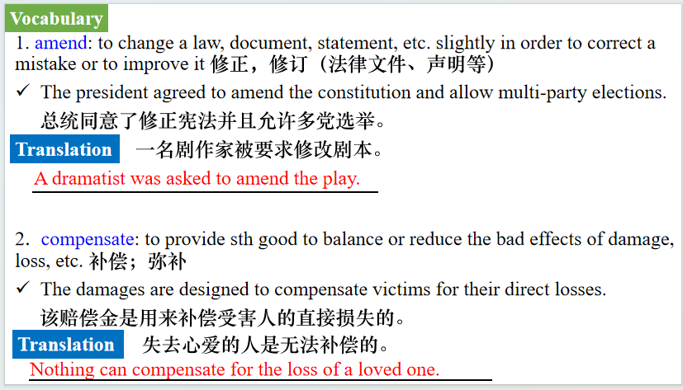
【设计意图】对文本中的词汇进行解读，并通过翻译句子对其进行巩固。
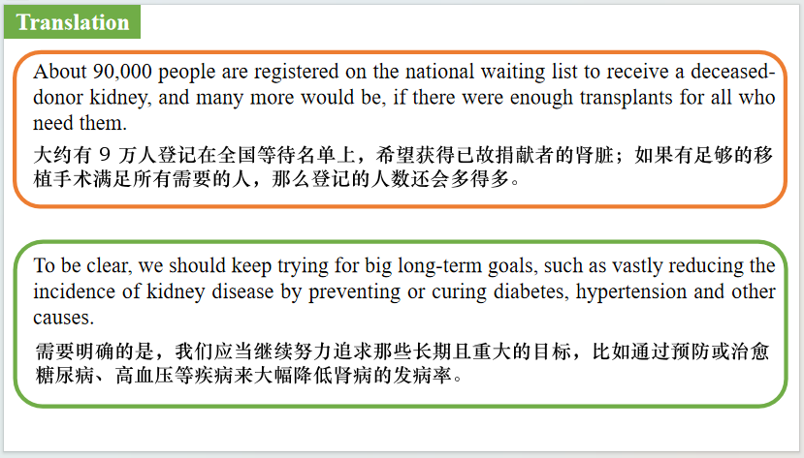
【设计意图】对文中的两个句子进行翻译练习，对其中单词、词组、句法进行巩固并关注句子结构。

Part 2: News Report 2 The Wall Street Journal (May 9, 2026 A1&A6)
Apple, Intel Set Chip-Making Deal
苹果与英特尔达成芯片制造协议
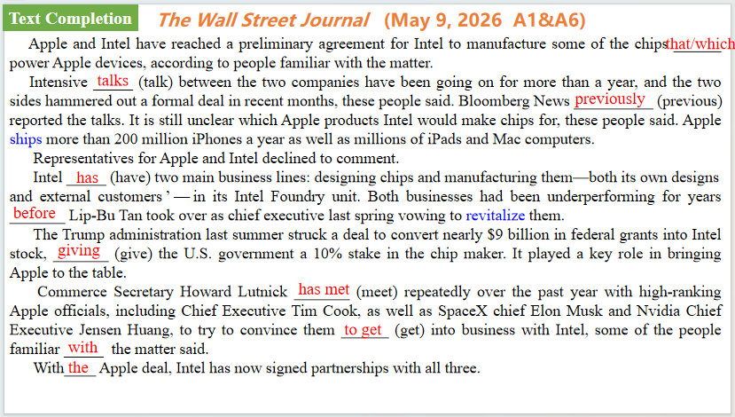
【设计意图】通过语篇填空的形式帮助学生理解新闻的主要内容，同时训练语言语法的运用能力：在语篇的视角下如何正确使用所给词汇，根据语法规则确定词汇的正确形式，使得文章通顺，激活学生的思维和语言。该新闻主题语境是关于“人与社会”中“科技发展与信息技术创新，科学精神”这一子主题，通过学习让学生了解苹果与英特尔达成芯片制造协议的具体情况。
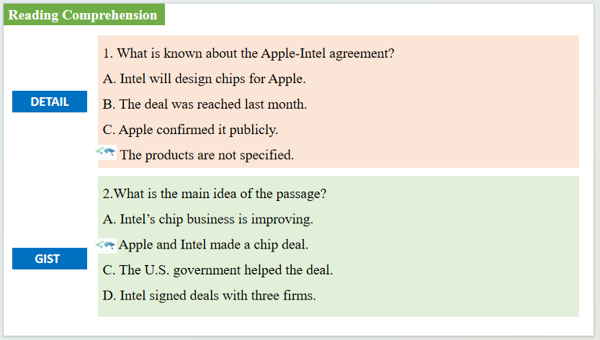
【设计意图】通过阅读理解的形式帮助学生理解新闻的主要内容。

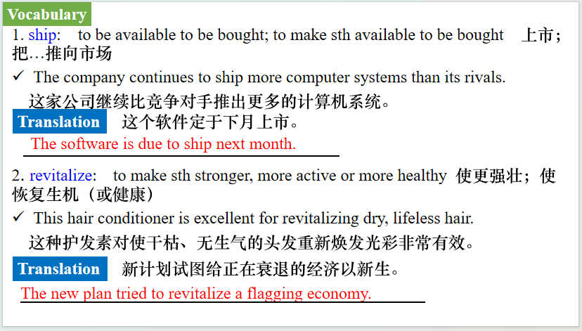
【设计意图】对文本中的词汇进行解读，并通过翻译句子对其进行巩固。
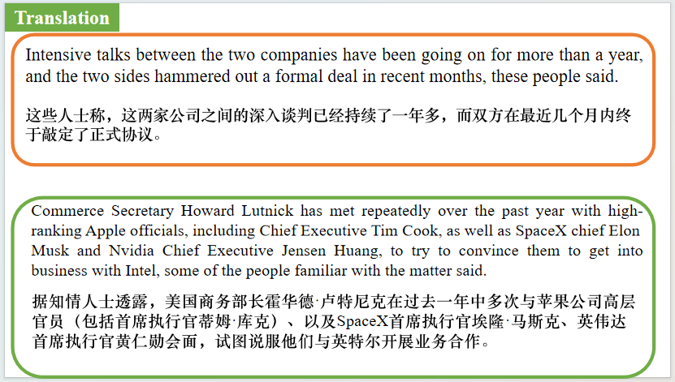
【设计意图】对文中的两个句子进行翻译练习，对其中单词、词组、句法进行巩固并关注句子结构。

Part 3: News Report 3 BBC Countryfile（May, 2026 P13)
Scientists Discover Heartbreaking Reason For Mass Whale Stranding
科学家发现鲸鱼大规模搁浅的令人心碎的原因
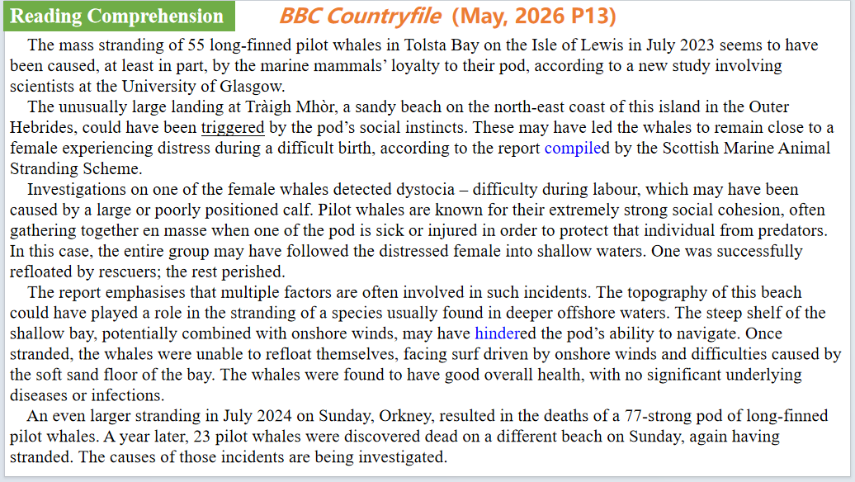
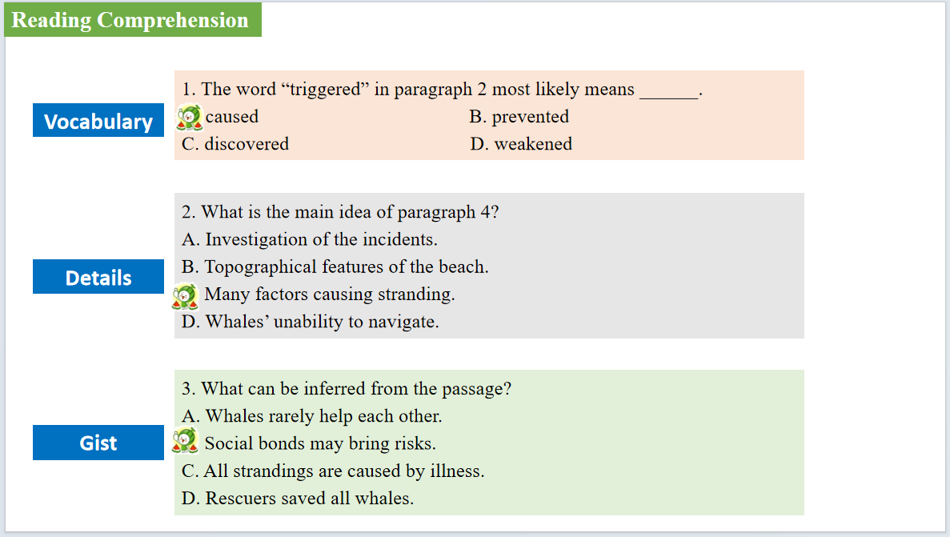
【设计意图】通过阅读理解的形式帮助学生理解新闻的主要内容。该新闻主题语境是关于“人与自然”中“自然生态”这一子主题，通过学习让学生了解鲸鱼大规模搁浅的的原因。

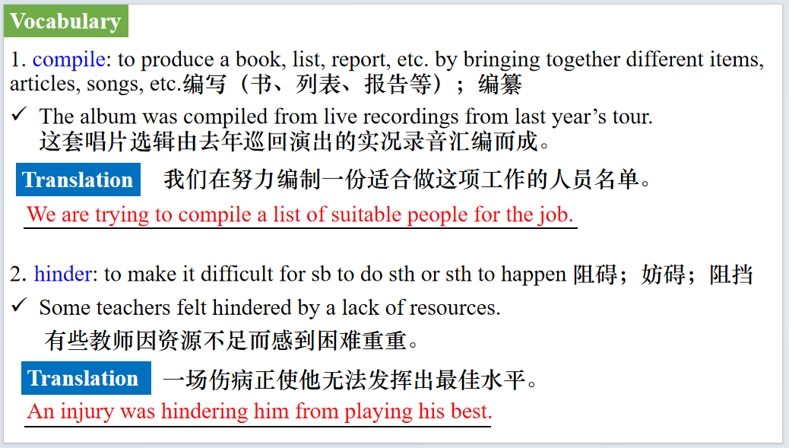
【设计意图】对文本中的词汇进行解读，并通过翻译句子对其进行巩固。
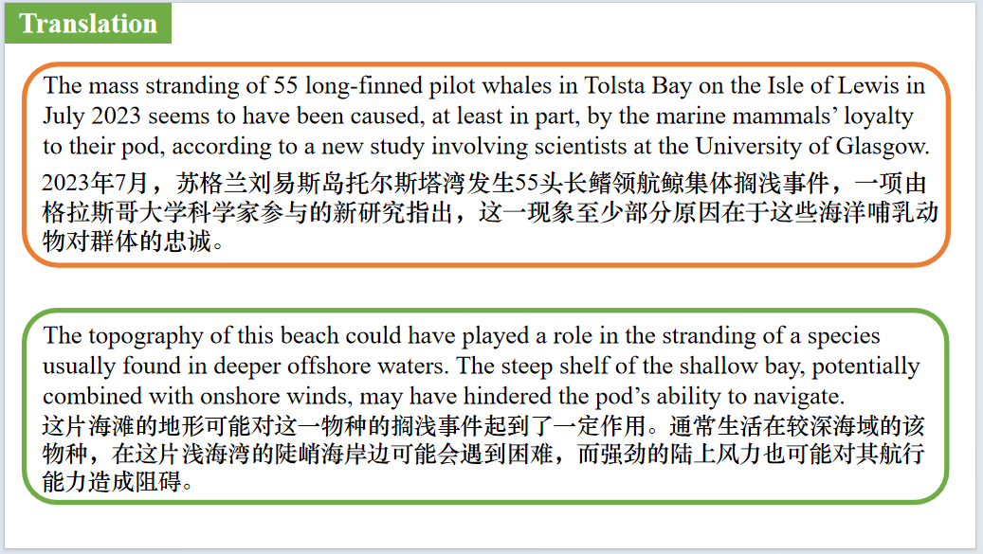
【设计意图】对文中的两个句子进行翻译练习，对其中单词、词组、句法进行巩固并关注句子结构。

Part 4: News Report 4 Outside USA（Summer, 2026 P14)
Earl Swift厄尔·斯威夫特
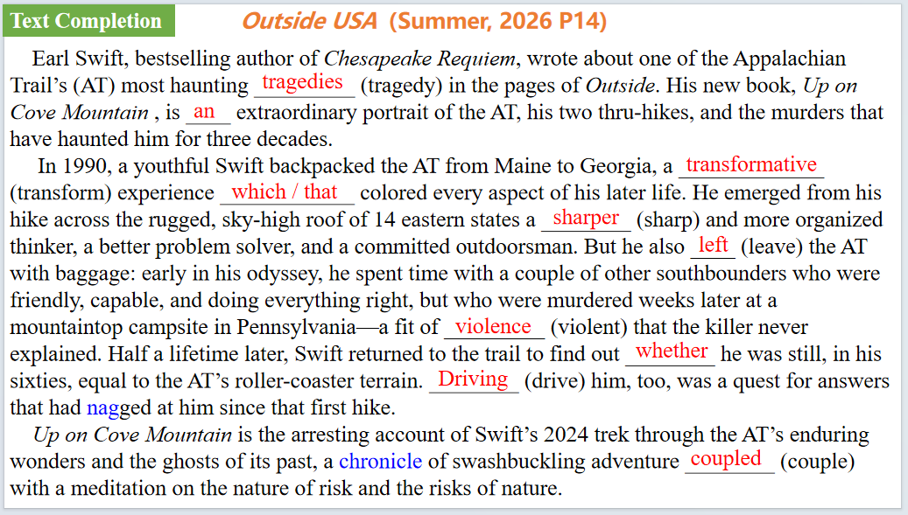
【设计意图】通过语篇填空的形式帮助学生理解新闻的主要内容，同时训练语言语法的运用能力：在语篇的视角下如何正确使用所给词汇，根据语法规则确定词汇的正确形式，使得文章通顺，激活学生的思维和语言。该新闻主题语境是关于“人与社会”中“小说”这一子主题，通过学习让学生了解厄尔·斯威夫特的新书。
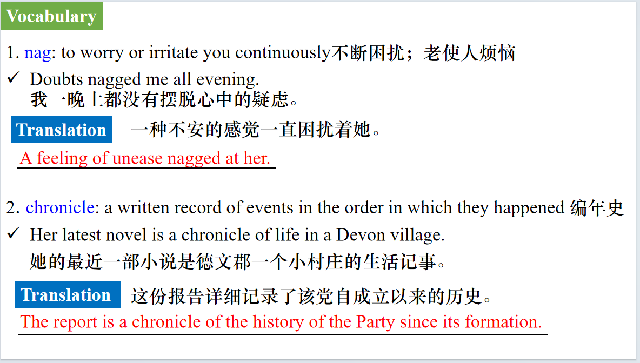
【设计意图】对文本中的词汇进行解读，并通过翻译句子对其进行巩固。
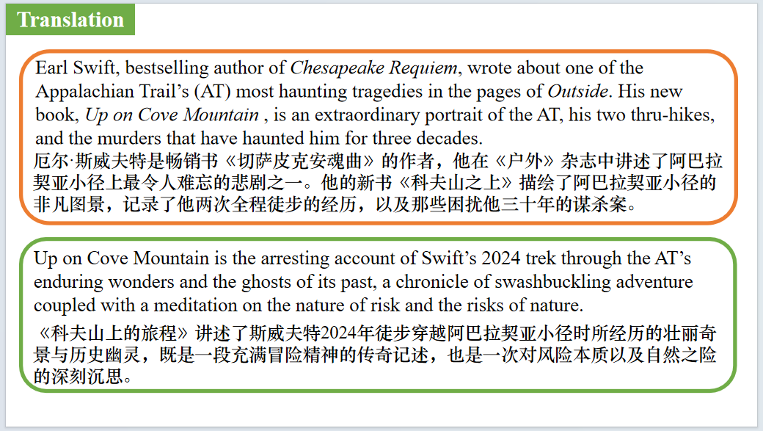
【设计意图】对文中的两个句子进行翻译练习，对其中单词、词组、句法进行巩固并关注句子结构。

Part 5: BBC News 05/14/2026
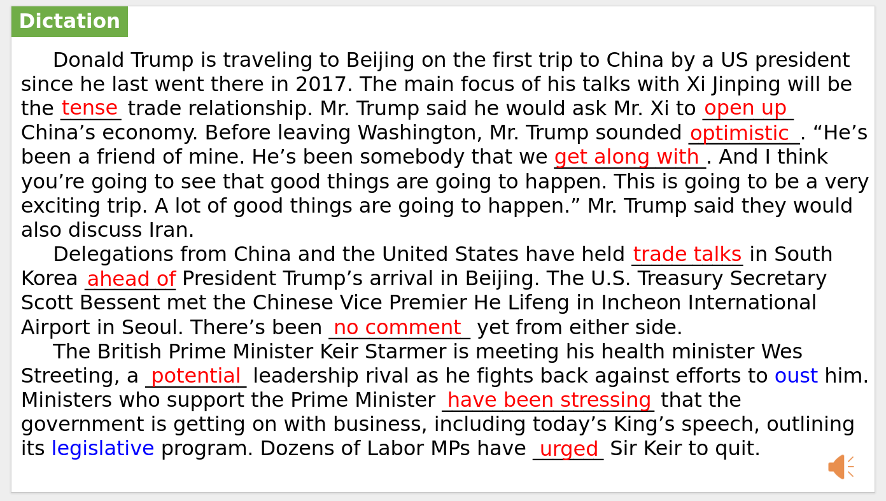
【设计意图】听一则材料，通过听力填空的方式理解文本，考察听力辨识词汇的能力。
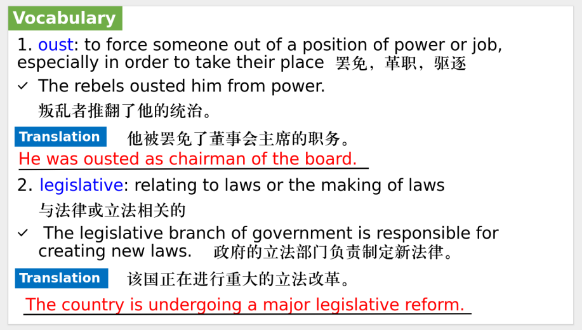
【设计意图】对文本中的词汇进行解读，并通过翻译句子对其进行巩固。
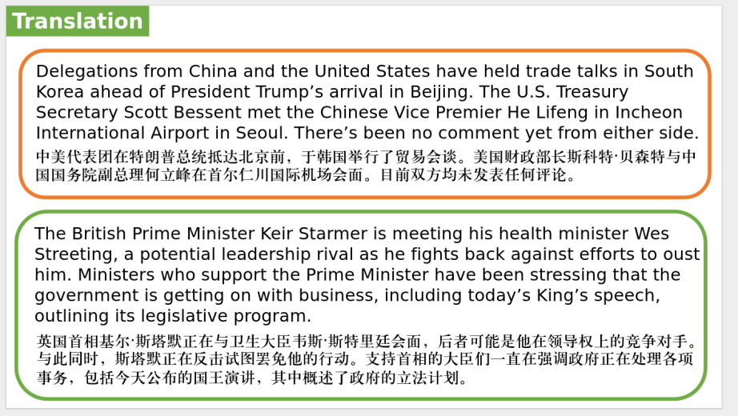
【设计意图】对文中的两个句子进行翻译练习，对其中单词、词组、句法进行巩固并关注句子结构。

附：外刊原文
Part 1: News Report 1 The Washington Post (May 10, 2026 A17)
90,000 people are waiting for an organ that can’t be bought
9万人在等待无法用金钱购买的器官
The time has come to carefully but urgently rethink payments to kidney donors.
There are approximately 130,000 new cases of kidney failure annually in the United States. It is disproportionately a disease of the poor, and is four times as likely to affect Black people as White people. Kidney failure costs Medicare alone more than $55 billion per year, mostly for dialysis. More than 500,000 people are presently on dialysis, about half of whom will die within five years of beginning treatment. The best treatment for kidney failure is transplantation, but in 2025 fewer than 30,000 people in the United States received kidney transplants. So most people who could benefit from a lifesaving transplant will die without one.
About 90,000 people are registered on the national waiting list to receive a deceased-donor kidney, and many more would be, if there were enough transplants for all who need them. Thousands die each year while waiting, and thousands more are removed from the waiting list when they become too sick to undergo transplant surgery.
The law in the U.S. and most of the world says kidneys must be gifts; their price must be zero. So, any attempt to raise the supply of kidneys by compensating donors would have to overcome the almost worldwide repugnance for payment.
About three-quarters of kidneys transplanted in the U.S. come from deceased donors, and the rest come from living donors: Healthy people have two kidneys and can remain healthy with one. But sometimes potential donors can’t donate to the person they love, because kidneys have to be medically compatible with the recipient. It’s a challenge even within families. For example, often a mother can’t receive a kidney from her spouse or children because during pregnancy, her immune system developed antibodies to some of their proteins.
For the last quarter-century, living-donor transplants have also been arranged through kidney exchange, in which each patient receives a compatible kidney from another patient’s intended donor. Some of these transplants take place in long chains initiated by a nondirected donor, who donates a kidney, anonymously, to anyone who needs one. That begins a chain of donations in which each recipient’s intended donor passes the gift forward. Kidney exchange has made possible thousands of additional transplants, without payments to donors.
Nevertheless, kidneys for transplant remain in tragically short supply. So it is past time to consider amending the 1984 law that prohibits giving “valuable consideration” for a kidney for transplant.
This would have to be done with care, because there are good reasons that the phrase “payments for kidneys” arouses repugnance. We wouldn’t want inappropriate donors to be unduly influenced to give up a kidney. (This is something already considered when screening the thousands of people who donate one of their kidneys each year without payment.) Another concern is that we wouldn’t want to live in a world in which only rich people could get kidneys, by buying them from poor people.
In the United States, we might think about letting individual states experiment with different regulations. Or we could explore a national system in which only the federal government could buy kidneys — from carefully qualified donors, after a significant period devoted to medical and psychological screening, and having obtained carefully informed consent. Those kidneys could then be allocated without regard to patients’ income, much as we presently allocate deceased-donor kidneys, which are treated as a national resource.
It would be financially feasible to pay donors quite generously without requiring recipients to pay anything at all. Donors could be paid entirely from the savings to the health care system by taking patients off dialysis.
There is a long history of thoughtful arguments in favor of allowing kidney donors to be legally paid or compensated in some way, with carefully considered precautions. These include a current proposal called the End Kidney Deaths Act, which would establish a limited pilot program for a tax credit to nondirected kidney donors.
To be clear, we should keep trying for big long-term goals, such as vastly reducing the incidence of kidney disease by preventing or curing diabetes, hypertension and other causes. We should keep trying to expand deceased donation (perhaps by offering funeral benefits in gratitude to the next of kin who allow it). We should keep exploring cures that don’t require transplants of human organs. But we can save many lives now by being more generous to living donors, and it makes sense to start experimenting with ways to do this legally, ethically and equitably.

Part 2: News Report 2 The Wall Street Journal (May 9, 2026 A1&A6)
Apple, Intel Set Chip-Making Deal
苹果与英特尔达成芯片制造协议
Apple and Intel have reached a preliminary agreement for Intel to manufacture some of the chips that power Apple devices, according to people familiar with the matter.
Intensive talks between the two companies have been going on for more than a year, and the two sides hammered out a formal deal in recent months, these people said. Bloomberg News previously reported the talks. It is still unclear which Apple products Intel would make chips for, these people said. Apple ships more than 200 million iPhones a year as well as millions of iPads and Mac computers.
Representatives for Apple and Intel declined to comment.
Intel has two main business lines: designing chips and manufacturing them—both its own designs and external customers’—in its Intel Foundry unit. Both businesses had been underperforming for years before Lip-Bu Tan took over as chief executive last spring vowing to revitalize them.
The Trump administration last summer struck a deal to convert nearly $9 billion in federal grants into Intel stock, giving the U.S. government a 10% stake in the chip maker. It played a key role in bringing Apple to the table.
Commerce Secretary Howard Lutnick has met repeatedly over the past year with high-ranking Apple officials, including Chief Executive Tim Cook, as well as SpaceX chief Elon Musk and Nvidia Chief Executive Jensen Huang, to try to convince them to get into business with Intel, some of the people familiar with the matter said.
With the Apple deal, Intel has now signed partnerships with all three.
Over the past decade, Intel fell badly behind rivals such as Taiwan Semiconductor Manufacturing Co. and Samsung Electronics after a series of technical missteps, leadership changes and failed attempts at consolidation led outside foundry customers to pull or curb their business.
When Intel hired Tan in March 2025 to succeed ousted Chief Executive Pat Gelsinger, President Trump raised concerns that Tan’s close ties with China would compromise him and called for his ouster.
But Tan won Trump over with a charm offensive, and the government announced its 10% investment in Intel shortly after. Following the investment, Intel’s share price rose sharply. On Friday, it closed up 14% at $124.92 per share.
Tan has been reshaping Intel’s top leadership ranks in recent months as well, including hiring former Taiwan Semiconductor Manufacturing executive WeiJen Lo, a move that prompted a lawsuit from TSMC.
The Intel CEO also ousted his head of product and hired new executives to lead the company’s data center processor and client computing units, as well as a newly formed custom silicon business. He has also invested heavily in Intel’s most-advanced manufacturing process, known as 14A.
Trump personally advocated for Intel to Cook in a meeting at the White House, according to people familiar with the matter.
“I like Intel,” Trump said in January. He said the government had made “tens of billions of dollars” from the Intel deal, and that the government’s backing of the company had attracted important partners to Intel.
“As soon as we went in, Apple went in, Nvidia went in, a lot of smart people went in,”Trump said.
Nvidia, the world’s largest chips firm, invested $5 billion in Intel in September, and thetwo companies announced a partnership under which Intel would build custom data center CPUs—the processing brains of most computer systems—for Nvidia. And last month, Musk and Intel announced an ambitious plan to build a chip manufacturing plant in Texas as part of Musk’s Terafab project to produce chips for Tesla, xAI and SpaceX.
Apple relies on TSMC to make the chips it designs for iPhones, iPads, Macs and other devices, and is under pressure to find additional chip suppliers. On Apple’s past two earnings conference calls, Cook has blamed a lack of availability of advanced chips for Apple’s inability to meet customer demand for iPhones.
The constraints are expected to continue into the current quarter, affecting several Mac models, Cook said.“We think, looking forward, that the Mac Mini and the Mac Studio may take several months to reach supply-demand balance,” Cook said. Last Friday, the day after the earnings call, Apple raised the Mac Mini’s starting price.
TSMC’s manufacturing capabilities far surpass those of Samsung and Intel. Makers of other kinds of chips, for memory and storage, for example,are more competitive with one another, giving Apple multiple sources of supply.
Apple has long been TSMC’s top customer, but skyrocketing demand for its manufacturing capacity from Nvidia and other designers of AI chips means that Apple no longer has as much leverage to secure the supplies it needs.
Starting in 2006, Apple used Intel-designed CPUs as the main processors for its personal computers, but switched to its own custom CPUs, based on a design architecture from Arm Holding, in 2020.
Asked during a February interview if Apple was working toward having Intel make its chips, Apple’s global head of procurement, David Tom, said, “We talk to Intel all the time.” He declined to offer specifics of the discussions.

Part 3: News Report 3 BBC Countryfile（May, 2026 P13)
Scientists Discover Heartbreaking Reason For Mass Whale Stranding
科学家发现鲸鱼大规模搁浅的令人心碎的原因
The mass stranding of 55 long-finned pilot whales (Globicephala melas) in Tolsta Bay on the Isle of Lewis in July 2023 seems to have been caused, at least in part, by the marine mammals’ loyalty to their pod, according to a new study involving scientists at the University of Glasgow.
The unusually large landing at Tràigh Mhòr, a sandy beach on the north-east coast of this island in the Outer Hebrides, could have been triggered by the pod’s social instincts. These may have led the whales to remain close to a female experiencing distress during a difficult birth, according to the report compiled by the Scottish Marine Animal Stranding Scheme.
Investigations on one of the female whales detected dystocia – difficulty during labour, which may have been caused by a large or poorly positioned calf. Pilot whales are known for their extremely strong social cohesion, often gathering together en masse when one of the pod is sick or injured in order to protect that individual from predators. In this case, the entire group may have followed the distressed female into shallow waters. One was successfully refloated by rescuers; the rest perished.
The report emphasises that multiple factors are often involved in such incidents. The topography of this beach could have played a role in the stranding of a species usually found in deeper offshore waters. The steep shelf of the shallow bay, potentially combined with onshore winds, may have hindered the pod’s ability to navigate. Once stranded, the whales were unable to refloat themselves, facing surf driven by onshore winds and difficulties caused by the soft sand floor of the bay. The whales were found to have good overall health, with no significant underlying diseases or infections.
An even larger stranding in July 2024 on Sunday, Orkney, resulted in the deaths of a 77-strong pod of long-finned pilot whales. A year later, 23 pilot whales were discovered dead on a different beach on Sunday, again having stranded. The causes of those incidents are being investigated.

Part 4: News Report 4 Outside USA（Summer, 2026 P14)
Earl Swift厄尔·斯威夫特
Earl Swift, bestselling author of Chesapeake Requiem, wrote about one of the Appalachian Trail’s (AT) most haunting tragedies in the pages of Outside. His new book, Up on Cove Mountain (HarperCollins, $32, August 18), is an extraordinary portrait of the AT, his two thru-hikes, and the murders that have haunted him for three decades.
In 1990, a youthful Swift backpacked the AT from Maine to Georgia, a transformative experience that colored every aspect of his later life. He emerged from his hike across the rugged, sky-high roof of 14 eastern states a sharper and more organized thinker, a better problem solver, and a committed outdoorsman.
But he also left the AT with baggage: early in his odyssey, he spent time with a couple of other southbounders who were friendly, capable, and doing everything right, but who were murdered weeks later at a mountaintop campsite in Pennsylvania — a fit of violence that the killer never explained.
Half a lifetime later, Swift returned to the trail to find out whether he was still, in his sixties, equal to the AT’s roller-coaster terrain. Driving him, too, was a quest for answers that had nagged at him since that first hike: What had happened at that campsite to turn two smart, bighearted people into prey? Why had fate chosen them, when other hikers—Swift included—seemed more likely candidates? And how could such a grisly episode have unfolded in the backcountry’s sylvan loveliness, not to mention one of the safest places around?
Up on Cove Mountain is the arresting account of Swift’s 2024 trek through the AT’s enduring wonders and the ghosts of its past, a chronicle of swashbuckling adventure coupled with a meditation on the nature of risk and the risks of nature.

