The World（0516-0531）材料分析和教学目标：
本次选用的材料：①National Geographic的Meet the conservationist helping people live with wild animals（她帮助人类与野生动物和谐共处）、②The Times 的Brain aneurysm treated via eye socket in UK first（英国首次通过眼眶治疗脑动脉瘤）、③The Week Junior USA的Leading young activists（杰出的年轻活动家）、④The People’s Friend的At The Heart Of Fostering Is Compassion（培育的核心在于关爱）和⑤BBC的新闻报道。通过语法填空、阅读理解、分析长难句、翻译句子、听力填空和词汇拓展等方式，让学生从多角度提升学习兴趣，提高分析句子、运用词块和听力能力。外媒英语新闻可以让学生体验真实语境下的语言运用，拓展学生的国际视野，了解时事，逐步提升跨文化沟通能力，形成正确的世界观、人生观和价值观。

教学思路：
Part 1: News Report 1 National Geographic (June, 2026 P14)
Meet the conservationist helping people live with wild animals
她帮助人类与野生动物和谐共处
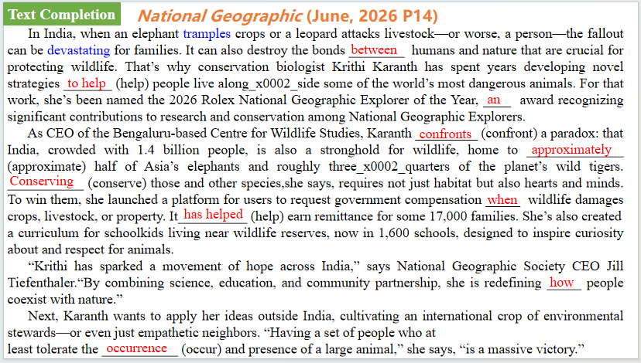
【设计意图】通过语篇填空的形式帮助学生理解新闻的主要内容，同时训练语言语法的运用能力：在语篇的视角下如何正确使用所给词汇，根据语法规则确定词汇的正确形式，使得文章通顺，激活学生的思维和语言。该新闻主题语境是关于“人与自然”中“人与环境，人与动植物”这一子主题，生态学家克里蒂·卡兰特多年来一直致力于研究创新策略，以帮助人类与世界上一些最危险的动物和谐共处。
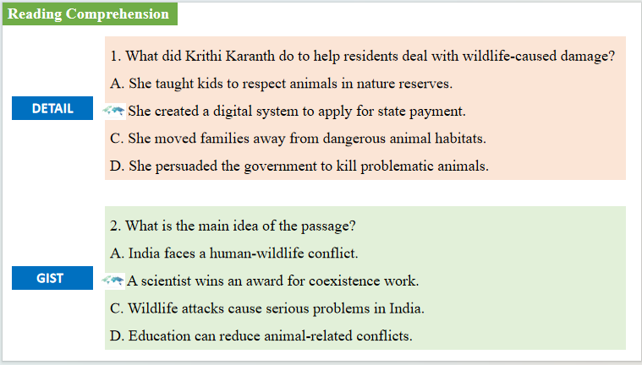
【设计意图】通过阅读理解的形式帮助学生理解新闻的主要内容。
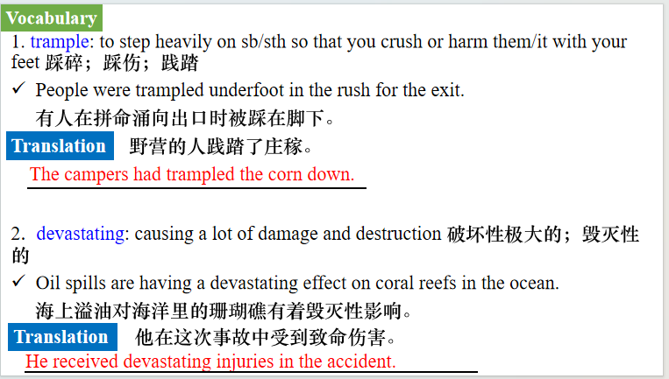
【设计意图】对文本中的词汇进行解读，并通过翻译句子对其进行巩固。
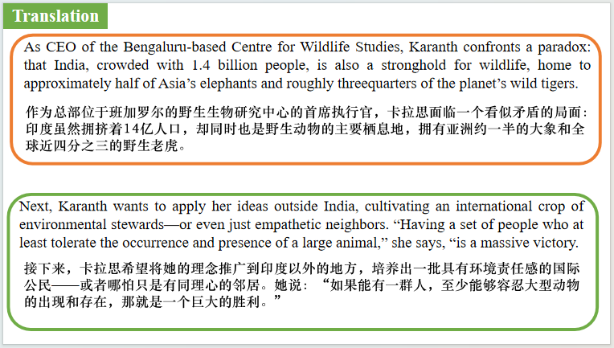
【设计意图】对文中的两个句子进行翻译练习，对其中单词、词组、句法进行巩固并关注句子结构。

Part 2: News Report 2 The Times (May 19, 2026 P14)
Brain aneurysm treated via eye socket in UK first
英国首次通过眼眶治疗脑动脉瘤
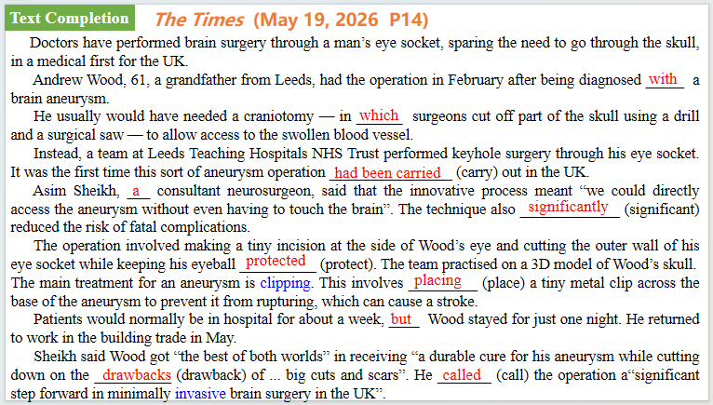
【设计意图】通过语篇填空的形式帮助学生理解新闻的主要内容，同时训练语言语法的运用能力：在语篇的视角下如何正确使用所给词汇，根据语法规则确定词汇的正确形式，使得文章通顺，激活学生的思维和语言。该新闻主题语境是关于“人与社会”中“科技发展与信息技术创新，科学精神”这一子主题，英国首次通过眼眶治疗脑动脉瘤具体情况。
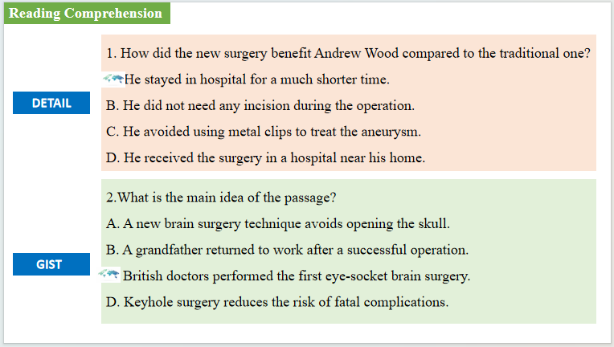
【设计意图】通过阅读理解的形式帮助学生理解新闻的主要内容。
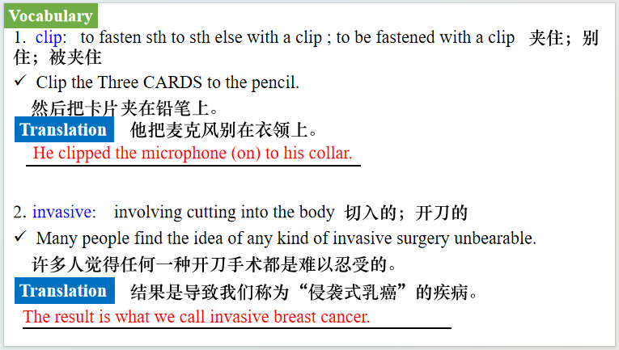
【设计意图】对文本中的词汇进行解读，并通过翻译句子对其进行巩固。
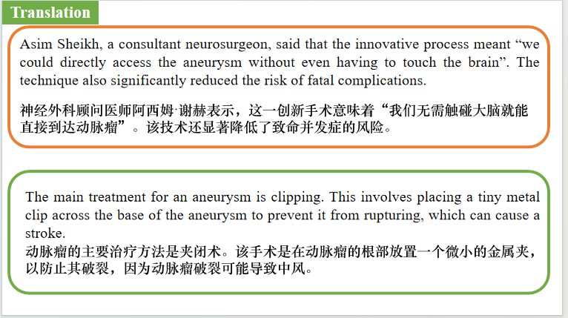
【设计意图】对文中的两个句子进行翻译练习，对其中单词、词组、句法进行巩固并关注句子结构。

Part 3: News Report 3 The Week Junior USA（May, 29, 2026 P9)
Leading young activists 杰出的年轻活动家
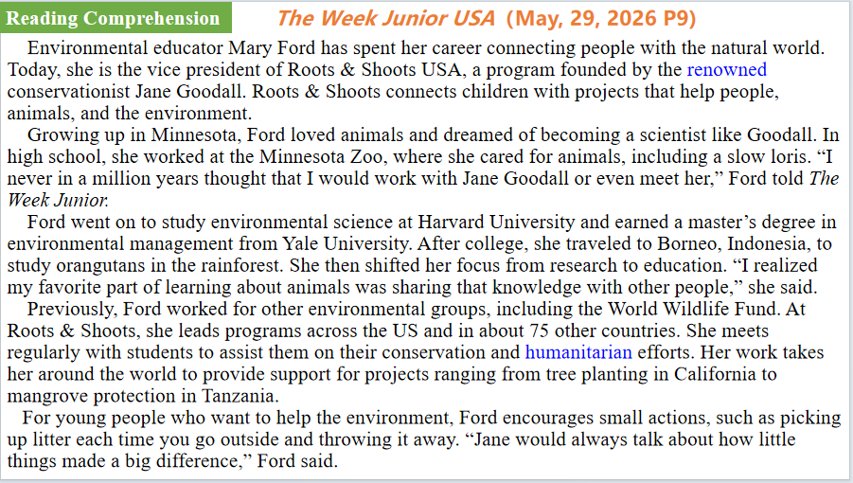
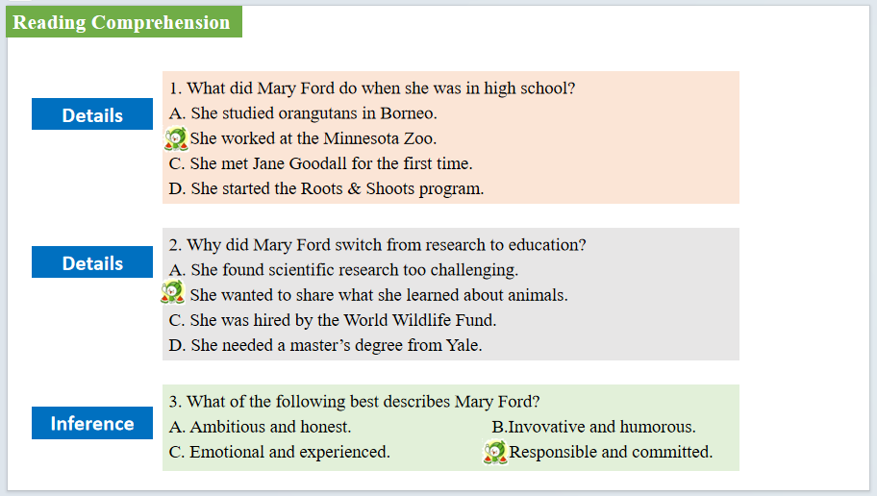
【设计意图】通过阅读理解的形式帮助学生理解新闻的主要内容。该新闻主题语境是关于“人与社会”中“对社会有突出贡献的人”这一子主题，通过学习让学生了解目前全球杰出的年轻活动家。
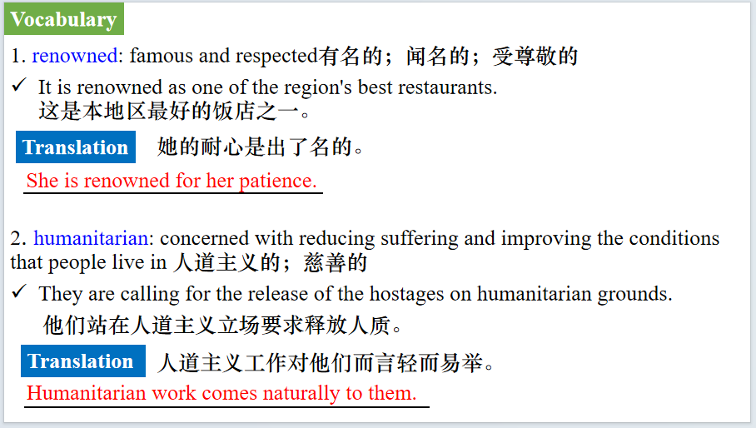
【设计意图】对文本中的词汇进行解读，并通过翻译句子对其进行巩固。
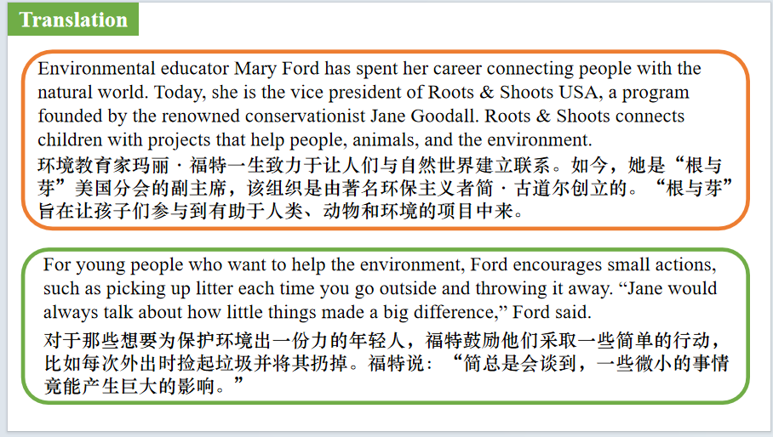
【设计意图】对文中的两个句子进行翻译练习，对其中单词、词组、句法进行巩固并关注句子结构。

Part 4: News Report 4 The People's Friend（May, 30, 2026 P27)
At The Heart Of Fostering Is Compassion 培育的核心在于关爱
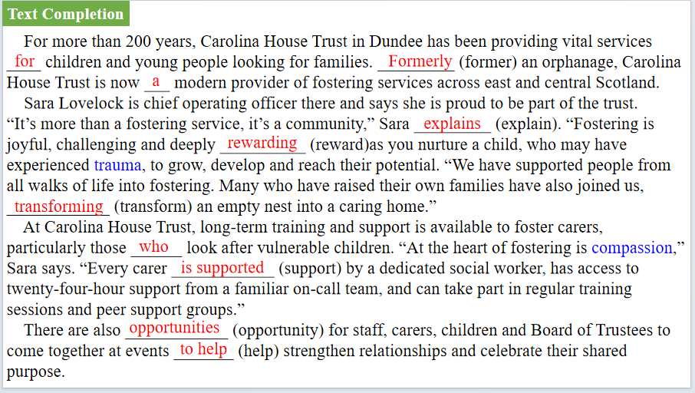
【设计意图】通过语篇填空的形式帮助学生理解新闻的主要内容，同时训练语言语法的运用能力：在语篇的视角下如何正确使用所给词汇，根据语法规则确定词汇的正确形式，使得文章通顺，激活学生的思维和语言。该新闻主题语境是关于“人与社会”中“重要社会公益机构”这一子主题，通过学习让学生了解卡罗琳娜之家信托。
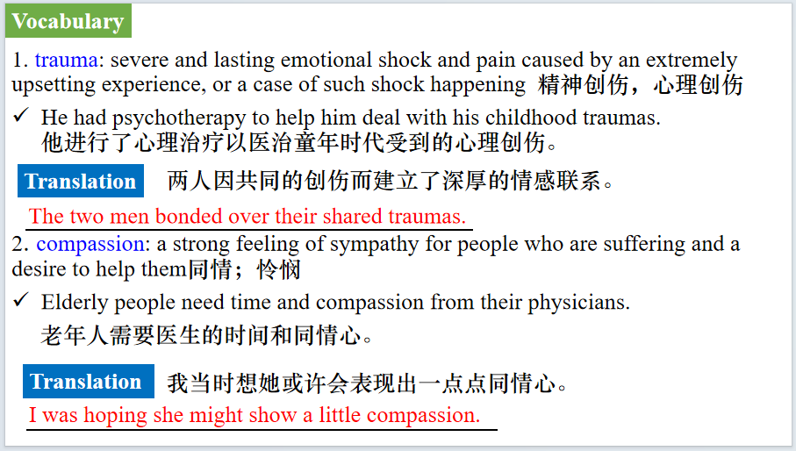
【设计意图】对文本中的词汇进行解读，并通过翻译句子对其进行巩固。
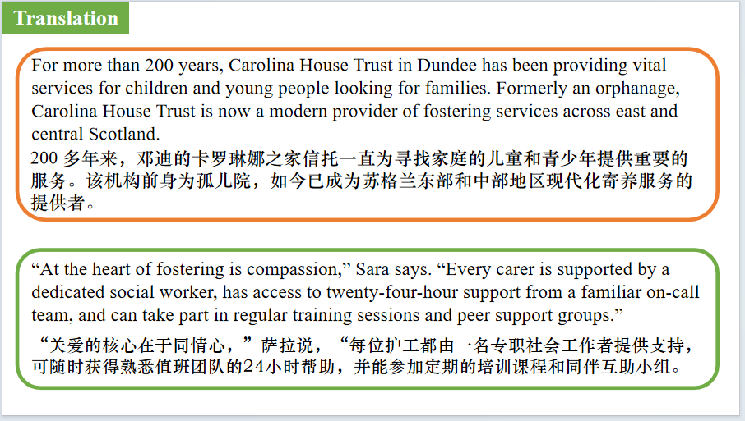
【设计意图】对文中的两个句子进行翻译练习，对其中单词、词组、句法进行巩固并关注句子结构。

Part 5: BBC News 05/20/2026
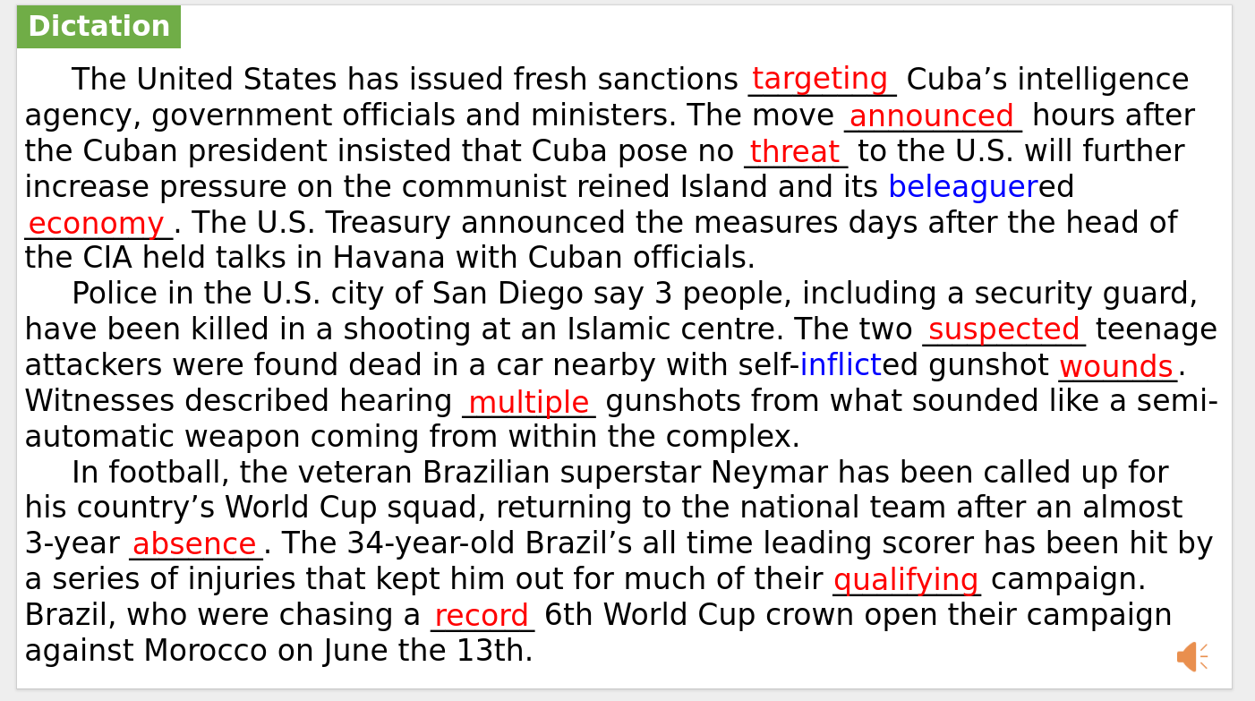
【设计意图】听一则材料，通过听力填空的方式理解文本，考察听力辨识词汇的能力。
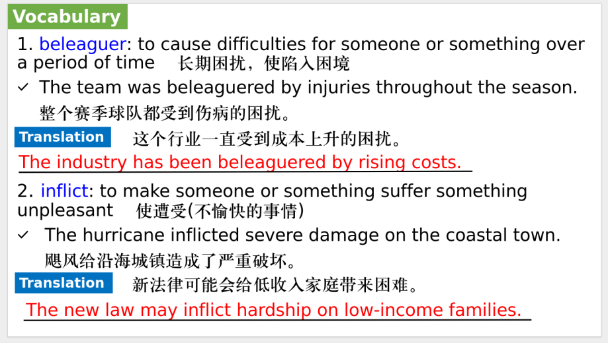
【设计意图】对文本中的词汇进行解读，并通过翻译句子对其进行巩固。
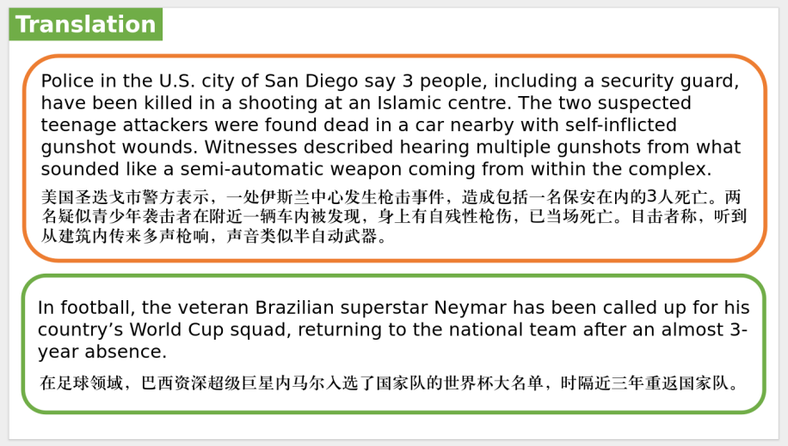
【设计意图】对文中的两个句子进行翻译练习，对其中单词、词组、句法进行巩固并关注句子结构。

附：外刊原文
Part 1: News Report 1 National Geographic (June, 2026 P14)
Meet the conservationist helping people live with wild animals
她帮助人类与野生动物和谐共处
In India, when an elephant tramples crops or a leopard attacks livestock—or worse, a person—the fallout can be devastating for families. It can also destroy the bonds between humans and nature that are crucial for protecting wildlife. That’s why conservation biologist Krithi Karanth has spent years developing novel strategies to help people live alongside some of the world’s most dangerous animals. For that work, she’s been named the 2026 Rolex National Geographic Explorer of the Year, an award recognizing significant contributions to research and conservation among National Geographic Explorers.
As CEO of the Bengaluru-based Centre for Wildlife Studies, Karanth confronts a paradox: that India, crowded with 1.4 billion people, is also a stronghold for wildlife, home to approximately half of Asia’s elephants and roughly three quarters of the planet’s wild tigers. Conserving those and other species,she says, requires not just habitat but also hearts and minds. To win them, she launched a platform for users to request government compensation when wildlife damages crops, livestock, or property. It’s helped earn remittance for some 17,000 families. She’s also created a curriculum for schoolkids living near wildlife reserves, now in 1,600 schools, designed to inspire curiosity about and respect for animals.
“Krithi has sparked a movement of hope across India,” says National Geographic Society CEO Jill Tiefenthaler.“By combining science, education, and community partnership, she is redefining how people coexist with nature.”
Next, Karanth wants to apply her ideas outside India, cultivating an international crop of environmental stewards—or even just empathetic neighbors. “Having a set of people who at least tolerate the occurrence and presence of a large animal,” she says, “is a massive victory.”

Part 2: News Report 2 The Times (May 19, 2026 P14)
Brain aneurysm treated via eye socket in UK first
英国首次通过眼眶治疗脑动脉瘤
Doctors have performed brain surgery through a man’s eye socket, sparing the need to go through the skull, in a medical first for the UK.
Andrew Wood, 61, a grandfather from Leeds, had the operation in February after being diagnosed with a brain aneurysm.
He usually would have needed a craniotomy — in which surgeons cut off part of the skull using a drill and a surgical saw — to allow access to the swollen blood vessel.
Instead, a team at Leeds Teaching Hospitals NHS Trust performed keyhole surgery through his eye socket. It was the first time this sort of aneurysm operation had been carried out in the UK.
Asim Sheikh, a consultant neurosurgeon, said that the innovative process meant “we could directly access the aneurysm without even having to touch the brain”. The technique also significantly reduced the risk of fatal complications.
The operation involved making a tiny incision at the side of Wood’s eye and cutting the outer wall of his eye socket while keeping his eyeball protected. The team practised on a 3D model of Wood’s skull.
The main treatment for an aneurysm is clipping. This involves placing a tiny metal clip across the base of the aneurysm to prevent it from rupturing, which can cause a stroke.
Patients would normally be in hospital for about a week, but Wood stayed for just one night. He returned to work in the building trade in May.
Wood, whose aneurysm was found while he was being scanned for another medical issue last spring, said: “I was asked to make some toast and a cup of tea to make sure my faculties were OK, I had another quick scan, and then they asked if I wanted to go home.
“It has been perfect since, I’ve had no double vision, no pain, I’m back at work — I just have to watch out that I don’t hit myself with a two-by-four.”
He said of the medics involved: “I’m really grateful for their kindness and expertise — they are an outstanding team. I’m proud to have been part of such an important procedure and I’m amazed at how quickly I recovered and returned home.”
The team performed a similar operation in 2024 when they removed a brain tumour through a patient’s eye socket. Sheikh said: “As we gained more experience, we realised that the same approach could be used to access other pathologies ... His aneurysm happened to be in a very easily accessible area, which would have been perfect for this technique.”
He said Wood got “the best of both worlds” in receiving “a durable cure for his aneurysm while cutting down on the drawbacks of ... big cuts and scars”. He called the operation a“significant step forward in minimally invasive brain surgery in the UK”.

Part 3: News Report 3 The Week Junior USA（May, 29, 2026 P9)
Leading young activists 杰出的年轻活动家
Environmental educator Mary Ford has spent her career connecting people with the natural world. Today, she is the vice president of Roots & Shoots USA, a program founded by the renowned conservationist Jane Goodall. Roots & Shoots connects children with projects that help people, animals, and the environment.
Growing up in Minnesota, Ford loved animals and dreamed of becoming a scientist like Goodall. In high school, she worked at the Minnesota Zoo, where she cared for animals, including a slow loris. “I never in a million years thought that I would work with Jane Goodall or even meet her,” Ford told The Week Junior.
Ford went on to study environmental science at Harvard University and earned a master’s degree in environmental management from Yale University. After college, she traveled to Borneo, Indonesia, to study orangutans in the rainforest. She then shifted her focus from research to education. “I realized my favorite part of learning about animals was sharing that knowledge with other people,” she said.
Previously, Ford worked for other environmental groups, including the World Wildlife Fund. At Roots & Shoots, she leads programs across the US and in about 75 other countries. She meets regularly with students to assist them on their conservation and humanitarian efforts. Her work takes her around the world to provide support for projects ranging from tree planting in California to mangrove protection in Tanzania.
For young people who want to help the environment, Ford encourages small actions, such as picking up litter each time you go outside and throwing it away. “Jane would always talk about how little things made a big difference,” Ford said.

Part 4: News Report 4 The People's Friend（May, 30, 2026 P27)
At The Heart Of Fostering Is Compassion培育的核心在于关爱
For more than 200 years, Carolina House Trust in Dundee has been providing vital services for children and young people looking for families.
Formerly an orphanage, Carolina House Trust is now a modern provider of fostering services across east and central Scotland.
Sara Lovelock is chief operating officer there and says she is proud to be part of the trust.
“It’s more than a fostering service, it’s a community,” Sara explains. “Fostering is joyful, challenging and deeply rewarding as you nurture a child, who may have experienced trauma, to grow, develop and reach their potential.
“We have supported people from all walks of life into fostering. Many who have raised their own families have also joined us, transforming an empty nest into a caring home.”
At Carolina House Trust, long-term training and support is available to foster carers, particularly those who look after vulnerable children.
“At the heart of fostering is compassion,” Sara says. “Every carer is supported by a dedicated social worker, has access to twenty-four-hour support from a familiar on-call team, and can take part in regular training sessions and peer support groups.”
There are also opportunities for staff, carers, children and Board of Trustees to come together at events to help strengthen relationships and celebrate their shared purpose.

